INTRODUCTION TO HIVE

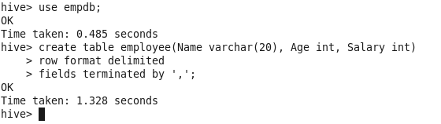
We have one table named as employee in the empdb database. The table has no records
Now we create 3 files employee1.txt, employee2.txt, employee3.txt, and we insert 3 records in each file.
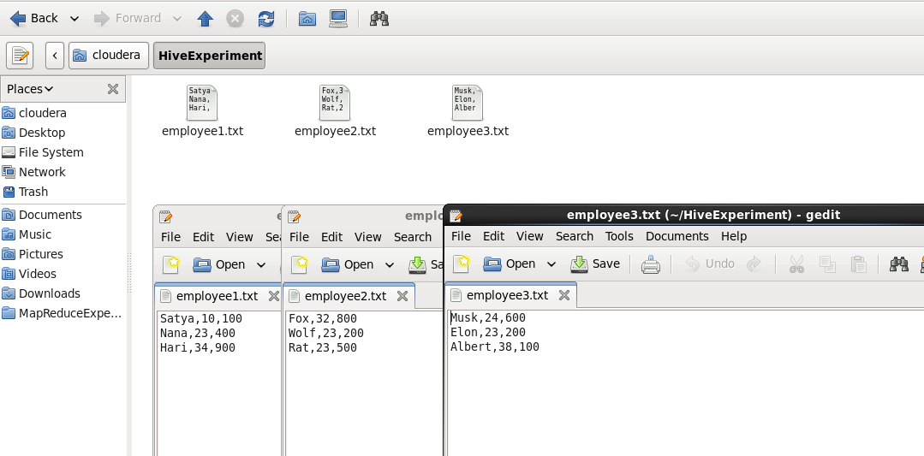
Let’s load these files in Hive Table (HDFS under the hood)
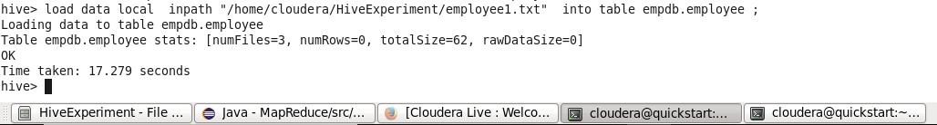
Now after the data load of all 3 files, when we try to print the contents of employee table:
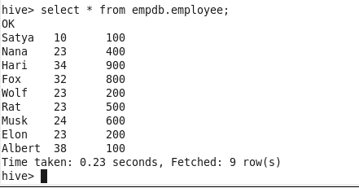
When we added these files in the Hive it became the part of HDFS. Let’s browse HDFS.
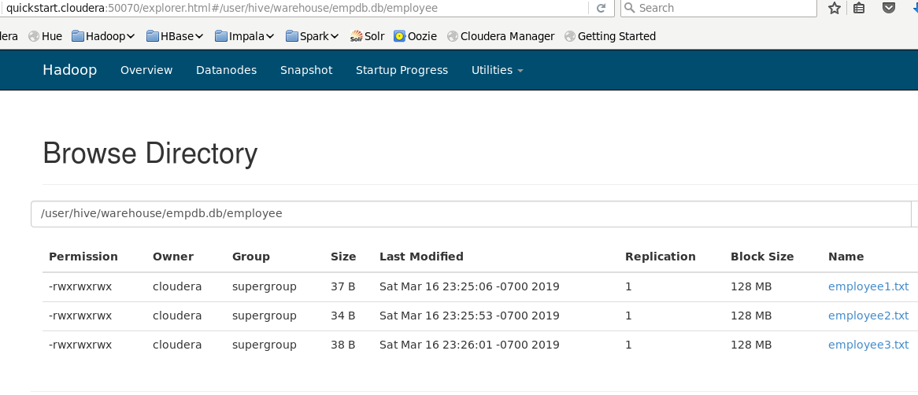
Notice the path. Don’t get confused the above with the HDFS experiments we performed:
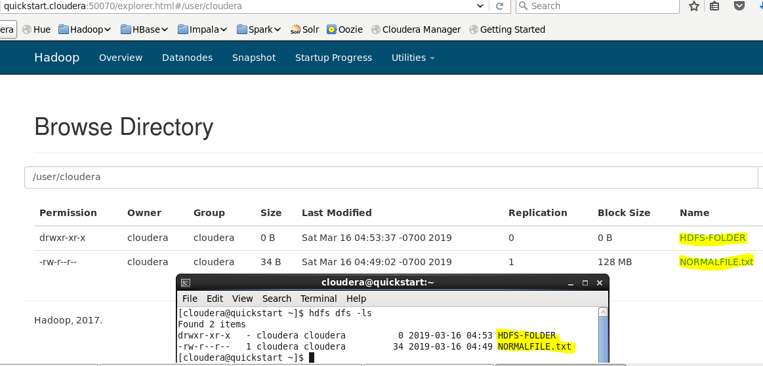
Now let say we made a file that is not of the type String,int, int. But of different datatypes like string, sting,string, int. Then here is the output :0
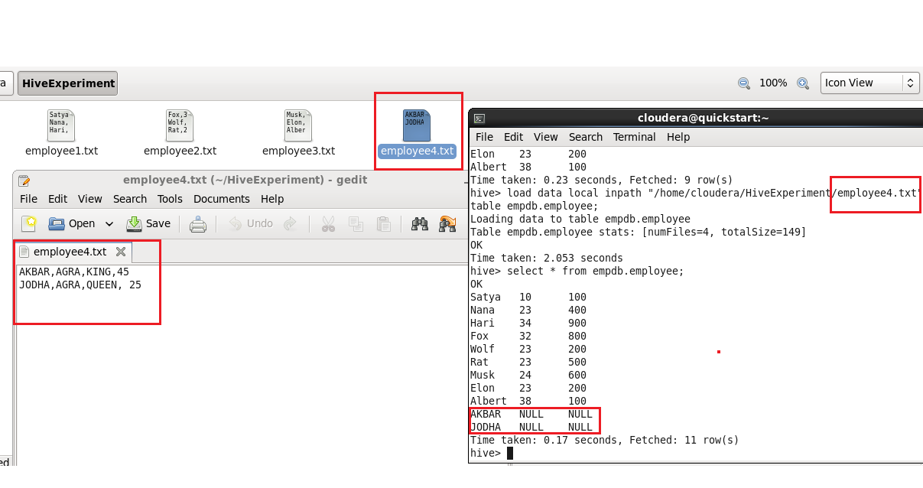
To view the metadata of Hive table:
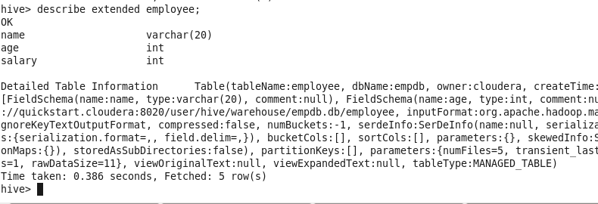 This gives metadata. This metadata is stored in mysql (if configured) else, by default this metadata is stored in the derby database.
So far, we loaded the data in hive was from the txt file. Let’s see other way – The insert query way !

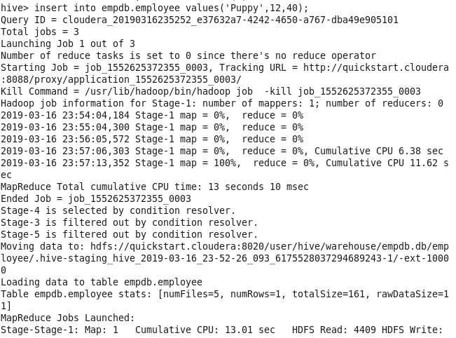
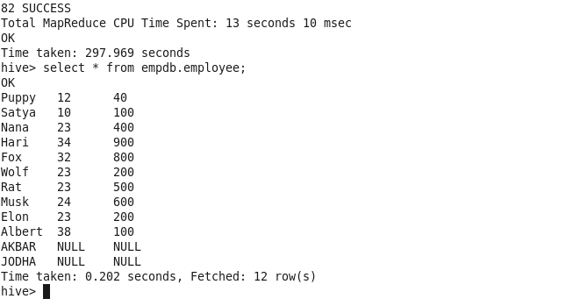

Let’s see third way of loading the data in hive table from an existing HDFS file. Let’s create a file:
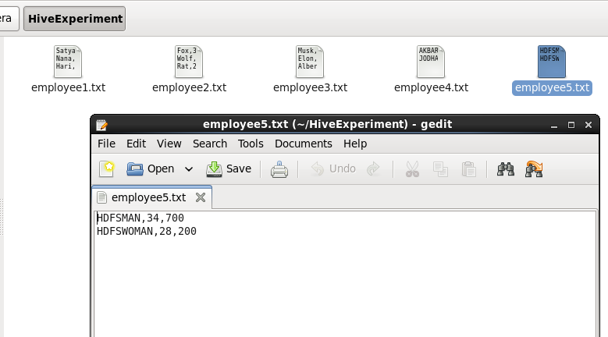

Create a folder in the HDFS, put this file there.
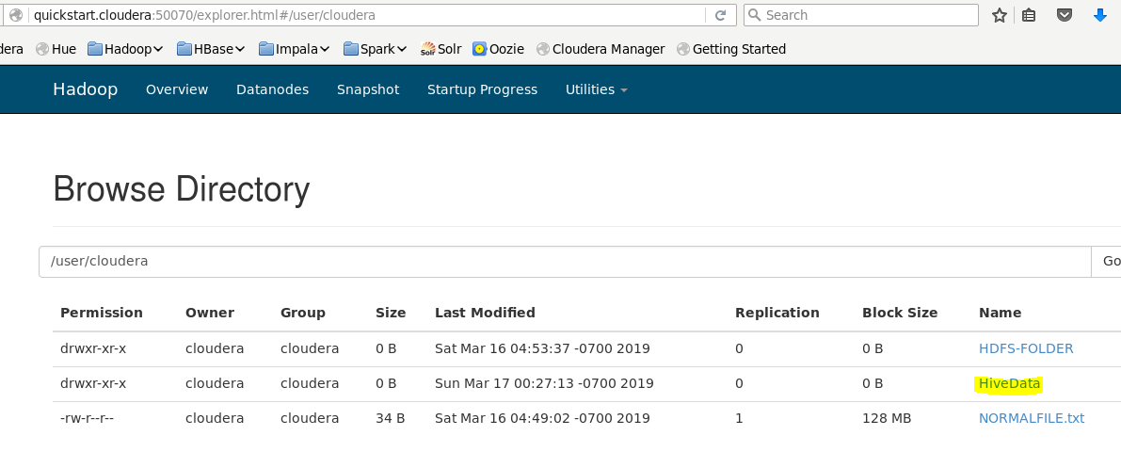
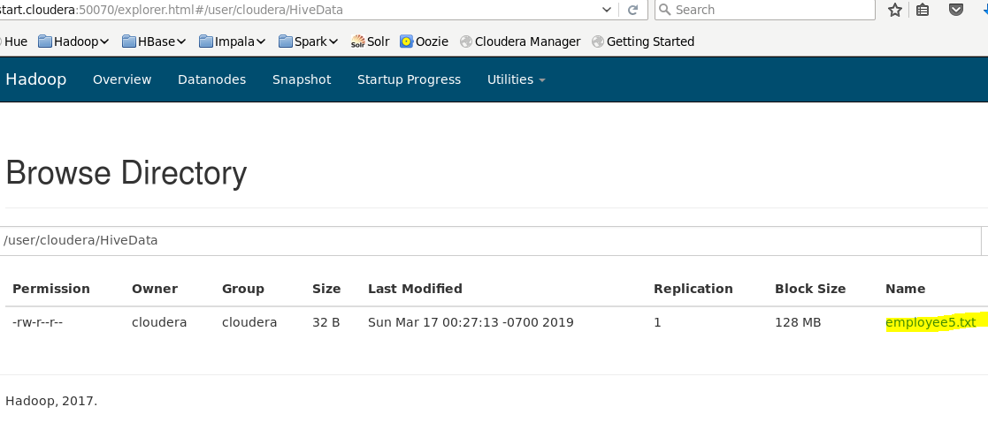

Now, its time to load this file into empdb.employee table:

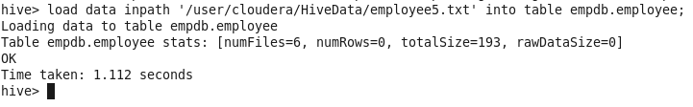
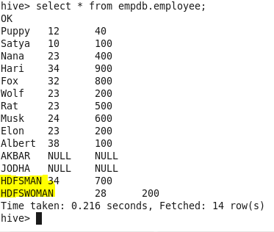
NOTE: Now as we have loaded the file from HDFS into table, one thing to note is that the file is now absent from the (HiveData) HDFS folder:

