PARTITIONING IN HIVE
(TECHNIQUE FOR BETTER IMPROVMENT)
- STATIC PARTITIONING

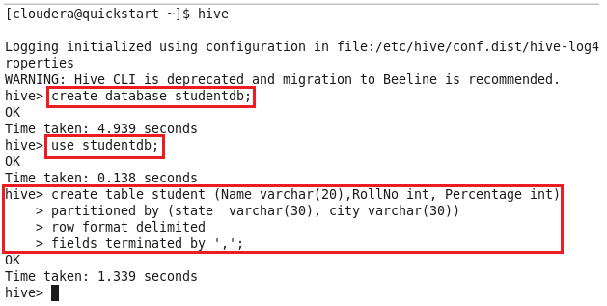
Now on describing this newly created table, we can see that the partitioned ‘tagged’ columns becomes the part of the original table.
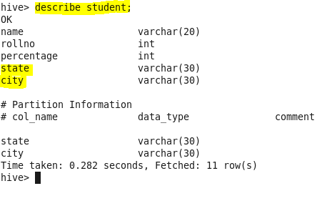

Now create 3 files, each containing – NAME, ROLLNO, PERCENTAGE. NO STATE, NO CITY.
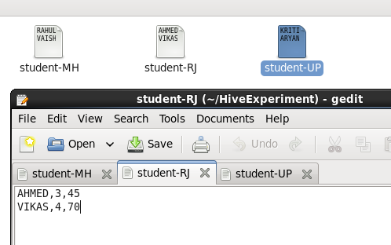

Now load this data in your students table:
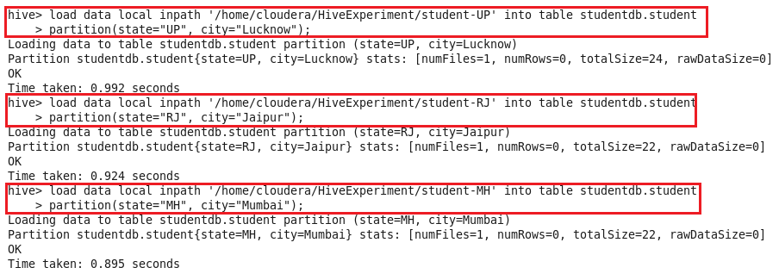
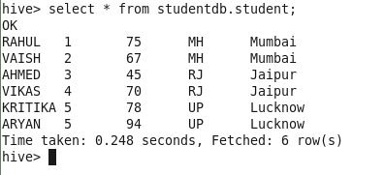
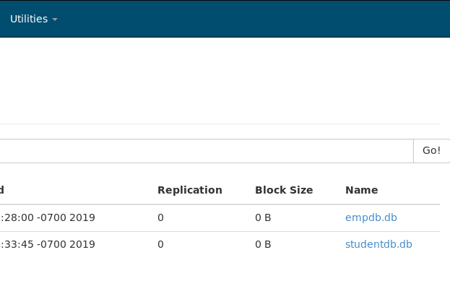On clicking studentdb.db
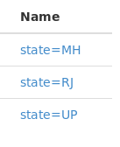
On clicking state=UP
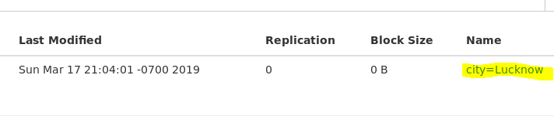

- DYNAMIC PARTITIONING

Now create a simple partitioned table
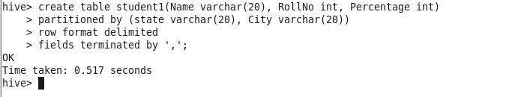
Insert into this table from a table (partitioned /non-partitioned table)
