BUCKETING IN HIVE
(TECHNIQUE FOR BETTER IMPROVMENT)


Make this initialization
Create a simple table.
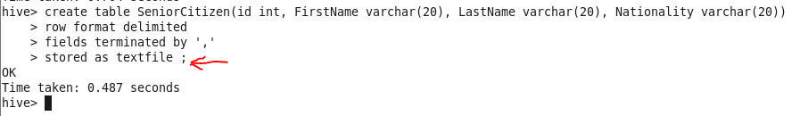
Now load the file into the table.
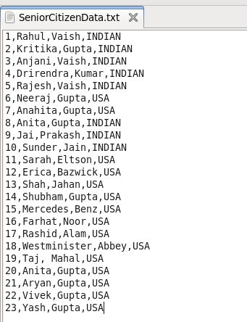

Now create a bucketed table.
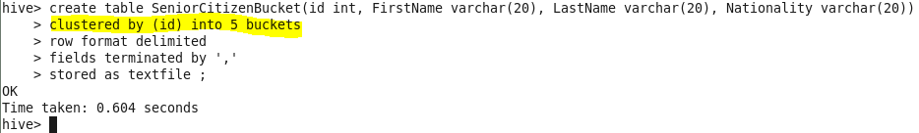
Now fetch the data from SeniorCitizen table to SeniorcitizenBucket table.
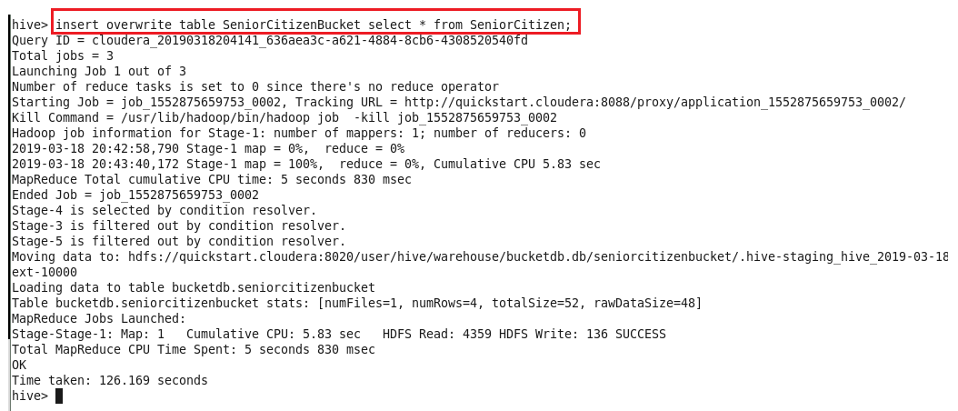
After this make select query.
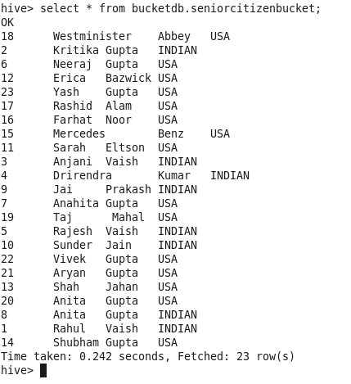
This looks normal, but how it’s being represented in HDFS –
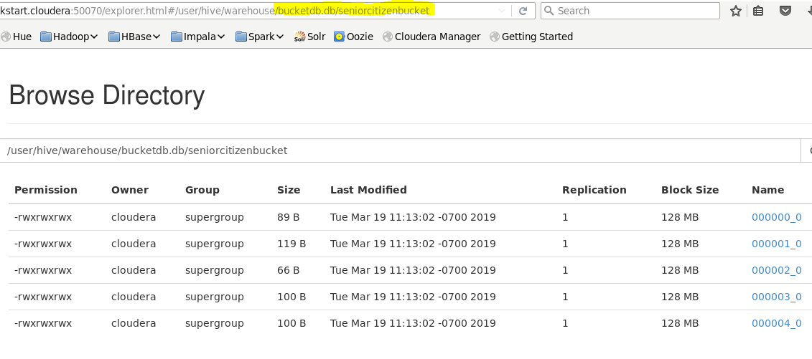
As we defined 5 buckets so we are seeing all 5 buckets ☺
Let’s see which records went in bucket#3 ?
