PARTITIONING + BUCKETING IN HIVE
(TECHNIQUE FOR BETTER IMPROVMENT)

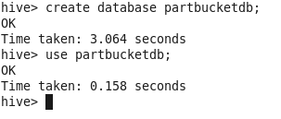
Make this initialization
&
Create a simple table with data:
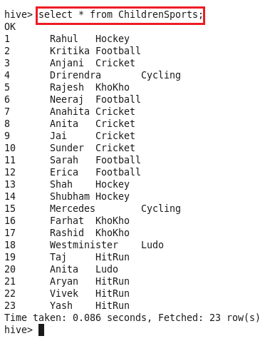

Create a table – D.PARTITIONING + BUCKETING.
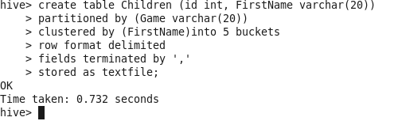
Now load the ChildrenSports table file into this above Children table.
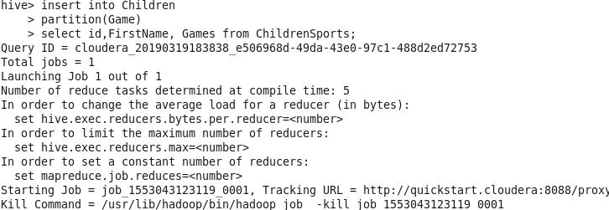
Now let’s see HDFS
