User Manual

*Excel Merge for Boardwalk Universal Template Version 3.1*

1. **Introduction**

Boardwalk Excel Merge is used to merge the data from Source Excel Range to Target Excel Range.

‘Merge Sheet’ is the Excel worksheet used to enter the data required to merge and will act as the Source Sheet.

‘Merge Rule Form’ is the functionality to generate a Merge Rule which is having all the configuration information of that rule. Executing this Merge Rule will merge the Source data into the Target Cuboid.

To define the merge rule for particular target Cuboid, open the worksheet having respective target Cuboid and then follow the steps given below to create merge rule.

To define merge rule, go to Universal Template > Configure Data Merge > Excel Merge > Add New Merge Rule.

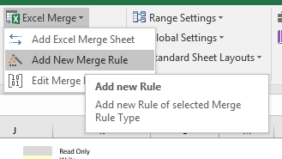

This generates a merge rule in worksheet ‘Merge_Rule’ and after generating rule confirms the addition with message as shown below.

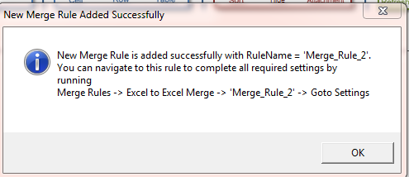

Click on ‘OK’ will add a new worksheet with name ‘Merge Sheet’ in template as shown below.

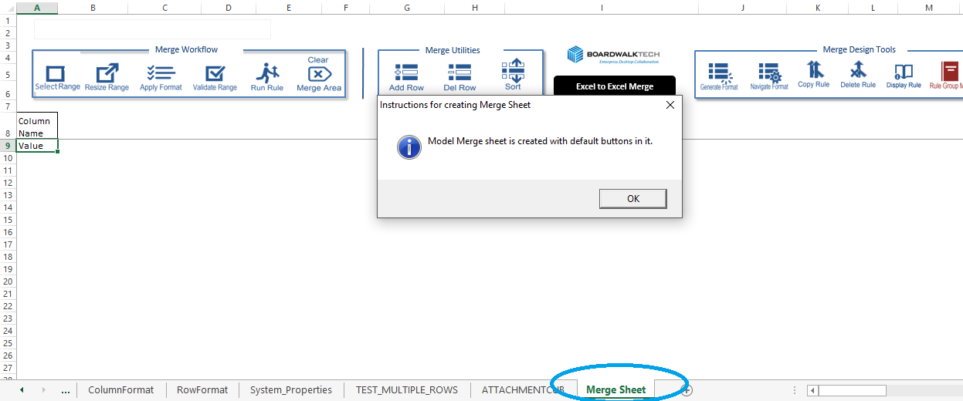

Click on ‘OK’ will open the merge rule settings form as shown below

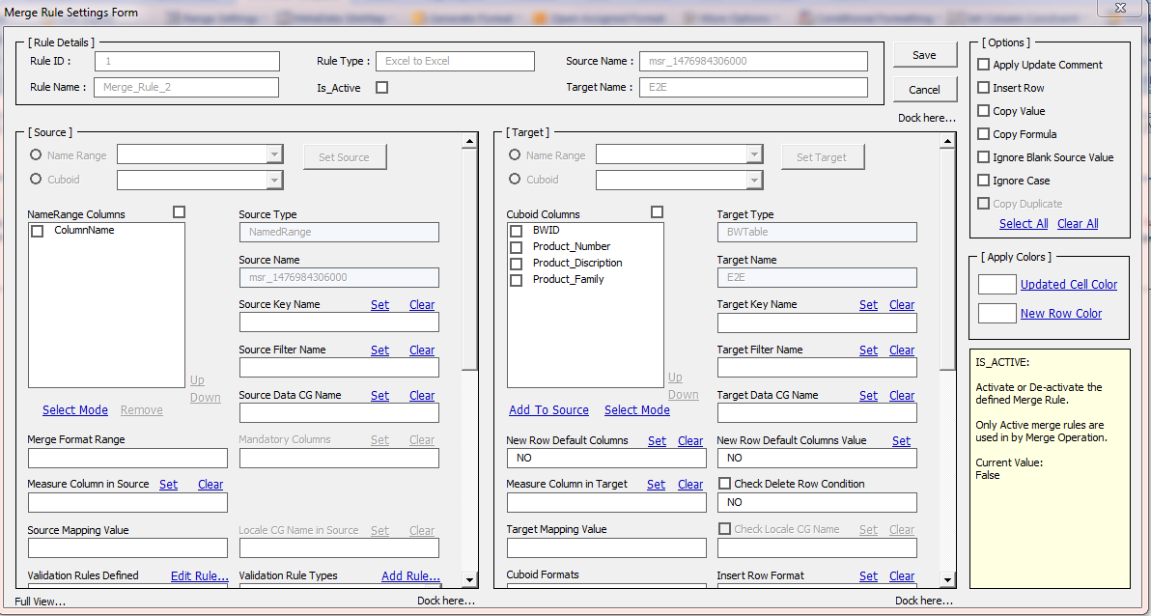

The Merge Rule is created for the target Cuboid with the source sheet as the newly created Merge Sheet.

1. **Merge Rule Form Sections**

The Merge Rule form basically contains 6 Sections as

* Rule Details
* Source
* Target
* Options
* Apply Colors
* Information Box
  1. **Rule Details Section**

This section has information about the Merge Rule.

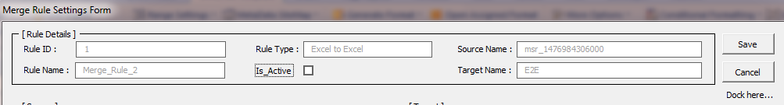

Each item of the Rule Details section is explained here

|  |  |  |  |
| --- | --- | --- | --- |
| **No** | **Merge Rule Form Fields** | **Columns in ‘Merge_Rules’ sheet** | **Description** |
| 1 | Rule Id | Rule Id | Id assigned to Merge Rule (System Generated) |
| 2 | Rule Name | Rule Name | Name of the Merge Rule (System Generated) |
| 3 | Rule Type | Rule Type | Type of Merge Rule i.e. Excel to Excel (System Generated) |
| 4 | Source Name | Source Name | Name of the Range assigned for merge data present in worksheet ‘Merge sheet’ (System Generated) |
| 5 | Target Name | Target Name | Name of Target Cuboid |
| 6 | Is_Active | Is_Active | There is check box present for ‘**Is_active**’. It indicates the status of the rule. Check rule to activate and uncheck to deactivate the rule. |

**Save:** Button to save the Merge Rule.

**Cancel:** Button to cancel the rule and close form without saving the Merge Rule.

**Dock Here:** This will reduce the form size, with only Rule Details section. Using ‘Full View’ entire form view can be obtained.

* 1. **Source Section**

It is used to set the information related to Source data in to Merge Rule. It has various fields to set the rule.

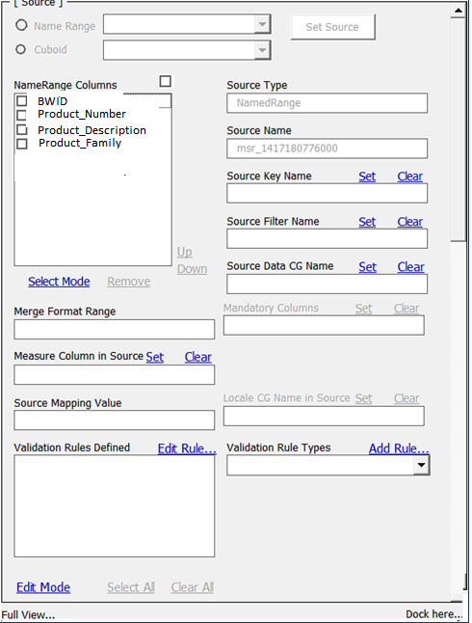

Each item of the Source section is explained here

|  |  |  |  |
| --- | --- | --- | --- |
| **No** | **Merge Rule Form Fields** | **Columns in ‘Merge_Rules’ sheet** | **Description** |
| 1 | Source Type | Source Type | Type of source Name Range or Cuboid (System Generated). |
| 2 | Source Name | Source Name | Name of range assigned in merge sheet for merge data (System Generated). |
| 3 | Source Key Name | Source Key Name | Pipe separated Primary Key column list. Primary Key list is used to identify the row in Target Cuboid. Data present in Primary Key column/s must be unique. |
| 4 | Source Filter Name | Source Filter Name | Pipe separated list of columns used for filtering data. |
| 5 | Source Data CG Name | Source Data CG Name | These are the columns used to get data for merge process i.e. data from these columns are used while copying or inserting operation. |
| 6 | Mandatory Columns | Mandatory Columns | Pipe separated list of columns which are mandatory i.e. blank values in these columns are not allowed. |
| 7 | Merge Format Range | MERGE FORMAT RANGE | Name of the format range assigned to the merge data (System Generated). |
| 8 | Measure Column in Source | MEASURE NAME SOURCE | Name of the Measure column of the source sheet if exists otherwise it is blank. |
| 9 | Source Mapping Value | SOURCE MAPPING VALUE | It is useful for the Measure Format for mapping. If Source Data has ‘Measure’ column then individual measure names are used for mapping with target Cuboid measures.  Each Measure name is pipe separated and the sequence of mentioned measures must be same as mentioned for ‘Target Mapping Values’. |
| 10 | Locale CG name in Source | LOCALE CG NAME SOURCE | Pipe separated list of columns having locale settings. Use ‘Set’ after selecting columns. |
| 11 | Validation Rules Defined |  | To generate new validation rule, use ‘Validation Rule Types’ and to edit already existing business rule use ‘Validation Rules Defined’. |
| 12 | Validation Rule Types |  | There are different type of validations can be applied on source data before merging it into Cuboid. |

* 1. **Target Section**

This section has fields related to Target Cuboid and properties related to target Cuboid can be set using this section. There are various fields are required to set.

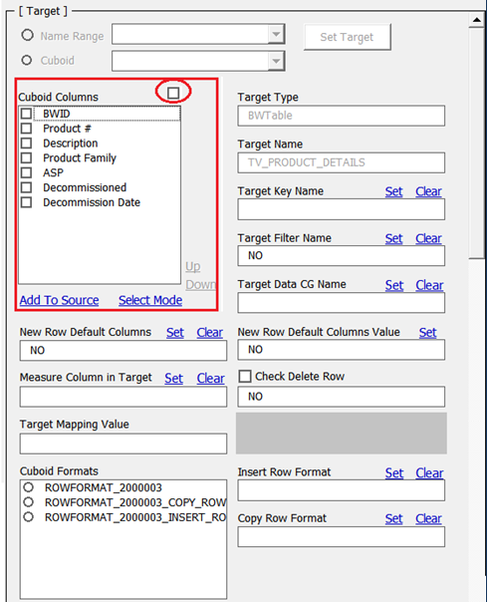

Field wise information is provided below.

|  |  |  |  |
| --- | --- | --- | --- |
| **No** | **Merge Rule Form Fields** | **Columns in ‘Merge_Rules’ sheet** | **Description** |
| 1 | Target Type | TARGET TYPE | Type of Target Cuboid is ‘BwTable’ (System Generated). |
| 2 | Target Name | TARGET NAME | Name of Target Cuboid (System Generated). |
| 3 | Target Key Name | TARGET KEY NAME | Pipe separated Primary Key column list. Primary key columns use to identify row from target cuboid. Data present in this/these column/s must be unique. |
| 4 | Target Filter Name | TARGET FILTER NAME | Pipe separated list of columns used for filtering data in target cuboid. |
| 5 | Target data CG Name | TARGET DATA CG NAME | These are the cuboid columns which need to be updated from source during copying or inserting operation. |
| 6 | New Row Default Columns | NewRowDefaultColumn | Pipe separated list of columns which has default values while merging new rows (Inserting Row operation). |
| 7 | New Row Default Column Values | NewRowDefaultColumnValue | Default values which is to be set for default columns. Using ‘Set’ values can be set. Multiple column values can be set using pipe separator. |
| 8 | Measure column in Target | MEASURE NAME TARGET | Name of the measure column from target Cuboid if exist in cuboid else blank. |
| 9 | Check Delete Row Condition | DELETE ROW and DELETE CONDITION | • If checked and if specific condition is not provided in text box then rows from target which are not present in the source range get deleted  • If checked and filter condition specified in the text box the rows are deleted on the basis of the condition specified from target.  For example condition can be put in box as [If (|Product Family|= “Server”, 0, 1)]  Rows with value “Server” in column “Product Family” will get deleted. Columns are placed in ‘|’ delimiter. |
| 10 | Target Mapping Value | TARGET MAPPING VALUE | It is used for Measure Format for mapping. Names of Measure are mentioned in this text box. Measure names are pipe ‘|’ separated. |
| 11 | Check Locale CG name |  | Pipe separated list of target cuboid columns depending upon locale settings. |
| 12 | Cuboid Formats |  | Lists the various Cuboid formats applied to specific target Cuboid with radio button. Select either format from the list. Insert Row/Measure Format or Copy Row/Measure Format can be selected from the Cuboid format list. |
| 13 | Insert Row Format | TARGET_INSERT_ROW_FORMAT | Select radio button from ‘Cuboid formats’ which is used for inserting new rows. |
| 14 | Copy Row Format | TARGET_COPY_ROW_FORMAT | Select radio button from cuboid format which is used for copying rows. |

* 1. **Options**

There are seven options which are part of merge process. User can select either or all options.

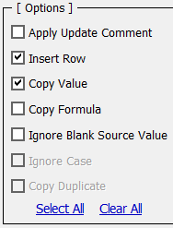

* 1. **Apply Colors**

Apply Colors can be used to set color for updated cells or newly inserted rows.

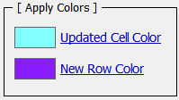

* 1. **Information box**

This box shows information about selected part of form. As following image shows that on selecting ‘Ignore Rows’ it indicates information related to that box.

1. **Merge Rule Configuration Steps**

Below are the sequential steps need to be performed to configure the Merge Rule.

* 1. **Setting Source Field Parameters**

There are two ways to get Source Columns in ‘NameRange Columns’ list box of source section in ‘Merge Rule Settings Form’.

**Case1:** Using ‘Add To Source’ Label (If the Source column names are same as Target Cuboid column names)

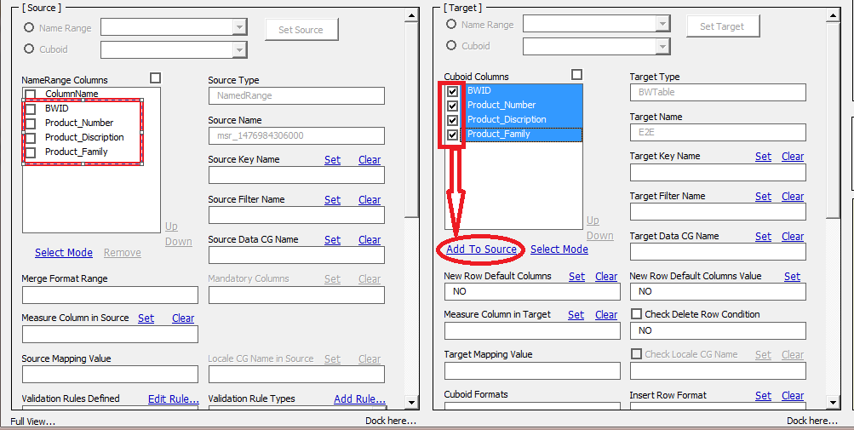

Select the required columns from target Cuboid which are used as source data header columns in worksheet ‘Merge sheet’.

Click on ‘Add To Source’ will add target Cuboid columns into ‘NameRange Columns’ list box and also in worksheet ‘Merge sheet’.

Remove column ‘ColumnName’ from source using ‘Select Mode’ and then select radio button for ‘ColumnName’ and click on ‘Remove’.

Click on ‘Arrange Mode’ to switch to ‘Select Mode’

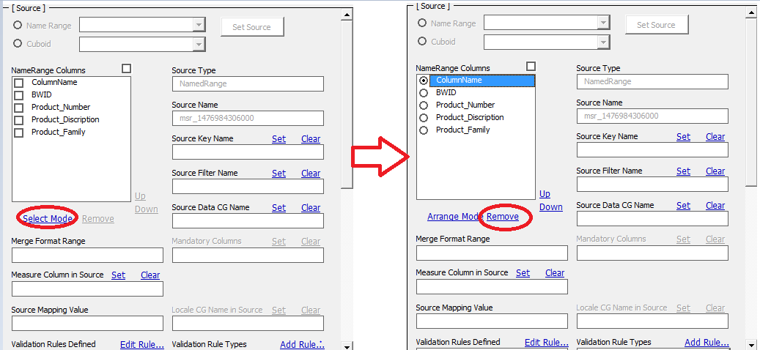

**Case2:** Creating Merge Data in ‘Merge Sheet’ Worksheet (If the Source column names are different than Target Cuboid column names).

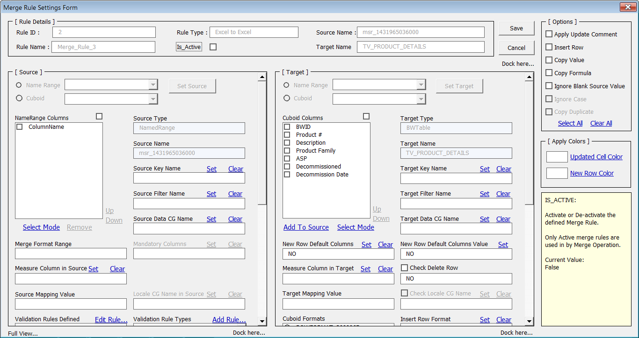

Capture the newly generated rule name in above form and close the ‘Merge Rule Settings Form’ using ‘Cancel’.

Go to the associated ‘Merge Sheet’ sheet.

Create the Source data in ‘Merge Sheet’ in cell “A8” where value ‘ColumnName’ is present as shown below.

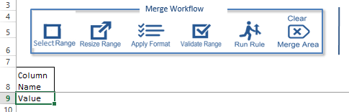

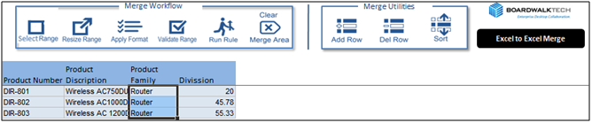

Select entire source data including header rows and click on ‘Resize Range’ to assign system generated range name to merge data present in worksheet ‘Merge Sheet’.

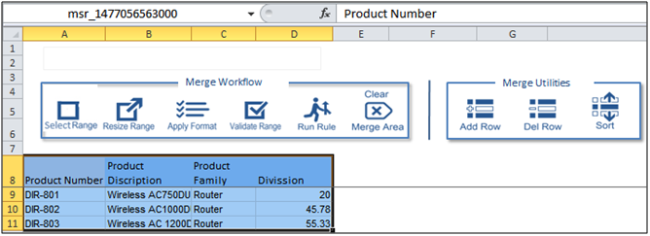

*Note: There can be 2 different formats created for Source data (Row or Measure).*

*Row Format is defined using header and first row as shown below.*

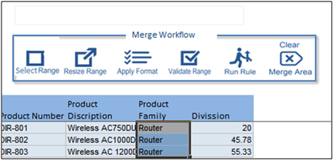

*Measure format is created with header and different measures from ‘Measure’ column.*

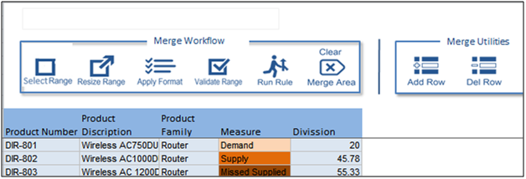

Click on ‘Display Rule’ will show the list of merge rules defined. Select proper rule from the list.

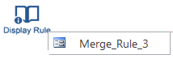

This will open the merge rule form as shown below.

Columns from Source Merge Sheet will be available in ‘NameRange Columns’ part of ‘Merge Rule Settings Form’ in ‘Source’ section as shown below.

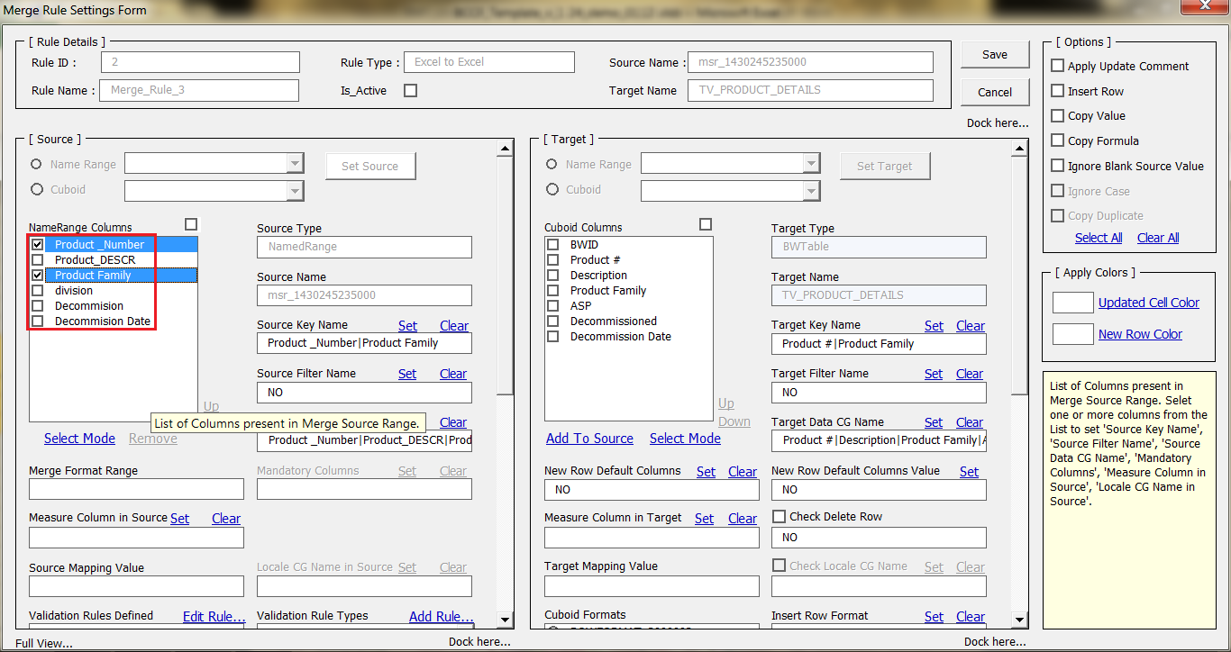

Once the Source columns are available in ‘NameRange Columns’, form fields like Source Name, Source Data CG Columns etc. can be set as explained below.

NameRange Columns

This box contains list of columns present in the ‘Merge Sheet’ acting as source columns. Selecting check box in front of ‘NameRange Columns’ will select all columns.

Each column is associated with the check box to select the column for setting Source Key Columns or Source Data CG Columns or Source Filter Name Columns etc.

* **Select Mode:** In this columns are visible with check boxes and altering sequence of columns not allowed.
* **Arrange Mode:** In this columns are with radio buttons. Remove and altering column sequence is allowed in this mode.

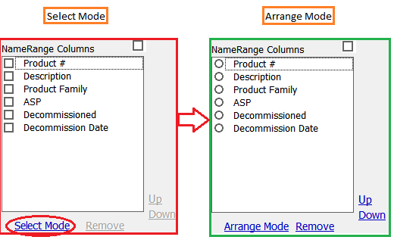

* **Remove:** It is used to delete column by selecting appropriate radio button.
* **Up Down:** This is used for altering the sequence of columns.

Source Key Name

Select columns to be set as key columns from ‘NameRange Columns’ and click on ‘Set’ as shown below. ‘Clear’ is used to remove column from ‘Source Key Name’ text box.

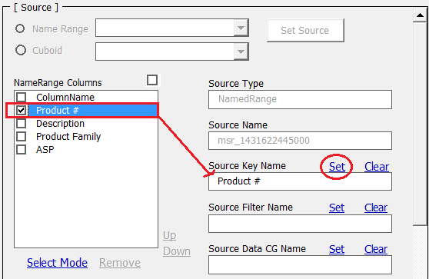

*Note: To use Merge functionality with Measure Format, specify ‘Measure’ column as ‘Source Key Column’. The Source data must contain rows equal to number of measures or number of rows which is multiple of measure count i.e. for example if there are total 7 measures then source data must contain 7 rows with individual measure in each row or row number in multiple of 7 (7,14,21…).*

Source Filter Name

Follow the same steps shown above for ‘Source Key Name’ to set ‘Source Filter Name’ columns.

Source Data CG Name

Follow the same steps shown above for ‘Source Key Name’ to set ‘Source Data CG Name’ columns.

Merge Format Range

It is system generated field. If format is created for merge data in worksheet ‘Merge Sheet’ then system generated name of that format is populated in this field.

Measure Column in Source

Select the source column containing measures and click on ‘set’ to set as ‘Measure Column in Source’. ‘Clear’ is used to remove column from ‘Measure Column In Source’ text box.

Source Mapping Value

It is used for Measure Format. It is used for Measure mapping between Source data Measures and Target Cuboid Measure. Specify names of measures used for mapping. Each measure is pipe ‘|’ separated. For example [Supply|Demand|Missed Supply|%Fulfilled].

* 1. **Setting Target Fields Parameters**

Once Source fields are set as per the business requirement, set the Target fields as per the below instructions.

Target Type

It is system generated field. Type can be ‘BWTable’ or ‘NamedRange’.

Target Name

It is a system generated field. Name of cuboid or MS-Excel named range.

Target Key Name

Select columns to be set as key columns from ‘Cuboid Columns’ and click on ‘Set’ as shown below in ‘Select Mode’.

‘Clear’ is used to remove column from ‘Target Key Name’ text box.

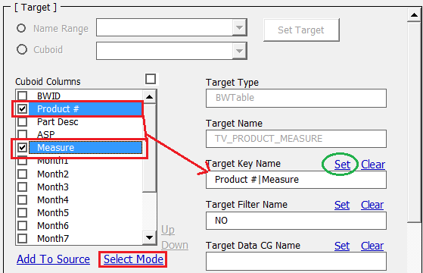

*Note: To use Merge functionality with Measure format; specify ‘Measure’ column as ‘Target Key Column’.*

Target Filter Name

Follow the same steps shown above for ‘Target Key Name’ to set ‘Target Filter Name’ columns.

Target Data CG Name

Follow the same steps shown above for ‘Target Key Name’ to set ‘Target data CG Name’ columns.

Measure Column in Target

Follow the same steps shown above for ‘Target Key Name’ to set ‘Measure Column in Target’ columns. (Useful for Measure Format; Current version not supports this functionality).

New Row Default Columns

Follow the same steps shown above for ‘Target Key Name’ to set ‘New Row Default Columns’ columns.

New Row Default Column Values

Default values can be set for default columns.

Click on ‘Set’ opens form shown below. Enter values in form with the same order as default columns are specified. Values for multiple columns can be set using pipe separator

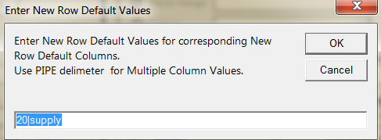

Click on ‘OK’ will set values in textbox ‘New Row Default Columns Value’ as



Check Delete Row

It is used to delete row from target data. Select or deselect check box to activate or deactivate delete row operation. The different status combinations are given in table below.

|  |  |  |
| --- | --- | --- |
| **Checkbox Status** | **Delete Condition specified in text box ‘Check Delete Row’** | **Delete Effect** |
| Checked | No | Deletes mismatch data from target Cuboid. Sets ‘DELETE ROW’= ‘YES’ and ‘DELETE CONDITION’= blank in Merge Rule. |
| Checked | Yes | Deletes rows from target which fulfills the specified condition. Sets ‘DELETE ROW’= ‘YES’ and ‘DELETE CONDITION’= “if (|ASP|=”98”,0,1) in Merge Rule. |
| Un-Checked | YES /NO | Delete operation is not performed as ‘Delete Row’ column has value as ‘NO’ since check box is unchecked. |

Target Mapping Value

It is useful Measure Format for mapping individual measures. All measures used for mapping are pipe separated ‘|’. For example mention measure names as (Supply|%Fulfilled|Demand)

Cuboid Formats

Lists the various cuboid formats applied to specific target cuboid and displayed in list box with radio button. Select either format from the list.

Insert Row/Measure Format or Copy Row/Measure Format can be selected from the Cuboid Format list.

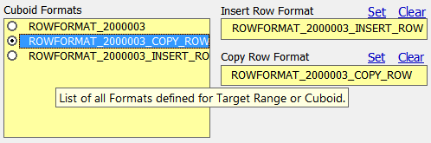

Insert Row Format

Select format from cuboid format used for inserting new rows. Use ‘Set’ to set the format. ‘Clear’ will remove value from box.

Copy Row Format

Select format from cuboid format used for copying rows. Use ‘Set’ to set the format. ‘Clear’ will remove value from box.

* 1. **Setting Options for Merge Operation**

Select appropriate option as per requirement as shown below from Options section.



Each option is described below for the information and with its significance.

Apply Update Comment

If ‘Checked’ it applies comments informing about cell value change on the modified cells of target Cuboid as shown below. If ‘Unchecked’ no comments are displayed.

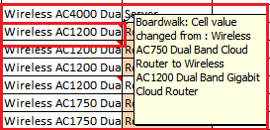

The table below shows this option setting field in ‘Merge_Rule’ worksheet.

|  |  |  |
| --- | --- | --- |
| **Status of check box for ‘Apply Update Comment’** | **Value Set in Merge Rule’s ‘APPLY UPDATE COMMENT’ column** | **Option Effect** |
| Checked | Yes | Displays Comment for updated cell/s as shown above.(Cell Value Change comment) |
| Unchecked | NO | No comment displayed for updated cell/s. |

Insert Row

If ‘Checked’ it adds new row in to the target Cuboid. If ‘Unchecked’ the new rows are not inserted into target Cuboid.

New merged rows are without ‘BWID’. ‘BWID’ will get assigned after Submit.

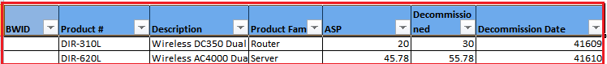

Table below shows the effect of this option and value set in worksheet ‘Merge_Rule’.

|  |  |  |
| --- | --- | --- |
| **Status of check box for ‘INSERT ROW’** | **Value Set in Merge Rule’s ‘INSERT ROW’ column** | **Option Effect** |
| Checked | Yes | Inserts new rows in to target cuboid. New rows are determined on the basis of primary key column values. |
| Unchecked | NO | New rows are not inserted in to target cuboid. |

Copy Value

If ‘Checked’ it copies values from source sheet (i.e. Merge Sheet) to target Cuboid for existing rows. If it is ‘Unchecked’ then values are not copied into Cuboid.

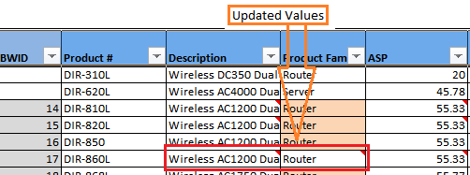

Table below shows the effect of this option and value set in worksheet ‘Merge_Rule’.

|  |  |  |
| --- | --- | --- |
| **Status of check box for ‘Copy Value’** | **Value Set in Merge Rule’s ‘COPY VALUE’ column** | **Option Effect** |
| Checked | Yes | On the basis of primary key columns, values will be copy from source data columns which is specified in ‘SOURCE DATA CG COLUMNS’ and ‘TARGET DATA CG COLUMNS’ into target cuboid. |
| Unchecked | NO | Values are not copied into target cuboid. |

Copy Formula

If ‘Checked’ it copies formula from source range to target Cuboid. If it is ‘Unchecked’ then no formulas will get copied in to target Cuboid.

It is applicable only for the newly inserted rows.

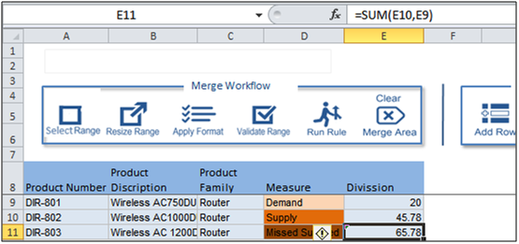

Table below shows the effect of this option and value set in worksheet ‘Merge_Rule’.

|  |  |  |
| --- | --- | --- |
| **Status of check box for ‘Copy Formula’** | **Value Set in Merge Rule’s ‘COPY FORMULA’ column** | **Option Effect** |
| Checked | Yes | Copies formula present in respective Source data cell into target data. |
| Unchecked | NO | Formula present in cell is not copied into target cuboid. |

Ignore Blank Source Values

If ‘Checked’ and any blank values present in source sheet then it will ignore those values and will not update blank values into target Cuboid. Data present in target Cuboid will remain as it is for respective blank values in source range. If it is ‘Unchecked’ it will update blank values into target Cuboid.

Table below shows the effect of this option and value set in worksheet ‘Merge_Rule’.

|  |  |  |
| --- | --- | --- |
| **Status of check box for ‘Ignore Blank Source Values’** | **Value Set in Merge Rule’s ‘IGNORE BLANK SOURCE VALUE’ column** | **Option Effect** |
| Checked | Yes | On the basis of primary key columns, it ignores blank values present in source data for columns which are specified in ‘SOURCE DATA CG COLUMNS’ and ‘TARGET DATA CG COLUMNS’ at the time of ‘Insert Row’ or ‘Copy Value’ options. |
| Unchecked | NO | On the basis of primary key columns, it will update cells of target data with blank values present in source data for columns which are specified in ‘SOURCE DATA CG COLUMNS’ and ‘TARGET DATA CG COLUMNS’. |

Ignore Case:Under Development Not in use for current version.

Copy Duplicate:Under Development Not in use for current version.

* 1. **Setting Color for highlighting Merge Cells or Rows**

Apply Colors can be used to set color for updated cells or newly inserted rows.



Clicking on ‘Updated Cell Color’ or ‘New Row Color’ will open color picker as shown below.

Any color can be selected by using the particular radio button and adjusting the shade (numbers between 0 to 255) using scroll bar and then clicking on ‘Pick’ will set respective color.

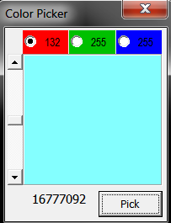

These color properties are applied to the cells updated or inserted on new rows in the target Cuboid range so that user gets information about cell changes or new rows addition with respective highlighted colors.

* 1. **Saving Merge Rule**

Once all required fields are set for defining Merge Rule in the ‘Merge Rule Settings Form’, Click on ‘Save’ will save the merge rule and ‘Cancel’ will close the form without saving rule.

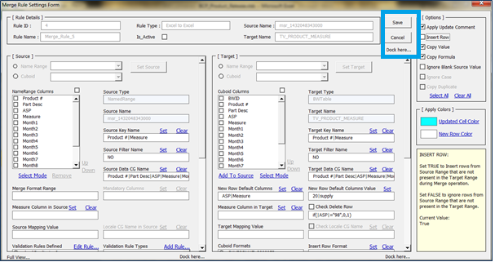

* 1. **Setting Source data in worksheet ‘Merge Sheet’**

*Note: This step is not necessary and can be performed depending upon the requirement.*

Create merge data in merge sheet as shown below.

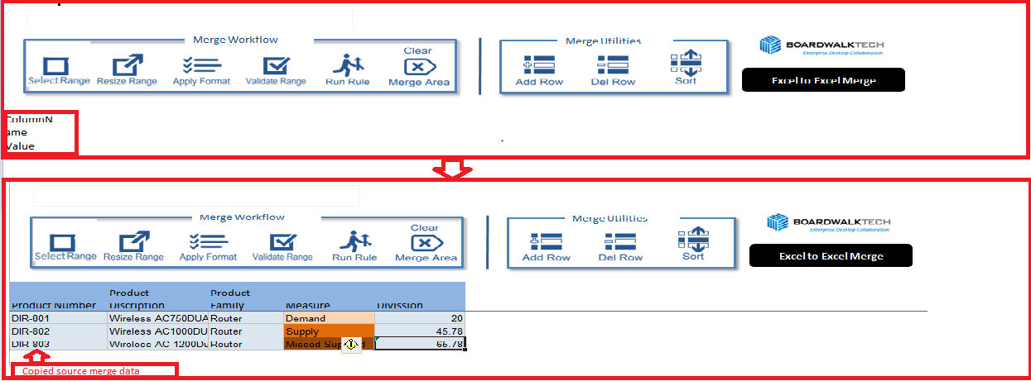

Select entire data and click on ‘Resize Range’ it will confirm the range size with message.

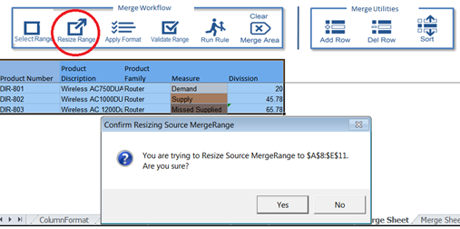

On successful setting of the range it will give appropriate message shown below.

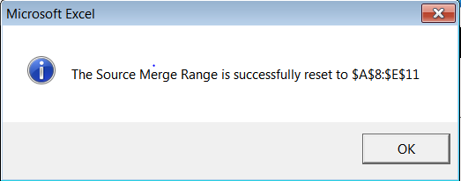

It will automatically allocate system generated range name to the entire merge data.

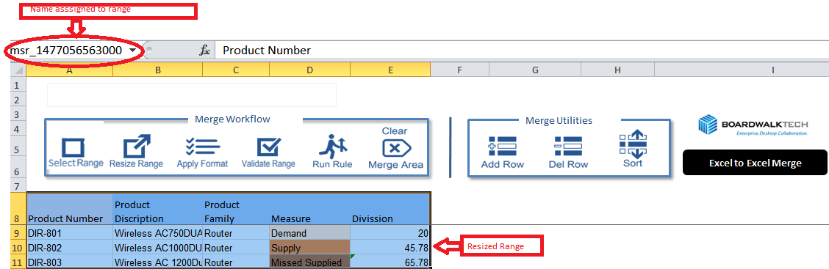

* 1. **Executing the Merge Rule**

To execute the Merge rule go to merge sheet and there will be a button named as ‘Run Rule’.

Click on ‘Run Rule’ will open the list of existing rules, select appropriate rule from the list will execute required merge rule.

On successful execution of rule, the data from source merge sheet will be merged into the target Cuboid.

1. **Merge Sheet Functionalities**

There are various functionalities present on worksheet ‘Merge Sheet’ which is explained below. These are used to work with Source data added in the ‘Merge Sheet’. These functionalities are as described below in short.

* 1. **Formatting related Functionalities**

There are three buttons provided for these operations as:

* Generate Format
* Navigate Format
* Apply Format

Generate Format

It is used to generate merge format for the merge data available in the worksheet.

Apply some format for merge data and Click on this button will generate format in worksheet named as ‘Merge Format’ and gives message as below.

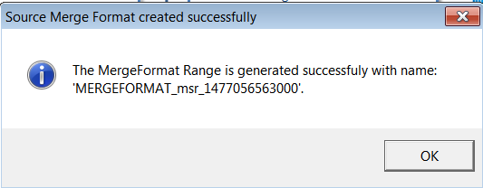

The name for the format is system generated and is present in worksheet ‘Merge Format’.

Navigate Format

This is used to navigate to worksheet ‘Merge Format’ where the generated formats are stored after clicking ‘Generate Format’.

Navigating to respective worksheet will reconfirm the generated format.

Apply Format

This is used for applying the merge format to the newly added data. It will apply format which was generated by using ‘Generate Format’.

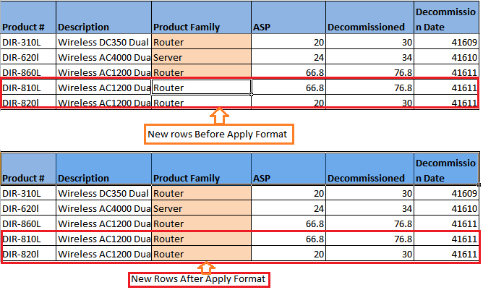

* 1. **Range Related Functionalities**

There are two buttons provided for these operations as:

* Resize Range
* Validate Range

Resize Range

It is important function in merge operation as it assigns system generated name to the merge data.

It will update the named range on addition or deletion of rows from the merge data.

First time when merge data is prepared and click on ‘Resize Range’ this will give message as below.

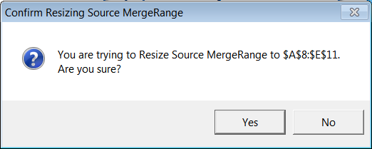

On confirmation it gives message as below and assigns system generated name to the merge data range.

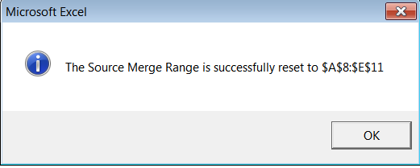

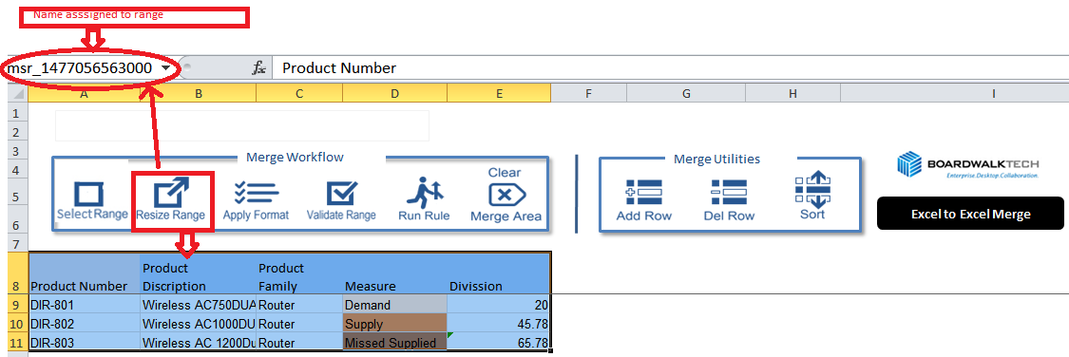

On addition or deletion of rows ‘Resize Range’ will update the range with new rows as

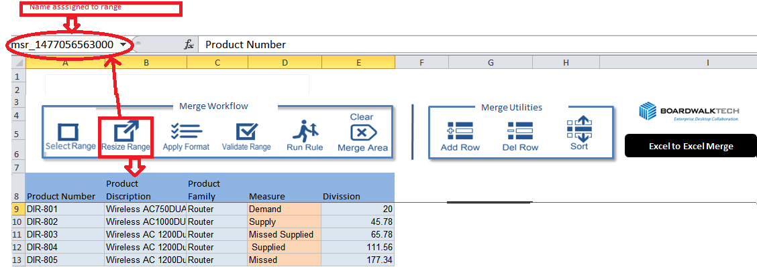

Validate Range

This is useful to execute ‘Business Rule’ defined for merge data. Merge Rule form has facility to define validation rules on merge data before merging data in to target cuboid. Validation rule can be set using merge rule form (Please refer  Validation Rule settings for details about validation rule).

* 1. **Row Related functionalities**

There are two buttons provided for these operations as:

* Add Row
* Delete Row

Add Row

It is used to add new blank single row.

Delete Row

It is used to delete row from merge data. Select the row or cell from a row need to be deleted and click on ‘Delete Row’. Single row deletion is allowed with this functionality.

* 1. **Merge Rule Related Functionalities:**

There are six buttons provided for these operations as:

* Copy Rule
* Delete Rule
* Display Rule
* Run Rule
* Sort Errors
* Clear Merge Area

Copy Rule

It is used to copy already existing merge rule so that new rule can be created by altering previously created merge rule.

Click on ‘Copy Rule’ will open the list of already generated merge rule, select required rule from the list to copy.

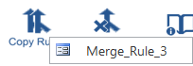

On selecting rule it will confirm with below message

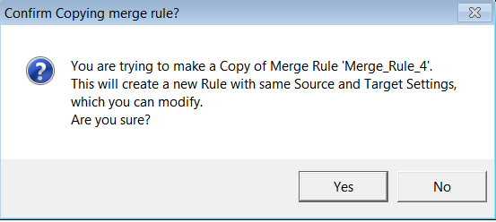

After confirmation message for successful addition of rule will get displayed as

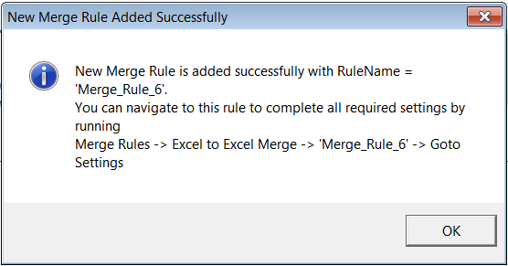

Also message for display rule will get followed by this as

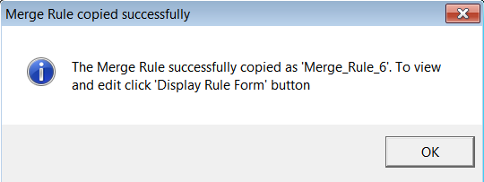

Delete Rule

It is used to delete merge rule.

Click on ‘Delete Rule’ will open the existing rule and select appropriate rule which is required to delete.

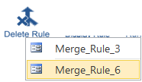

On selecting specific rule it will first ask for confirmation about deletion as

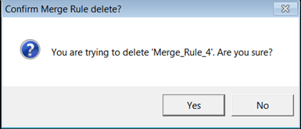

On Successful deletion gives confirmation message as

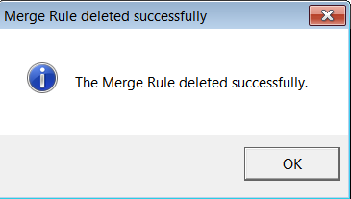

Display Rule

It is used to display existing merge rule by selecting from the list. It opens the merge rule form to view the details of the rule with various sections.

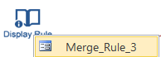

Selected Rule can be modified using Merge Rule Form and saved the changes made using ‘Save’ button available on the form.

Run Rule

It is used to execute merge rule.

Click on this will open the list of existing merge rule. Select appropriate rule to execute. It performs validation check before executing the merge rule for defined business rule and then executes merge operation.

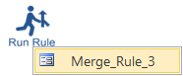

Sort Errors

It is used to get the error cells in sequence i.e. the cells which are violating business rules are described sequentially on the basis of column names and values.

Click on ‘Sort Errors’ opens form ‘SORT’ as

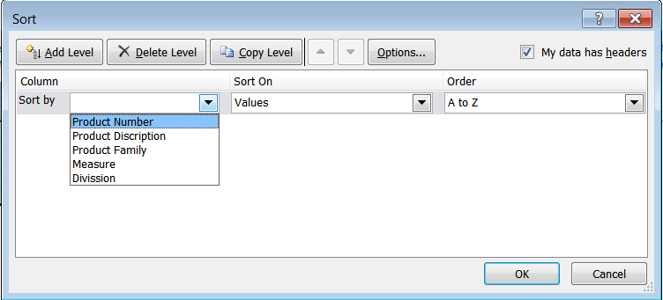

Selecting specific columns will sort merge data on the basis of selected columns.

Clear Merge Area

It is used to remove merge data from worksheet.

1. **Validation Rules**

Validation Rules are used to validate the source data available in the merge sheet before the data is merged to the destination.

There are 2 items in the Source Section of the Excel Merge Form to work with the Validation Rules as shown below.

* Validation Rules Defined
* Validation Rule Types

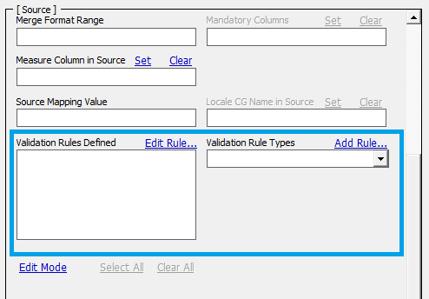

To apply the validations, Select required Validation Rule Type from the list.

*Note: Single validation rule type can be selected at a time.*

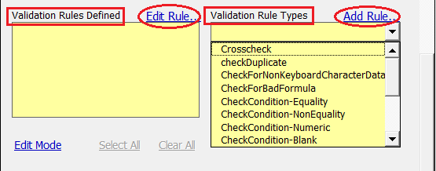

Click on ‘Add Rule’ which generates Business Rule of selected validation type.

It gives message as below.

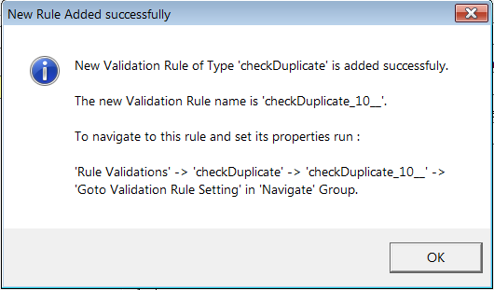

Click on ‘Ok’ will open the Business Rule form.

This form is used to set business rule (validation rule).

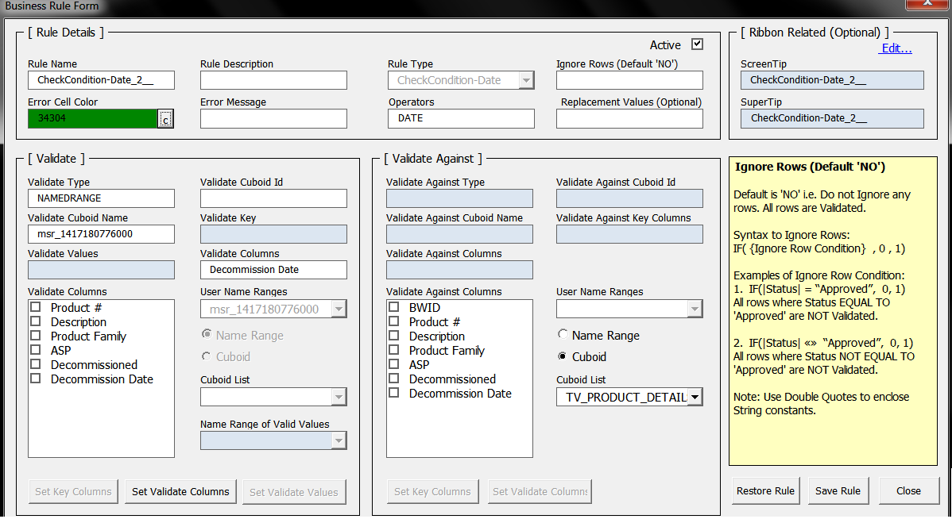

Type wise description of all the Validation Rules are given below

|  |  |
| --- | --- |
| **Rule Type** | **Description** |
| Crosscheck | It is used to compare data between source data and target data. If matching values not found those cells are highlighted in Source data sheet. |
| CheckDuplicate | It is used to check for duplicate values present in column/s specified in ‘VALIDATE COLUMNS’ field of ‘Validate’ section in Business Rule form. It will highlight the duplicate cells in Source data sheet. |
| CheckForNonKeyboardCharacterData | It is used to check Non-Keyboard characters in data so that ‘Submit’ data process will be error free. It highlights invalid cells in Source data sheet. |
| CheckForBadFormula | It is used to check for any cell containing formula with errors like ‘#REF’ or ‘DIV/0’ etc. It will highlight invalid cells in Source data sheet. |
| CheckCondition-Equality | This highlights cells in Source data sheet if the cells containing value not matching with the value specified in ‘VALIDATE VALUE’ field for columns specified in ‘VALIDATE COLUMNS’ field of Business Rule form.  Ex: If [VALIDATE COLUMNS =|Product No|] and [VALIDATE VALUE = 10], then this will check for ‘Product No’ column value as 10 in source data and the cells not equals to 10 will be highlighted. |
| CheckCondition-NonEquality | This highlights cells in Source data sheet if the cells containing value matching with the value specified in ‘VALIDATE VALUE’ field for columns specified in ‘VALIDATE COLUMNS’ field of Business Rule form.  Ex: If [VALIDATE COLUMNS =|Product No|] and [VALIDATE VALUE = 10], then this will check for ‘Product No’ column value as 10 in source data will be highlighted. |
| CheckCondition-Numeric | It is used to validate for columns specified in ‘VALIDATE COLUMNS’ if the values present are non-numeric and those cells are highlighted in Source data sheet.  Ex: If a cell contains ‘XYZ’ text value in numeric data type column it will be highlighted. |
| CheckCondition-NonNumeric | It is used to validate for columns specified in ‘VALIDATE COLUMNS’ if the values present are numeric and those cells are highlighted in Source data sheet.  Ex: If a cell contains ‘123’ value in non-numeric data type column it will be highlighted. |
| CheckCondition-Integer | It is used to validate for columns specified in ‘VALIDATE COLUMNS’ if the values present are non-integers and those cells are highlighted in Source data sheet.  Ex: If a cell contains ‘1.5’ value in Integer data type column it will be highlighted. |
| CheckCondition-Blank | This highlights the Non Blank cells in specified columns of ‘VALIDATE COLUMNS’ in Source data sheet.  Ex: If Validate Columns = |Product No| then cells of ‘Product No’ column which are not blank are highlighted. |
| CheckCondition-NonBlank | This highlights the Blank cells in specified columns of ‘VALIDATE COLUMNS’ in Source data sheet.  Ex: If Validate Columns = |Product No| then cells of ‘VALIDATE COLUMNS’ which are blank are highlighted. |
| CheckCondition-Greater than | This highlights the cells of columns specified in ‘VALIDATE COLUMNS’ if the value of cell is less than or equal to the value specified in ‘VALIDATE VALUE’.  Ex: If [VALIDATE COLUMNS =|Revenue|] and [VALIDATE VALUE = 10] then this will check the Revenue column of source data for 10 and cells having value less than or equal to 10 will be highlighted. |
| CheckCondition- Greater than Equal To | This highlights the cells of columns specified in ‘VALIDATE COLUMNS’ if the value of cell is less than the value specified in ‘VALIDATE VALUE’.  Ex: If [VALIDATE COLUMNS =|Revenue|] and [VALIDATE VALUE = 10] then this will check the Revenue column of source data for 10 and cells having value less than 10 will be highlighted. |
| CheckCondition- Less than | This highlights the cells of columns specified in ‘VALIDATE COLUMNS’ if the value of cell is greater than or equal to the value specified in ‘VALIDATE VALUE’.  Ex: If [VALIDATE COLUMNS =|Revenue|] and [VALIDATE VALUE = 10] then this will check the Revenue column of source data for 10 and cells having value greater than or equal to 10 will be highlighted. |
| CheckCondition- Less than Equal To | This highlights the cells of columns specified in ‘VALIDATE COLUMNS’ if the value of cell is greater than the value specified in ‘VALIDATE VALUE’.  Ex: If [VALIDATE COLUMNS =|Revenue|] and [VALIDATE VALUE = 10] then this will check the Revenue column of source data for 10 and cells having value greater than 10 will be highlighted. |
| CheckCondition-Date | This check for Date value in a cell for a specified column/s in ‘VALIDATE COLUMNS’. If it is in invalid format, those cell/s will be highlighted.  Ex: If [VALIDATE COLUMNS =|Commission Date|] and specified column contains text value or value other than date then it will highlight those invalid cells. |
| CheckDropDownValue | This highlights the cells of columns specified in ‘VALIDATE COLUMNS’ if the value of cell is other than value defined in a set of values. The name range is created for set of values and name of the range is specified in ‘VALIDATE VALUE’.  Ex: If [VALIDATE COLUMNS =|PRODUCT|] and [VALIDATE VALUE = PRODUCT_RANGE] then this will check for values present in mentioned range in source data for specified column and if cells of specified columns are not in specified range value then it will be highlighted. |
| CheckColumnLength-EqualsTo | This highlights the cells of columns specified in ‘VALIDATE COLUMNS’ if the length of cell is not equals to the value specified in ‘VALIDATE VALUE’.  Ex: If [VALIDATE COLUMNS =|Product Id|] and [VALIDATE VALUE = 5] then this will check the column of source data cells having length not equals to 5 will be highlighted. |
| CheckColumnLength-LessThan | This highlights the cells of columns specified in ‘VALIDATE COLUMNS’ if the length of cell is greater than or equals to the value specified in ‘VALIDATE VALUE’.  Ex: If [VALIDATE COLUMNS =|Product Id|] and [VALIDATE VALUE = 5] then this will check the column of source data cells having length greater than or equals to 5 will be highlighted. |

To set the validation rule, Business Rule Form should be configured as per the business requirement.

The Business Rule Form has following sections as

* Rule Details
* Validate
* Validate Against
* Ribbon Related(optional)
* Information Box

The field values of these sections are used to set ‘Business Rule’.

The worksheet ‘BusinessValidationRules’ stores all generated business rules in Excel named range ‘business_validation_rules’.

* 1. **Rule Details**

Business Rule related information can be set like Rule Name, Rule description, color for invalid cells etc.

‘Active’ check box is used to activate or deactivate specific rule.

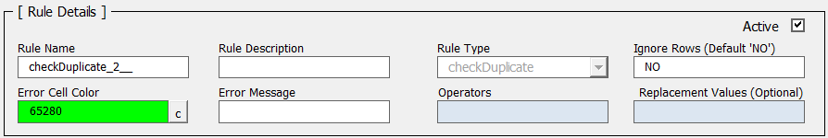

The Business Rule Form fields used to populate rule details and the corresponding columns of Business Rules which are populated from Business Rule form fields.

The following table gives field wise description.

|  |  |  |
| --- | --- | --- |
| **Columns in**  **Worksheet  ‘BusinessValidationRules’** | **Business Rule Form Fields** | **Description** |
| RULE_NAME | Rule Name | Custom Name assigned to validation rule. User can edit the system generated rule name. |
| RULE_DESC | Rule Description | Describes about the validation rule. |
| RULE_TYPE | Rule Type | Type of selected validation rule (System Generated). |
| TO_IGNORE_ROWS | Ignore Rows(Default ‘NO’) | Default value ‘No’ to validate all rows. If any rows to ignore then put condition.  Syntax: If({Ignore Row Condition},0,1)  Ex: If(|Status|= “Approved”,0,1) :-it will ignore all rows with status having “Approved”. |
| ERROR_CELL_COLOR | Error Cell Color | Displays number of selected color combination and respective color at background which gets applied to the invalid cells. |
| ERROR_MSG | Error Message | Error Message to display for invalid cells (User Entry Field). |
| OPERATORS | Operators | Depending on type of validation rule operator is selected. (It is read only filed).  Available Operators are   * Blank * Not Blank * Greater than * Greater than equal to * Less than * Less than equal to * Equal * Non-Equal * Numeric |
| REPLACEMENT_VALUE | Replacement Values(Optional) | The value should be replaced into invalid cells. (Optional) |
| IS_ACTIVE | Active | It is a check box used to activate or deactivate validation rule.  Value ‘1’ for active rule  Value ‘0’ for inactive rule. |

Follow the below instructions to configure each option

Rule Name

Enter appropriate name.

It is editable field and system generated rule name can be edited with appropriate business rule name.

Rule Description

Enter proper description of the rule to get in short information about the rule functioning.

Ignore Rows (Default ‘No’)

Default ‘No’ to validate all rows else put condition to ignore validation of rows.

Ex: If (|Status|=”Approved”,0,1) It will ignore all rows with column name ‘Status’ with values “Approved”. Column is mentioned in pipe ‘|’.

Error Cell Color

Select appropriate combination of color from color picker by clicking on ‘C’.

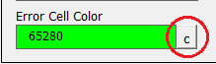

Color can be selected by using the particular radio button and adjusting the shade (numbers between 0 to 255) using scroll bar and then clicking on ‘Pick’ will set respective color.



This color is applied to the Invalid cells and user get information about invalid cells with highlighted colors.

Error Message

User editable field. Enter appropriate message to indicate reason for invalidation.

Replacement Values (Optional)

It is editable or non-editable depends upon the type of validation rule.

|  |  |
| --- | --- |
| **Editable for** | **Non-Editable for** |
| CheckCondition-Equality CheckCondition-NonEquality CheckCondition-Numeric  CheckCondition-NonNumeric  CheckCondition-Integer CheckCondition-Blank CheckCondition-NonBlank CheckCondition-GreaterThan CheckCondition-GreaterThanEqualTo CheckCondition-LessThan CheckCondition-LessThanEqualTo CheckCondition-Date  CheckColumnLength-EqualsTo  CheckColumnLength-LessThan | checkDuplicate Crosscheck CheckForNonKeyboardCharacterData CheckForBadFormula CheckDropDownValue |

Active

It is check box. Select check box to activate current business rule and deselect to deactivate business rule.

* 1. **Validate**

It is used specially to set validate columns i.e. columns used for validation for selected validation rule type.

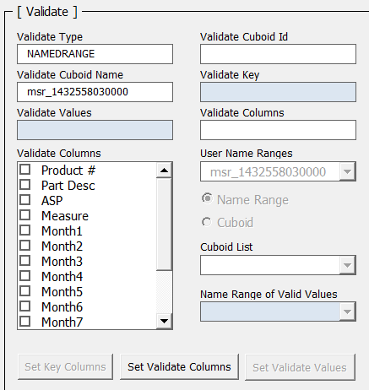

Table below describes the fields of ‘Validate’ Section and corresponding columns in ‘Business Rule’.

|  |  |  |
| --- | --- | --- |
| **Columns in Worksheet ‘BusinessValidationRules’** | **Business Rule Form Fields** | **Description** |
| TO_VALIDATE_TYPE | Validate Type | Type of source data. (It is non-editable column) Available types are   * Named Range * Cuboid Range |
| TO_VALIDATE_TABLE | Validate Cuboid ID | If Validate type is cuboid Range then populate Id of boardwalk cuboid. If Validate Type is ‘Named Range’ then it is blank. (It is non-editable column) |
| -- | Validate Cuboid Name | If validate type is cuboid range then Name of cuboid. If Validate type is named range System generated name of excel range. (It is non-editable column) |
| TO_VALIDATE_KEYS | Validate Key | It will populate Key column names of Source data using button ‘Set Key Columns’. (Used for Cross Check Validation type only) |
| TO_VALIDATE_VALUE | Validate Values | It is used to specify values used for validation. It is useful in following type of validation   * CheckCondition-Equality * CheckCondition-NonEquality * CheckCondition-Greater Than * CheckCondition- Greater Than Equal To * CheckCondition- Less Than * CheckCondition- Less Than Equal To * CheckDropDownValue |
| TO_VALIDATE_COLS | Validate Columns | Column name of source data used for validating target cuboid data for ‘Cross Check’ validation rule type. Column names used to validate source data for other than ‘Cross Check’ validation rule type. |
| -- | User Name Ranges | Lists the Named ranges if Name Range is selected using radio button(Not in use for current version) |
| -- | Cuboid List | List of boardwalk cuboids is displayed if cuboid option is selected(Not in use for current version) |
| -- | Cuboid List | List of boardwalk cuboids is displayed if cuboid option is selected(Not in use for current version) |

Follow the below instructions to configure each option

Set Validate Columns

Select the column from the ‘Validate Columns’ list and click on ‘Set Validate Columns’.

It will set the column and add entry in ‘Validate Columns’ box. If multiple columns are present these are pipe separated.

Ex: (ASP|Products|Product Family) - Pipe separated multiple columns.

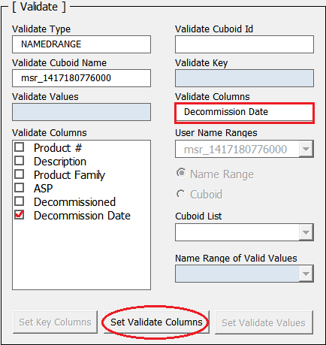

Set Key Columns

If the validation type is ‘CrossCheck’ then button ‘Set Key Columns’ can be used to set ‘Validate Key’ columns.

Select required columns from ‘Validate Columns’ list box and click on ‘Set Key Columns’ to set ‘Validate Key’.

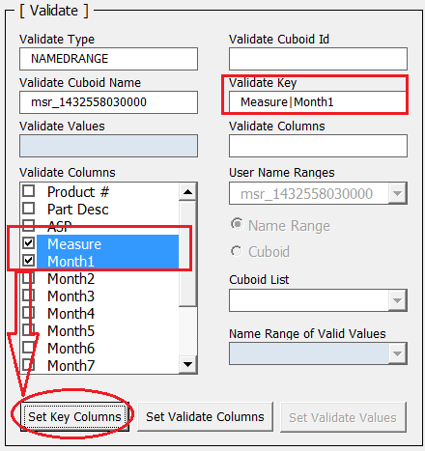

* 1. **Validate Against**

It is used to validate data between Source sheet (i.e. Merge sheet) and specific named range or target cuboid. This section is used for ‘Crosscheck’ validation type. ‘Crosscheck’ validation validates data in target cuboid based on data in source cuboid using ‘Key Columns’ and ‘Validate Columns’.

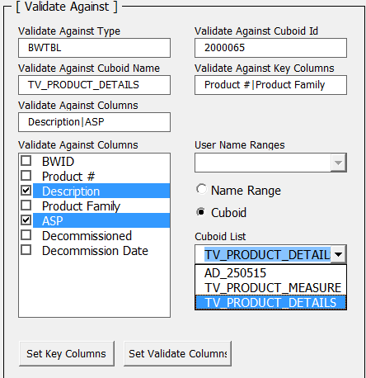

Table below describes the fields of ‘Validate Against’ Section and corresponding columns in ‘Business Rule’.

|  |  |  |
| --- | --- | --- |
| **Business Rule Columns in Worksheet ‘BusinessValidationRules’** | **Business Rule Form Fields** | **Description** |
| VALIDATE_AGAINST_TYPE | Validate Against Type | Type of target. It can be   * NamedRange * BWTable (Boardwalk Cuboid)   (It is system populated and value depends on radio button (Cuboid or Name Range) selected and read only) |
| VALIDATE_AGAINST_TABLE | Validate Against Cuboid Name | Name of boardwalk cuboid selected from list after selecting radio button ‘Cuboid’. If Validate against type is ‘BWTable’.  Name of ‘Name Range’, if Validate against type is ‘Name Range’. (It is system populated and read only) |
| VALIDATE_AGAINST_CUBOID_ID | Validate Against Cuboid ID | If Validate against type is ‘BWTable’. It is id of that selected boardwalk cuboid.  If Validate against type is ‘Name Range’ then it is ‘blank’.  (it is read only and system populated) |
| VALIDATE_AGAINST_KEYS | Validate Against Key Columns | Key columns of target cuboid used for matching key columns of source. Selected values are populated after click on ‘Set Key Columns’ button. (It is read only field) |
| VALIDATE_AGAINST_COLS | Validate Against Columns | Name of target column/s used for actual validation matched with source ‘Validate Columns’. Selected values are populated after click on ‘Set Validate Columns’ button. (It is a read only field) |

User Name Ranges

Lists named ranges present in workbook and gets visible on selecting ‘Name Range’ radio button option.

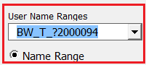

Cuboid List

It lists the boardwalk cuboids present in template on selecting ‘Cuboid’ radio button option.

‘Set Key Columns’ and ‘Set Validate Columns’ buttons are operative for ‘Crosscheck’ validation type only.

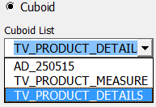

Set Validate Against Columns

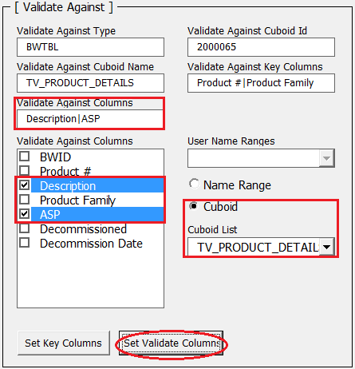

Select the radio button ‘Cuboid’ if Validate Against type is ‘BWTable’ or ‘NamedRange’ if Validate Against type is ‘Name Range’.

Select the required cuboid from Cuboid list if ‘Cuboid’ radio button is selected and if ‘Name range’ is selected select appropriate name range from the list, so that the columns of selected cuboid or name range will appear in ‘Validate Against Columns’ list box.

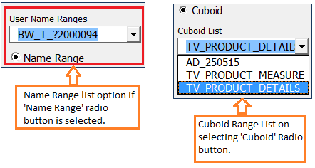

Select the column from the ‘Validate Against Columns’ list and click on **‘Set Validate Columns’** which will set the column and add entry in ‘Validate Against Columns’ box. If multiple columns are present these are pipe separated.

For example: (ASP|Products|Product Family) :- pipe separated multiple columns.

Set Validate Against Key Columns

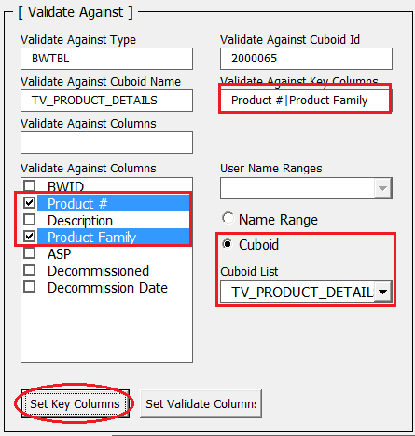

Select the radio button ‘Cuboid’ if Validate Against type is ‘BWTable’ or ‘NamedRange’ if Validate Against type is ‘Name Range’.

Select the required cuboid from Cuboid list if ‘Cuboid’ radio button is selected and if ‘Name range’ is selected select appropriate name range from the list, so that the columns of selected cuboid or name range will appear in ‘Validate Against Columns’ list box.



If the validation type is ‘CrossCheck’ then button ‘Set Key Columns’ can be used to set ‘Validate Against Key’ columns. Select required columns from ‘Validate Against Columns’ list box and click on ‘Set Key Columns’ to set ‘Validate Against Key Columns’.

Validation Rules Defined

This indicates the list of already created validation rules.

There are two modes to work with validation rule as:

1. **Edit mode**

Used to edit validation rule.

There is option to edit specific validation rule by using ‘Edit Rule’ in ‘Edit Mode’ which opens ‘Business Rule Form’.

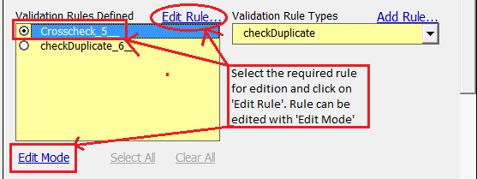

Select the rule from the list and click on ‘Edit Rule’ will open ‘Business Rule Form’ with selected rule details as shown below.

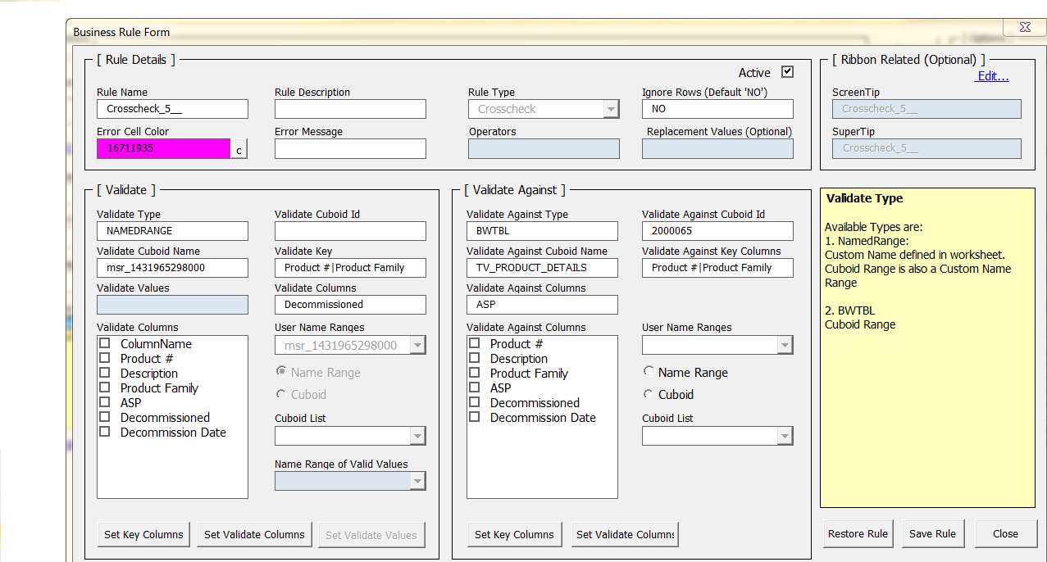

Edit the existing Validation rule and set the changes with the help of this form and new changes are saved using ‘Save Rule’ button.

1. **Activate Mode**

Used to activate specific rule from the list of validation rule or to view active rules in list.

It is used to activate business rule from the list of multiple rules defined. Click on ‘Edit Mode’ will show ‘Activate Mode’ as

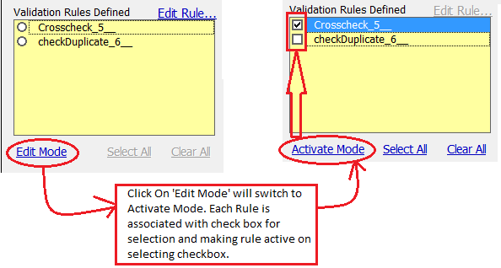

Defined Business rules are listed with check boxes.

Select required rule from list for activation and click on ‘Activate Mode’.

* ‘Select All’ will select all rules from the list and will be activated using ‘Activate Mode’.
* ‘Clear All’ deselects all rules and make rules inactive.
  1. **Ribbon Related (Optional)**

It is used to set tips for the user to give information about the rule at ribbon level. Tips can be edited using ‘Edit’ option.

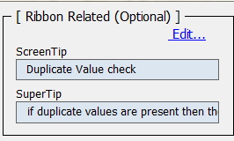

The screen tip and super tips are getting displayed to give information about defined rule at the ribbon level as shown below.

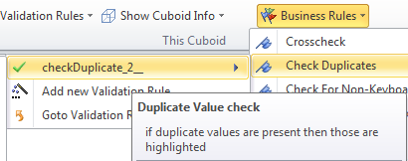

Information box

This box shows information about selected part of the business rule form.

For example, following image shows that on selecting ‘Ignore Rows’ it indicates information related to that box.

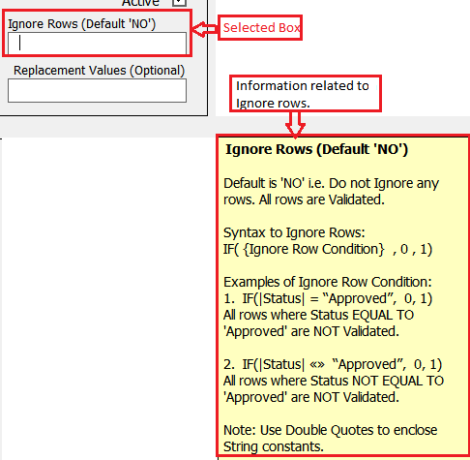

Buttons (Save Rule, Restore Rule, Close)

Restore Rule: will restore previous saved rule settings if new settings are not saved.

Save Rule: Saves new changes made in Business rule.

Close: Closes the business form.

