CROP WATER REQUIREMENT MODEL.

CLIMWAT

SUPPORTING FOR CROP WAT

USING CLIM WAT WE CANNOT DOWNLOAD FUTURE DATA

Google Latititude and Longitutde

And paste in the lcoatiino.

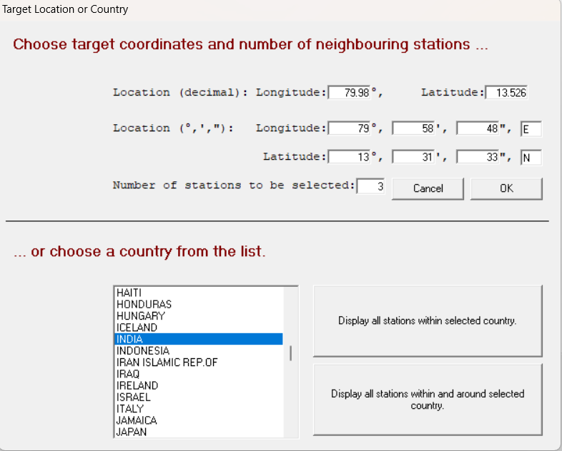

Click Ok

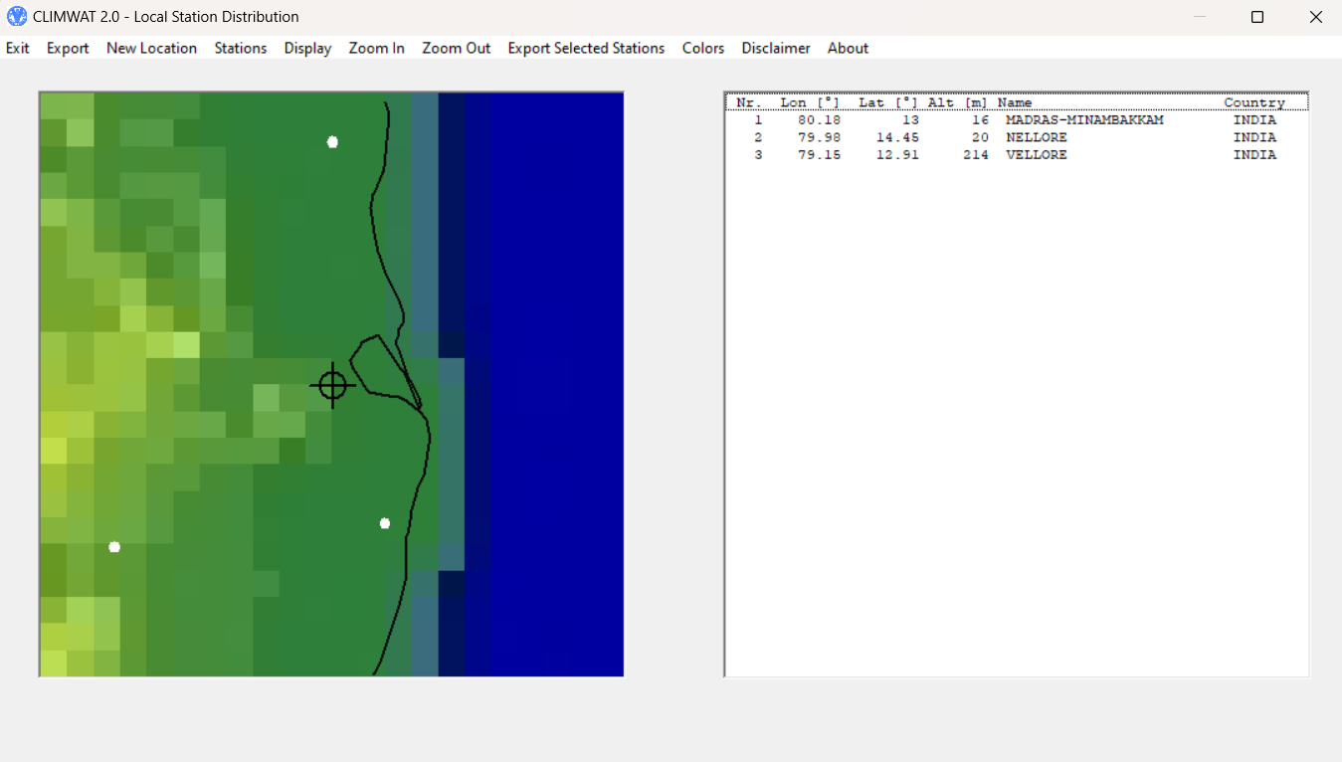

Export selected stations

Select Chennai

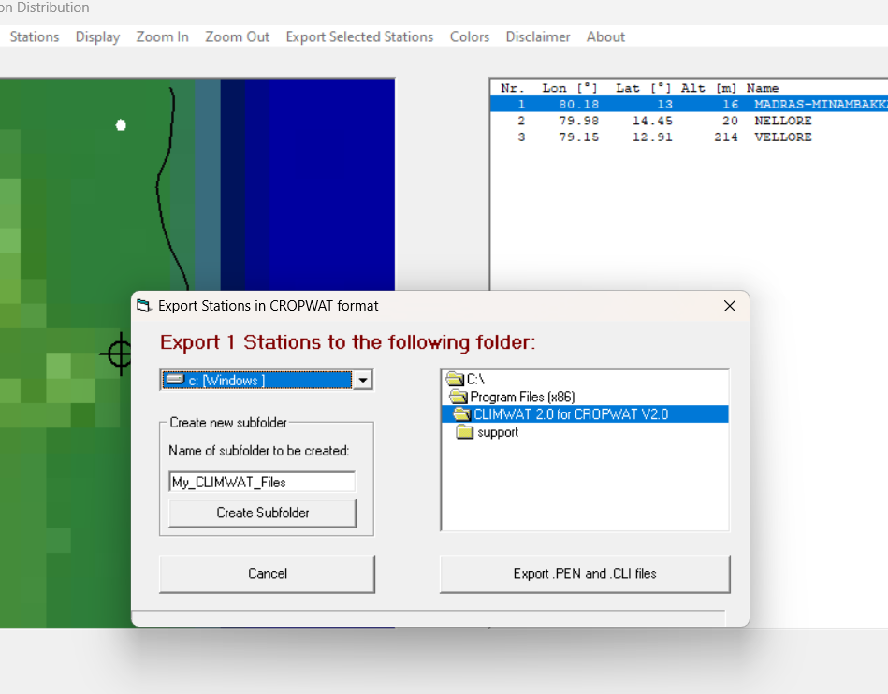

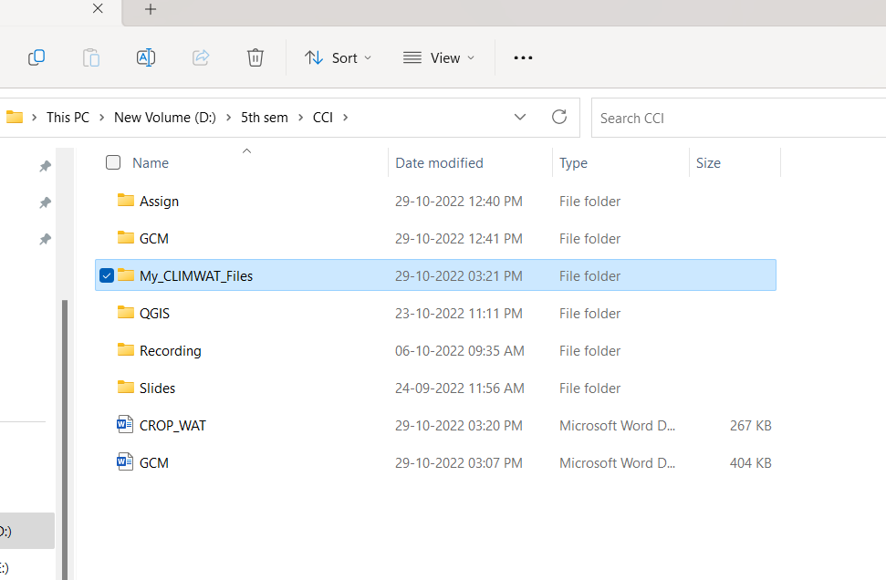

Climate/ Evapotrans

Rain

Crop

Soil

CWR

Schedule

Crop pattern…

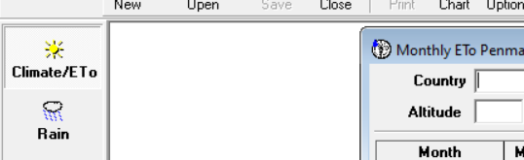

Climate eto

Monthly mean data

Open and select the File

Navigate to correct Folder Safely

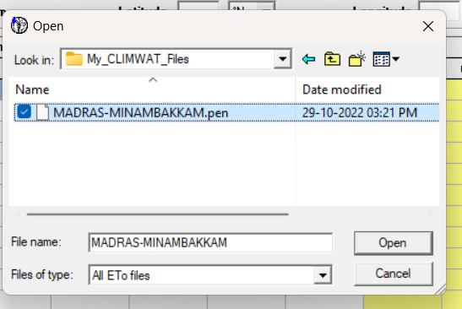

Don’t Close Let it be there

The second File.

Select Rain

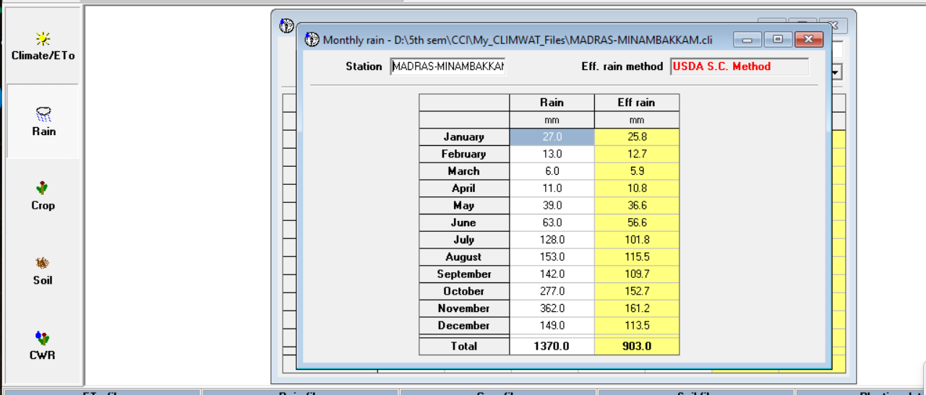

Select Crop

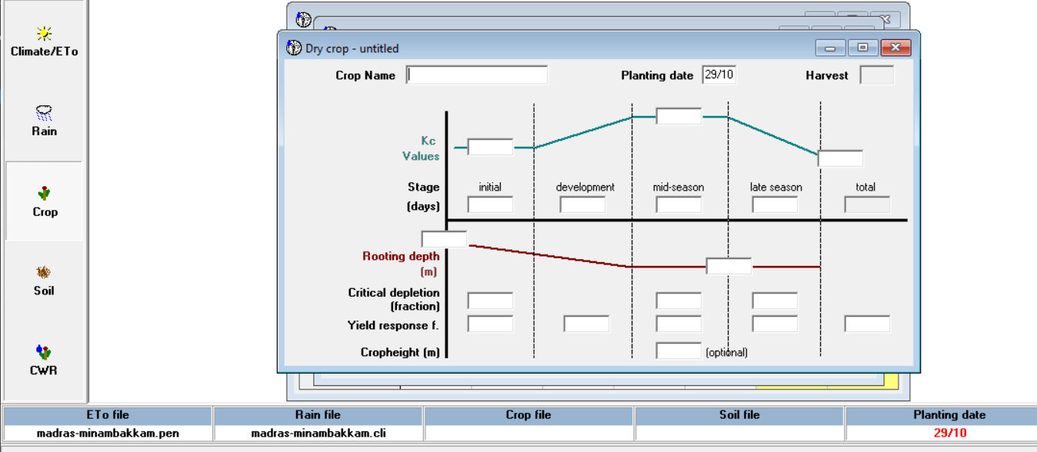

marksim weather generator

Website

<http://gisweb.ciat.cgiar.org/MarkSimGCM/>

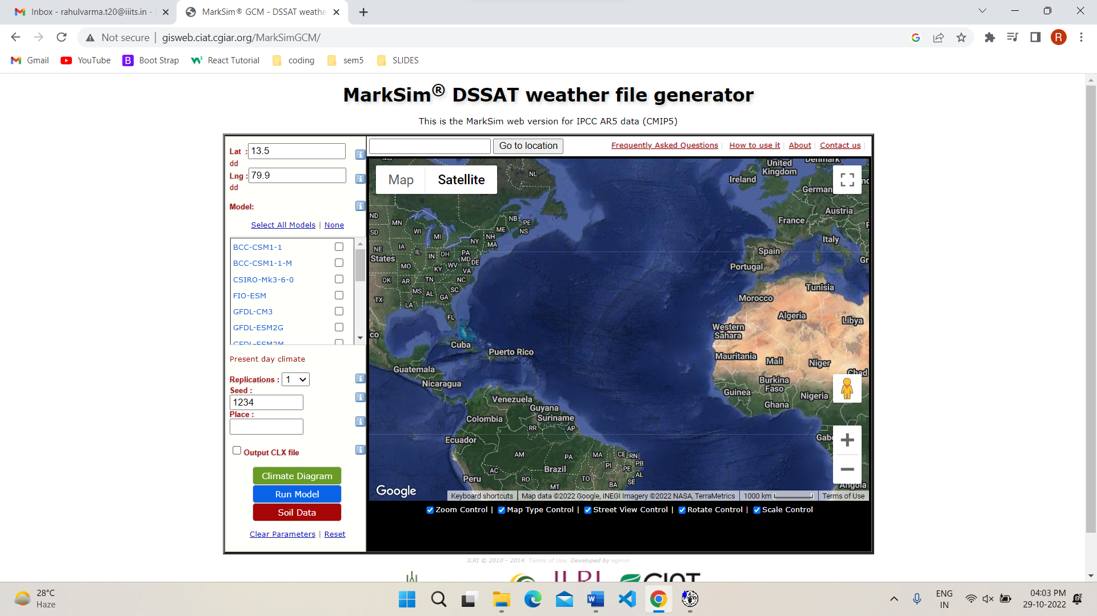

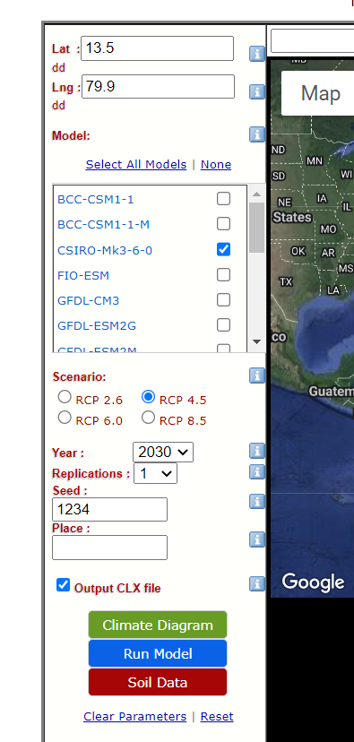

<https://www.fao.org/3/x0490e/x0490e0b.htm>

Crop coefficient



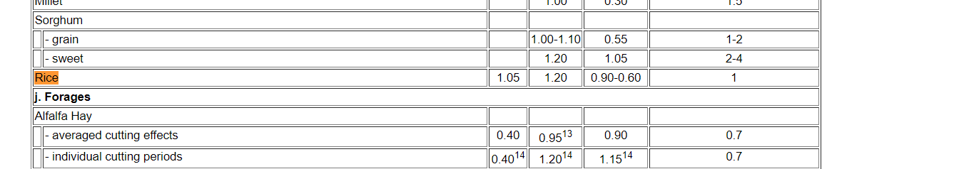

Kc Values

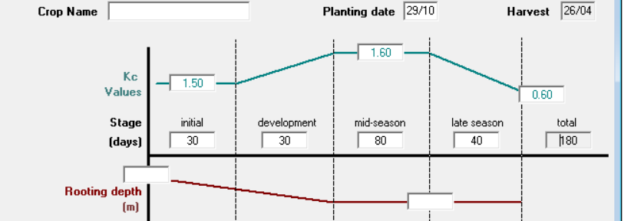

Search Value in the Website and keep in the above image

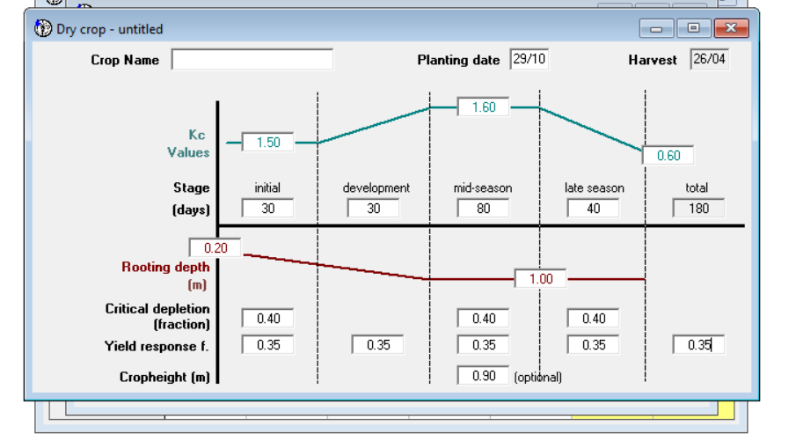

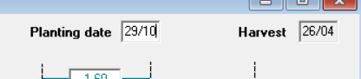

Soil Name:

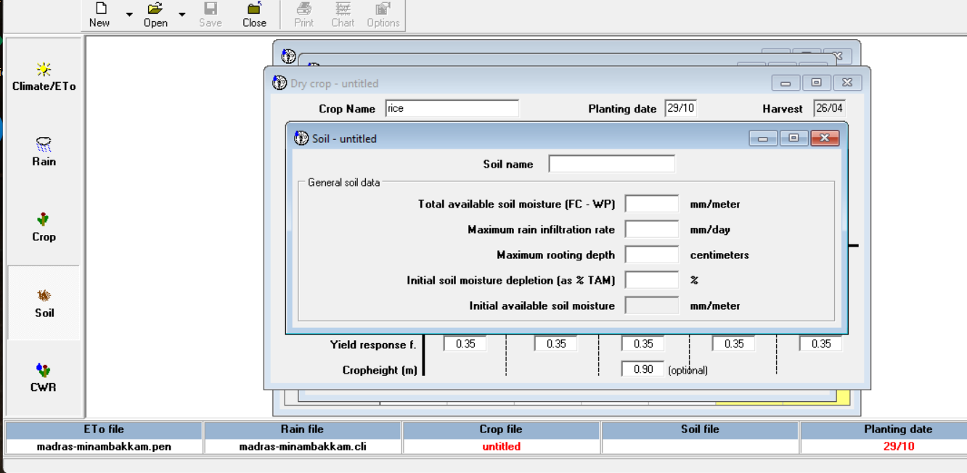

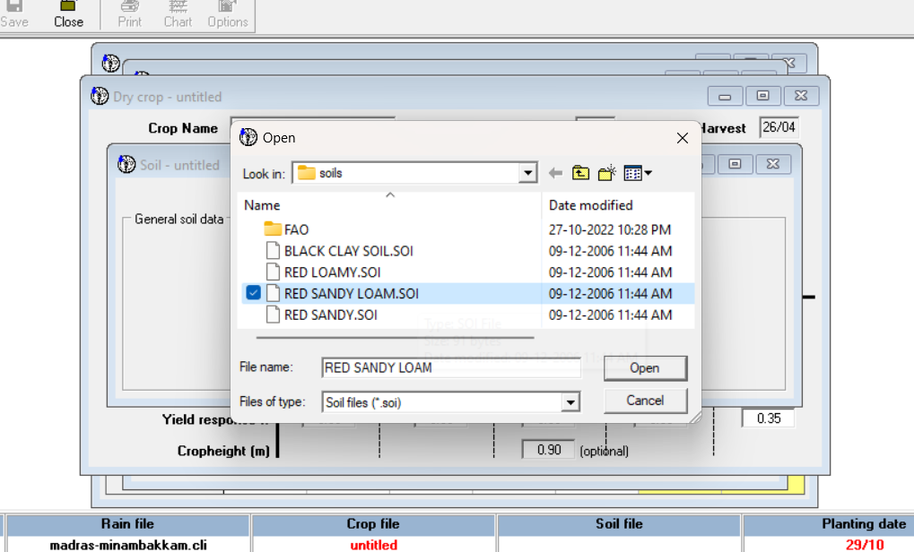

CWR:

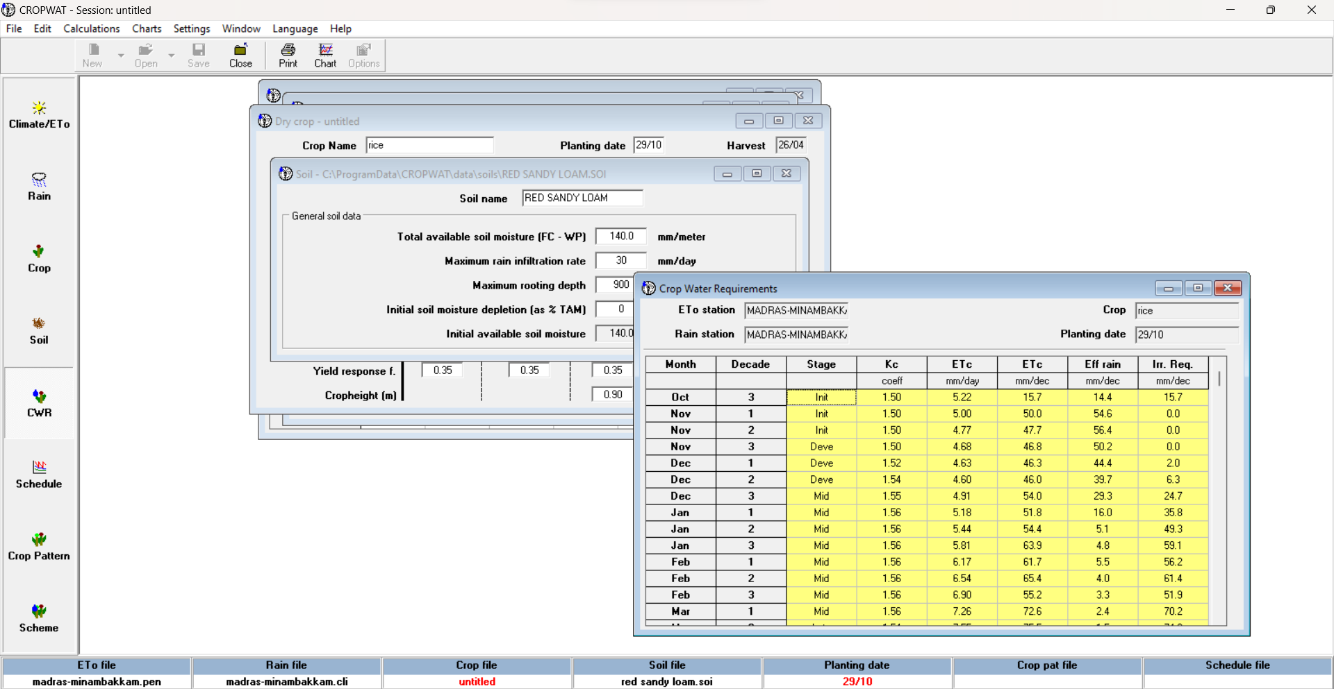

Selcet Chart for Graph

Select Schedule

