CABI INTERNATIONAL WEBSITE.



First

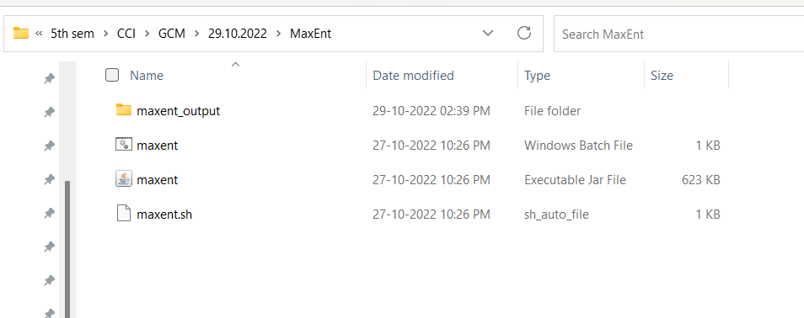

Open maxent

Click executable jar file

LEFT SIDE

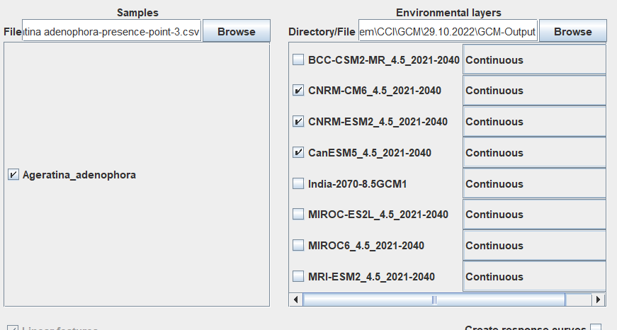

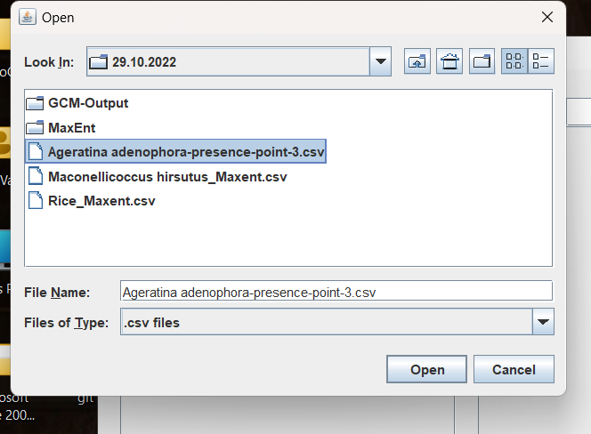

DOWNLOAD THE DATA AND ENTER IN THE SECOND PART

THIS IS RIGHT SIDE

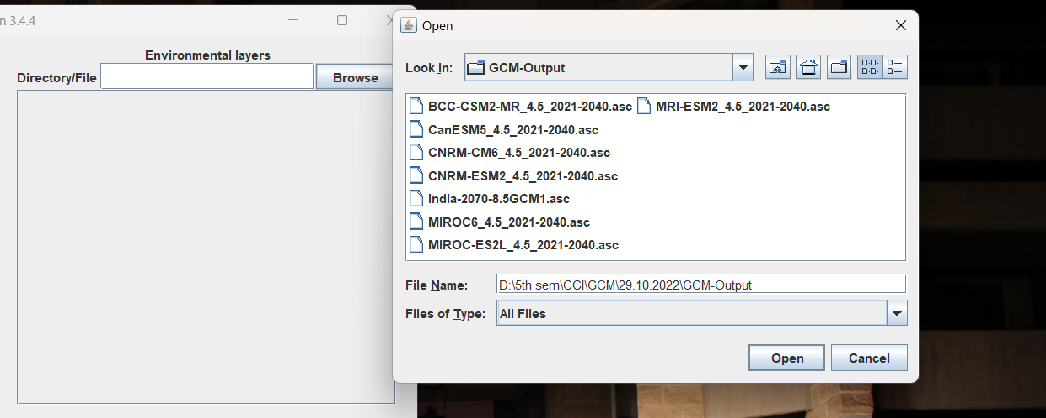

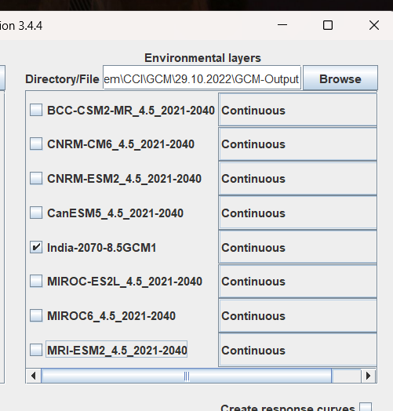

SELECTED FOR INDIA

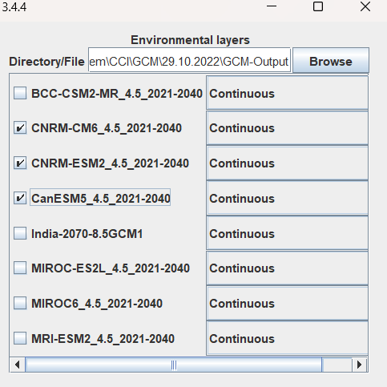

Output directory

Created new folder and created maxent_output

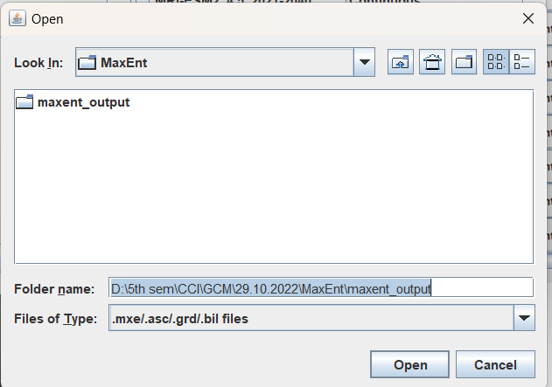

CLICK RUN

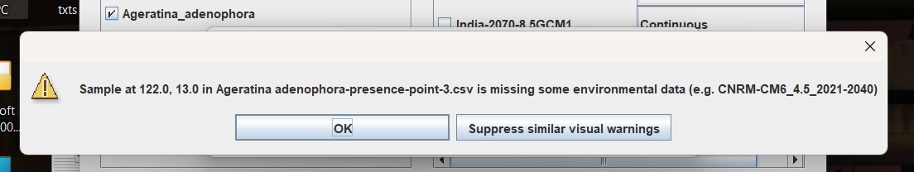

OPEN PLOTS

AND MAP COLOUR FULL MAP

LOCATION WITH PROBABILTY

2nd Trail:

Re run for rice crop and india

