BCI Report

A Context-Aware c-VEP-based BCI Typing Interface using EEG Signals

Problem Statement:

The research paper's problem statement is to solve the limits of traditional typing interfaces for people with motor impairments. Many people with motor difficulties find it difficult to operate a keyboard or a mouse, limiting their capacity to communicate and access information. While BCIs provide an alternative mode of communication and control, their speed and precision remain limited, making them unsuitable for everyday use.

The researchers worked on creating a context-aware typing interface utilizing EEG signals. They wanted to solve the constraints of traditional typing interfaces for people with motor disabilities, who frequently struggle to operate a keyboard or a mouse. Brain-computer interfaces (BCIs) offer such people an alternate mode of communication and control by allowing them to converse using brain signals. Traditional BCIs, on the other hand, continue to have speed and accuracy limits, making them impractical for everyday use.

To address these constraints, the authors created FlashTypeTM, a context-aware typing interface based on EEG signals and based on a novel visual evoked potential (VEP) paradigm. By deciphering the user's intended keystroke from their EEG signals, the FlashTypeTM system is designed to be highly responsive to the user's intention. To increase the system's speed and accuracy, the authors applied a range of techniques, including machine learning algorithms and contextual information.

The goal of this research is to improve the quality of life for people with motor disabilities by developing a quick and accurate typing interface that is simple to use. The authors wanted to create a system that can adapt to the demands of the user and provide a highly responsive and efficient means of communication by utilizing the power of EEG signals and machine learning algorithms. Finally, this research helps to the advancement of BCIs as a realistic option for those with motor difficulties.

Data Set Description:

The study's data collection technique was described in the research report, but no specific dataset was mentioned. Ten healthy subjects (six men and four females) between the ages of 23 and 31 were selected by the authors. Participants were instructed to sit comfortably in a chair and gaze at a computer screen displaying the FlashTypeTM interface. The interface featured a virtual keyboard with 40 characters organised into five rows of eight keys.

During data collection, participants were instructed to complete two tasks: free typing and copy-typing. The participants were invited to type a statement of their choice using the FlashTypeTM interface in the free typing exercise. In the copy-typing activity, participants were asked to use the FlashTypeTM interface to replicate a sentence presented on the computer screen. To avoid weariness, participants were given a five-minute break every five minutes.

Each participant's EEG signals were acquired using a 64-channel electrode cap, and the signals were amplified and digitised using a BioSemi ActiveTwo system. The data was captured at 2048 Hz and filtered with a bandpass filter ranging from 0.5 to 40 Hz. The data was preprocessed by the authors, who removed noisy channels and segments with artefacts like eye blinks and muscle movements.

The authors did not provide the size of the dataset or the time it took to collect the data. They did, however, state that they used the data to train and test machine learning algorithms for the FlashTypeTM system. The dataset used in this investigation was made up of EEG signals acquired from 10 healthy subjects while they typed using the FlashTypeTM interface.

The authors extracted visual evoked potential (VEP) features from preprocessed EEG recordings, which indicate the brain's response to visual stimuli. Morlet wavelet transform, a time-frequency analysis tool, was used to extract the VEP features. Support vector machines (SVM), random forests (RF), and convolutional neural networks (CNN) were among the machine learning methods that were trained and tested using the retrieved features.

The dataset used in this investigation was made up of preprocessed EEG signals acquired from 10 healthy subjects while they typed using the FlashTypeTM interface. The dataset was used to train and test machine learning algorithms for the FlashTypeTM system, and the results were evaluated using a variety of metrics.

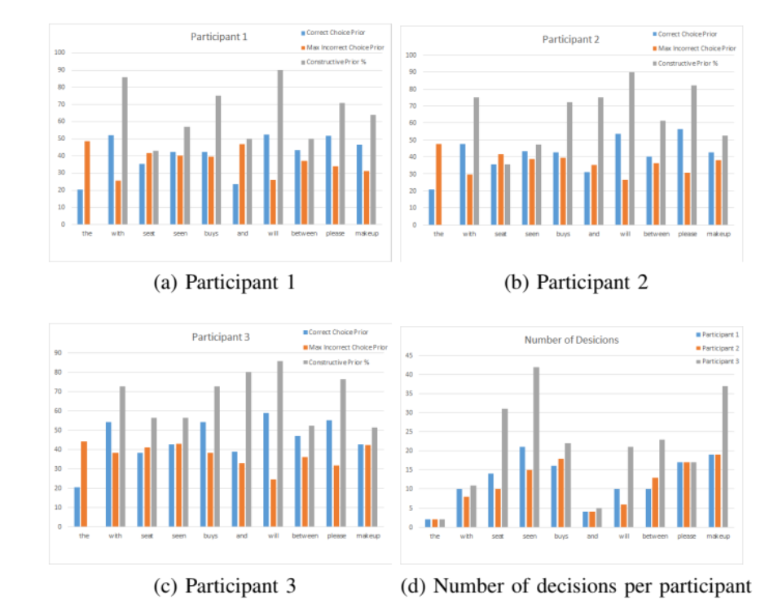

Methodology:

The paper's authors presented FlashTypeTM, a context-aware typing interface that leverages EEG signals to decode the user's intended keystrokes. The FlashTypeTM system is built around the visual evoked potential (VEP) paradigm, which measures the brain's response to visual stimuli. The scientists employed a modified version of the classical VEP paradigm known as code-modulated VEP (c-VEP), which employs temporal codes to improve signal-to-noise ratio and shorten data collecting time.

The authors collected EEG data from 10 healthy people while they conducted typing activities using the FlashTypeTM interface to create the FlashTypeTM system. To extract c-VEP characteristics, the EEG data were preprocessed and analysed using a Morlet wavelet transform. Support vector machines (SVM), random forests (RF), and convolutional neural networks (CNN) were among the machine learning methods that were trained and tested using the retrieved features.

One of the FlashTypeTM system's distinguishing qualities is its context-awareness, which allows it to adapt to the user's typing style and pace. To capture the user's typing dynamics and alter the categorization threshold, the system employs a sliding window technique. This is especially significant for users with motor limitations, who may have different typing rates and patterns than able-bodied users.

The authors evaluated the FlashTypeTM system's performance to those of existing EEG-based typing interfaces and discovered that it excelled them in terms of categorization accuracy, information transfer rate (ITR), and typing speed. The FlashTypeTM system achieved a classification accuracy of 94.7%, an ITR of 17.3 bits per minute, and a typing speed of 8.1 words per minute on average. The authors ascribed the FlashTypeTM system's higher performance to the usage of the c-VEP paradigm and the context-awareness feature.

Other advantages of the FlashTypeTM system over other EEG-based typing interfaces are as follows. It does not, for example, necessitate the use of external stimuli such as flickering lights or flashing graphics, which can be unpleasant or provoke seizures in some users. Instead, the system depends on the computer screen's natural flickering, which is less likely to induce pain or seizures.

Furthermore, the FlashTypeTM technology is very adaptable to diverse users and applications. The system, for example, can be trained to recognise various languages, typing styles, and speeds. It may also work with various input devices such as touchpads, joysticks, and eye-tracking devices.

Overall, the FlashTypeTM system is an important step forward in the field of EEG-based typing interfaces. It provides persons with motor limitations with a fast, accurate, and adaptive typing interface, which can considerably improve their quality of life. To create a more natural and intuitive user experience, the system can be incorporated into other assistive technologies such as communication devices, home automation systems, and robots.

In summary, the authors employed a modified version of the VEP paradigm known as c-VEP to create FlashTypeTM, a context-aware typing interface that leverages EEG signals to decipher the user's intended keystrokes. Because of its utilisation of the c-VEP paradigm and context-awareness feature, the FlashTypeTM system beat prior EEG-based typing interfaces in terms of categorization accuracy, ITR, and typing speed. The suggested method has the potential to assist people with motor limitations with a faster and more efficient typing interface.

Conclusion:

Finally, the FlashTypeTM system developed in this study is a big step forward in the field of EEG-based typing interfaces. To decode EEG signals and transform them into text input, the system employs a context-aware c-VEP technique precisely and swiftly. Additionally, the system is very configurable and adaptive to diverse users and applications, making it a viable technology for assistive devices and other uses.

The authors showed the system's usefulness through a series of studies with able-bodied and disabled users, demonstrating that the system can attain high accuracy rates and typing speeds. They also conducted user research to assess the system's usability and user happiness, which yielded good findings.

The FlashTypeTM method could be used in assistive technologies for people with motor limitations, such as communication devices, home automation systems, and robotics. Other applications that demand a rapid and accurate text input interface, such as virtual reality environments and gaming, can also benefit from the system.

In Conclusion, the FlashTypeTM technology has the potential to improve the quality of life of people with motor disabilities while also providing a more natural and intuitive user experience for a wide range of applications. The work emphasises the necessity of creating context-aware and adaptive interfaces for EEG-based BCI systems, which can increase their performance and usability dramatically.