CGC ASSIGNMENT – 5

Name: RAHUL VARMA

Roll No: S20200010212

Car Detection:

Car detection is a computer vision task that involves identifying cars or other vehicles in images or videos. It is an important application of object detection, which is a subfield of computer vision.

In car detection, a machine learning model is trained using labeled data to detect cars in images or videos. The model is typically trained using deep learning techniques such as convolutional neural networks.

Once the model is trained, it can be used to detect cars in real-time video streams or images. Car detection has numerous applications, including traffic monitoring, surveillance, and self-driving cars.

Folder Structure:

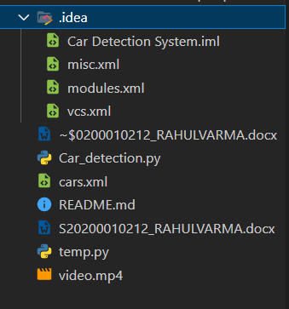

Output:

Car count = 3

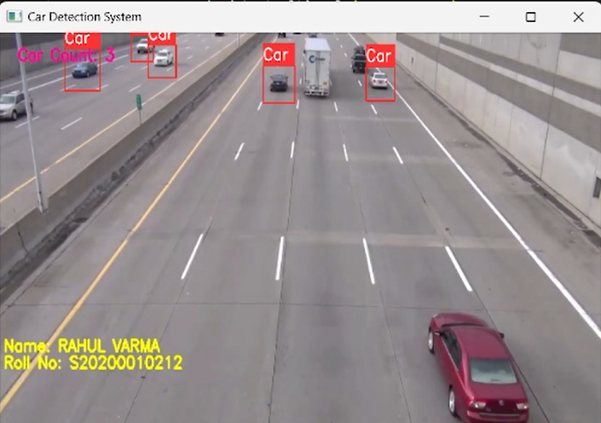

Car Count = 14:

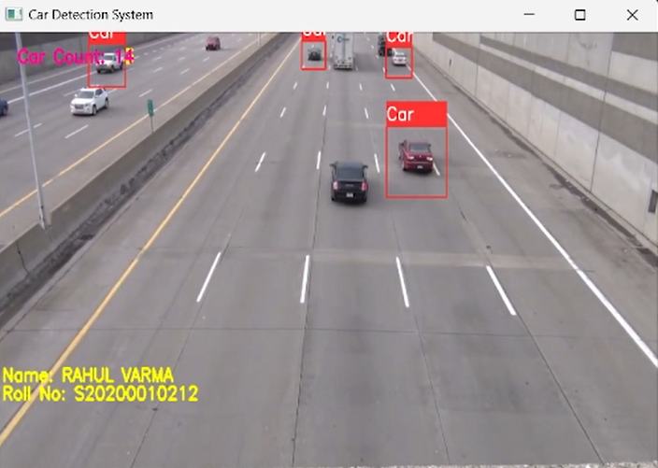

Car Count = 22

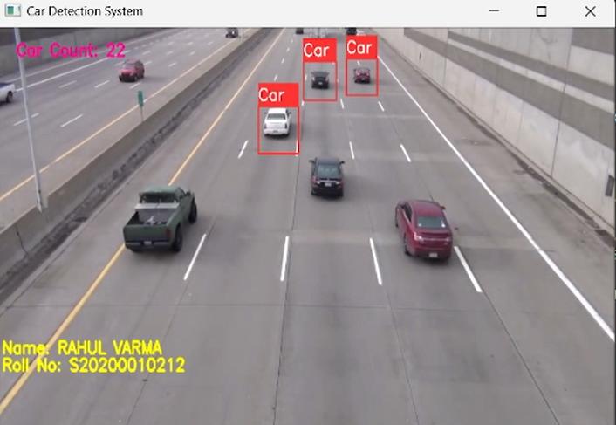

Code:

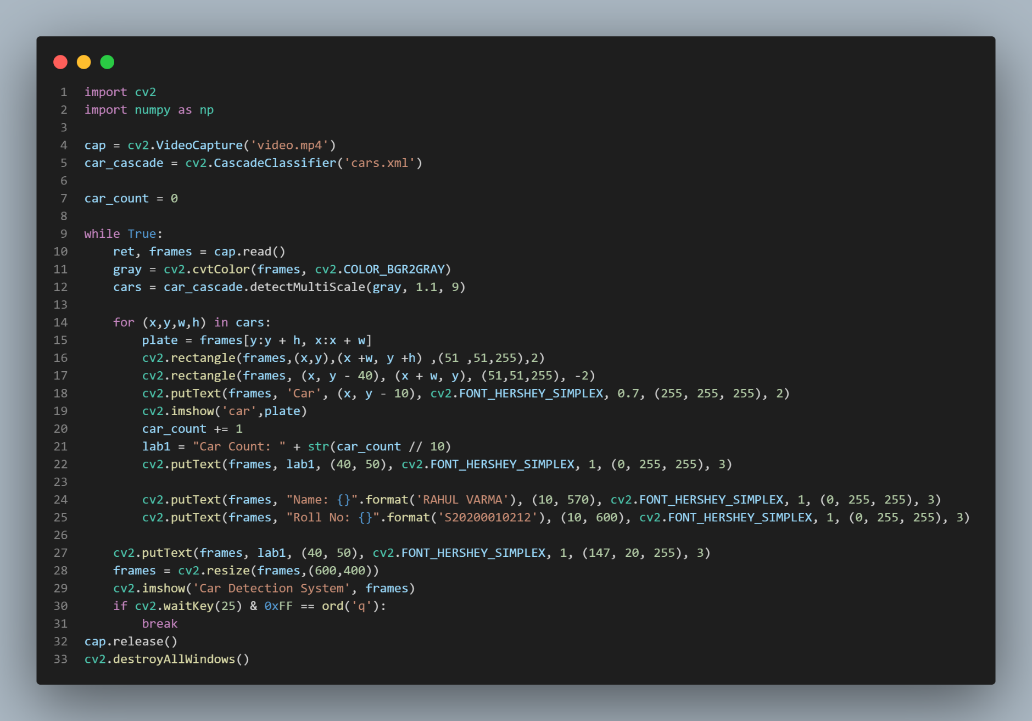

import cv2

import numpy as np

cap = cv2.VideoCapture('video.mp4')

car_cascade = cv2.CascadeClassifier('cars.xml')

car_count = 0

while True:

    ret, frames = cap.read()

    gray = cv2.cvtColor(frames, cv2.COLOR_BGR2GRAY)

    cars = car_cascade.detectMultiScale(gray, 1.1, 9)

    for (x,y,w,h) in cars:

        plate = frames[y:y + h, x:x + w]

        cv2.rectangle(frames,(x,y),(x +w, y +h) ,(51 ,51,255),2)

        cv2.rectangle(frames, (x, y - 40), (x + w, y), (51,51,255), -2)

        cv2.putText(frames, 'Car', (x, y - 10), cv2.FONT_HERSHEY_SIMPLEX, 0.7, (255, 255, 255), 2)

        cv2.imshow('car',plate)

        car_count += 1

        lab1 = "Car Count: " + str(car_count // 10)

        cv2.putText(frames, lab1, (40, 50), cv2.FONT_HERSHEY_SIMPLEX, 1, (0, 255, 255), 3)

        cv2.putText(frames, "Name: {}".format('RAHUL VARMA'), (10, 570), cv2.FONT_HERSHEY_SIMPLEX, 1, (0, 255, 255), 3)

        cv2.putText(frames, "Roll No: {}".format('S20200010212'), (10, 600), cv2.FONT_HERSHEY_SIMPLEX, 1, (0, 255, 255), 3)

    cv2.putText(frames, lab1, (40, 50), cv2.FONT_HERSHEY_SIMPLEX, 1, (147, 20, 255), 3)

    frames = cv2.resize(frames,(600,400))

    cv2.imshow('Car Detection System', frames)

    if cv2.waitKey(25) & 0xFF == ord('q'):

        break

cap.release()

cv2.destroyAllWindows()

Detailed Explanation:

* Python code that uses OpenCV library to detect cars in a video file. The code reads a video file using the cv2.VideoCapture() method and initializes a cascade classifier to detect cars using cv2.CascadeClassifier() method.
* It then enters into an infinite loop where it reads the video frames using cap.read() method and converts the color of the frame to grayscale using cv2.cvtColor() method. The cascade classifier then detects cars in the grayscale frame using car_cascade.detectMultiScale() method.
* If the classifier detects a car, the code draws a rectangle around the car using cv2.rectangle() method and puts a text 'Car' on top of it using cv2.putText() method. It also increases the car_count variable by 1 for each detected car.
* Finally, the code displays the original frame with car detection bounding boxes and car count text using cv2.imshow() method. It waits for 25 milliseconds for a keyboard event to occur using cv2.waitKey() method. If the key pressed is 'q', it breaks out of the infinite loop and exits the program using cap.release() and cv2.destroyAllWindows() methods.