CV ASSIGNMENT – 3

Name: Rahul Varma

Roll No: S20200010212

Dataset Used: CIFAR-10 Dataset

Three ML Model’s Compared:

1. K-Nearest Neighbor
2. Non-Linear SVM
3. Deep Convolutional Neural Network (CNN)

Splitting Data:

1. 80% Train.
2. 10% Validation.
3. 10% Test.

as show in the image below.

Total Data = 60,000 -> 48,000 – 6,000 – 6,000.

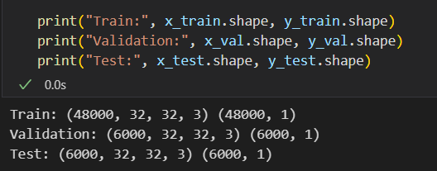

1. K-Nearest Neighbor:

Train, Validation, Test’s Accuracy and Error (Loss) for KNN.

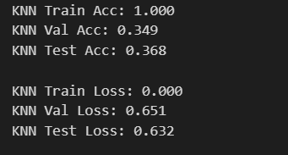

Precision, Recall and Accuracy for KNN:

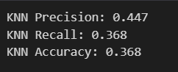

Classification Report for KNN:

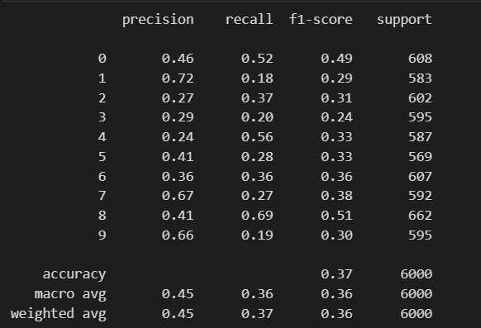

ROC Curve KNN Model:

False Positive Rate on X-axis and True Positive Rate on Y-axis.

And Confusion Matrix.

Area under the curve = 0.742

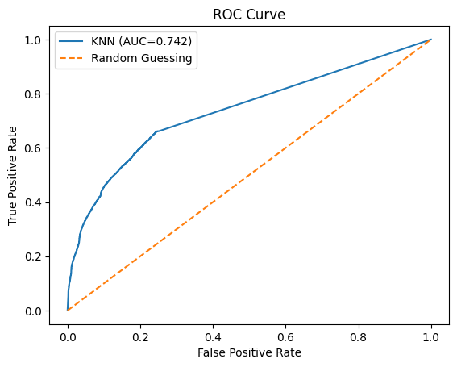 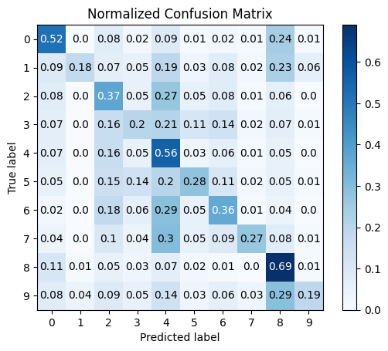

KNN

ROC Curve for each class in the CIFAR Data set:

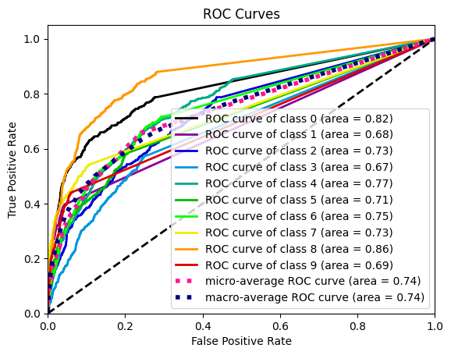

1. Non-Linear SVM:

SVM Model took nearly 6 hour’s for Training.

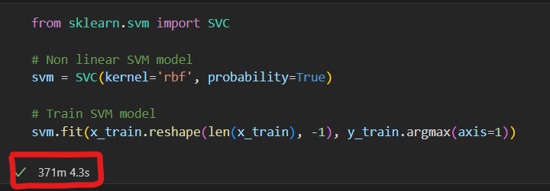

Train, Validation, Test’s Accuracy and Error (Loss) for SVM.

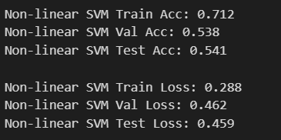

Precision, Recall and Accuracy for SVM.

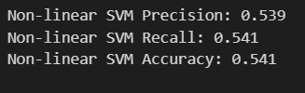

Classification Report for SVM:

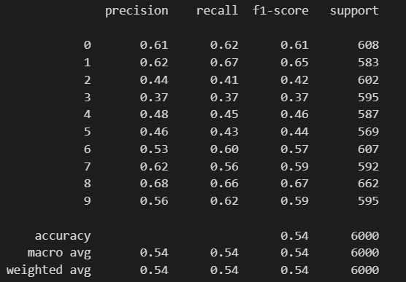

ROC Curve SVM Model:

False Positive Rate on X-axis and True Positive Rate on Y-axis.

And Confusion Matrix.

Area Under the Curve is 0.896

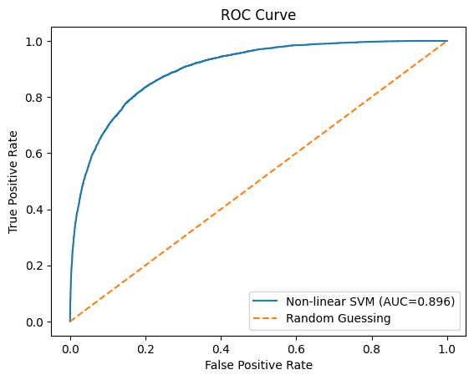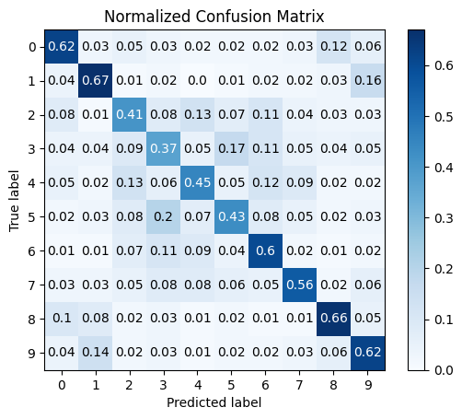

SVM

ROC Curve for each class in the CIFAR Data set:

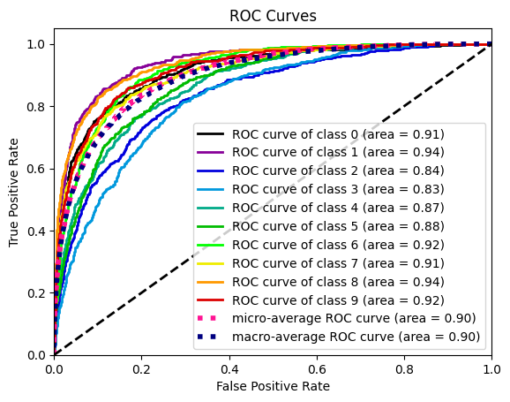

1. CNN Model:

Trained the Model for 20 Epochs.

CNN model that includes a pre-trained VGG16 model as a feature extractor. The model has two sets of convolutional layers, pooling layers, and dropout layers, followed by a fully connected dense layer and a softmax output layer.

The layers used in the model are:

* VGG16 model
* Conv2D layer
* MaxPooling2D layer
* Dropout layer
* Flatten layer
* Dense layer
* Softmax layer

The VGG16 model is used as the initial layers of the model, followed by two sets of Conv2D, MaxPooling2D, and Dropout layers. The output of these layers is flattened and passed through a dense layer with ReLU activation and another Dropout layer. Finally, the output is passed through a dense layer with softmax activation to produce the final class probabilities.

The model is compiled with categorical cross-entropy loss, Adam optimizer, and accuracy metrics. It is trained for 20 epochs on the training data with a batch size of 128 and validated on a separate validation set.

CNN Train, Validation, Test’s Precision, Recall and Accuracy Accuracy and Error(Loss) : for CNN.

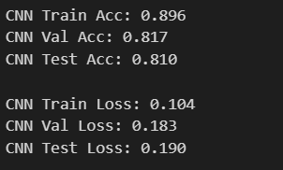 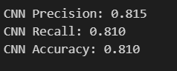

Classification Report for CNN:

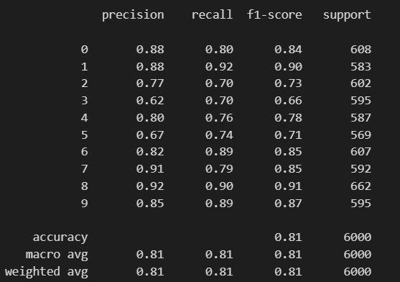

Training for 20 Epochs:

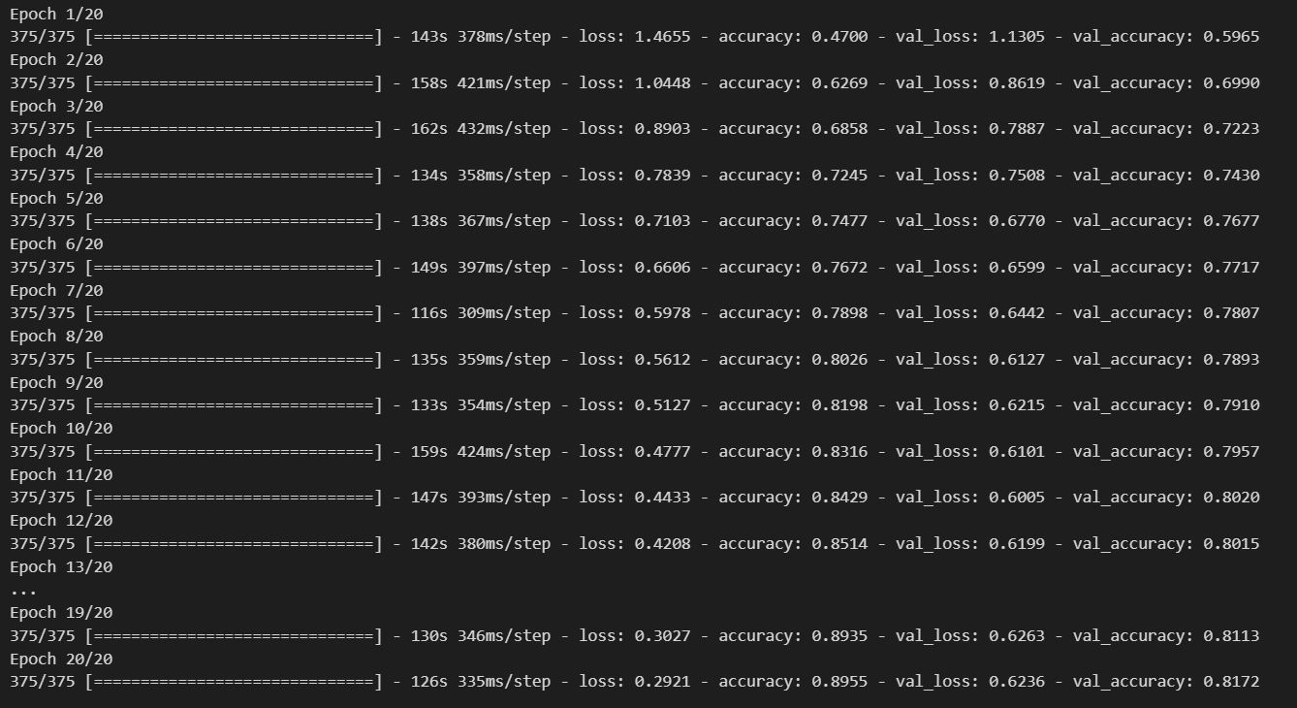

ROC Curve CNN Model:

False Positive Rate on X-axis and True Positive Rate on Y-axis. And Confusion Matrix.

Area Under the Curve is 0.980

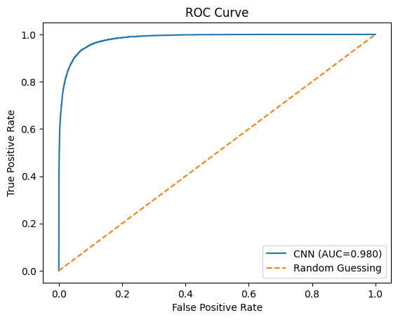 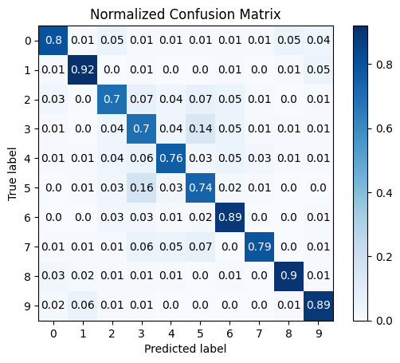

CNN

ROC Curve for each class in the CIFAR Data set:

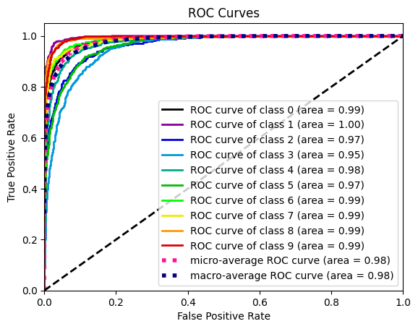

Final Report from the above observation on ROC Analysis:

Based on the ROC curve analysis, the CNN model using VGGNet has the highest AUC score of 0.98, indicating that it has the best overall performance for distinguishing between the classes. The non-linear SVM model comes in second with an AUC score of 0.896, while KNN has the lowest AUC score of 0.742.

In terms of accuracy, the CNN model also has the highest performance on both the validation and test sets, achieving 81.7% and 81.0% accuracy respectively. The non-linear SVM model has the second-best accuracy, achieving 53.8% on the validation set and 54.1% on the test set. KNN has the lowest accuracy on both sets, achieving only 34.9% on the validation set and 36.8% on the test set.

The CNN model also has the lowest loss on both the validation and test sets, indicating better performance in minimizing the error. Additionally, the CNN model has the highest precision and recall values, indicating that it has the best overall performance for identifying true positive cases.

In conclusion, based on the ROC curve analysis, accuracy, loss, precision, and recall values, the CNN model using VGGNet is the best among the given models for this classification task.

Based on the given results, we can conclude that the CNN model using VGGNet architecture is the best among the three models for the CIFAR dataset. This conclusion is based on the analysis of ROC curves, where the CNN model has the highest AUC value of 0.980 compared to KNN (0.742) and Non-linear SVM (0.896).

Furthermore, the CNN model has higher accuracy and lower loss values for both training and validation sets compared to KNN and Non-linear SVM. In terms of precision, recall, and accuracy, the CNN model also outperforms the other two models.

Therefore, we can conclude that the CNN model using VGGNet architecture is the most suitable and effective model for the CIFAR dataset.