Part A – Repository Setup & Version Control Basics
Description:
- Created a local Git repository.
- Configured Git username and email.
- Added project files (app.py, README.md, config.txt).
- Made the first commit.

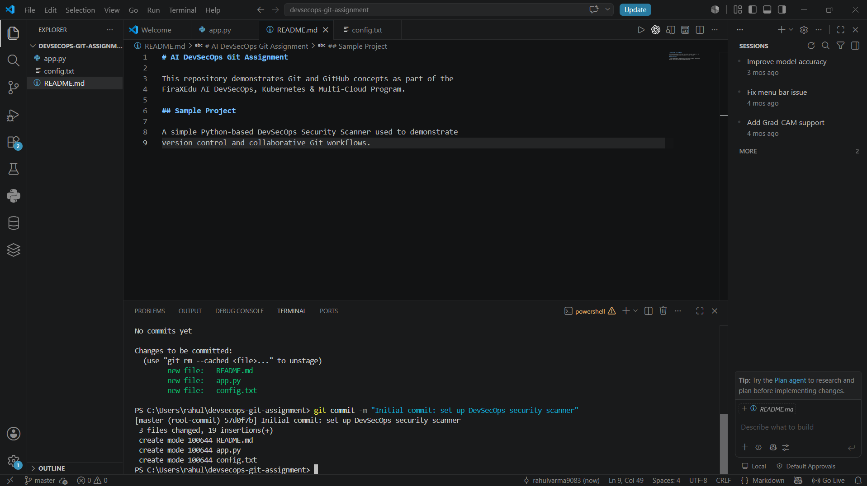
Screenshot 1: First Commit Output

Part B – Git Stages & Working Directory
Description:
- Modified an existing file and created a new file.
- Used git status to observe the Working Directory and Staging Area.
- Staged one file, committed it, then committed the remaining file separately.
- Observed the changes at each stage using git status.

Part C – Git Diff & .gitignore
Description:
- Compared unstaged changes using git diff.
- Compared staged changes using git diff --staged.
- Created a .gitignore file to ignore log files, cache folders, and environment files.

Part D – Git Flow & Trunk-Based Development
Description:
- Created a Git Flow branch (feature/login-page).
- Created a trunk-based branch (trunk-fix-typo).

Comparison:
- Git Flow uses multiple long-lived branches and is suitable for structured release cycles.
- Trunk-Based Development focuses on frequent integration into the main branch with short-lived branches.
- Git Flow is ideal for large teams with scheduled releases.
- Trunk-Based Development is preferred for Continuous Integration and rapid deployments.

Part E – Merge & Cherry-pick
Description:
- Created two commits in a feature branch.
- Merged the feature branch into the main branch.
- Created another branch and used git cherry-pick to copy a specific commit to the main branch.

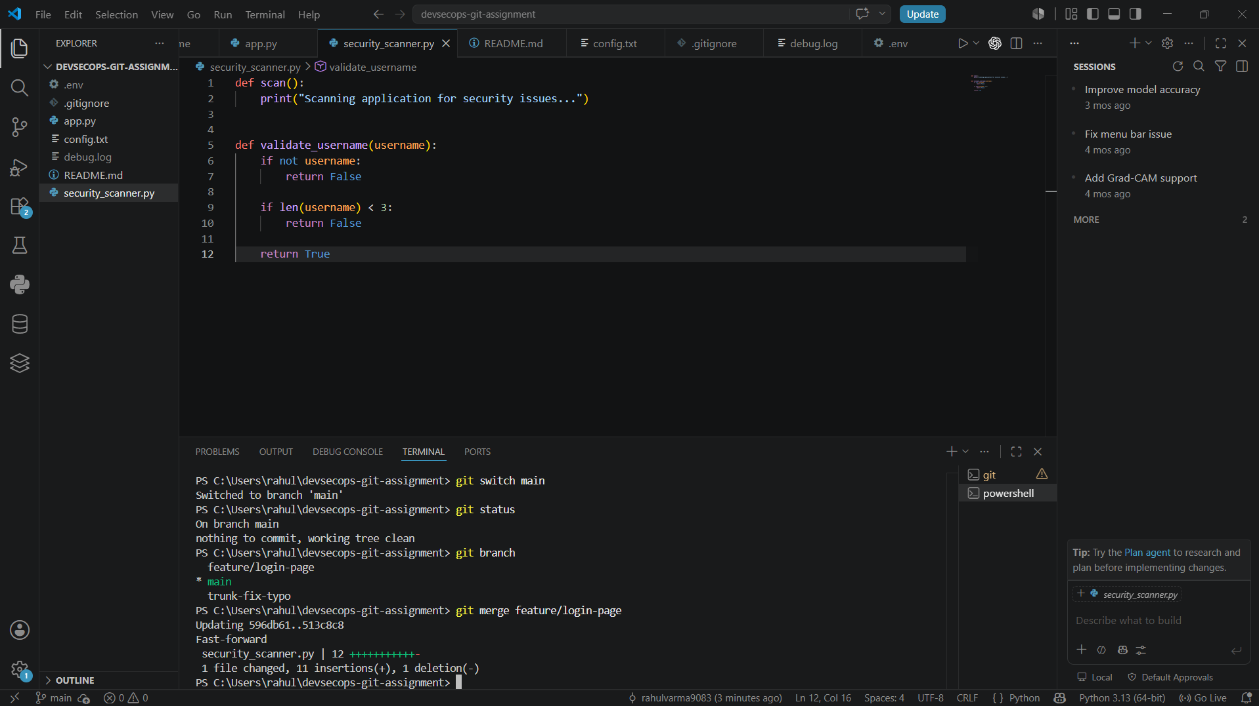
Screenshot 2: Merge Result

Part F – Rebase & Remote Repository
Description:
- Created divergent commits.
- Rebased the branch onto the main branch.
- Added GitHub as a remote repository.
- Pushed the local repository to GitHub.

Part G – GitHub Repository Settings
Description:
- Configured branch protection for the main branch.
- Explored repository settings.
- Documented repository settings for team collaboration.

Part H – Pull Request
Description:
- Created a Pull Request.
- Added a review comment.
- Merged the Pull Request using GitHub.
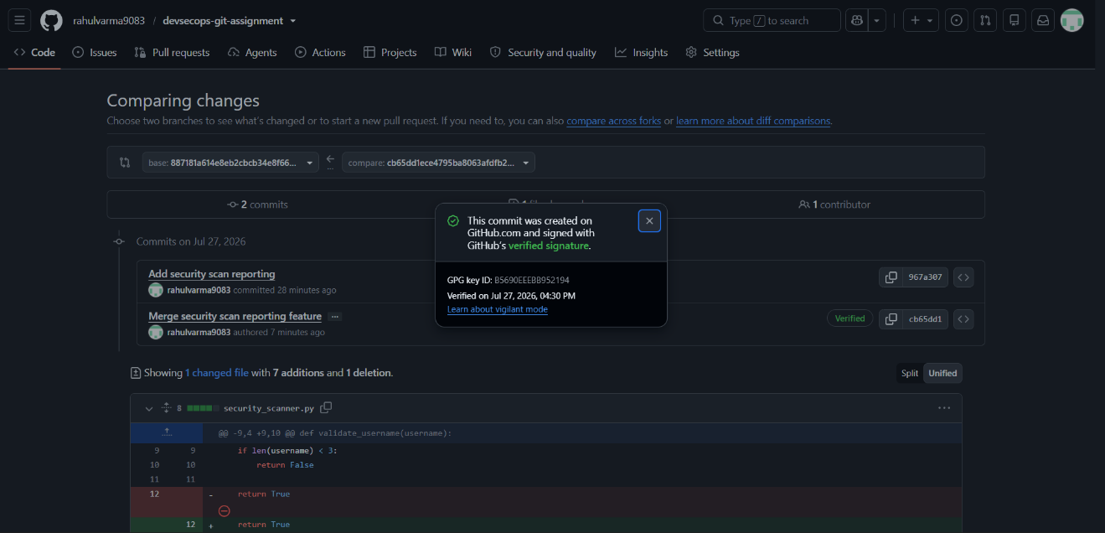
Screenshot 3: Merged Pull Request
Part I – GitHub Desktop & VS Code
Description:
- Cloned the repository using GitHub Desktop.
- Made a commit and pushed changes.
- Used VS Code Source Control to stage, commit, and push changes.

Part J – Git Revert & Git Reset
Description:
- Used git revert to safely undo a commit.
- Demonstrated git reset --soft, --mixed, and --hard.
- Compared the behavior of each reset option.
Difference Between git reset --soft, --mixed, and –hard:
• git reset --soft: Moves the HEAD to a previous commit but keeps all changes staged. This is useful when you want to modify or combine commits without losing your work.
• git reset --mixed: Moves the HEAD to a previous commit and unstages the changes while keeping them in the working directory. This is the default reset mode.
• git reset --hard: Moves the HEAD to a previous commit and permanently removes all staged and working directory changes. This should be used carefully because the discarded changes cannot be easily recovered.
Part K – GitHub Copilot & Git Flow
Description:
- Used GitHub Copilot to generate code.
- Committed the Copilot-assisted code.
- Designed a Git Flow branching diagram and explained the hotfix workflow.
Git Flow Diagram:
feature/*
│
▼
develop ─────► release/*
▲ │
│ ▼
hotfix/* ◄────── main
Hotfix Workflow:
A hotfix is created from the main branch when a critical issue is found in production. After the bug is fixed, the hotfix branch is merged back into main to release the fix immediately. The same changes are then merged into the develop branch so that future development also includes the fix. This ensures both the production code and the ongoing development remain synchronized.

Conclusion
Successfully completed all Git & GitHub tasks, including repository management, branching, merging, rebasing, remote collaboration, Pull Requests, GitHub Desktop, VS Code integration, Git Revert, Git Reset, GitHub Copilot, and Git Flow.

