HABIT TRACKER

By

Mythili Nandamuri – AP23110010543
Ayush Kumar Giri – AP23110010548
Rahul Vemula – AP23110010571
Harsh Bais – AP23110010653

SUBMITTED TO:
Himanshu Mishra



SRM UNIVERSITY, AP
(DECEMBER, 2025)

Introduction: -
Consistency is the backbone of personal growth, yet in today’s fast-paced digital world, maintaining habits has become increasingly challenging. People set goals to exercise, study, read, sleep early, or practice mindfulness but often struggle to stay consistent due to lack of structure, unclear progress, and no real sense of accountability. While there are countless productivity apps available, users still face recurring issues: cluttered interfaces, distracting ads, inconsistent tracking methods, and the absence of meaningful feedback to motivate daily action. The modern user needs more than a simple to-do list; they need a clean, reliable system that makes habit-building intuitive, enjoyable, and measurable.
With the growth of web applications, there is immense potential to simplify how individuals organize their daily routines. Yet many existing habit apps either overwhelm users with unnecessary complexity or offer only basic tracking without deeper insights. Very few platforms successfully combine goal-setting, analytics, streak tracking, visualization, and personalization into a smooth, distraction-free experience. This gap highlights the need for a dedicated solution that not only records habits but actively helps users build them.
The Habit Tracker has been created to address these limitations by providing a structured, user-friendly digital companion for building long-term habits. Built with modern frontend technologies, the platform presents habits in a clean and organized layout, supported by accurate, structured data. Users can create custom habits across multiple categories, set target goals, and track their daily progress with clear visual indicators such as streak counters, progress bars, and completion history. Smart features like preventing duplicate daily entries, offering detailed statistics, showing recent completion dates, and supporting quick habit updates make the tracking process smooth and seamless. Beyond just recording habits, the application encourages consistency by giving users immediate visual feedback every time they complete an action.
This project demonstrates how thoughtful UI/UX design, lightweight technologies, and interactive features can transform the simple act of tracking habits into a motivating and engaging experience. The Habit Tracker serves as a foundation for a growing digital wellness ecosystem—one that can scale into advanced analytics, reminders, user authentication, community challenges, and deeper personalization in the future.

Scenario-Based Intro: -
Imagine someone waking up determined to follow a healthier routine maybe to drink more water, study for an hour, meditate, or go for a walk. But as the day progresses, they get busy, forget what they planned, and by the end of the week, they have no idea which habits they actually stuck to. Instead of juggling reminders, notebooks, or random notes on their phone, they open the Habit Tracker app.
Within seconds, they can create new habits like “Read for 20 minutes,” “Exercise,” or “Learn React,” assign a target goal, and set how frequently the habit should be performed. Each day, they simply tap “Mark Done,” and the app automatically updates their streak, records the date, and visually shows their progress through streak counters and progress bars. They can also view their history to see how consistent they’ve been during the week, motivating them to stay on track.
Meanwhile, users can organize all their habits into categories such as Health, Study, Work, Mindfulness, Finance, or Personal. They can edit habits, delete old ones, and track improvements over time all inside their own personalized habit dashboard. Smart features like preventing duplicate daily entries ensure clean and accurate tracking, while detailed statistics help users understand their overall growth.
On the other side, the system allows administrators or developers to extend functionalities, manage data, or integrate new features easily due to its clean, structured codebase and RESTful architecture.
This Habit Tracker System simulates a real-world personal development assistant and provides an integrated digital solution for building, organizing, and maintaining habits effortlessly.

Target Audience: -
Individuals Focused on Personal Growth & Self-Improvement
- People who want to build positive daily habits like reading, exercising, studying, or practicing mindfulness.
- Users who need a simple, clean system to track progress and stay consistent.
Students & Working Professionals
- Individuals trying to manage routines, boost productivity, or improve discipline.
- Busy people who prefer visual progress indicators like streaks, progress bars, and reminders.
Fitness, Wellness & Mental-Health Enthusiasts
- Users tracking gym sessions, meditation, diet habits, sleep routines, or hydration goals.
- People who want measurable insights and motivational tools to maintain their lifestyle habits.
Organizers & Productivity Seekers
- Anyone who wants a structured digital space to create, update, and categorize habits.
- Users who benefit from detailed analytics, habit history, and personalized goal setting.
Developers, Learners & Tech Enthusiasts
- Students exploring modern web technologies such as React, REST APIs, and JSON Server.
- Developers interested in building or extending interactive habit-tracking applications.
Project Goals and Objectives: -
Complete Habit-Tracking Fundamentals
- Daily habit creation, editing, and deletion
- Progress visualization using streaks and progress bars
- Preventing duplicate daily entries
- Maintaining historical completion data
- Clean, structured UI for smooth habit-building workflow
Modern Tech Stack
- Built using React.js for a fast, interactive user interface
- Styled with Tailwind CSS for a fully responsive design
- Uses Axios for API communication
- JSON Server for REST API–based habit data storage and CRUD operations
- Optional backend extensions for user authentication and cloud data storage
- Designed for seamless performance across mobile, tablet, and desktop
Seamless Habit-Building Workflow
- Users can create habits with name, category, frequency, and target goals
- View organized habit cards with streak count, progress, and last completed date
- Mark habits as complete with a single click
- Access structured analytics: total completions, current streak, 7-day history
- Edit and update habits to match changing routines
- Delete habits that are no longer needed
- Receive toast notifications for smooth feedback throughout the app

Key Features:-
1. Habit Creation & Management
- Create new habits with customizable properties
- Edit existing habits
- Delete habits with confirmation
- Categorize habits (Health, Study, Work, Mindfulness, Personal, Finance)
- Set frequency (Daily, Weekly)
- Define target completion goals
2. Progress Tracking
- Mark habits as complete for the current day
- Automatic streak calculation
- Prevention of duplicate daily completions
- Visual progress bars showing completion percentage
- Last completion date tracking
3. Detailed Statistics
- Individual habit detail pages
- Current streak display
- Total completion count
- Last 7 days completion history
- Target progress visualization
4. User Interface
- Responsive design for all screen sizes
- Card-based layout for habit display
- Color-coded category badges
- Interactive buttons with hover effects
- Loading states for async operations
- Toast notifications for user actions
5. Navigation & Routing
- Home page with habit overview
- Add habit page
- Edit habit page
- Habit details page
- Smooth transitions between pages

PRE-REQUISITES: -
Technical Requirements:
- Node.js (v14 or higher)
- npm or yarn package manager
- Modern web browser (Chrome, Firefox, Safari, Edge)
- Text editor/IDE (VS Code recommended)
Knowledge Prerequisites:
- JavaScript ES6+ - Arrow functions, destructuring, spread operator, async/await
- React Basics - Components, props, state, hooks (useState, useEffect)
- HTML & CSS - Basic web markup and styling
- REST API Concepts - HTTP methods (GET, POST, PUT, DELETE)
- Command Line Basics - Running npm commands

Project structure:

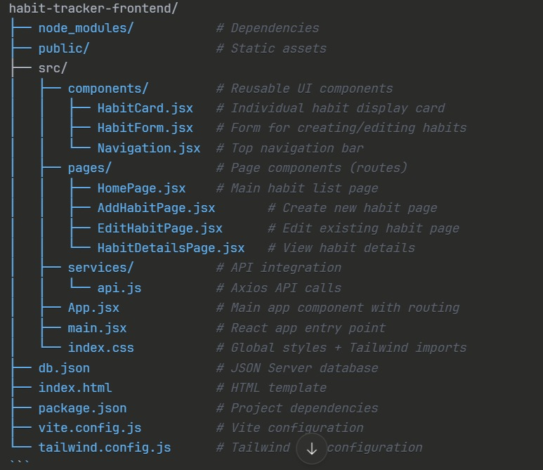
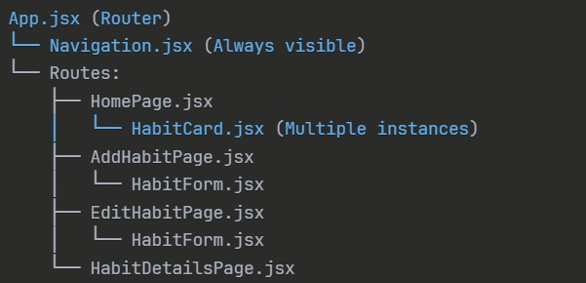

The project contains:
• Frontend (React.js)
Contains all UI screens, components, and client-side logic.
• Components:
Navbar, Habit Cards, Progress Bars, Habit Form, Streak Counter, Toast Notifications, Add Habit Button, Delete/Edit Buttons.
• Pages:
Home, AddHabit, EditHabit, HabitDetails.
• State Management:
Handles global and shared states such as habit lists, streaks, progress updates, and completion status using React hooks.
• Styles:
Global CSS, Tailwind CSS utility classes, component-level styling.
• Utils:
Date formatting helpers, progress calculation functions, completion checkers, localStorage utilities (optional), and API helper methods.
Backend (JSON Server)
• db.json stores all habit data
Contains fields such as:
id, name, category, completedDates, targetCount, currentStreak, and frequency.
• JSON Server handles all CRUD operations
No MySQL or PHP required.
Supports:
- Create habit
- Read habit list
- Update habit details
- Delete habit
- Mark habit as completed

API (Fetch / Axios)
• Used for communicating with JSON Server
Performs:
- GET all habits
- GET single habit by ID
- POST new habits
- PUT/PATCH updates
- DELETE habits
Assets (Media Files)
Includes icons, images, backgrounds, logos, and UI graphics used across the app.
Configuration Files
• package.json:
Project dependencies and scripts.
• vite.config.js:
Vite development and production configuration.
• db.json:
Local database file for habits.
• .gitignore:
Specifies ignored files (node_modules, dist, logs).
• index.html:
Root HTML file where the React app is mounted.

PROJECT FLOW: -
1. User Opens the Application
The user lands on the Home Page, which displays all existing habits in a clean card layout.
2. Home Page Loads All Habits
- React sends a GET request to JSON Server (/habits).
- Habit cards are displayed with:
  - Habit name
  - Category
  - Current streak
  - Progress bar
  - Target count
  - Last completed date
  - Action buttons (View / Edit / Delete / Mark Done)
3. User Creates a New Habit
- User clicks “Add Habit” button.
- Navigated to AddHabit Page.
- User fills the form → name, category, frequency, target.
- Form validation runs.
- On submit:
  - React sends a POST request to create a new habit.
  - A success toast message appears.
  - User is redirected back to Home Page.
4. User Marks a Habit as Completed
- User clicks “Mark Done” on a habit card.
- App checks if that habit is already completed today.
- If not completed:
  - Adds today’s date to completionDates[].
  - Increases the currentStreak.
  - Updates progress.
  - Sends a PUT request to update habit data.
- If completed already:
  - Button gets disabled to prevent duplicates.
5. User Views Habit Details
- User clicks the View (Eye icon).
- Navigated to HabitDetails Page.
- Page displays:
  - Total completions
  - Current streak
  - Target progress
  - Last 7 completion dates
  - A progress chart-style layout
6. User Edits an Existing Habit
- User clicks Edit.
- Navigated to EditHabit Page, pre-filled with existing data.
- User updates fields.
- On submit:
  - React sends a PUT request.
  - Habit updates in db.json.
  - Success toast is shown.
  - Redirects to Home Page.
7. User Deletes a Habit
- User clicks Delete on the habit card.
- Shows a confirmation alert.
- If confirmed:
  - Sends a DELETE request.
  - Removes the habit from the Home Page.
  - Displays a toast message.
8. UI Re-Renders with Updated State
After every action (Add, Edit, Delete, Mark Done):
- The updated data is fetched again OR the local state is updated.
- React re-renders the updated list without reloading the page.
9. Data Storage
- All habits, completions, streaks, and progress are stored in db.json using JSON Server.
- The app works like a fully functional mini-backend system.
10. Smooth UX Throughout
- Toast notifications provide feedback.
- Responsive Tailwind UI adjusts across devices.
- Navigation is handled by React Router for seamless transitions.

Code Description: -
A React-based Habit Tracker application with streak tracking, CRUD operations, and a JSON Server backend. Users can create habits, mark them as completed, view streaks, and manage all habits via a clean UI.
Tech Stack
Frontend: React + Vite, Tailwind CSS, React Router DOM, Axios, React Toastify, Lucide Icons
Backend: JSON Server with db.json as the data source
Architecture: Component-based UI + centralized API service
App Structure
App.jsx
Wraps the app with BrowserRouter
Loads global Navigation and ToastContainer
Defines routes:
/ → HomePage
/add → AddHabitPage
/edit/:id → EditHabitPage
/details/:id → HabitDetailsPage
Key Components
Navigation.jsx
Top navigation bar with logo and “Add Habit” button
Gradient background + responsive layout
HabitCard.jsx

Displays habit info (name, description, streak, status)
Buttons to mark done, delete, and view details
HabitForm.jsx
Reusable form for both adding and editing habits
Fields: name, description, frequency, category
Pages
HomePage.jsx
Fetches habits on mount
Displays them in a responsive grid
Handles:
Marking done for today
Deleting habits
Streak updates
Shows loading spinner and empty state
AddHabitPage / EditHabitPage
Use HabitForm
Create or update habits via API
HabitDetailsPage
Shows full habit info + completion history + streak stats
API Service (api.js)
Centralized Axios wrapper for all REST communication.
Endpoints
GET /habits → fetch all

GET /habits/:id → single habit
POST /habits → create habit
PUT /habits/:id → update habit
DELETE /habits/:id → remove habit
Habit Data Structure
{
id,
name,
description,
currentStreak,
completionDates: [],
lastCompleted
}
Core Features
CRUD habit management
Daily completion tracking
Automatic streak calculation
Toast notifications for actions
Responsive Tailwind UI
Smooth data flow from UI → API → Backend
Development
Frontend: npm run dev
Backend: JSON Server on port 3001
Build: npm run build
Project Execution:

After completing the code, run your habit tracker JSON server using “json-server --watch db.json --port 3001” and start the frontend using “npm run dev”. These commands will launch your JSON Server API and your Vite React application.

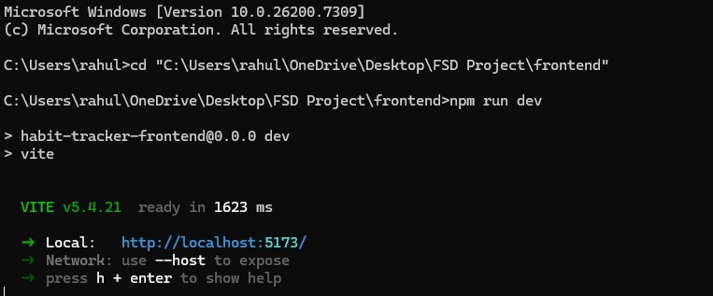
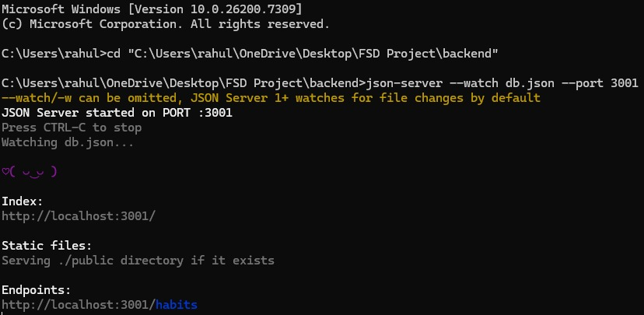
Output

