**DAYANANDA SAGAR UNIVERSITY**

#### Devarakaggalahalli, Harohalli Kanakapura Road, Dt, Ramanagara, Karnataka 562112



**Bachelor of Technology in COMPUTER SCIENCE AND ENGINEERING**

**(Artificial Intelligence and Machine Learning)**



### COURSE TITLE: SKILL ENHANCEMENT COURSE DEVELOPMENT

" Portfolio Website"

By

## Rahul V ENG22AM0189

Under the supervision of

## Dr. M. Lakshmanan

Assistant Professor

DEPARTMENT OF COMPUTER SCIENCE & ENGINEERING

(Artificial Intelligence and Machine Learning) SCHOOL OF ENGINEERING

DAYANANDA SAGAR UNIVERSITY, BANGALORE



### School of Engineering

**Department of Computer Science & Engineering (Artificial Intelligence and Machine Learning)**

Devarakaggalahalli, Harohalli Kanakapura Road, Dt, Ramanagara, Karnataka 562112



# CERTIFICATE

This is to certify that the Mini-Project titled **“Portfolio”** is carried out by **Rahul V (ENG22AM0189)** bonafide student of Bachelor of Technology in Computer Science and Engineering (Artificial Intelligence and Machine Learning) at the School of Engineering, Dayananda Sagar University.

#### Dr. M. Lakshmanan

Assistant Professor

Department Of Computer Science & Engineering (Artificial Intelligence and Machine Learning)

School Of Engineering Dayananda Sagar University

#### Dr. Jayavrinda Vrindavanam V

Professor and Chairperson Department of Computer Science & Engineering (Artificial Intelligence and Machine Learning)

School Of Engineering Dayananda Sagar University

# DECLARATION

I, **Rahul V**, student of Fifth semester B. Tech in **Computer Science and Engineering with speciation in Artificial intelligence and machine learning,** at School of Engineering, **Dayananda Sagar University**, hereby declare that the **SKILL ENHANCEMENT COURSE-III-WEB TECHNOLOGY titled “Portfolio”** has been carried out by me and submitted in partial fulfilment for the award of degree in **Bachelor of Technology in Computer Science and Engineering** during the academic year **2024- 2025**

#### SIGNATURE

**NAME: Rahul V**

**USN: ENG22AM0189 PLACE: BANGALORE DATE: 29/11/2024**

**ACKNOWLEDGEMENT**

It is a great pleasure for us to acknowledge the assistance and support of many individuals who have been responsible for the successful completion of this project work.

First, I take this opportunity to express my sincere gratitude to School of Engineering & Technology, Dayananda Sagar University for providing us with a great opportunity to pursue my Bachelor’s degree in this institution.

I would like to thank **Dr. Udaya Kumar Reddy K R, Dean**, **School of Engineering**, **Dayananda Sagar University** for his constant engagement and expert advice. It is a matter of immense pleasure to express my sincere thanks to **Dr. Jayavrinda Vrindavanam V, Professor and Chairperson**, **Computer Science and Engineering (Artificial Intelligence and Machine Learning)**, **School of Engineering, Dayananda Sagar University,** for providing the right academic guidance that made my task possible.

I would like to thank my guide **Prof. Lakshmanan, Assistant Professor, Dept. of Computer Science and Engineering (Artificial Intelligence and Machine Learning), School of Engineering, Dayananda Sagar University**, for sparing their valuable time to extend help in every step of my UG Research project work, which paved the way for smooth progress and the fruitful culmination of the research.

I am also grateful to my family and friends who provided us with every requirement throughout the course. I would like to thank one and all who directly or indirectly helped us in the Research work.

## TABLE OF CONTENTS

|  |  |  |
| --- | --- | --- |
| **S.No** | **Topic** | **Page No** |
| **1** | Abstract | 5 |
| 2 | Introduction | 6 |
| 3 | Objectives | 7 |
| 4 | Problem description | 8 |
| 5 | Methodology | 9 |
| 6 | Implementation of code | 10 |
| 7 | Output | 23 |
| 8 | Technology used | 24 |
| 9 | Result and analysis | 25 |
| 10 | Conclusion | 26 |

**ABSTRACT:**

This report explores the creation of a professional web portfolio for Rahul V. The portfolio is designed to showcase his expertise in programming and development, including proficiency in Python, C, PHP, HTML, and CSS. The project employs a combination of HTML for structure, CSS for styling, and JavaScript for interactivity. The goal of the portfolio is to present Utpal's work and skills effectively while maintaining a clean and user-friendly interface. The portfolio features dynamic navigation, responsiveness, and links to external platforms like GitHub and LinkedIn, allowing users to access additional information and project details. The report covers the development process, challenges, and results, concluding with potential areas for future improvement.

## INTRODUCTION:

In the modern professional landscape, having a strong online presence is essential. A web portfolio serves as a digital résumé, providing a comprehensive overview of skills, projects, and achievements in a visually engaging way. This portfolio was developed for Utpal Kumar to highlight his technical abilities and accomplishments.

It features sections such as "Home," "Projects," "About Me," and "Contact," each designed to provide a unique perspective on his journey. The portfolio not only organizes information effectively but also uses interactivity to engage users.

With a minimalist layout, vibrant colors, and intuitive navigation, it caters to a wide audience, including potential employers and collaborators. The focus on responsiveness ensures usability across devices, enhancing its accessibility and reach.

## OBJECTIVES:

The project was undertaken with the following goals:

1. To create a visually appealing, professional web portfolio for showcasing skills and projects.
2. To design an intuitive and interactive interface that enables easy navigation.
3. To employ modern web development technologies for a responsive and cross-browser- compatible design.
4. To highlight programming expertise through concise yet informative content.
5. To provide a flexible and scalable design for potential future updates.

The overarching objective was to build a portfolio that not only presents information effectively but also reflects the creator’s technical and creative abilities.

## PROBLEM DEFINITION:

**Design your own Portfolio:**

In the current digital era, having an attractive, responsive, and user-friendly website is essential for businesses, organizations, and individuals to establish their online presence. However, many websites fail to meet user expectations due to poor design, lack of interactivity, or limited accessibility across devices. This creates challenges such as:

* 1. Poor User Experience: Websites with unappealing layouts or difficult navigation frustrate users and lead to reduced engagement.
  2. Limited Responsiveness: Many websites do not adapt seamlessly to different devices and screen sizes, resulting in inconsistent user experiences.
  3. Lack of Interactivity: Websites that lack interactive elements fail to engage users effectively, which can impact user retention.
  4. Branding and Connectivity Gaps: Insufficient attention to branding elements and the absence of social media integration can limit outreach and connectivity with the audience.
  5. Inefficient Visual Presentation: Poor use of modern design principles and styling can detract from a website’s credibility and professionalism.

This project addresses these challenges by developing a modern, responsive, and visually appealing website using HTML and CSS. It incorporates dynamic features, well-structured navigation, responsive layouts, and engaging elements to create a seamless and impactful user experience.

## METHODOLOGY:

The development of this project follows a systematic and modular approach, ensuring the creation of a responsive and visually appealing website. The methodology is divided into the following steps:

1. Requirement Analysis:
   * Understand the goals of the website, such as creating an engaging user interface, responsive design, and seamless navigation.
   * Identify target users and their expectations to ensure an optimal user experience.
2. Design Planning:
   * Develop a wireframe or layout blueprint to organize sections like navigation bar, hero section, content containers, and footer.
   * Choose a color scheme, typography, and design elements aligned with modern UI/UX principles. Define reusable CSS variables for consistency in colors, font sizes, and other styling elements.
3. Development Process:
   * HTML Creation:
     + Structure the website using semantic HTML5 tags to ensure clarity and accessibility.
     + Include sections such as the navigation bar, hero content, about us, services, and contact information.
   * CSS Styling:
     + Implement a responsive design using CSS media queries to adapt to different screen sizes.
     + Apply consistent styling using CSS variables and classes for ease of maintenance.
     + Add animations and hover effects to enhance interactivity.
     + Optimize layouts with the use of flexbox and grid for alignment and spacing.
4. Testing and Optimization:
   * Test the website for responsiveness across various devices (mobile, tablet, desktop).
   * Verify cross-browser compatibility to ensure the website works on major browsers like Chrome, Firefox, Edge, and Safari. Optimize the code to minimize redundancy and improve load times.
5. Social Media Integration:
   * Include interactive icons linked to social media platforms. Test hover effects and ensure proper alignment and visibility across devices.
6. Feedback and Refinement:
   * Gather user feedback on the design and usability of the website.
   * Incorporate suggestions to further enhance functionality and user experience.
7. Deployment and Maintenance:
   * Deploy the website on a suitable platform or server.
   * Plan regular updates to incorporate new features and adapt to changing user requirements.
   * This methodology ensures a structured development process, resulting in a functional, appealing, and user-friendly website.

## IMPLEMENTATION OF CODE:

### Homepage

### <!DOCTYPE html>

### <html lang="en">

### <head>

### <meta charset="UTF-8" />

### <meta name="viewport" content="width=device-width, initial-scale=1.0" />

### <title>Rahul Vijay</title>

### <!-- Google Fonts -->

### <link href="https://fonts.googleapis.com/css2?family=Poppins:wght@300;400;600;700&family=Montserrat:wght@400;500;700&display=swap"

### rel="stylesheet" />

### <style>

### /* CSS Variables for Dark & Light Mode */

### :root {

### --bg-dark: #0e172a;

### --bg-light: #f0f4fa;

### --text-dark: #ffffff;

### --text-light: #222222;

### --primary-accent-dark: #4fa3d1;

### --primary-accent-light: #0056b3;

### --shadow-dark: rgba(0, 0, 0, 0.7);

### --shadow-light: rgba(0, 0, 0, 0.2);

### }

### /* Reset & Global Styles */

### * {

### margin: 0;

### padding: 0;

### box-sizing: border-box;

### }

### body {

### font-family: 'Poppins', sans-serif;

### transition: background-color 0.5s ease, color 0.5s ease;

### }

### body.dark-mode {

### background: var(--bg-dark);

### color: var(--text-dark);

### }

### body.light-mode {

### background: var(--bg-light);

### color: var(--text-light);

### }

### /* Navigation Bar */

### nav {

### position: fixed;

### top: 0;

### left: 0;

### right: 0;

### height: 60px;

### display: flex;

### justify-content: space-between;

### align-items: center;

### padding: 0 2rem;

### background: var(--bg-dark);

### color: var(--text-dark);

### box-shadow: 0 3px 6px var(--shadow-dark);

### z-index: 1000;

### }

### nav a {

### text-decoration: none;

### color: var(--primary-accent-dark);

### margin: 0 15px;

### font-weight: 500;

### transition: color 0.3s ease, transform 0.3s ease;

### }

### nav a:hover {

### transform: translateY(-3px);

### color: var(--primary-accent-light);

### }

### .theme-toggle {

### cursor: pointer;

### font-size: 1.4rem;

### transition: transform 0.3s ease;

### }

### .theme-toggle:hover {

### transform: scale(1.1);

### }

### /* Hero Section */

### .hero-section {

### height: 100vh;

### display: flex;

### justify-content: center;

### align-items: center;

### text-align: center;

### flex-direction: column;

### animation: slideIn 1.5s ease-in-out;

### }

### h1 {

### font-size: 3.5rem;

### font-weight: 700;

### letter-spacing: 2px;

### color: var(--primary-accent-dark);

### animation: bounceText 1.8s ease-in-out;

### }

### p {

### margin-top: 15px;

### font-size: 1.2rem;

### font-weight: 400;

### color: var(--text-light);

### }

### @keyframes bounceText {

### 0% {

### transform: translateY(-20px);

### }

### 50% {

### transform: translateY(10px);

### }

### 100% {

### transform: translateY(0);

### }

### }

### @keyframes slideIn {

### from {

### transform: translateY(-20%);

### opacity: 0;

### }

### to {

### transform: translateY(0);

### opacity: 1;

### }

### }

### /* Footer */

### footer {

### text-align: center;

### padding: 1rem;

### font-size: 0.9rem;

### color: var(--text-light);

### }

### /* Responsive Design */

### @media (max-width: 768px) {

### h1 {

### font-size: 2.5rem;

### }

### nav {

### flex-direction: column;

### height: auto;

### padding: 1rem;

### }

### nav a {

### margin: 10px 0;

### }

### }

### </style>

### </head>

### <body class="dark-mode">

### <!-- Navigation Section -->

### <nav>

### <div>

### <a href="Homepage.html">Home</a>

### <a href="about.html" class="active">About Me</a>

### <a href="licenses.html">Licenses & Certifications</a>

### <a href="projects.html">Projects</a>

### <a href="resume.html">Resume</a>

### <a href="contact.html">Contact Me</a>

### </div>

### <div class="theme-toggle" onclick="toggleTheme()">🌓</div>

### </nav>

### <!-- Homepage Hero Section -->

### <section class="hero-section">

### <h1>Building a Better Tomorrow</h1>

### <p>Your vision, your journey, our solutions.</p>

### </section>

### <!-- Footer Section -->

### <footer>

### &copy; 2024 Rahul Vijay. All rights reserved.

### </footer>

### <!-- JavaScript -->

### <script>

### function toggleTheme() {

### const body = document.body;

### body.classList.toggle('dark-mode');

### body.classList.toggle('light-mode');

### }

### </script>

### </body>

### </html>

### About me:

### <!DOCTYPE html>

### <html lang="en">

### <head>

### <meta charset="UTF-8" />

### <meta name="viewport" content="width=device-width, initial-scale=1.0" />

### <title>About Me</title>

### <link href="https://fonts.googleapis.com/css2?family=Poppins:wght@300;400;600;700&family=Montserrat:wght@400;500;700&display=swap"

### rel="stylesheet" />

### <style>

### /* CSS Variables for Dark & Light Mode */

### :root {

### --bg-dark: #0e172a;

### --bg-light: #e3e6f0;

### --text-dark: #ffffff;

### --text-light: #333333;

### --primary-accent-dark: #4fa3d1;

### --primary-accent-light: #0056b3;

### --card-bg-dark: #1c2942;

### --card-bg-light: #ffffff;

### --shadow-dark: rgba(0, 0, 0, 0.7);

### --shadow-light: rgba(0, 0, 0, 0.2);

### }

### /* Reset & Global Styles */

### * {

### margin: 0;

### padding: 0;

### box-sizing: border-box;

### }

### body {

### font-family: 'Poppins', sans-serif;

### transition: background 0.5s ease, color 0.5s ease;

### }

### body.dark-mode {

### background: var(--bg-dark);

### color: var(--text-dark);

### }

### body.light-mode {

### background: var(--bg-light);

### color: var(--text-light);

### }

### /* Navigation Bar */

### nav {

### position: fixed;

### top: 0;

### left: 0;

### right: 0;

### height: 60px;

### display: flex;

### justify-content: space-between;

### align-items: center;

### padding: 0 2rem;

### background: var(--bg-dark);

### color: var(--text-dark);

### box-shadow: 0 3px 6px var(--shadow-dark);

### transition: background 0.5s ease, color 0.5s ease;

### }

### nav a {

### text-decoration: none;

### color: var(--primary-accent-dark);

### margin: 0 1rem;

### font-weight: 500;

### transition: transform 0.3s ease, color 0.3s ease;

### }

### nav a:hover {

### transform: translateY(-3px);

### color: var(--primary-accent-light);

### }

### .theme-toggle {

### cursor: pointer;

### font-size: 1.4rem;

### transition: transform 0.3s ease;

### }

### .theme-toggle:hover {

### transform: scale(1.1);

### }

### /* About Me Section */

### .about-me {

### margin-top: 80px;

### padding: 2rem;

### max-width: 800px;

### margin-left: auto;

### margin-right: auto;

### background: var(--card-bg-dark);

### color: var(--text-dark);

### border-radius: 8px;

### box-shadow: 0 4px 12px var(--shadow-dark);

### animation: fadeIn 1.3s ease-in-out;

### }

### body.light-mode .about-me {

### background: var(--card-bg-light);

### color: var(--text-light);

### box-shadow: 0 4px 12px var(--shadow-light);

### }

### h1 {

### font-size: 2.5rem;

### margin-bottom: 1rem;

### font-weight: 700;

### color: var(--primary-accent-dark);

### }

### body.light-mode h1 {

### color: var(--primary-accent-light);

### }

### p {

### font-size: 1.2rem;

### margin-bottom: 1rem;

### line-height: 1.6;

### }

### .highlight {

### color: var(--primary-accent-dark);

### font-weight: 600;

### }

### footer {

### text-align: center;

### font-size: 0.9rem;

### padding: 1rem;

### margin-top: 2rem;

### color: var(--text-dark);

### }

### body.light-mode footer {

### color: var(--text-light);

### }

### @keyframes fadeIn {

### 0% {

### opacity: 0;

### transform: translateY(10px);

### }

### 100% {

### opacity: 1;

### transform: translateY(0);

### }

### }

### </style>

### </head>

### <body class="dark-mode">

### <!-- Navigation -->

### <nav>

### <div>

### <a href="Homepage.html">Home</a>

### <a href="about.html" class="active">About Me</a>

### <a href="licenses.html">Licenses & Certifications</a>

### <a href="projects.html">Projects</a>

### <a href="resume.html">Resume</a>

### <a href="contact.html">Contact Me</a>

### </div>

### <div class="theme-toggle" onclick="toggleTheme()">🌓</div>

### </nav>

### <!-- About Me Section -->

### <section class="about-me">

### <h1>About Me</h1>

### <p>

### Hello! I'm <span class="highlight">Rahul Vijay</span>, a passionate software developer with a strong interest in

### <span class="highlight">AI, Machine Learning, and Data Science</span>.

### My expertise lies in crafting innovative solutions that merge technology with real-world applications.

### </p>

### <p>

### With a background in engineering and experience in projects like <span class="highlight">The Speech Triage</span> and

### <span class="highlight">Teaching Genie</span>, I aim to create meaningful impacts through technology.

### </p>

### <p>

### Outside work, I enjoy <span class="highlight">cricket, astronomy</span>, and exploring the potential of

### <span class="highlight">AI in aerospace engineering</span>. Let's build the future together!

### </p>

### </section>

### <!-- Footer -->

### <footer>

### &copy; 2024 Rahul Vijay. All rights reserved.

### </footer>

### <script>

### function toggleTheme() {

### const body = document.body;

### if (body.classList.contains('dark-mode')) {

### body.classList.remove('dark-mode');

### body.classList.add('light-mode');

### } else {

### body.classList.remove('light-mode');

### body.classList.add('dark-mode');

### }

### }

### </script>

### </body>

### </html>

### Projects:

### <!DOCTYPE html>

### <html lang="en">

### <head>

### <meta charset="UTF-8" />

### <meta name="viewport" content="width=device-width, initial-scale=1.0" />

### <title>Projects</title>

### <link href="https://fonts.googleapis.com/css2?family=Poppins:wght@300;400;600;700&family=Montserrat:wght@400;500;700&display=swap"

### rel="stylesheet" />

### <style>

### :root {

### --bg-dark: #0e172a;

### --bg-light: #e3e6f0;

### --text-dark: #ffffff;

### --text-light: #333333;

### --primary-accent-dark: #4fa3d1;

### --primary-accent-light: #0056b3;

### --card-bg-dark: #1c2942;

### --card-bg-light: #ffffff;

### --shadow-dark: rgba(0, 0, 0, 0.7);

### --shadow-light: rgba(0, 0, 0, 0.2);

### }

### * {

### margin: 0;

### padding: 0;

### box-sizing: border-box;

### }

### body {

### font-family: 'Poppins', sans-serif;

### transition: background 0.5s ease, color 0.5s ease;

### }

### body.dark-mode {

### background: var(--bg-dark);

### color: var(--text-dark);

### }

### body.light-mode {

### background: var(--bg-light);

### color: var(--text-light);

### }

### nav {

### position: fixed;

### top: 0;

### left: 0;

### right: 0;

### height: 60px;

### display: flex;

### justify-content: space-between;

### align-items: center;

### padding: 0 2rem;

### background: var(--bg-dark);

### color: var(--text-dark);

### box-shadow: 0 3px 6px var(--shadow-dark);

### transition: background 0.5s ease, color 0.5s ease;

### }

### nav a {

### text-decoration: none;

### color: var(--primary-accent-dark);

### margin: 0 1rem;

### font-weight: 500;

### transition: transform 0.3s ease, color 0.3s ease;

### }

### nav a:hover {

### transform: translateY(-3px);

### color: var(--primary-accent-light);

### }

### .theme-toggle {

### cursor: pointer;

### font-size: 1.4rem;

### transition: transform 0.3s ease;

### }

### .theme-toggle:hover {

### transform: scale(1.1);

### }

### .projects-section {

### margin-top: 80px;

### padding: 2rem;

### max-width: 1200px;

### margin-left: auto;

### margin-right: auto;

### }

### .project-card {

### background: var(--card-bg-dark);

### color: var(--text-dark);

### border-radius: 8px;

### margin-bottom: 1.5rem;

### padding: 1.5rem;

### box-shadow: 0 4px 12px var(--shadow-dark);

### transition: transform 0.3s ease, box-shadow 0.3s ease;

### }

### .project-card:hover {

### transform: translateY(-5px);

### box-shadow: 0 6px 18px var(--shadow-dark);

### }

### body.light-mode .project-card {

### background: var(--card-bg-light);

### color: var(--text-light);

### box-shadow: 0 4px 12px var(--shadow-light);

### }

### h1 {

### text-align: center;

### font-size: 2.5rem;

### margin-bottom: 2rem;

### font-weight: 700;

### color: var(--primary-accent-dark);

### }

### body.light-mode h1 {

### color: var(--primary-accent-light);

### }

### .project-card h2 {

### font-size: 1.8rem;

### margin-bottom: 0.5rem;

### color: var(--primary-accent-dark);

### }

### body.light-mode .project-card h2 {

### color: var(--primary-accent-light);

### }

### .project-card p {

### font-size: 1rem;

### line-height: 1.6;

### }

### footer {

### text-align: center;

### font-size: 0.9rem;

### padding: 1rem;

### margin-top: 2rem;

### color: var(--text-dark);

### }

### body.light-mode footer {

### color: var(--text-light);

### }

### </style>

### </head>

### <body class="dark-mode">

### <!-- Navigation -->

### <nav>

### <div>

### <a href="Homepage.html">Home</a>

### <a href="about.html">About Me</a>

### <a href="licenses.html">Licenses & Certifications</a>

### <a href="projects.html" class="active">Projects</a>

### <a href="resume.html">Resume</a>

### <a href="contact.html">Contact Me</a>

### </div>

### <div class="theme-toggle" onclick="toggleTheme()">🌓</div>

### </nav>

### <!-- Projects Section -->

### <section class="projects-section">

### <h1>Projects</h1>

### <!-- Project 1 -->

### <div class="project-card">

### <h2>Teaching Genie</h2>

### <p>

### A personalized AI-based educational platform that adapts teaching methods to students' needs. Features

### include interactive dashboards, personalized learning paths, and voice/text-based user interfaces.

### </p>

### </div>

### <!-- Project 2 -->

### <div class="project-card">

### <h2>The Speech Triage</h2>

### <p>

### An automated voice-based system for hospitals in India, capable of identifying symptoms and

### recommending suitable doctors using deep learning and NLP.

### </p>

### </div>

### <!-- Project 3 -->

### <div class="project-card">

### <h2>Mindmate</h2>

### <p>

### A chatbot for mental health counseling leveraging natural language processing and sentiment

### analysis to simulate empathetic, human-like interactions.

### </p>

### </div>

### <!-- Project 4 -->

### <div class="project-card">

### <h2>Automated Expiry Date Tracking System</h2>

### <p>

### Integrates barcode scanners with ML to track expiry dates, reduce food waste, and provide

### automated reminders and recipe suggestions.

### </p>

### </div>

### <!-- Project 5 -->

### <div class="project-card">

### <h2>NASA Space Apps Challenge</h2>

### <p>

### Developed a web app to compare Landsat reflectance data with ground-based observations, offering

### real-time notifications and data filtering for researchers.

### </p>

### </div>

### </section>

### <!-- Footer -->

### <footer>

### &copy; 2024 Rahul Vijay. All rights reserved.

### </footer>

### <script>

### function toggleTheme() {

### const body = document.body;

### if (body.classList.contains('dark-mode')) {

### body.classList.remove('dark-mode');

### body.classList.add('light-mode');

### } else {

### body.classList.remove('light-mode');

### body.classList.add('dark-mode');

### }

### }

### </script>

### </body>

### </html>

## OUTPUT:

*Figure 1: Home page*

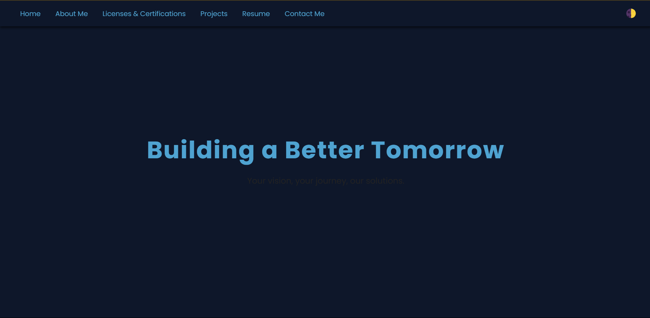

*Figure 2: About section*

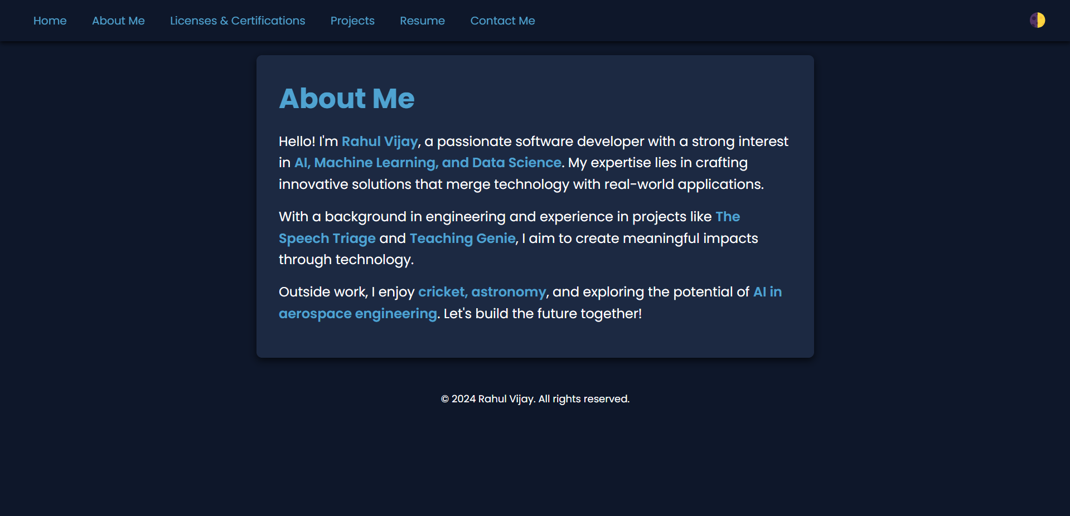

*Figure 3: Projects page*

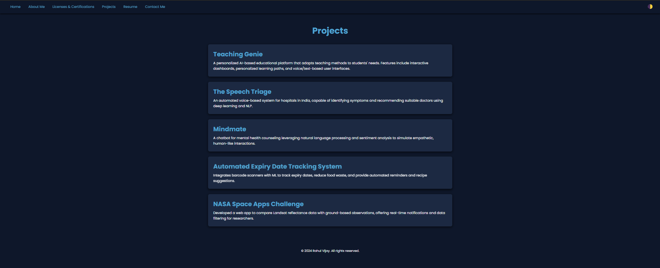

## TECHNOLOGIES USED:

The following technologies were utilized in the development of this project to create a responsive, visually appealing, and functional website:

#### Frontend Technologies:

* + **HTML5:** Used for structuring the website content and ensuring semantic, accessible, and SEO- friendly markup.
  + **CSS3:** Applied for styling, layout design, animations, and responsiveness, enabling a modern and cohesive visual design.
  + **CSS Variables:** Utilized for consistent and maintainable theming across the website (e.g., colors, font sizes).
  + **Flexbox and Grid:** Used for flexible and responsive layout designs.

#### Development Tools:

* + **Code Editor:** Tools like Visual Studio Code were used for writing and managing code effectively.
  + **Version Control:** Git was used for version management, enabling collaboration and rollback features.

#### Responsive Design Techniques:

* + Media queries were implemented to ensure that the website adapts seamlessly to different screen sizes, including mobile, tablet, and desktop devices.

#### Web Fonts:

* + Integrated custom fonts like "Poppins" and "Miniver" from Google Fonts for better typography and branding.

#### Browser Compatibility:

* + Ensured compatibility across major browsers like Google Chrome, Mozilla Firefox, Microsoft Edge, and Safari.

#### Social Media Integration:

* + Added social media icons with hover effects, enhancing interactivity

## RESULT AND ANALYSIS:

The web portfolio project achieved its goals by delivering a professional, responsive, and interactive platform that showcases skills, projects, and achievements effectively. Below are the key outcomes of the project:

#### Intuitive Navigation

* + The portfolio allows users to easily switch between sections such as "Home," "My About me," and "Projects."
  + The navigation system is user-friendly, ensuring a smooth browsing experience.

#### Visual Appeal

* + Aesthetic elements such as gradient backgrounds, custom fonts (Great Vibes and Pacifico), and hover effects add a modern and appealing look to the design.
  + The minimalistic yet vibrant layout captures attention while maintaining professionalism.

#### Enhanced Functionality

* + External links to platforms like GitHub and LinkedIn are seamlessly integrated, enabling users to access additional resources and project details.
  + These links enhance the portfolio's credibility and usability.

#### Responsive Design

* + The layout is fully responsive, adapting to various screen sizes including desktops, tablets, and smartphones.
  + This ensures accessibility for a diverse audience across devices.

#### Robust Performance

* + Rigorous testing confirmed compatibility across major browsers, demonstrating the stability and reliability of the portfolio.
  + No significant issues were identified, highlighting the effectiveness of the design and implementation process.

In summary, the web portfolio successfully combines functionality, aesthetics, and accessibility, creating a dynamic platform that effectively presents Utpal Kumar’s expertise and accomplishments. It serves as a testament to modern web development practices and provides a strong foundation for future enhancements.

## CONCLUSION:

The web portfolio project successfully met its objectives, presenting Rahul V's skills, projects, and professional experience in an engaging and polished manner. By leveraging modern web development technologies such as HTML, CSS, and JavaScript, the portfolio offers a seamless user experience with a clean and intuitive interface. Its responsive design ensures that the portfolio is accessible across a wide range of devices, including desktops, tablets, and smartphones, making it highly versatile and user-friendly.

The portfolio acts as a digital résumé, highlighting key achievements and technical expertise while reflecting a strong personal brand. Each section is thoughtfully organized to showcase different aspects of Rahul V's capabilities, from programming and application development to game design and web development. The dynamic interactivity, such as the ability to navigate between sections effortlessly, enhances the user's experience, ensuring that information is both accessible and engaging.

The inclusion of external links to platforms like GitHub, LinkedIn, and Stack Overflow further enriches the portfolio. These links not only add credibility but also provide visitors with direct access to detailed project repositories, professional profiles, and active contributions to technical communities. This integration makes the portfolio a comprehensive tool for networking, job applications, and collaboration opportunities.

While the current portfolio demonstrates a strong foundation, there are numerous avenues for enhancement. Adding animations and transitions could further elevate the visual appeal, creating a more dynamic experience. A functional contact form would provide a direct communication channel, making it easier for potential clients or employers to reach out. Backend integration, such as a content management system or database connectivity, could enable the portfolio to support advanced functionality like project updates, testimonials, or personalized recommendations.

The gradient background, custom fonts, and carefully chosen color schemes contribute to the portfolio's aesthetic appeal, ensuring that it is visually distinct and memorable. At the same time, the content is presented concisely, ensuring that viewers can quickly grasp the key highlights of Utpal Kumar's work and expertise. The portfolio effectively balances style with substance, maintaining professionalism while showcasing creativity.

This project underscores the significant role of web development in personal branding and professional representation. A well-designed portfolio not only demonstrates technical skills but also communicates a sense of dedication, attention to detail, and the ability to deliver quality work. The process of creating the portfolio involved problem-solving, creativity, and the application of modern development practices, reflecting the creator’s adaptability and proficiency.

In conclusion, this web portfolio serves as an impactful digital asset, offering a professional yet creative way to present Rahul V's accomplishments and aspirations. It is a testament to the power of combining technical knowledge with thoughtful design. As the portfolio evolves with potential future updates, it will continue to serve as a valuable tool for showcasing expertise, fostering connections, and unlocking new opportunities in the ever-growing digital space.