

**MEDICINE REMINDER USING ARDUINO**

A Project Report

Submitted as part of the course

Internet of Things

CSE3009

School Of Computer Science and Engineering

VIT Chennai

**FALL 2019-2020**

Course Faculty: Dr. B Radhika Selvamani

Submitted By

Rahul Mahajan (17BCE1063)

Govardhan Reddy (17BCE1096)

**Abstract –**

The Importance of Taking Your Medications Correctly. To get maximum benefit from your medications, it is important to take them exactly as prescribed by your doctor. In fact, your chance of a better health outcome improves when you take your medications as directed.

In our project we have proposed a medicine reminder using Arduino which will help you to remind times when you are restricted to take medicine. We have used real time module to check time corresponding to alarm set in our Arduino based device. Also we have implemented a cardboard box using servo motor which will give you which particular medicine you need to take. **Medicine Reminder Using Arduino** which reminds to take medicines 1 or 2 or 3 times a day. The time slot can be selected using push buttons. Also, it shows current Date and Time using LCD display.

**Introduction –**

When it comes to our loved ones, we always want to stay them healthy and fit. But what will happen if they get ill and forget to take medicine on time. We would be worried, right? At hospitals, there are many patients and it is difficult to remind every patient to take medicine on time. The traditional ways require human efforts to remind to take medicines on time. The digital era doesn’t follow that and we can use machines to do that. The application of Medicine Reminder Using Arduino is very wide and can be used by patients at home, doctors at hospitals and at many other places.

**Related Works –**

1. <https://electronicsforu.com/arduino-projects-ideas>

2. <https://howtomechatronics.com/arduino-projects/>

3. <https://create.arduino.cc/projecthub/projects/tags/sensor>

**Design –**

An actuator is a motor that converts energy into torque which then moves or controls a mechanism or a system into which it has been incorporated. It can introduce motion as well as prevent it.

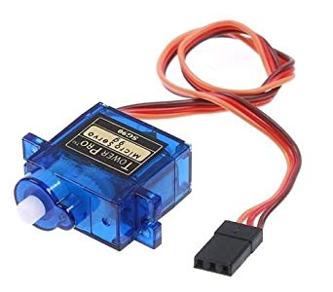The **TowerPro SG90 9g Mini Servo** is 180° rotation servo. It is a Digital Servo Motor which receives and processes PWM signal faster and better. It equips sophisticated internal circuitry that provides good torque, holding power, and faster updates in response to external forces.

The **Arduino Uno** is an open-source microcontroller board based on the Microchip ATmega328P microcontroller and developed by Arduino.cc. The board is equipped with sets of digital and analog input/output (I/O) pins that may be interfaced to various expansion boards (shields) and other circuits.

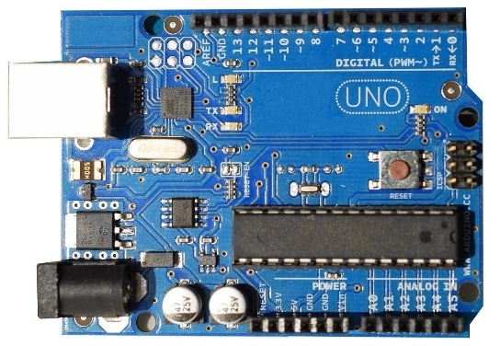

Arduino boards are able to read inputs - light on a sensor, a finger on a button, or a Twitter message and turn it into an output - activating a motor, turning on an LED, publishing something online.

Its biggest advantage is that we connect the board to the computer via a USB cable which does a dual purpose of supplying power and acting as a Serial port to interface the Arduino and the computer.

We have connected our Arduino to the laptop device for power supply and also for providing required code to Arduino which is connected to our other components using wires (male to female, female to male, etc.) on the breadboard. We have divided time slots into three modes. Mode 1 selects to take medicine once/day at 8am when user presses 1st push button. Mode 2 selects to take medicine twice/day at 8am and 8pm when user presses 2nd push button. Mode 3 selects to take medicine thrice/day at 8am, 2pm and 8pm if user presses 3rd push button.

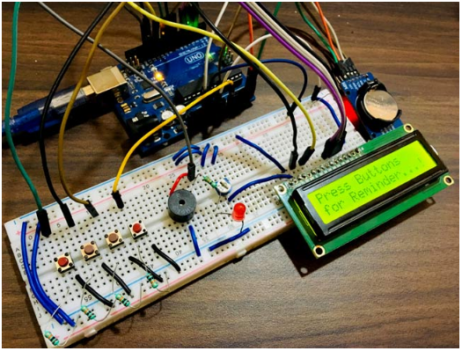

**Results and Discussion –**

**Taking your medications at the proper intervals during the day.** Try to divide up your dosing times as evenly as possible throughout the day: for example, every 12 hours for a drug that needs to be taken twice a day, or every 8 hours for a drug that needs to be taken three times a day. Make up a schedule that fits into your daily routine, and try to take your medications within 1 hour of each scheduled time.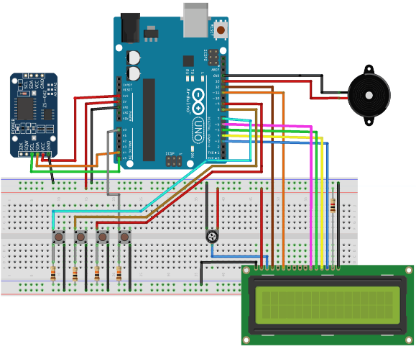 In the figure we connected the model to laptop to provide the required code. Also we have connected a servo motor to it with a cardboard box on its top. We have set timing in our code which will be checked by our real time clock module and when it matches according to our time, buzzer will buzz and pill will get drop with the help of our servo motor. We can hit the push button to stop the buzzing. Push button reminds to take medicines 1 or 2 or 3 times a day. The time slot can be selected using push buttons.

**Alternative Solutions –**

1. We can make use of Arduino board and other related components to achieve our project (currently using). The Arduino is a flexible platform with great ability to interface to most anything. It is a great platform to learn first and perfect for many smaller projects.

2. We can Raspberry Pi and combine further it with Google voice assistant or Alexa to have more comfort solution. The Raspberry Pi is good for projects that require a display incredible price/performance capabilities and network connectivity.

3. The Beagle Bone is a great combination of some of the interfacing flexibility of the Arduino with the fast processor and full Linux environment of the Raspberry Pi (more so in fact).

4. We can also make use of microcontroller 8051.

**Unique Feature of our proposed model –**

Our work is similar to many other project but it differ when it comes to talk about which medicine to take at that time. Our project let you know what particular medicine you are required to take when alarm rang. For example you need to take 3 different medicines a day. Servo motor with a cardboard box situated on it will drop the required medicine for you take with the help of rotation of device we set.

**Conclusion & Future Work –**

The project "MEDICINE REMINDER USING ARDUINO" has been developed as per the requirementspecification. It has been developed using Arduino IDE platform. Design procedure and output reports are presented in this project report. This design is easy to understand that any new modules can be incorporated easily.

Overall making this project is a really helpful and recommended to my friends. It helps to enhance and develop my skills, abilities, and knowledge. It was a good experience and memories as I have gained experience.

For future work we can connect our model to a smart phone which will be helpful for not only medicine reminder but for many other scenarios as well. Also we can use PIR motion detection sensor module HC-SR501. It will help us know if the patient (someone) is alone then he/she is within the room and not roaming somewhere else which might harm the patient.

**References –**

1. <https://www.youtube.com/watch?v=3SQGt3E-Jgs>

2. <https://en.wikipedia.org/wiki/Pill_reminder>

3. <https://www.hackster.io/TechnicalEngineer/medicine-reminder-using-arduino-dad47d>