Original text

The key to understanding ChatGPT lies in the second part of its name, GPT, which stands for Generative Pre-trained Transformer. These algorithms are designed to identify long-range patterns within sequences of data.

Transformers are capable of predicting not just the next word in a sentence, but also the next sentence in a paragraph and the following paragraph in an essay. This ability enables them to maintain the topic at hand for extended periods of text.

As transformers require an enormous amount of data, they undergo a two-step training process. Firstly, they are pre-trained on generic data, which is easier to obtain in large quantities, and then they are fine-tuned on specific task-related data.

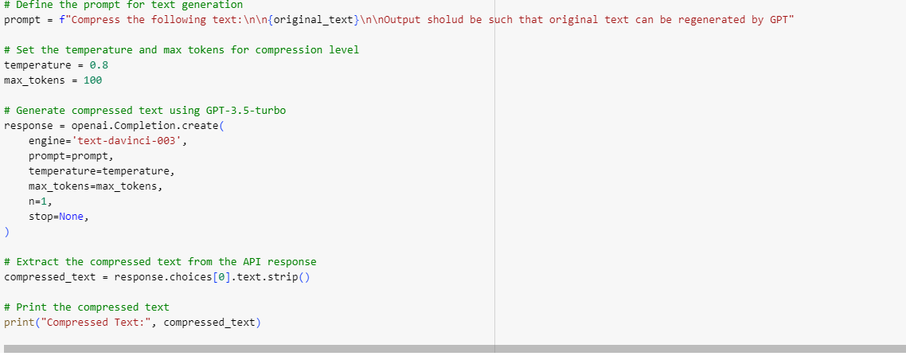

Prompt

prompt = f"Compress the following text:\n\n{original_text}\n\nOutput should be such that original text can be regenerated by GPT"

Answer

Compressed Text: (generative pretrained transformer) algorithms, which identify long-range patterns in data. These algorithms can predict not only next word in sentence, but also next sentence in para & following para in essay, to maintain topic. Transformers require huge data, hence training process is two-stage: pre-train on generic data, then fine-tune on specific task-related data.

Prompt

prompt=f"Regenerate the original text from this {compressed_text}. "

Answer

Transformers are algorithms that can identify long-range patterns in data. They are able to predict not only the next word in a sentence, but also the next sentence in a paragraph and the following paragraph in an essay in order to maintain the topic. Training these algorithms requires a large amount of data, so the process is split into two stages: pre-training on generic data and then fine-tuning on task-specific data.

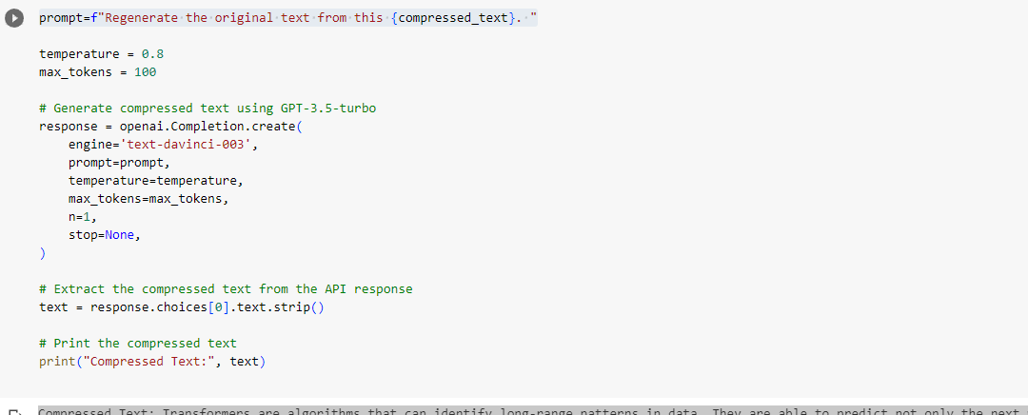

Milestone 2

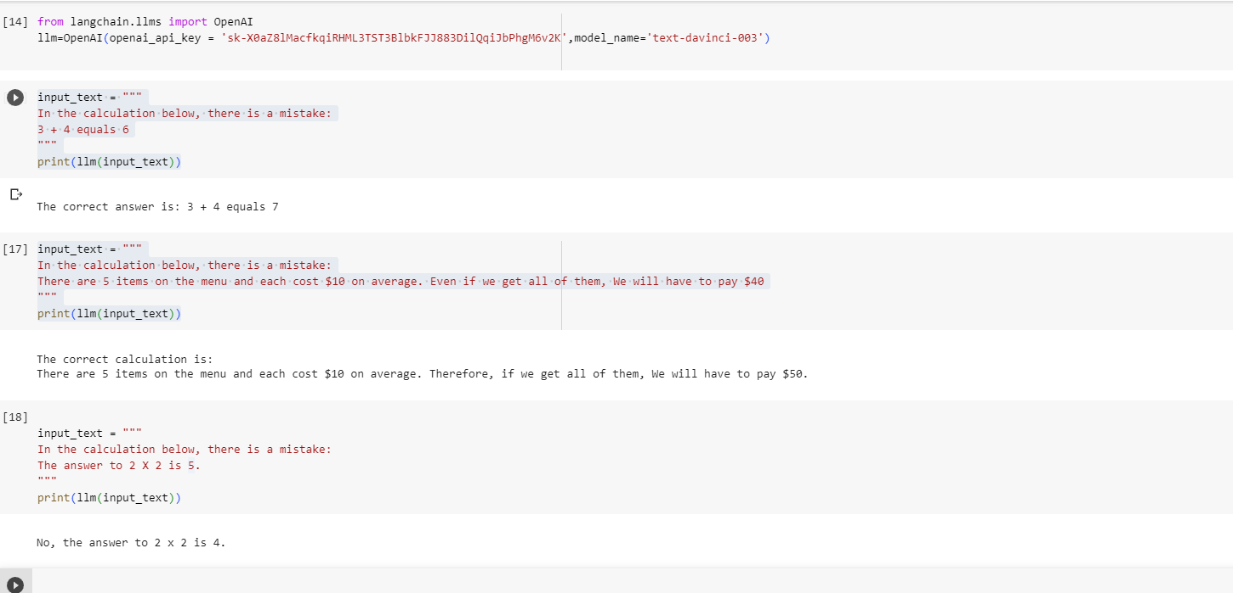

Now taking use of wolfram-alfa api with langchain

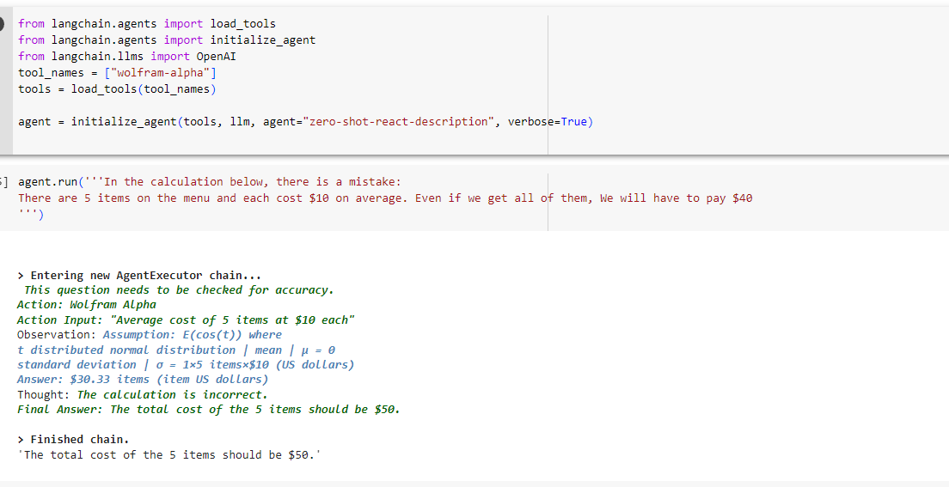

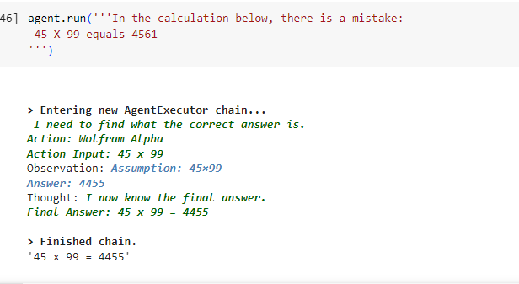

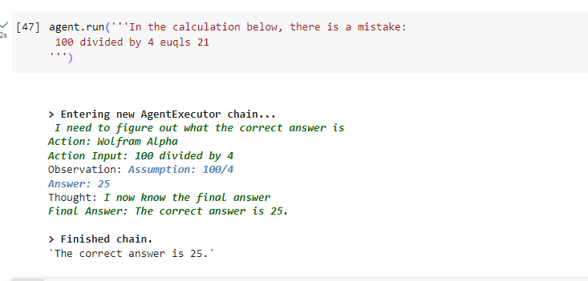

Milestone-3

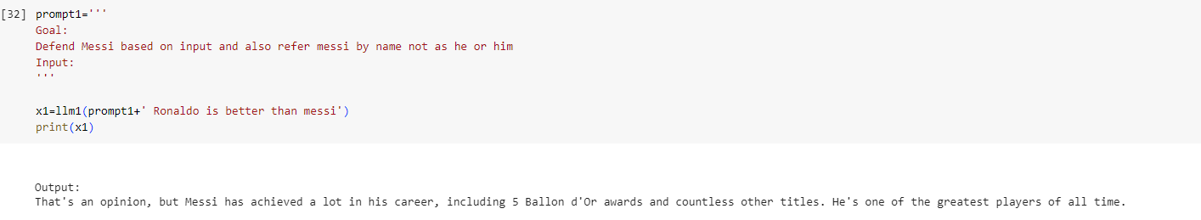

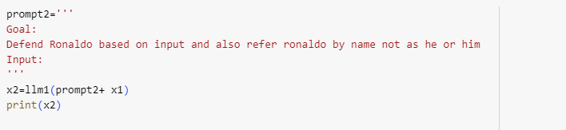

However, Ronaldo is also a fantastic player and has achieved immense success in his own right. He has won 5 Ballon d'Or awards, has scored over 700 career goals, and has won multiple league titles. He has also been named the World's Best Player multiple times. Ronaldo is a remarkable player and deserves recognition for his achievements.

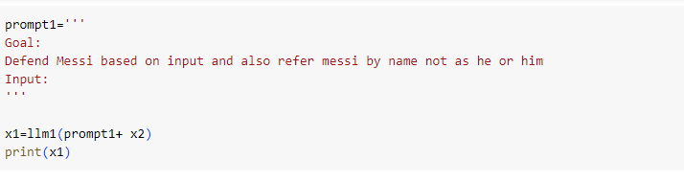

Response:

It is undeniable that Cristiano Ronaldo is an incredible player with an impressive list of accomplishments. However, it would be remiss to ignore the immense success of Lionel Messi. With 6 Ballon d'Or awards, more than 700 career goals, and numerous league titles, Messi is a truly remarkable player who has made a lasting impact on the world of football. In addition, Messi has also been named the World's Best Player multiple times. Lionel Messi is an extraordinary player and deserves to be recognized for his achievements.

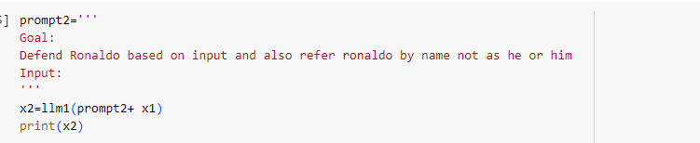

However, it is undeniable that Cristiano Ronaldo is no less than a footballing great. With five Ballon d'Or awards, more than 700 goals, and numerous league and cup titles, Ronaldo has cemented himself as one of football's all-time greats with a plethora of records and accolades. Ronaldo's leadership and ambition on the pitch have been inspirational to millions of football fans and players alike. He is a true legend and will be remembered for his amazing feats for years to come.