Laboratory
9

Queuing Disciplines

Order of Packet Transmission and Dropping

Objective

The objective of this lab is to examine the effect of different queuing disciplines on packet delivery and delay for different services.

Overview

As part of the resource allocation mechanisms, each router must implement some queuing discipline that governs how packets are buffered while waiting to be transmitted. Various queuing disciplines can be used to control which packets get transmitted (bandwidth allocation) and which packets get dropped (buffer space). The queuing discipline also affects the latency experienced by a packet, by determining how long a packet waits to be transmitted. Examples of the common queuing disciplines are first-in-first-out (FIFO) queuing, priority queuing (PQ), and weighted-fair queuing (WFQ).

The idea of FIFO queuing is that the first packet that arrives at a router is the first packet to be transmitted. Given that the amount of buffer space at each router is finite, if a packet arrives and the queue (buffer space) is full, then the router discards (drops) that packet. This is done without regard to which flow the packet belongs to or how important the packet is.

PQ is a simple variation of the basic FIFO queuing. The idea is to mark each packet with a priority; the mark could be carried, for example, in the IP Type of Service (ToS) field. The routers then implement multiple FIFO queues, one for each priority class. Within each priority, packets are still managed in a FIFO manner. This queuing discipline allows high-priority packets to cut to the front of the line.

The idea of the fair queuing (FQ) discipline is to maintain a separate queue for each flow currently being handled by the router. The router then services these queues in a round-robin manner. WFQ allows a weight to be assigned to each flow (queue). This weight effectively controls the percentage of the link’s bandwidth each flow will get. We could use ToS bits in the IP header to identify that weight.

In this lab you will set up a network that carries three applications: FTP, Video, and VoIP. You will study how the choice of the queuing discipline in the routers can affect the performance of the applications and the utilization of the network resources.

Procedure

Create a New Project

- Start Riverbed Modeler Academic Edition ⇒ Choose New from the File menu.

- Select Project and click OK ⇒ Name the project <your initials>_Queues, and the scenario FIFO ⇒ Click OK.

- In the Startup Wizard: Initial Topology dialog box, make sure that Create Empty Scenario is selected ⇒ Click Next ⇒ Select Campus from the Network Scale list ⇒ Click Next twice ⇒ Click Finish.

Create and Configure the Network

The QoS Attribute Config node defines attribute configuration details for protocols supported at the IP layer. These specifications can be referenced by the individual nodes using symbolic names. It defines different queuing profiles such as FIFO, WFQ, priority queuing,

custom queuing, MWRR, MDRR, and DWRR.

Initialize the Network:

- The Object Palette dialog box should be now on the top of your project space. If it

is not there, open it by clicking . Make sure that the internet_toolbox item is selected from the pull-down menu on the object palette.

- Add to the project workspace the following objects from the palette: Application Config, Profile Config, QoS Attribute Config, five ethernet_wkstn, one ethernet_server, and two ethernet4_slip8_gtwy routers.

- Connect both routers together with a bidirectional PPP_DS1 link.

- Connect the workstations and the server to the routers using bidirectional 10Base_T links as shown.

- Rename the objects you added as shown and then save your project.
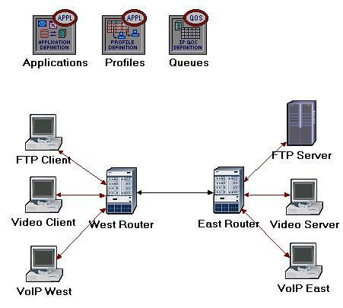

2

Type of Service (ToS) is assigned to the IP packets. It represents a session attribute that allows packets to be provided the appropriate service in the IP queues.

Best-effort delivery means that delivery of a packet is attempted but is not guaranteed.

PCM (Pulse Code Modulation) is a procedure used to digitize speech before transmitting it over the network.
Configure the Applications:
- Right-click on the Applications node ⇒ Edit Attributes ⇒ Expand the

Application Definitions hierarchy ⇒ Set rows to 3 ⇒ Name the rows: FTP Application, Video Application, and VoIP Application.

  - Go to the FTP Application row ⇒ Expand the Description hierarchy ⇒ Assign High Load to Ftp ⇒ Click on the High Load value and choose Edit

from the drop-down menu ⇒ Assign Constant(10) to Inter-Request Time ⇒ Assign Constant(1000000) to File Size. Keep the Type of Service (ToS) as Best Effort (0).

  - Go to the Video Application row ⇒ Expand the Description hierarchy ⇒ Assign Low Resolution Video to Video Conferencing ⇒ Click on the Low Resolution Video value and choose Edit ⇒ Edit the value of the Type of Service field (the Configure TOS/DSCP window appears) ⇒ From the drop-down menu, assign Streaming Multimedia (4) to ToS ⇒ Click OK twice.

  - Go to the VoIP Application row ⇒ Expand the Description hierarchy ⇒

Assign PCM Quality Speech to Voice. If you edit it, you can see that the ToS assigned to it is Interactive Voice (6).

- Click OK and then save your project.
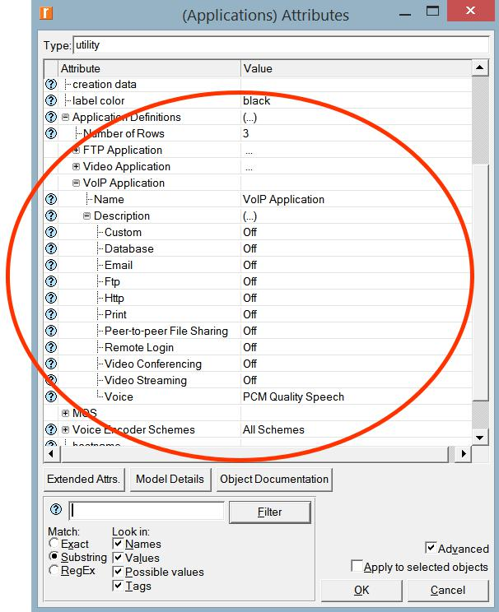

3
Configure the Profiles:

- Right-click on the Profiles node ⇒ Edit Attributes ⇒ Expand the Profile Configuration hierarchy ⇒ Set rows to 3.

  - Name and set the attributes of row 0 as shown:
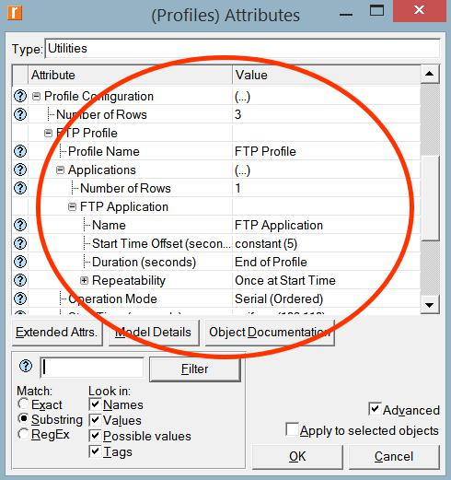

ii. Name and set the attributes of row 1 as shown:
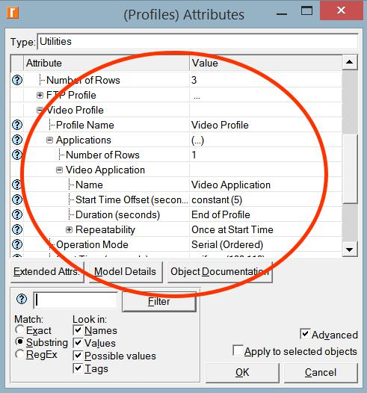

4
iii. Name and set the attributes of row 2 as shown:
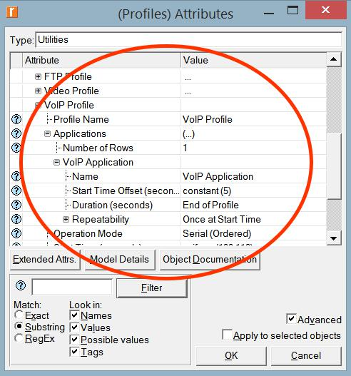

2. Click OK and then save your project.

Configure the Queues:

We will keep the default queuing profiles that are defined in our Queues object. It is recommended that you check out the configuration of the FIFO, PQ, and WFQ profiles.

Configure the Workstations and Servers:

- Right-click on the FTP Client ⇒ Edit Attributes ⇒ Expand the Application: Supported Profiles hierarchy inside Applications ⇒ Set rows to 1 ⇒ Set Profile Name to FTP Profile ⇒ Click OK.

- Right-click on the Video Client ⇒ Edit Attributes ⇒ Expand the Application: Supported Profiles hierarchy inside Applications ⇒ Set rows to 1 ⇒ Set Profile Name to Video Profile ⇒ Click OK.

- Right-click on the VoIP West ⇒ Edit Attributes.

  - Expand the Application: Supported Profiles hierarchy inside Applications ⇒ Set rows to 1 ⇒ Set Profile Name to VoIP Profile.

  - Edit the Application: Supported Services value inside Applications ⇒ Set rows to 1 ⇒ Set Service Name to VoIP Application ⇒ Click OK twice.

5
- Right-click on the VoIP East ⇒ Edit Attributes.

  - Expand the Application: Supported Profiles hierarchy inside Applications ⇒ Set rows to 1 ⇒ Set Profile Name to VoIP Profile.

  - Edit the Application: Supported Services value inside Applications ⇒ Set rows to 1 ⇒ Set Service Name to VoIP Application ⇒ Click OK twice.

- Right-click on the FTP Server ⇒ Edit Attributes ⇒ Edit the Application: Supported Services value inside Applications ⇒ Set rows to 1 ⇒ Set Service Name to FTP Application ⇒ Click OK twice.

- Right-click on the Video Server ⇒ Edit Attributes ⇒ Edit the Application: Supported Services value inside Applications ⇒ Set rows to 1 ⇒ Set Service Name to Video Application ⇒ Click OK twice.

- Save your project.

Configure the Routers:

- Click on the link connecting the East and West routers to select it ⇒ From the Protocols, menu choose IP → QoS → Configure QoS.

- Make sure the selected items are as shown in the following QoS Configuration dialog box ⇒ Click OK.
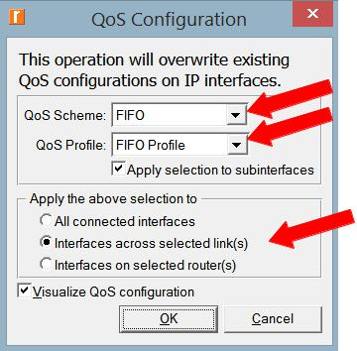

Note: Since the Visualize QoS Configuration radio button is checked, the link is colored based on the QoS scheme used.

3. Save your project.

6
Choose the Statistics

To test the performance of the applications defined in the network, we will collect one of the many available statistics as follows:

- Right-click anywhere in the project workspace and select Choose Individual Statistics from the pop-up menu.

- In the Choose Results dialog box, select the following global statistic:
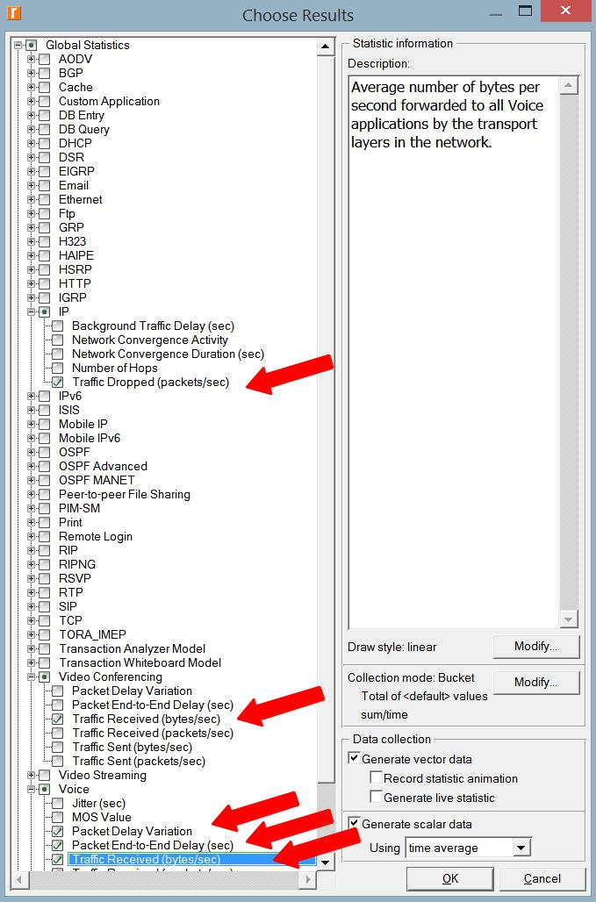

Traffic Dropped: The number of IP datagrams dropped by all nodes in the network across all IP interfaces. The reasons for dropping an IP datagram can be any one of the following:

- Insufficient space in the queue.

- Maximum number of hops exceeded by an IP datagram.

- On nonrouting nodes, a local router interface was not found to be used as the next hop.
- On routing nodes, the route table lookup failed to yield a route to the destination..

- Click OK and then save your project.

7
Configure the Simulation

Here we need to configure the duration of the simulation:

- Click on and the Configure Simulation window should appear.

- Set the duration to be 150 seconds.

- Click RUN and then save your project.

Duplicate the Scenario

In the network we just created, we used the FIFO queuing discipline in the routers. To analyze the effect of different queuing disciplines, we will create two more scenarios to test the PQ and WFQ disciplines.

A. Select Duplicate Scenario from the Scenarios menu and give it the name PQ ⇒ Click OK.

- Click on the link connecting the East and West routers to select it ⇒ From the Protocols menu choose IP → QoS → Configure QoS.

- Make sure the selected items are as shown in the following QoS Configuration dialog box ⇒ Click OK.
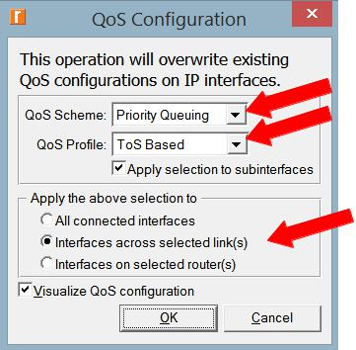

Note: Since the Visualize QoS Configuration radio button is checked, the link is colored based on the QoS scheme used.

- Click RUN and then save your project.

8

B. Select Duplicate Scenario from the Scenarios menu and give it the name WFQ ⇒ Click OK.

- Click on the link connecting the East and West routers to select it ⇒ From the Protocols menu choose IP → QoS → Configure QoS.

- Make sure the selected items are as shown in the following QoS Configuration dialog box ⇒ Click OK.
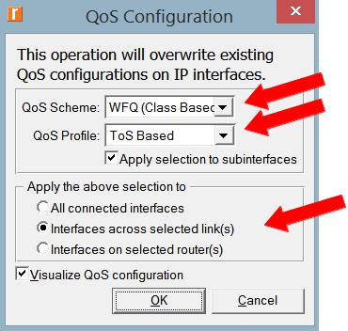

Note: Since the Visualize QoS Configuration radio button is checked, the link is colored based on the QoS scheme used.

3. Click RUN and then save your project.

9
View the Results

To view and analyze the results:

- Select Compare Results from the Results menu.

- Select the IP Traffic Dropped statistic and click Show. The resulting graph should resemble the one below. Note: The shown graph is the result of zooming into the region of interest on the original graph.
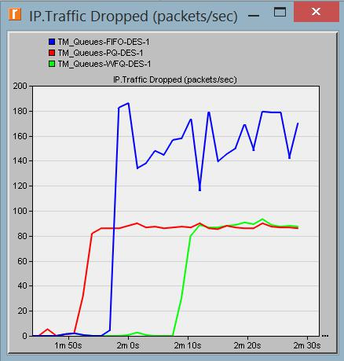

- Create the graph for Video Conferencing Traffic Received:
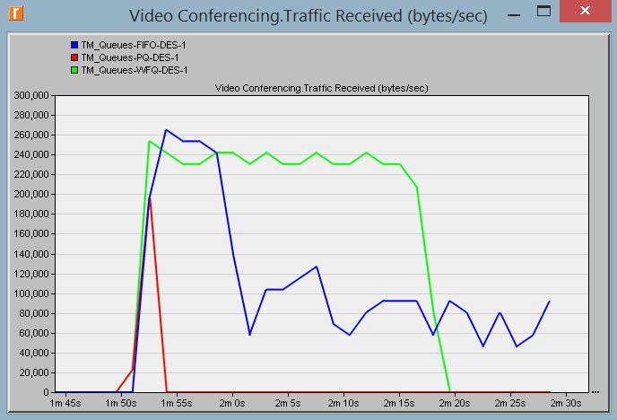

10

- Create the graph for Voice Traffic Received:
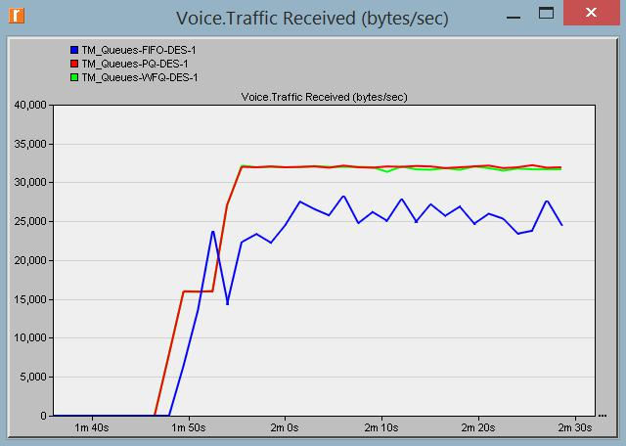

- Create graphs for Voice Packet End-to-End Delay and Voice Packet Delay Variation: (Note: the trace for WFQ is not shown on the following graphs because it is overlapped by the trace of PQ.)
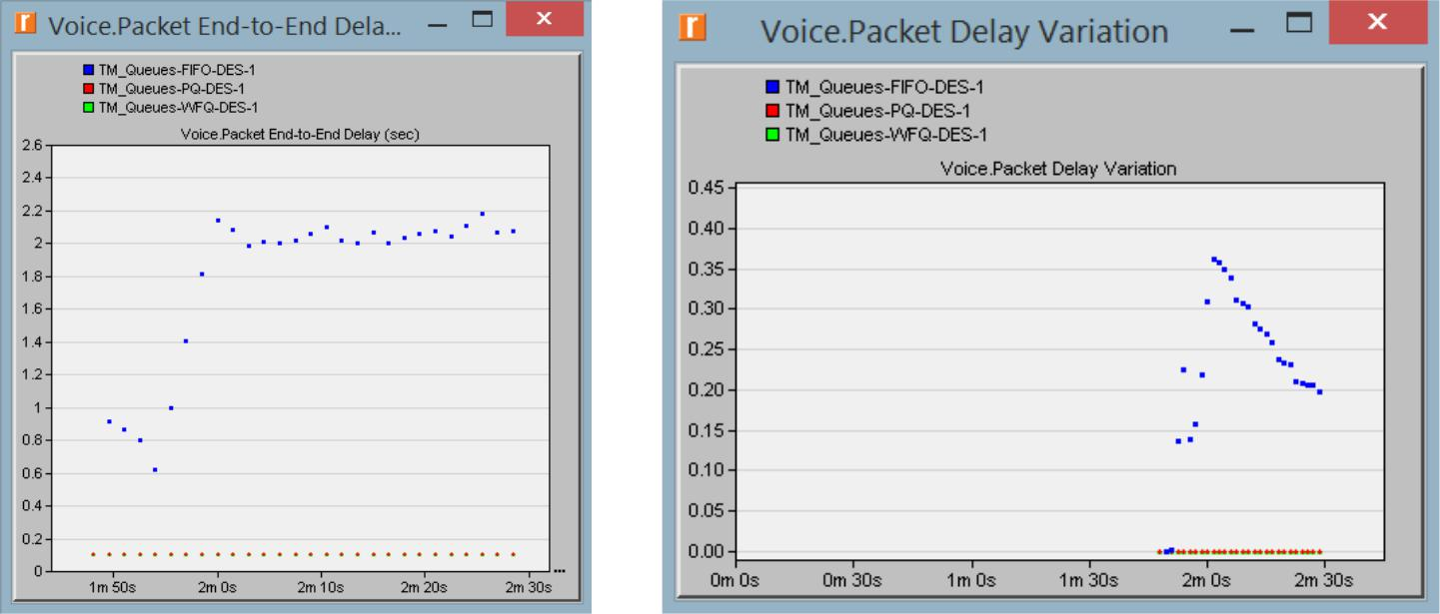

11

Further Readings

- The Differentiated Services Field: IETF RFC number 2474 (www.ietf.org/rfc.html).

Questions

- Analyze the graphs we obtained and verify the overlap of the Voice Packet End-to-End Delay and Voice Packet Delay Variation graphs. Compare the three queuing disciplines and explain their effect on the performance of the three applications.

- In the implemented project, edit the Queues object and check the profiles assigned

to the FIFO, PQ, and WFQ disciplines. For each profile answer the following questions:

    - How many queues are associated with each discipline?

    - In this lab, we used ToS to identify the priority and weight for the PQ and WFQ disciplines respectively. What are the other parameters that can be used to identify the priority and weight?

    - In PQ, how are queues configured to serve different ToS values?

    - In WFQ, how are queues configured to serve different ToS values?

- For all scenarios, choose the “queuing delay <--“statistic for the link that connects East Router and West Router. Rerun the simulation and generate the graph that compares that queuing delay for all queuing disciplines (scenarios). Analyze this graph.

Hint:

  - The “queuing delay <--“statistic is under the point-to-point hierarchy..

Lab Report

Prepare a report that follows the guidelines explained in Lab 0. The report should include the answers to the above questions as well as the graphs you generated from the simulation scenarios. Discuss the results you obtained and compare these results with your expectations. Mention any anomalies or unexplained behaviors.

12

