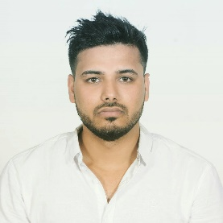

Name: Rahul Kumar Yadav   
Phone: 9861697278  
E-mail: [yadavrahulyadav1530@outlook.com](mailto:yadavrahulyadav1530@outlook.com)

# OBJECTIVE

To obtain position in the capacity of ASP. NET language, where my programming skills and abilities can be utilized by the company to achieve excellence in the field of software development.

Keen to work under growing company to learn and implement emerging technologies. I am dedicated to work with a team that focus on technical as well as managerial growth of myself and company as a whole.

# EDUCATION (Academic)

* B.Sc.(Hons) in Computing, Islington college. Kamal Pokhari (2018 Running)
* High school Liverpool International College, New Baneshwar, Kathmandu (2069)

# Academic Projects

* Web Application ​for ​Travel Agency ​ (On Progress)
* CRUD ​Android ​Application ​System
* Database ​Design ​for ​the ​Tour ​and ​Travel ​Company
* Academics Restaurant ​Management ​System ​using ​JAVA
* Website using HTML CSS and JavaScript.

# QUALIFICATIONS

* C# ASP.NET (Desktop application)
* ASP.NET MVC (Project running on)
* Advance database
* MySQL
* Oracle database
* JAVA (GUI)
* visual basic
* Html, CSS, JavaScript, bootstrap
* Android
* python (AI) – Running

# SKILLS

* Team Working
* Time management
* Communication
* Ability to work under pressure.
* Project management skills
* Truthfulness
* Decision making

# REFERENCES

Dhurba Sen: [dhurba.sen@islingtoncollege.edu.np](mailto:dhurba.sen@islingtoncollege.edu.np)

Rohit Pandey: [rohit.pandey@islingtoncollege.edu.np](mailto:rohit.pandey@islingtoncollege.edu.np)

Sanjiv Udash : [sanjiv.udash@islingtoncollege.edu.np](mailto:sanjiv.udash@islingtoncollege.edu.np)