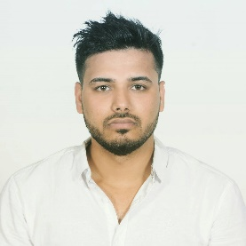

Name: Rahul Kumar Yadav   
Phone: 9861697278  
E-mail: [yadavrahul1530@outlook.com](mailto:yadavrahul1530@outlook.com)

# OBJECTIVE

To obtain position in the capacity of .NET language, where my programming skills and abilities can be utilized by the company to achieve excellence in the field of software development.

Keen to work under growing company to learn and implement emerging technologies. I am dedicated to work with a team that focus on technical as well as managerial growth of myself and company as a whole.

# EDUCATION (Academic)

* B.Sc. (Hons) in Computing, Islington College. Kamal Pokhari (2018 Running)
* High school Liverpool International College, New Baneshwor, Kathmandu (2069)

# Internship

* Participation in Braindigit company for internship program

# Academic Projects

* CRUD ​Android ​Application ​System
* Database ​Design ​for ​the ​Tour ​and ​Travel ​Company
* Academics Restaurant ​Management ​System ​using ​JAVA
* Website using HTML CSS and JavaScript.
* Job portal web application for final year project on asp.net MVC.
* Stock Management project on asp.net.

# QUALIFICATIONS

* C# ASP.NET (Desktop application)
* ASP.NET MVC
* Advance database
* MySQL
* Oracle database
* JAVA (GUI)
* visual basic
* Html, CSS, JavaScript, bootstrap
* Android
* python (AI)

# SKILLS

* Team Working
* Time management
* Communication
* Ability to work under pressure.
* Project management skills
* Truthfulness
* Decision making