Step1 :- Go to Android Studio -> File -> New -> Import Module.

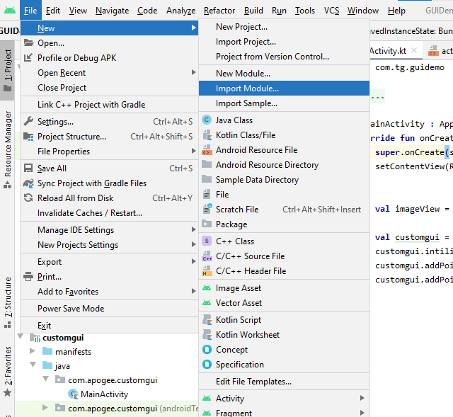

Step2: - Select module from the window which you want to import.

Step3:- Click on Ok button and then finish & wait until all the module’s file include in your project.

Now it will show on left side Once successfully included.

Step 4:- Include the module to your app Gradle and sync the project.

Now, the module is successfully configured into your project. You can use module functionality into your project.

Module has function which can be used according. To requirements.

First change in .xml file

Then how to use in any activity. Class

