**DAY_01: Introduction to Statistics**

Statistics is like a toolkit we use to understand and make sense of information. It helps us collect, organize, analyze and interpret data to find patterns, trends and relationships in the world around us.

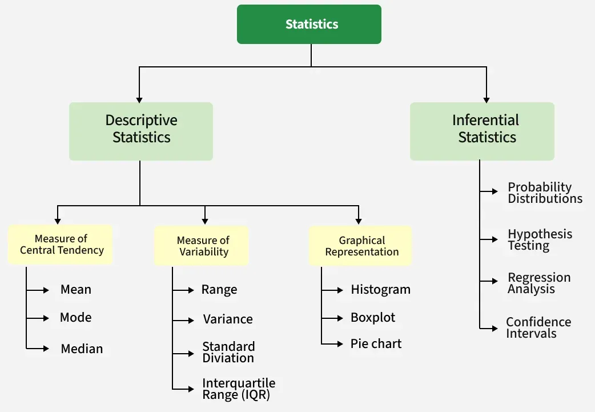

**Descriptive Statistics**: To summarize and describe the main features of a dataset.

Example: Calculating the average height of students in a class or creating a bar chart showing the distribution of exam scores.

**Inferential Statistics**: To make generalizations and predictions about a population based on a sample of data.

Example: Using a survey of a sample of voters to predict the outcome of an election or conducting a clinical trial to determine if a new drug is effective for a larger population.

**Types of Data**

1. Qualitative Data: This data is descriptive. For example - She is beautiful, He is tall, etc.

2. Quantitative Data: This is numerical information. For example- A horse has four legs.

Discrete Data: It has a particular fixed value and can be counted.

Continuous Data: It is not fixed but has a range of data and can be measured.

**Sample(n) and Population(N)**

n: Sample Size

Refers to the number of elements in your sample, which is a subset of the population. Example: If you survey 50 interns from Bangalore, n = 50.

N: Population Size

Refers to the total number of elements in the entire population. Example: If you're studying all Vodafone interns across India, N is the total number of interns.

**Levels of measurements**

1. Nominal: Data is categorized into distinct groups with no inherent order or ranking. Examples: Colors (red, blue, green), types of fruit (apple, banana, orange), or gender (male, female).
2. Ordinal: Data can be categorized and ranked, but the intervals between ranks are not necessarily equal or meaningful. Examples: Educational levels (high school, bachelor's, master's), satisfaction ratings (very dissatisfied, dissatisfied, neutral, satisfied, very satisfied), or rankings in a race.
3. Interval: This level categorizes data with a specific order and equal, measurable intervals between points. However, there is no true zero point. Examples: Temperature in Celsius or Fahrenheit, IQ scores, calendar years.
4. Ratio: The highest level, possessing all characteristics of the others plus a true zero point, indicating the complete absence of the attribute. All mathematical operations are possible. Examples: Height, weight, age, time spent on a task

