**CS5551_Team_4_Project**

**Project Name: Factory Maintenance System (FMS).**

**Team Number: 4**

**Members :**

**Name & Class ID :** MURALI KRISHNA SAI CHUKKA & 09

**Name & Class ID :** RUPESH SAI RAM DODDALA & 10

**Name & Class ID :** KAVIN KUMAR ARUMUGAM & 63

**Name & Class ID :** RAHUL REDDY YERVA & 59

**Name & Class ID :** TEJASWI AYYADAPU & 03

**Domain: MES (Manufacturing Execution System).**

**Technologies used:**

1. MEAN Stack.
2. Ionic.

**Source code:**

<https://github.com/chkrish9/CS5551_Team_4_Project/tree/master/Code>

**Wiki URL:**

<https://github.com/chkrish9/CS5551_Team_4_Project/wiki/Increment-2>

**Modules Delivered:**

1. Document.
2. Part.
3. Step group.
4. Template.
5. Settings.
6. Import.
7. Mobile Login.

**Screenshots :**

**1. Document Module:**

**Class diagram:**

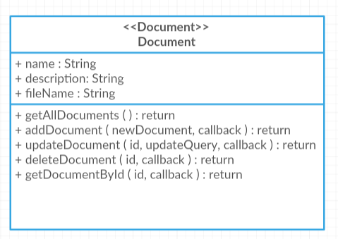

**Wireframe:**

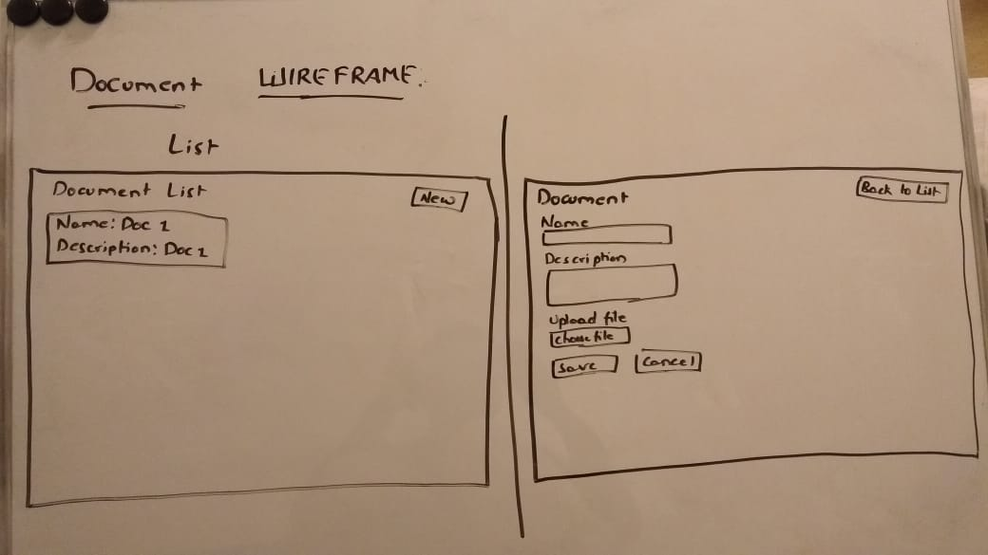

**Screenshots:**

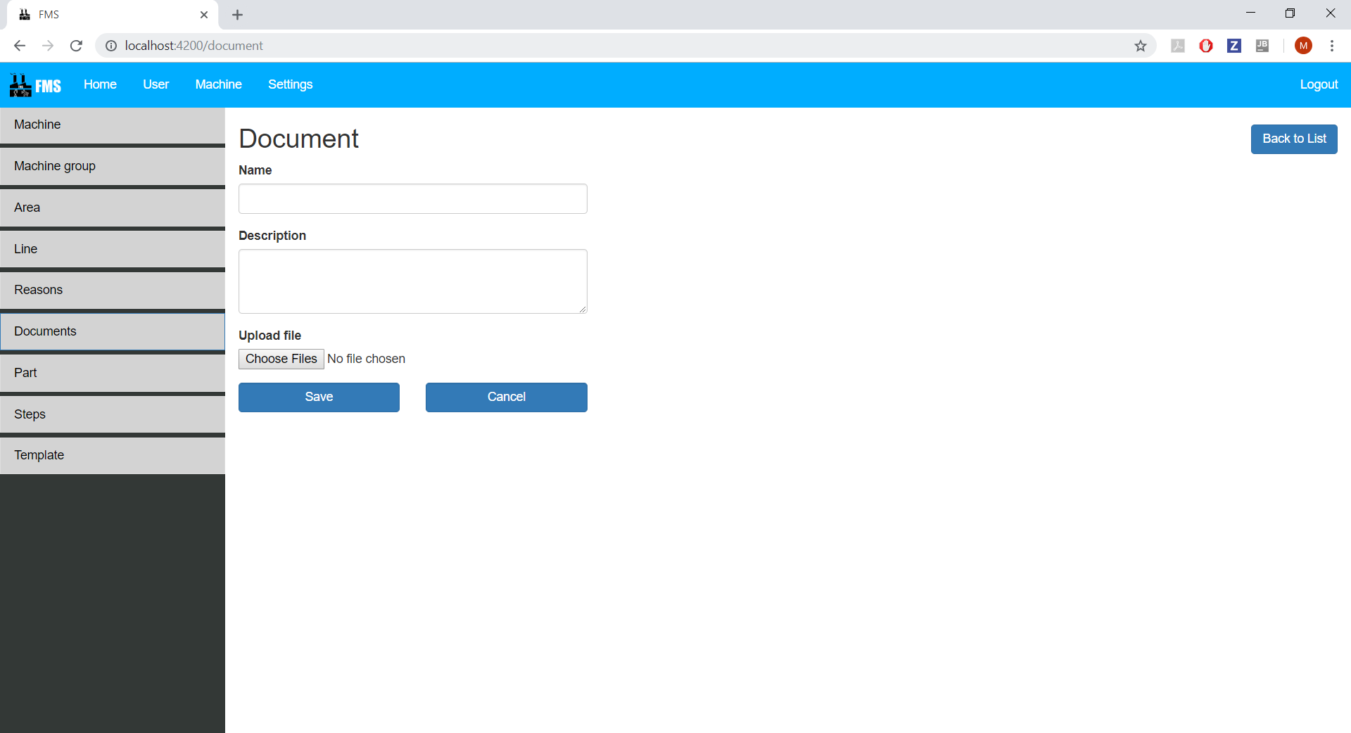

**2. Part Module:**

**Class diagram:**

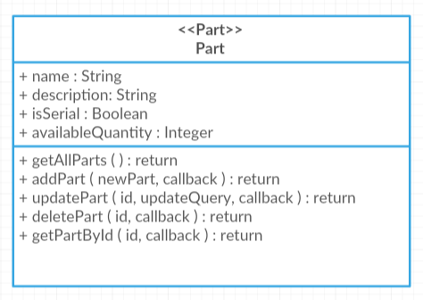

**Wireframe:**

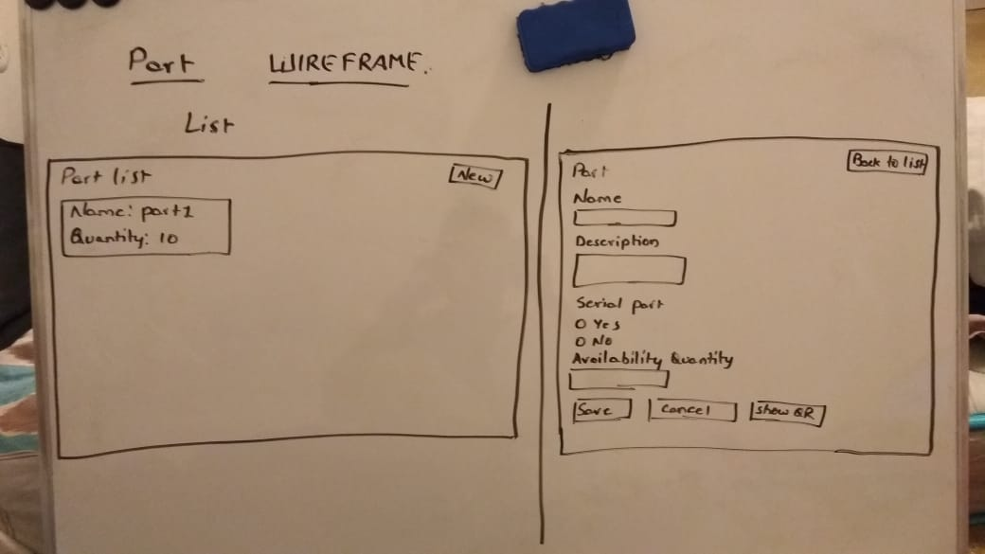

**Screenshots:**

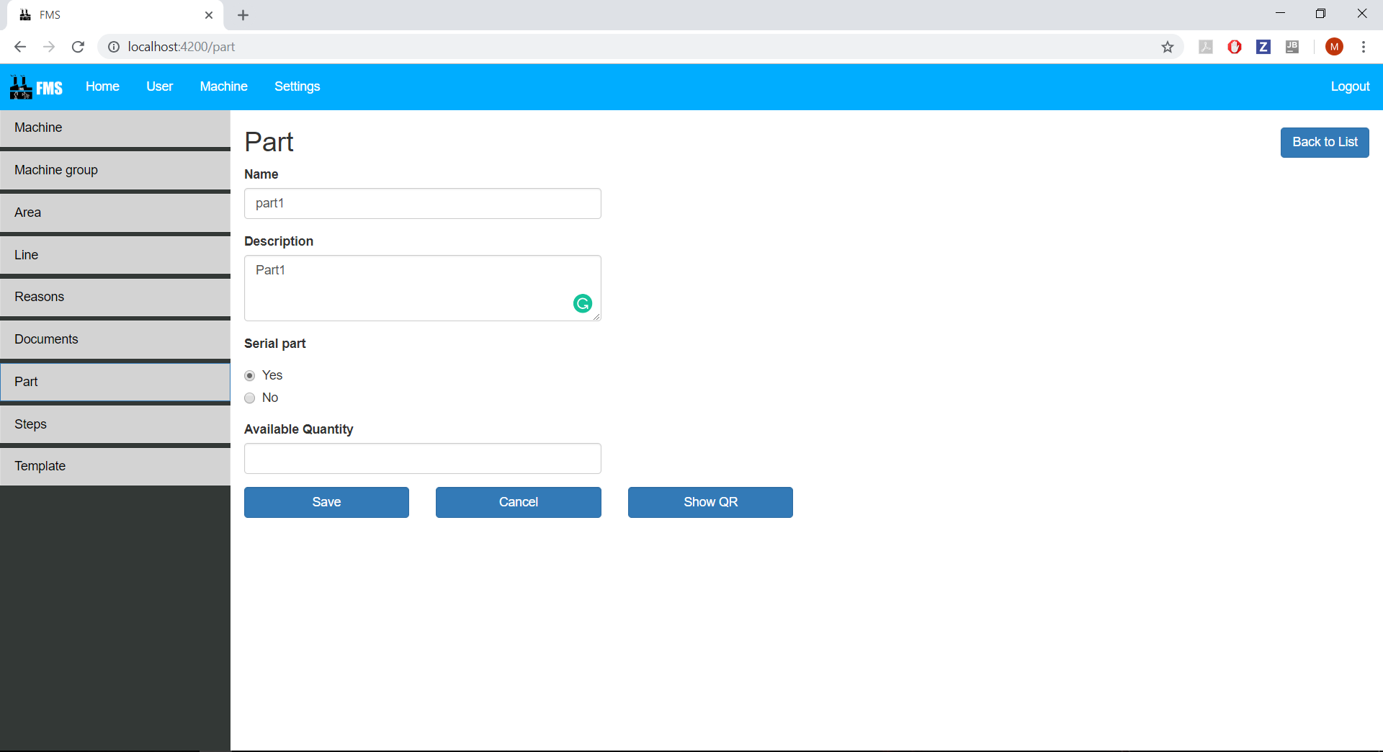

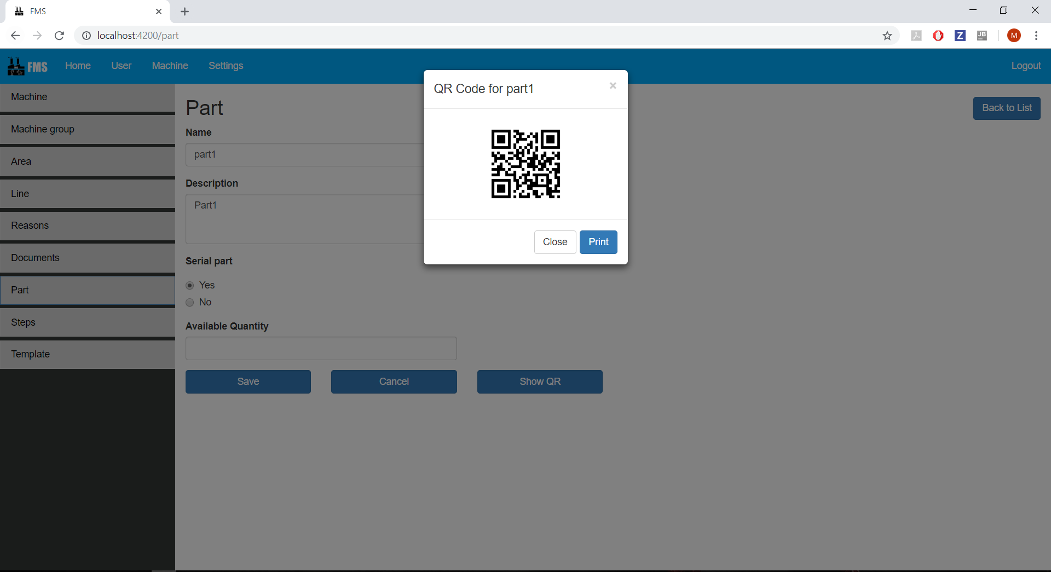

**3. Step group Module:**

**Class diagram:**

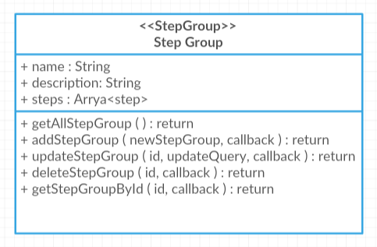

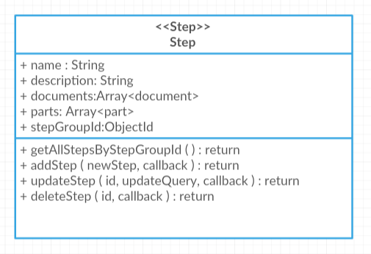

**Wireframe:**

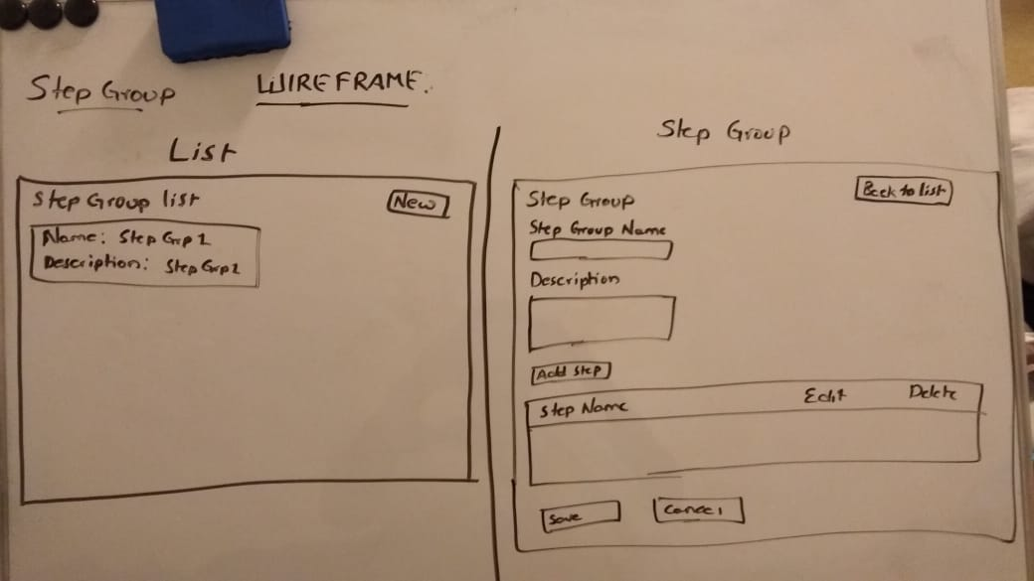

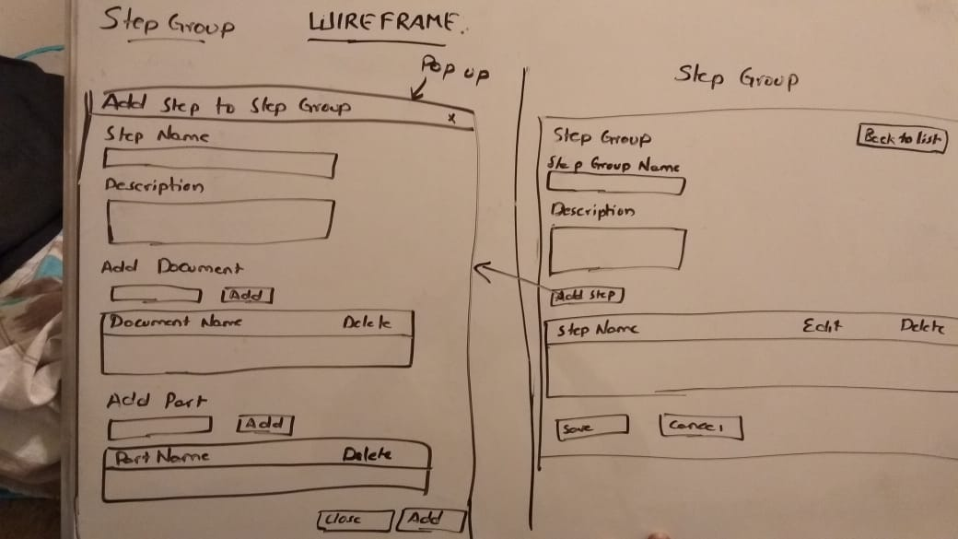

**Screenshots:**

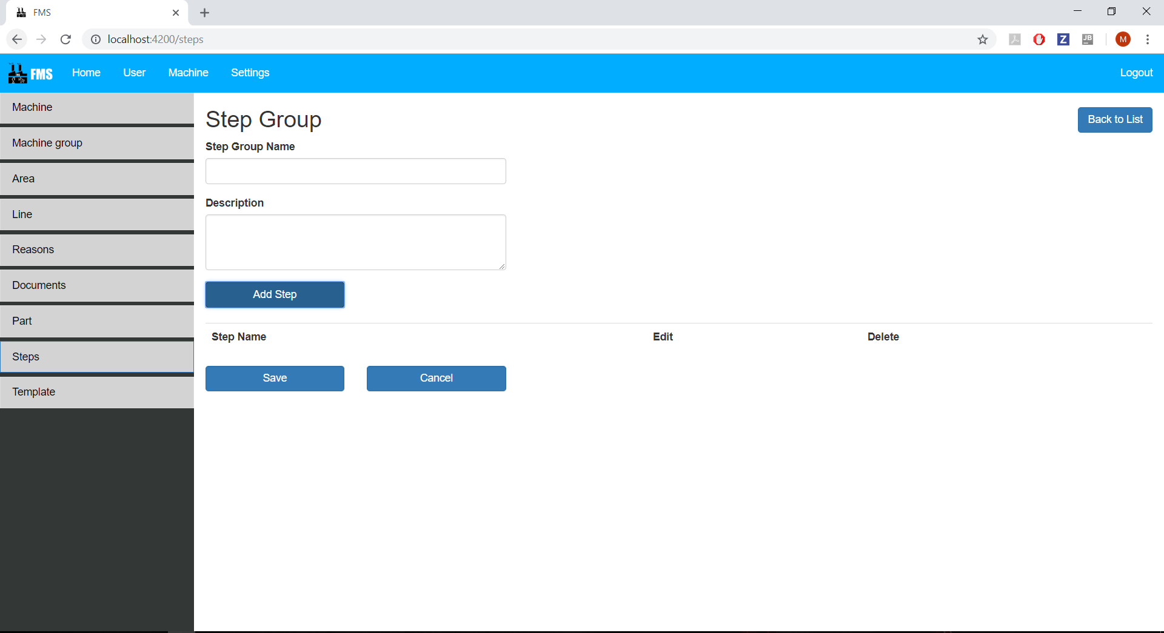

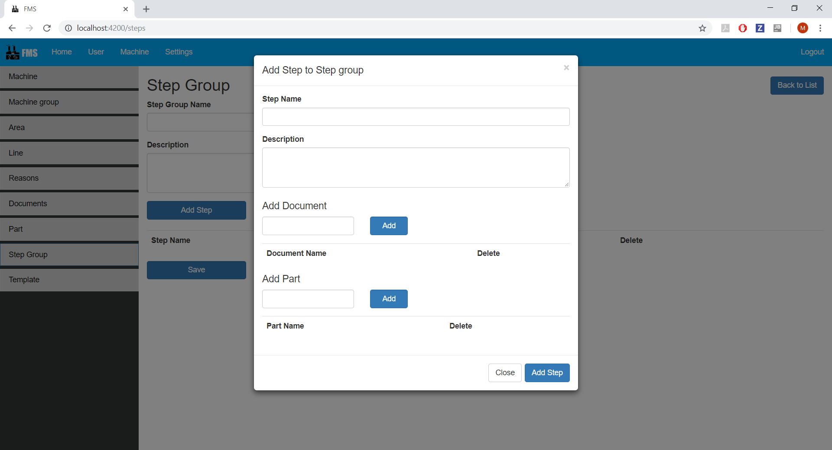

**4. Template Module:**

**Class diagram:**

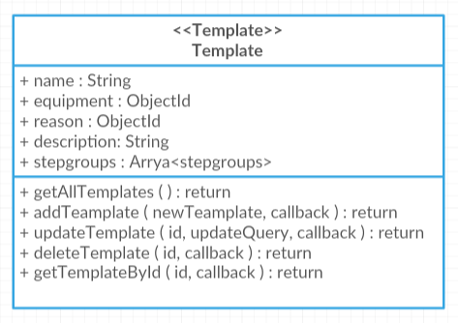

**Wireframe:**

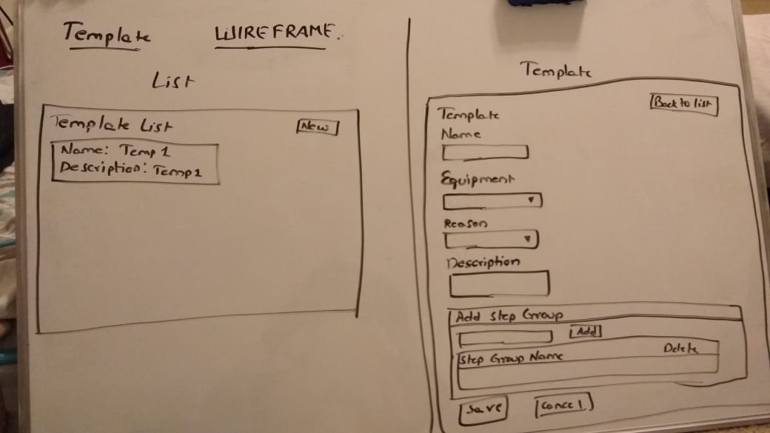

**Screenshots:**

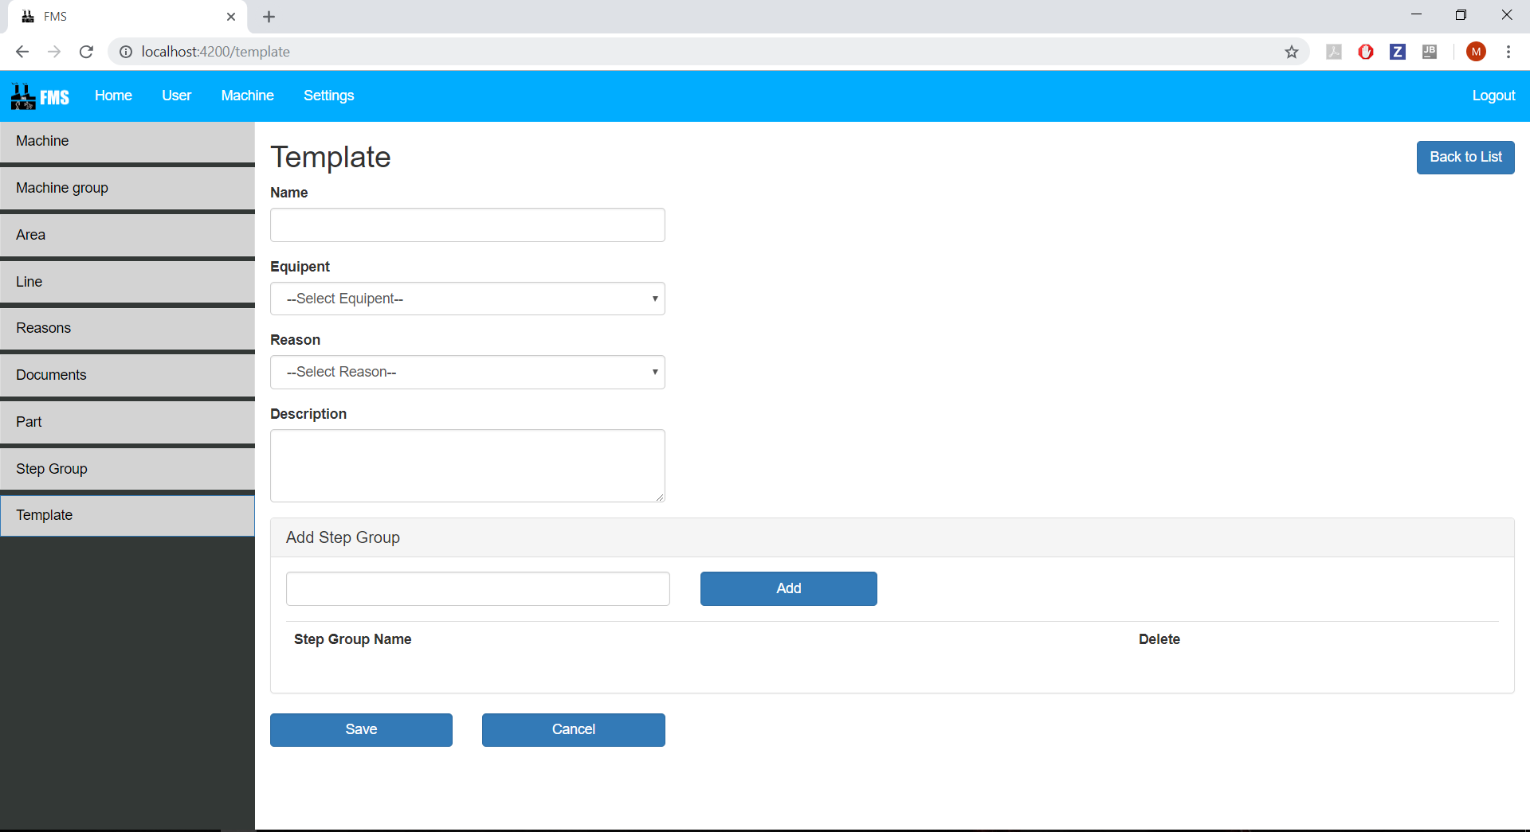

**5. Settings Module:**

**Class diagram:**

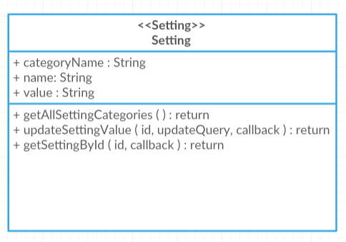

**Wireframe:**

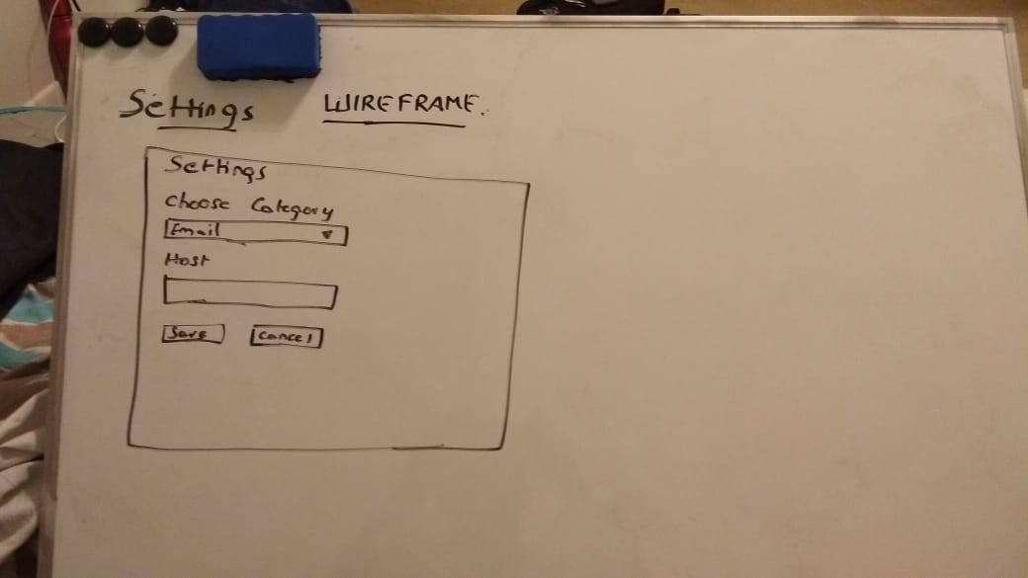

**Screenshots:**

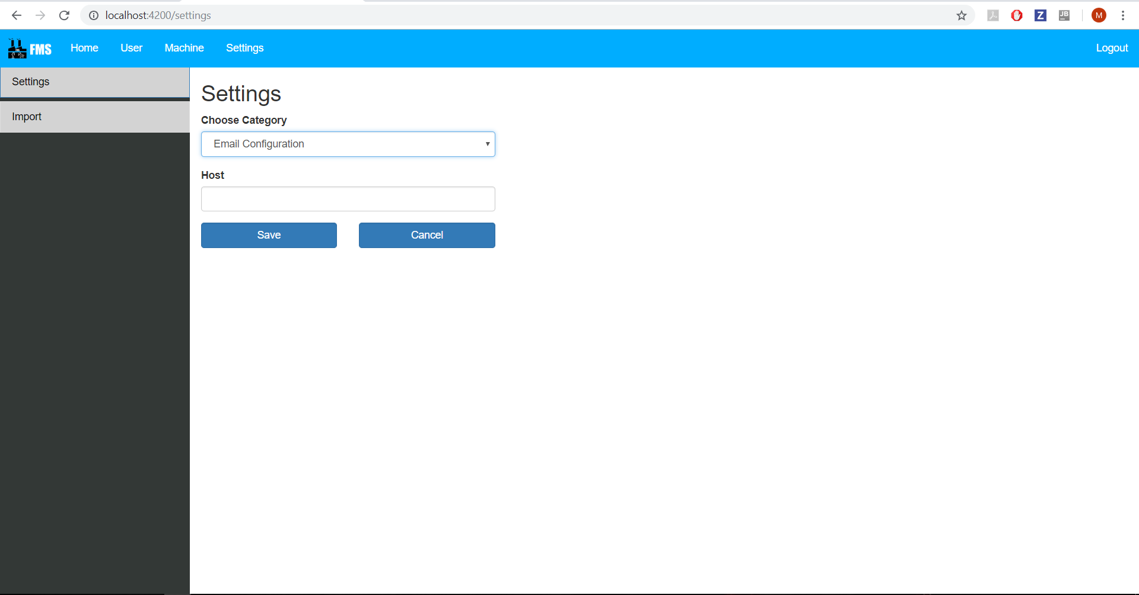

**6. Import-Module:**

**Class diagram:**

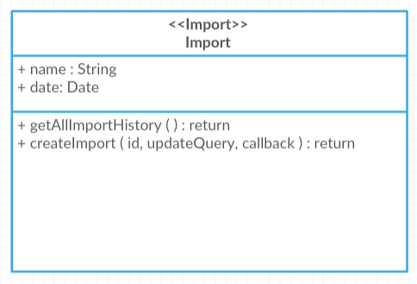

**Wireframe:**

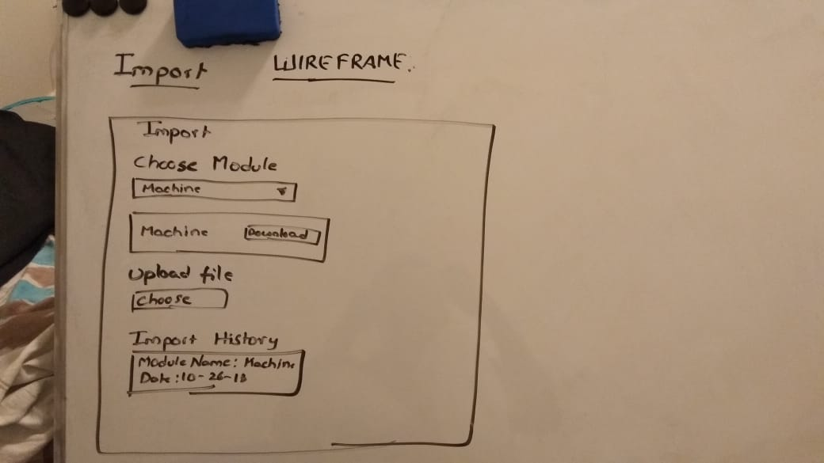

**Screenshots:**

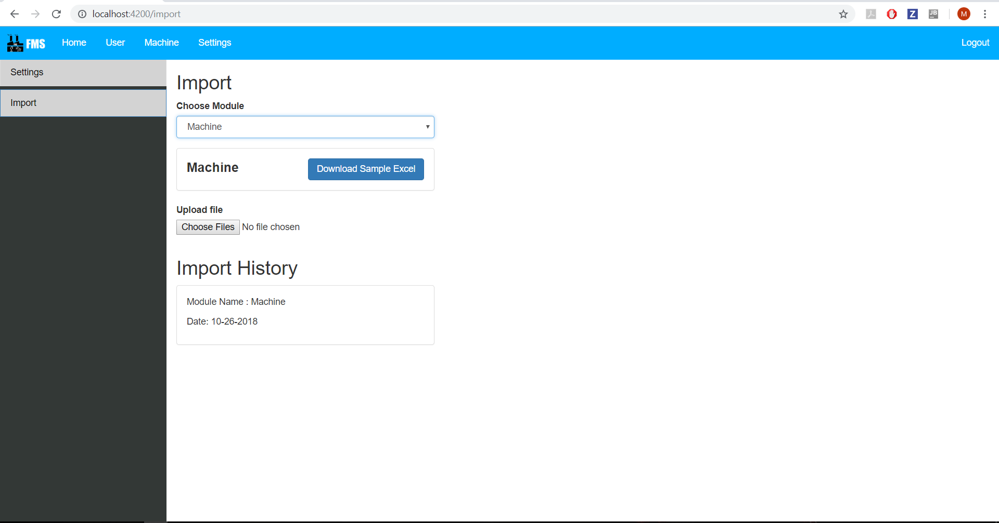

**7. Mobile Login Module:**

**Screenshots:**

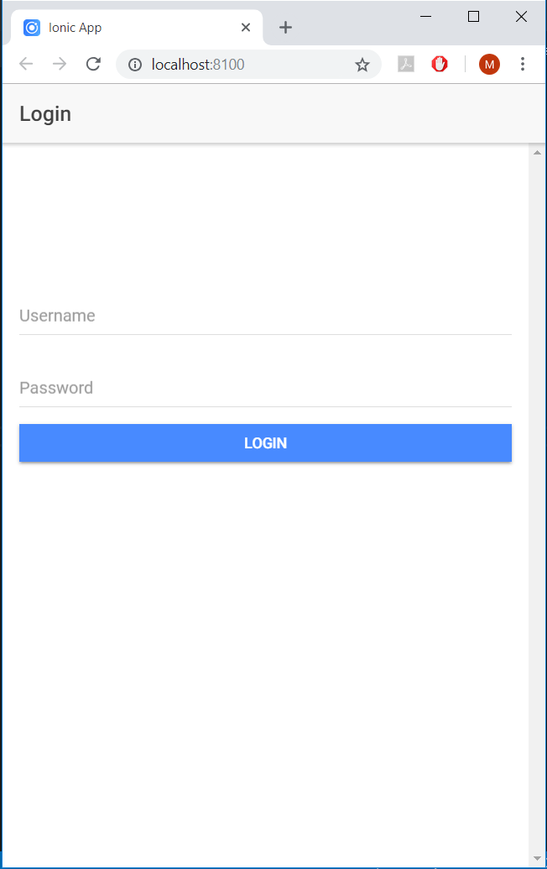

**Zenhub :**

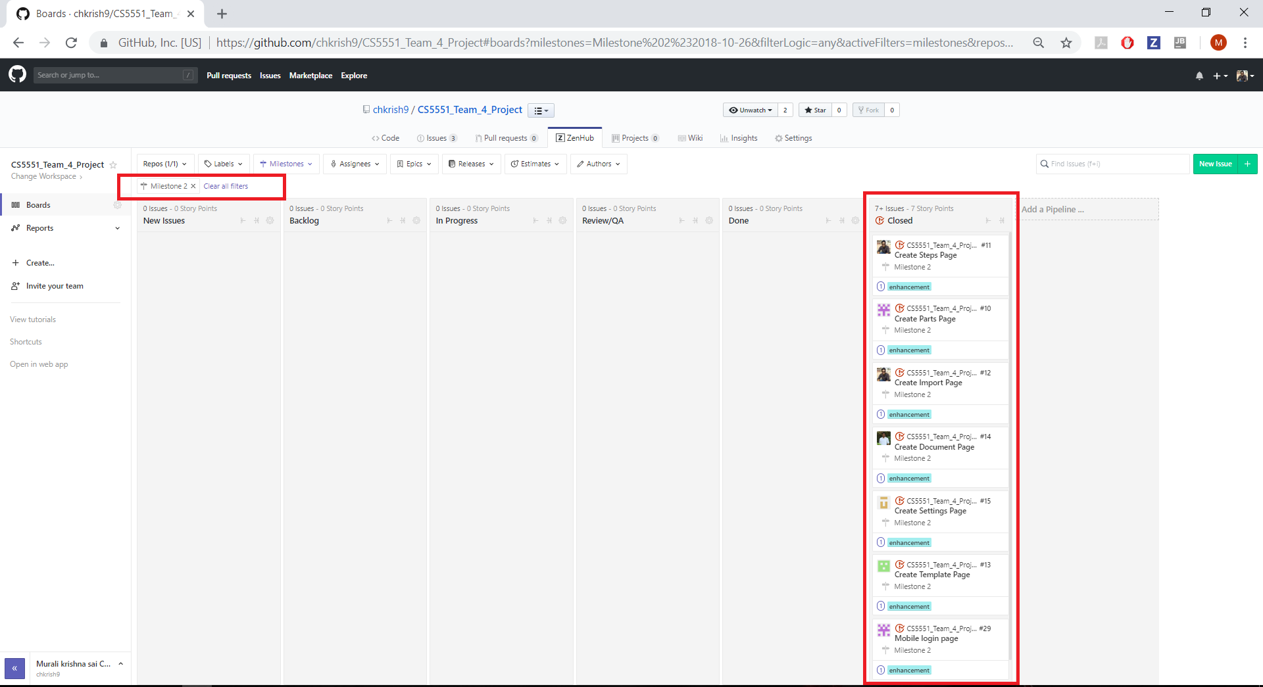

**Burndown chart :**

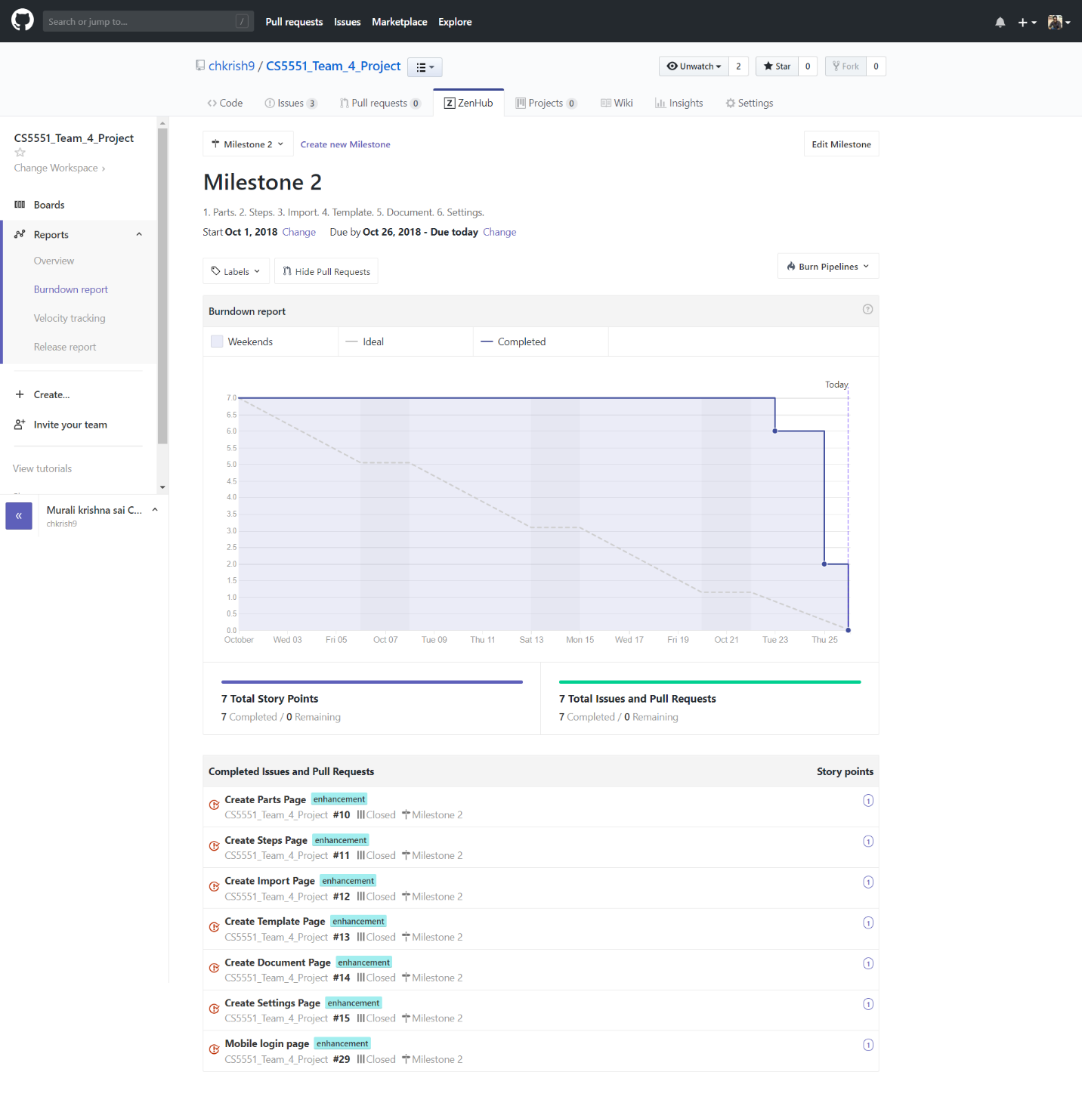

**Contribution :**

**1. Murali krishna sai Chukka**

**Modules Worked:**

1. Steps page. (Zenhub Issue No: #11)
2. Import. (Zenhub Issue No: #12)

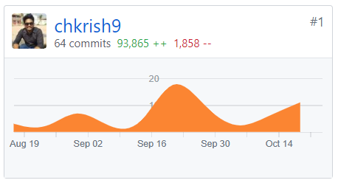

**2. Kavin Kumar Arumugam**

**Modules Worked:**

1. Document. (Zenhub Issue No: #14)

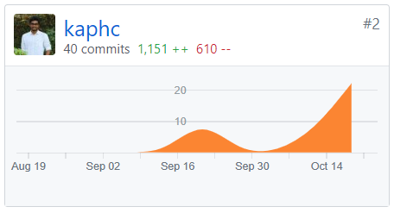

**3. Rupesh Sai Ram Doddala**

**Modules Worked:**

1. Template. (Zenhub Issue No: #13)

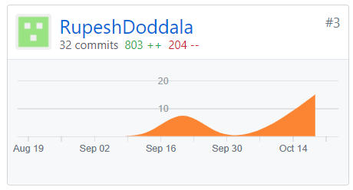

**4. Rahul Reddy Yerva**

**Modules Worked:**

1. Settings. (Zenhub Issue No: #15)

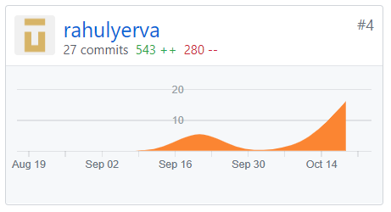

**5. Tejaswi Ayyadapu**

**Modules Worked:**

1. Parts. (Zenhub Issue No: #10)
2. Mobile Login. (Zenhub Issue No: #29)

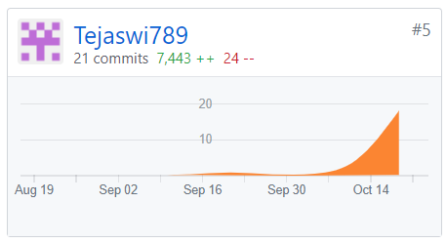

**References:**

<https://www.npmjs.com/package/ng2-file-upload>

<https://www.npmjs.com/package/xlsx>

<https://www.npmjs.com/package/multer>