**PROJECT MANAGEMENT SYSTEM**

**Scope:-**

The purpose of the project is to store complete details of the projects undertaken by the organization. The details contain all the informations such as name of project, client name ,team members, technologies used, project manager, expected date of delivery and other related things. We can also add new custom fields either to a particular project or to all the projects based on the requirements. The system also contains the documents related to the project and is connected with git to store the code.

The project will allow a simple interface for getting an overview of the project and also provide the facility to keep the details ,documents and code together.

**Functionalities:-**

**1. Add Project Details.**

This function allow the user to create a new project entry and fill the initial details.

**2. Add Custom fields to project locally or globally based on role.**

This function is used to add custom fields to the project that are specific to the project and are used only within it. The admin can also add fields that are applicable to each and every project.

**3. Edit project details.**

The edit project details function is used to make changes in the data which is already saved for the given project and needs to be changed.

**4. Save documents related to the project.**

The project also provide the facility to store the documents related to the project to be kept at some place where it can be accessed along with the project details.

**5. Connect the git repos. Of the project to see code on git.**

The code for the project will be stored on the git repos related to the project and can be viewed from the interface based on the level of access.

**6. Admin login for global changes.**

There will be a admin login which will provide the facilities of creating new project and adding custom fields to the project .The admin can also view the code for a project and he/she can also delete the project if he/she wants.

**7. PM login for changes applicable only to project.**

Similar to the admin login the project manager can also login in the application and can make changes to the details ,create custom field that will be applicable for only that project.

**8. Show project Details.**

The show project details function is used to display the details of the project.The amount of details to be shown to user will be depending on the level of access.

**Roles:-**

**1. Admin**

The admin can add new projects and add fields that are applicable for each and every project.He can view any project details and code. for the projects.

**2. Project Manager**

Project manager can edit the details of the project that he/she is assigned to and make changes that are local to the project and will be applied only to that single project.He/She can add the documents and code related to the project.

**3. Guest User**

Guest user can only view the project details and cannot modify any of them and may also be restricted to view the documents and code of the project.

**FEATURES ACCESS:-**

| Features | Admin | Project Manager | Guest User |
| --- | --- | --- | --- |
| Add New Project |  |  |  |
| Edit Project Details |  |  |  |
| Add Custom fields |  |  |  |
| Save Document related to project |  |  |  |
| View code from git repos |  |  |  |
| Admin login |  |  |  |
| PM Login |  |  |  |
| View Project Details |  |  |  |

**USE CASES:-**

For Admin:-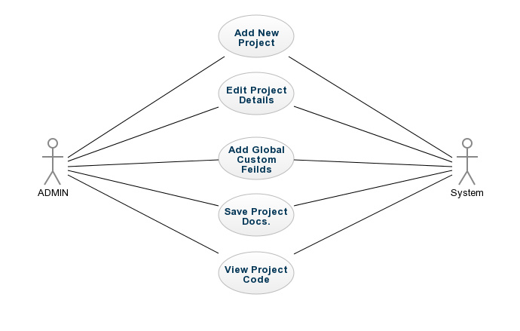

For Project Manager:-

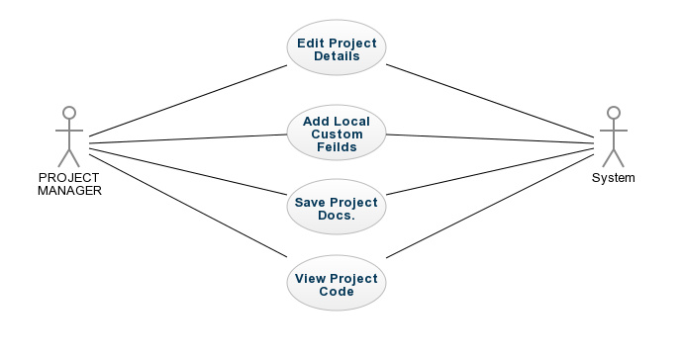

For Guest User:-

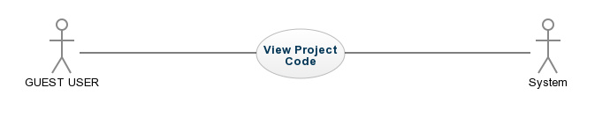

**TECHNOLOGIES:-**

**For Backend:**

1. NodeJs

2.ExpressJs

**For Frontend:**

1.AngularJs

2.HTML,CSS,JAVASCRIPT

3.Bootstrap

**Database:**

1.Mongodb

2.Mongoose