PROJECT REPORT
CONTENT
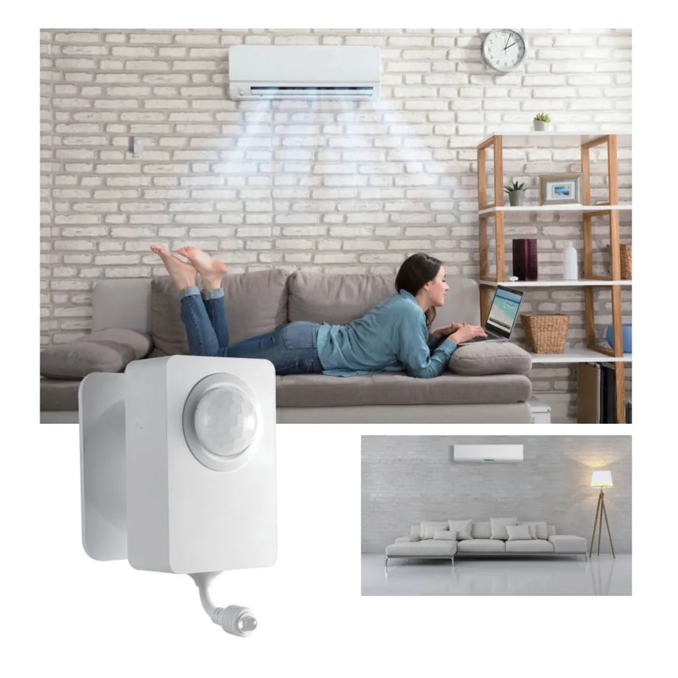  Automated Occupancy detecting Ac control system | RASHMIKA R.R.P. (230538L)  RIFNAZ K.R.M. (230550P)  RODRIGO B.K.G.S. (230551U)

- Technical workflow and Timeline
- Current status
- System operation and logic
- Contribution of group members
- Challenges and solutions
- Key features
- Resources
- System Enhancements and Future Developments
- Conclusion

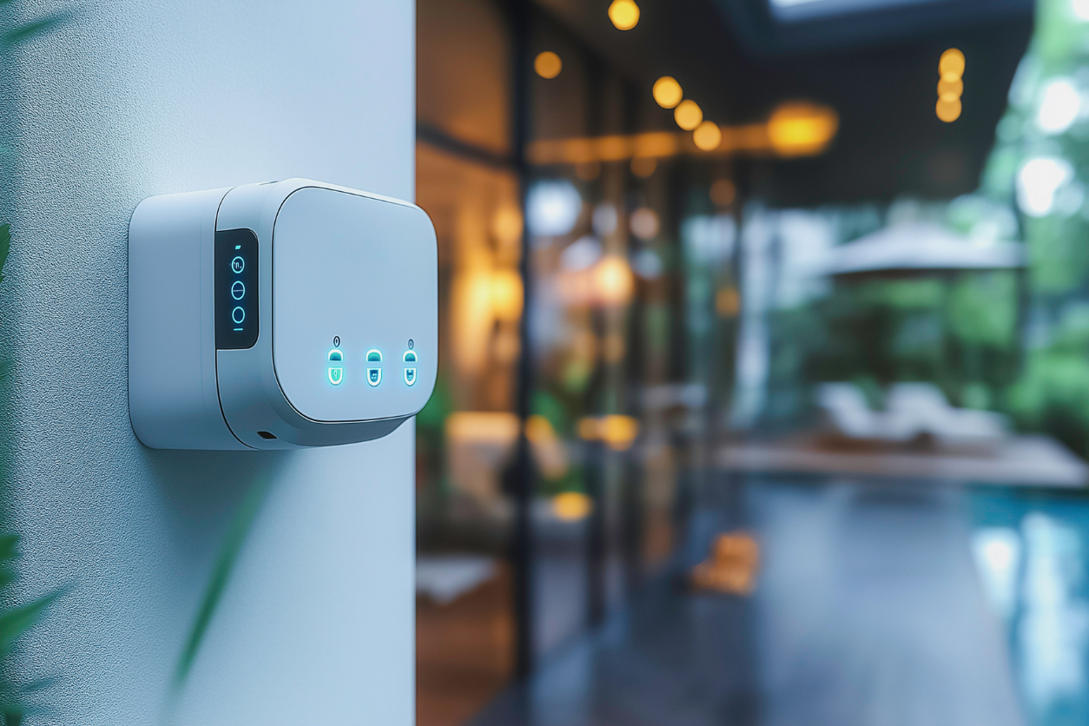

1)Technical Workflow and Timeline

  - Problem Statement
  - Leaving Air conditionings running unattended has become a common issue in many companies, offices and even households nowadays. This practice leads to unnecessary energy consumption and environmental harm. Since air conditioning systems are among the highest energy consuming appliances their misuse can have significant economic and environmental impacts.
Energy Waste, Environmental Impact, Financial Cost, Increased Maintenance are main drawbacks of leaving air conditioners running unoccupied.

  - System concept development

  - Current market solutions for air conditioning control are polarized. Manual operation relies entirely on human memory, leading to unavoidable negligence and waste, while commercial smart thermostats are often highly expensive and designed for central HVAC systems rather than the split unit ACs common in regions. As well as most basic retrofit sensors suffer from false negatives, cutting power when occupants are stationary, and completely ignoring the mechanical reality of compressor wear, causing short cycling that damages the equipment and shortens its lifespan.

Our team is motivated to bridge this gap by leveraging a Sensor Fusion approach, where PIR and Microwave sensors work together to accurately distinguish between true occupancy and false alarms. We are uniquely positioned to solve this by implementing staged Eco-Mode logic that intelligently differentiates between short-term absences and long-term vacancy, ensuring maximum energy efficiency and equipment protection while maintaining user comfort without the need for complex infrastructure.
MATLAB Simulation and Modeling
MATLAB and Simulink were used to design and simulate the control logic of the system. Different occupancy scenarios were tested to verify correct AC switching behavior, time delays and energy savings.
  - System validation through simulation
Simulation results were analyzed to ensure stable operation, correct sensor response and reliable decision making under various conditions.

  - SolidWorks mechanical design
SolidWorks was used to design the physical enclosure for sensors and control components. The design focused on proper sensor placement, protection of electronics, and practical installation.
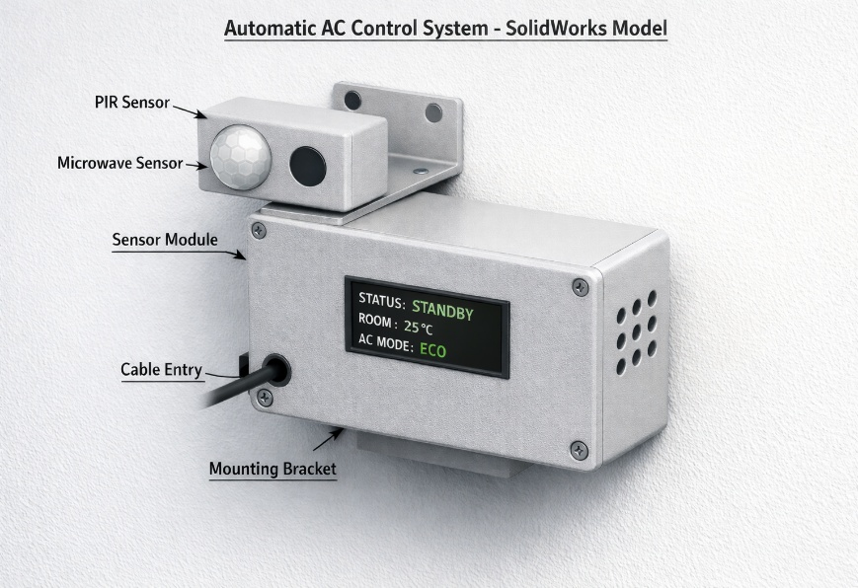
  - Technical Report Preparation
A detailed technical report was prepared, including system description, design methodology, simulation results, discussions and conclusions.
  - Final Review
The complete project was reviewed for technical accuracy, clarity and completeness before final submission

  - Timeline
- (Weeks 1-4): Prototype Development

After Finalizing the ideal solution for our problem during the prototype development physical casing was made using SolidWorks software and a MATLAB Simulink model was developed to simulate the staged Eco Mode logic. And selected components ESP32 as the central IoT controller, PIR and Microwave radar modules for the sensor fusion.

- (Weeks 5-8): Sensor Integration & Logic

Programming the ESP32 to read inputs from both PIR and Microwave sensors simultaneously, implementing the Eco Mode" (2°C) and Deep Eco/Off Mode, ensuring the system sends the correct IR signals to the AC unit when the timers up.

- (Weeks 9-12): Field Hardening.

3D printing and assembling the SolidWorks designed housing, checking the PIR and Microwave modules are elevated for the optimal detection. Installing the screen into the front cutout of the enclosure to show real-time data.

- (Weeks 13+): Pilot & Validation

Installing the device in a test room and connecting it to a split-type AC unit for a multi-week observation period. Comparing electricity usage and Collecting feedback from room users.

2)Current Status
- Occupancy detection completed
The system can correctly detect the presence or absence of occupants using combined sensor inputs.
- AC control logic verified
The switching between normal, eco and OFF modes works as intended in simulation.
- Simulation results validated
Output response times confirm stable and reliable system operation.
- Design ready for implementation
The project is technically complete and suitable for future hardware development.
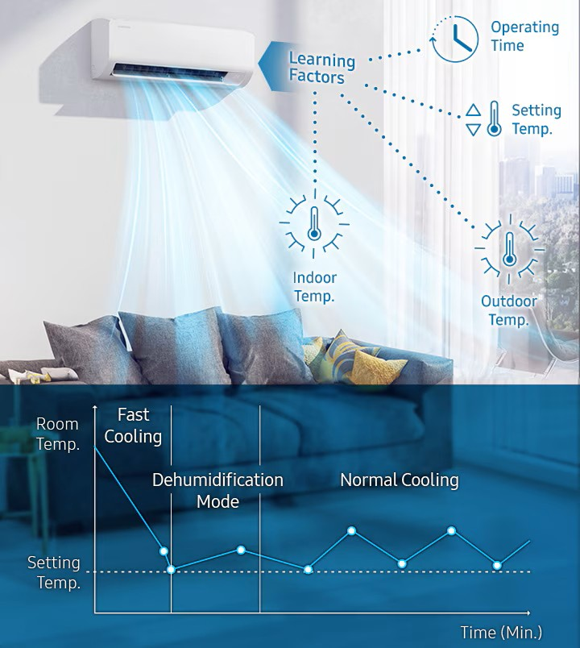

3)System Operation and Logic
- Continuous monitoring
Sensors continuously observe the room to detect human presence.
- Motion – based detection
The PIR sensor detects changes in infrared radiation caused by human movement.
- Stationary detection support
The microwave sensor helps detect occupants even when they remain still.
- Sensor fusion approach
Using both sensors together improves accuracy and reduces false detection.
- Time delay mechanism
Delays are added so that short absences don’t immediately switch off the AC.
- Energy efficient control
The AC operates only when needed, reducing unnecessary power consumption.

4)Contribution of Group Members

All members contributed to every part of the project using different approaches. Each member took responsibility for one or more specific sections.
The contributions of each member are mentioned below.

- R. R. P. Rashmika (230538L)
LaTeX Technical Report
In making the Technical Report using overleaf software in Latex. Latex is important in IEEE standard format. Because of that according to relevant rules and regulations main code is written on the main platform. References are in the bibliography. Using solid work design, past innovation results and other sources, the relevant images are taken. The control logic workflow has been generated using relevant codes from block diagrams. Actively supported the team during discussions and final report preparations.

- K. R. M. Rifnaz (230550P)
SolidWorks and the Project Report
Worked mainly on the SolidWorks design and the project report. Designed the outer casing of the system using SolidWorks, making sure the sensors and electronic components are placed correctly and protected from damage. The design is focused on being practical, easy to install, and suitable for real-world use. Also contributed to writing the project report by organizing sections, explaining the system working and simulation results, adding figures, and checking the report for mistakes and clarity. Actively supported the team during discussions and final report preparations.

- B. K. G. S. Rodrigo (230551U)
MATLAB and Simulink simulations.
Worked on the MATLAB and Simulink model, used to simulate the system’s control logic. Used MATLAB code to simulate a real-time scenario of an air-conditioned room (sensor outputs) and tested different occupancy scenarios to observe AC switching behavior, time delays, and Eco-mode operation. Reviewed the simulation results to confirm the system worked as intended before hardware implementation. Used the help of AI tools and YouTube to create the simulation. Actively supported the team during discussions and final report preparations.

5) Challenges and Solutions
- Sometimes detection is incorrect
Sometimes the system may fail to identify a person who sits still and may falsely turn the AC off.
Solution: The problem described was diminished by using more than one sensor type so that occupancy could be detected reliably.
- False sensor triggering
The wrong decisions may be obtained if the sensors are prone to heat sources or movement that is not caused by a human.
Proper placement of sensors and their corresponding logical conditions ensured filtering out unnecessary triggers.
- Frequent ON/OFF switching of the AC
The rapid switching can shorten the life span of AC's compressor and even increase the power stress.
Solution: Introducing time delays before changing the state of ACs to ensure stable operation.

- Simulation complexity
The challenge was to model sensor behavior and AC response accurately in simulation. The solution yielded simplified and realistic assumptions necessary to represent the behavior of the system effectively.
- Limited access to hardware components
Due to the limited availability of physical components, real-time testing was not possible.
Solution: Further detailed simulation and design analysis have validated the system.

6)Key Features
- Automatic operation
The process does not require human control.
- Energy saving
AC power consumption decreases drastically when the room is unoccupied.
- Enhanced comfort
The inhabitants feel a constant cooling effect without having to intervene.
- Scalability
This system could also be extended to offices, classroom settings, or smart buildings.
- Manual override
This gives the user a certain amount of control over the automated system.

7)Resources
https://www.youtube.com/watch?v=blIr-JVWoG8
https://www.youtube.com/watch?v=NxIIVglnQRE
https://www.mathworks.com/solutions/control-systems.html
https://www.youtube.com/watch?v=hUkjtqKqn2A
https://www.solidworks.com/sw/resources/getting-started.html

8) System Enhancements and Future Developments

This system currently utilizes an occupancy detection system and some basic controlling logic, however, there are many ways in which we could improve upon both the performance and usability. In the future, for example, we could use advanced sensors (like cameras or CO₂ sensors) to accurately detect occupancy, as well as provide a permanent location for storing data on occupancy levels. The system could also have the capability to connect to the Internet via IoT so that you could monitor and control it remotely using mobile phone apps. We could implement some kind of AI or machine learning techniques to study user patterns and make automatic adjustments to AC settings, thereby providing greater comfort and energy efficiency. Furthermore, we will be performing real-time hardware tests and longitudinal testing of our products to validate their reliability and power-saving ability in the actual operating environment. Implementing any of these types of improvements will result in a more intelligent, more efficient AC control solution that is appropriate for use in large applications like offices, schools, and commercial facilities.

9) Conclusion
The system is able to effectively fulfill the aim of minimizing energy wastage.
Simulation results show that it operates correctly.
The design is functional. It can therefore be used practically.
This shows the good application of sensing and control techniques.

----------------THE END---------------

