InvistiMapp - Platform

## Description of Platform

The platform for InvestiMapp will be as follows.

AWS Codestar will be used to quickly get up and running with the AWS cloud platform. We will use AWS Lambda (serverless) and Python templates, AWS Elastic Beanstalk with Node.js, and a browser caching. Every time a user adds or deletes a stock, the cached data will be updated. 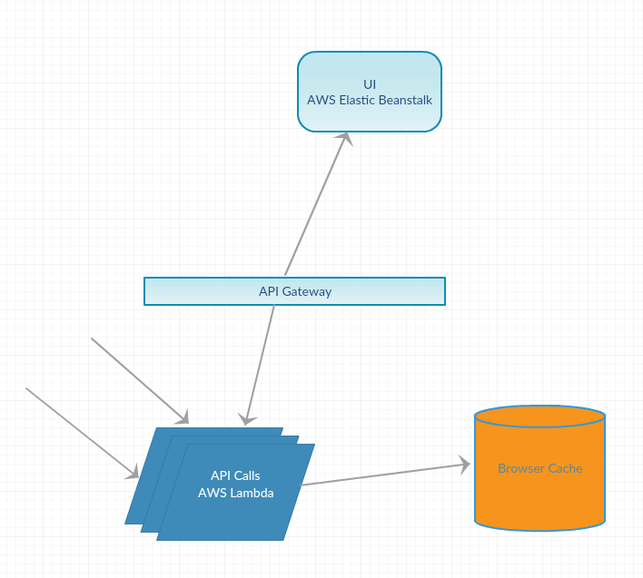

## IDE

AWS CloudStar integrates with AWS Cloud9 IDE. This will be easy to use but since it will be setup with Github, setup will be easy for any team member using Git. We will also use Atom and MySQL cli for some other parts of the project.

## Installation Instructions

Installation is not required. Development,testing,deployment are all in the cloud.

## Configuration and Compile Instructions

These directions assume you want to develop on your local computer, and not from the Amazon EC2 instance itself. If you're on the Amazon EC2 instance, the virtual environment is already set up for you, and you can start working on the code.

To work on the sample code, you'll need to clone your project's repository to your local computer. If you haven't, do that first. You can find instructions in the AWS CodeStar user guide.

Install Node.js on your computer. For details on available installers visit https://nodejs.org/en/download/.

Install NPM dependencies:

**$ npm install**

Start the development server:

## Running Instructions

All testing will be done in the cloud on a test instance of the application and service.

**$ node app.js**

Open <http://127.0.0.1:3000/> in a web browser to view your application.

## Usernames and Passwords not needed.

Each team member can use the same instance of the application in order to test. Through browser caching, each member can save the chosen stocks.