AI Ops Incident Investigator
Agentic AI Design Workshop — Pre-Workshop Information
Prepared by: Integration Solutions Lead, | October 2026
1. PoC Summary
This document covers the Boomi integration scope for the AI Ops Incident Investigator PoC. It is provided ahead of the Infotech Agentic AI Design Workshop to help facilitators understand our process landscape, failure patterns, and what we want the agent to do.

What we are building
- An AI-assisted agent that investigates Boomi integration failures automatically
- Reads the Boomi execution log, identifies the error type, and recommends team assignment
- Human reviews and confirms before any ticket action is taken — no autonomous execution

PoC Scope — Single Failure Domain
- 4 Boomi processes, all failing at the NetSuite boundary
- 3 distinct NetSuite error patterns + 1 business rule violation (success status, error in log)
- Owning team in all cases: NetSuite team
- Design must be extensible — these 4 processes prove the pattern; others can be added later

What the workshop needs to design
- Agent reads Boomi execution log (not just the status field)
- Classifies the NS error type from the log content
- Generates a plain-English finding with recommended team assignment
- Human confirms before ticket is reassigned

2. The 4 Boomi Processes
All 4 processes are in CA ANZ PROD (Boomi). All failures occur at the NetSuite integration boundary.

Process Name | App / Source | What It Does | Destination
Employment History Listener | Salesforce (webhook) | Syncs employment history changes from Salesforce into NetSuite in real time | NetSuite — Customer & Member Attributes
Individual Listener (Sub Process) NetSuite | Internal queue | Picks up customer/member records from queue and upserts into NetSuite | NetSuite — Customer & Member Attributes
Listener - ecr Order Update | ECR order queue | Picks up incoming orders and posts as cash sales in NetSuite | NetSuite — Cash Sale records
SR-01: Proceed To Checkout | Member Portal (webhook) | Processes customer checkout — creates/updates sales order in NetSuite and Salesforce | NetSuite — Sales Order; Salesforce — Order record

From Confluence:
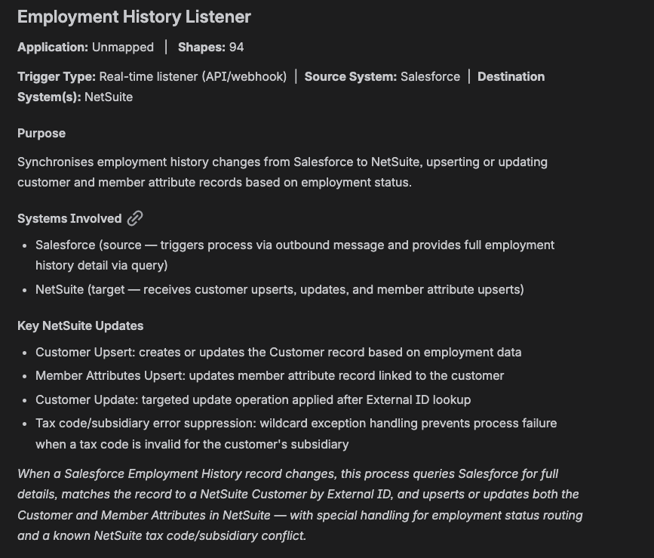

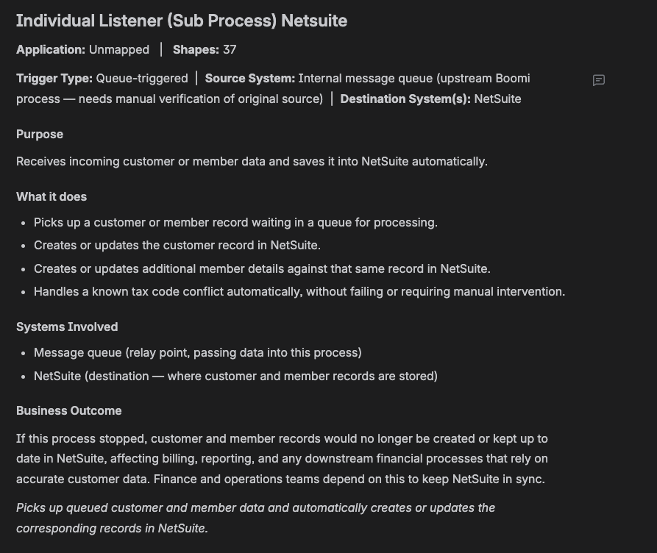

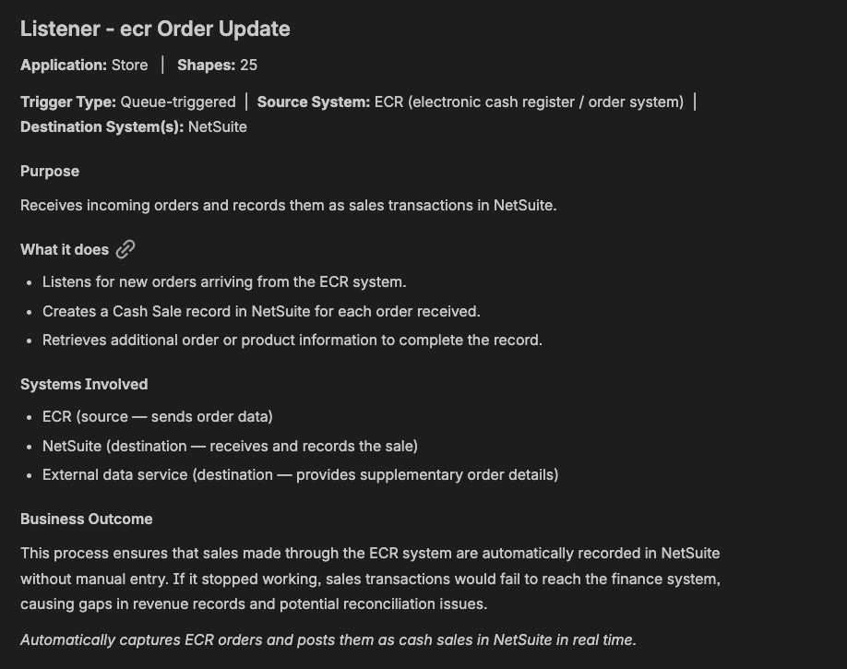

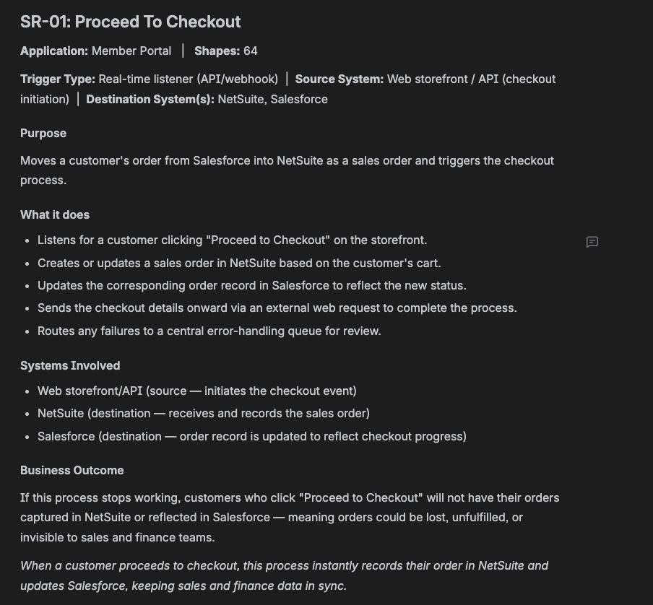

3. Failure Patterns — Sample Log Evidence
The following 4 failure patterns have been observed in PROD logs. These form the basis of the agent's classification logic.

Pattern 1 — NS Data Error: Nonexistent External ID
Processes affected:
- Employment History Listener
- Individual Listener (Sub Process) NetSuite
Error message: NetSuite Error: Nonexistent externally [record not found]
- NetSuite cannot find the customer record being referenced by its external ID
- Record may have been deleted, never created, or has a mismatched ID between Salesforce and NetSuite
- Process status: Red (failure)
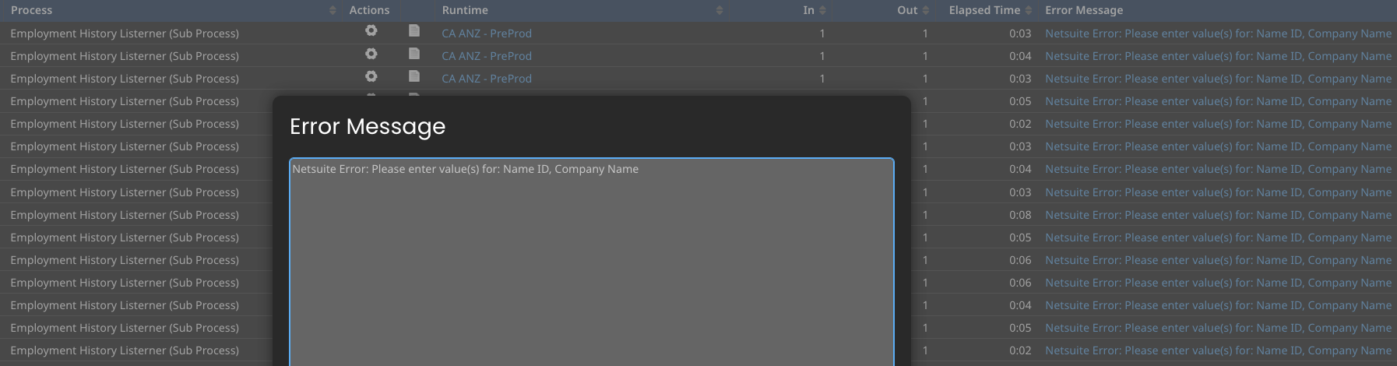
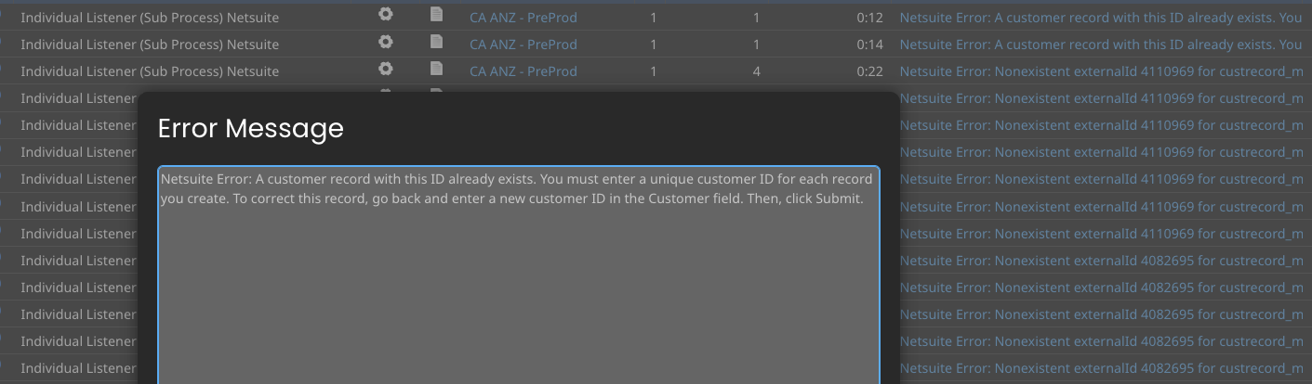

Pattern 2 — NS API Rejection
Process affected:
- Listener - ecr Order Update
Error message: {"success":false,"id":null,"error":"An unexpected error..."}
- Raw NetSuite REST API response — request was rejected at the NS API layer
- Process status: Red (failure)

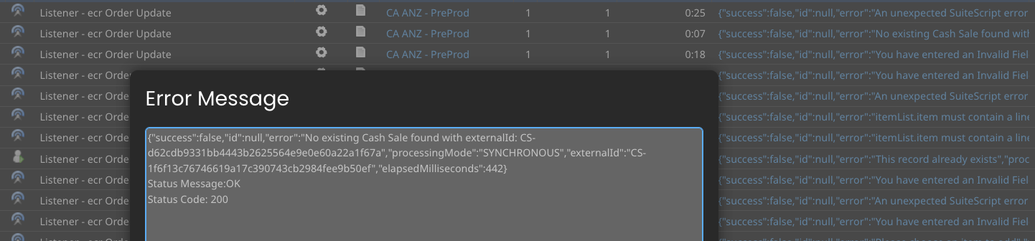

Pattern 3 — NS Timeout: Execution Time Limit Exceeded
Process affected:
- SR-01: Proceed To Checkout
Error message: Process exceeded maximum execution time limit
- NetSuite is slow to respond; Boomi process hits the execution time limit and terminates
- Observed consistently across both PROD and PreProd
- Process status: Red (failure) — no NS error string, only timeout message
- Agent must identify this from the timeout message, not an NS error code

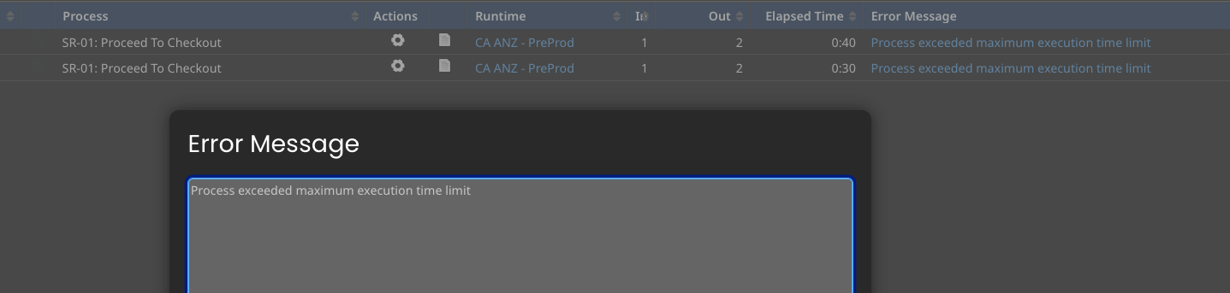

Pattern 4 — Business Rule Violation (Success Status, Error in Log)
Process affected:
- SR-01: Proceed To Checkout
Error message (SEVERE in log): Process terminating -- some documents reached an exception which is set to halt all documents: NS Error: Items on this line have been fulfilled. To delete this line, you must first delete the corresponding line(s) in the associated transaction(s).
- Process completes with green/success status — but contains a SEVERE exception in the log
- NetSuite is rejecting a modification to an order line that has already been fulfilled
- Likely a timing or duplicate update issue upstream (Salesforce or Member Portal)
- CRITICAL DESIGN POINT: Agent must read the log, not just the execution status field
- Process status: Green (complete) — failure only visible inside the log

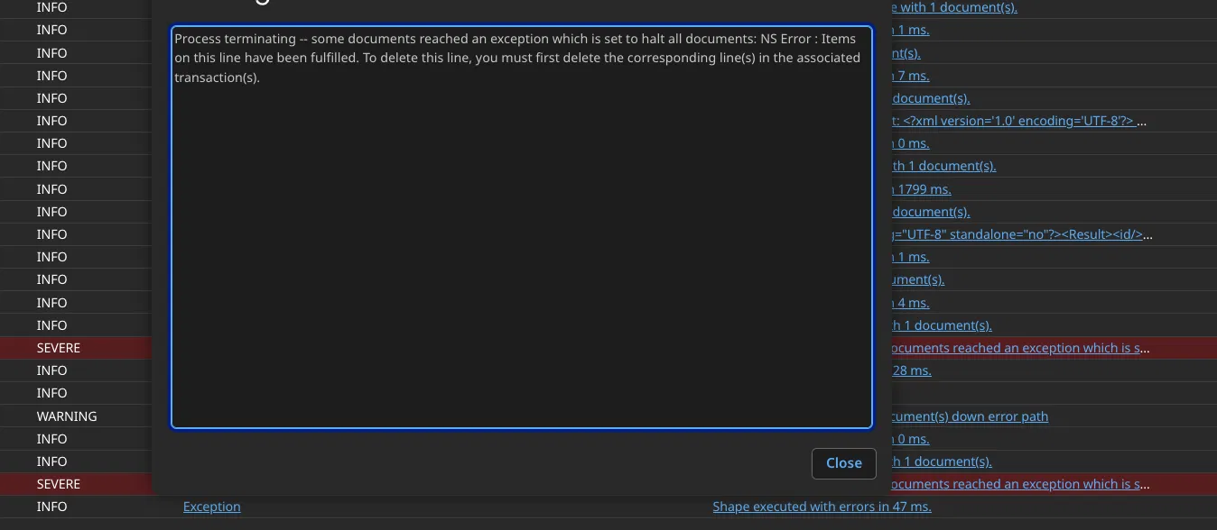

4. Key Design Notes for the Workshop
- All 4 failures are at the NetSuite boundary — the agent's classification covers one failure domain for this PoC
- Patterns 1–3 are visible from the process status (red). Pattern 4 requires log inspection — the agent must always read the log
- The agent should classify the error type and recommend NS team assignment in all 4 cases
- Pattern 4 is the most sophisticated test case — it validates that the agent goes beyond status and reads log content
- The design should be extensible — same logic pattern can be applied to other Boomi processes and failure domains after PoC

Automated Error Diagnosis (boomi_scan.py)



