EXPLORATORY DATA ANALYSIS AND VISUALIZATION
YuvaIntern – Week 2
UCI Online Retail Dataset
Student Name: Harshita Rai

1. Introduction
This report presents the Exploratory Data Analysis (EDA) and visualization performed on the cleaned UCI Online Retail dataset as part of Week 2 of the YuvaIntern Data Science Internship. The cleaned dataset contains 524,878 transaction records and 9 columns, including the engineered TotalAmount feature. The purpose of this analysis was to understand statistical characteristics, identify sales patterns, compare countries and products, examine customer spending, and communicate findings through visualizations.

2. Dataset Used
The Week 2 analysis continues from the cleaned dataset prepared in Week 1. It contains transaction-level information including InvoiceNo, StockCode, Description, Quantity, InvoiceDate, UnitPrice, CustomerID, Country and TotalAmount. The dataset contains 524,878 rows and 9 columns.

3. Objectives of EDA
- Generate descriptive statistics for numerical variables.
- Analyze total sales across countries.
- Study monthly sales trends.
- Identify top products by sales and quantity.
- Examine transaction amount and quantity distributions.
- Analyze customer spending patterns.
- Examine correlations among Quantity, UnitPrice and TotalAmount.

4. Descriptive Statistics
The describe() function was used to summarize the numerical variables. Quantity has a mean of 10.6166 and median of 4, UnitPrice has a mean of 3.922573 and median of 2.08, and TotalAmount has a mean of 20.275399 and median of 9.92. The differences between means and medians indicate the influence of higher-value observations.
Variable | Mean | Median | Maximum
Quantity | 10.616600 | 4.00 | 80,995
UnitPrice | 3.922573 | 2.08 | 13,541.33
TotalAmount | 20.275399 | 9.92 | 168,469.60
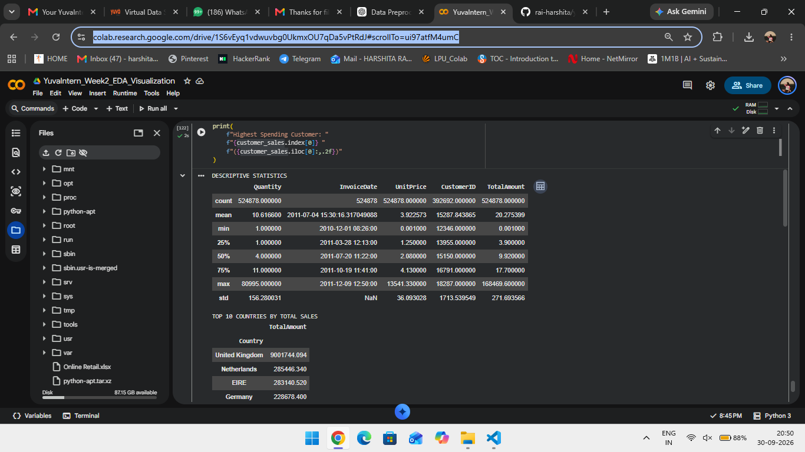
Figure 1: Descriptive statistics output from the Week 2 Colab notebook.

5. Country-wise Sales Analysis
TotalAmount was grouped by Country and sorted in descending order. The United Kingdom recorded the highest total sales, followed by the Netherlands, EIRE, Germany and France.
Country | Total Sales
United Kingdom | 9,001,744.094
Netherlands | 285,446.340
EIRE | 283,140.520
Germany | 228,678.400
France | 209,625.370
Australia | 138,453.810
Spain | 61,558.560
Switzerland | 57,067.600
Belgium | 41,196.340
Sweden | 38,367.830
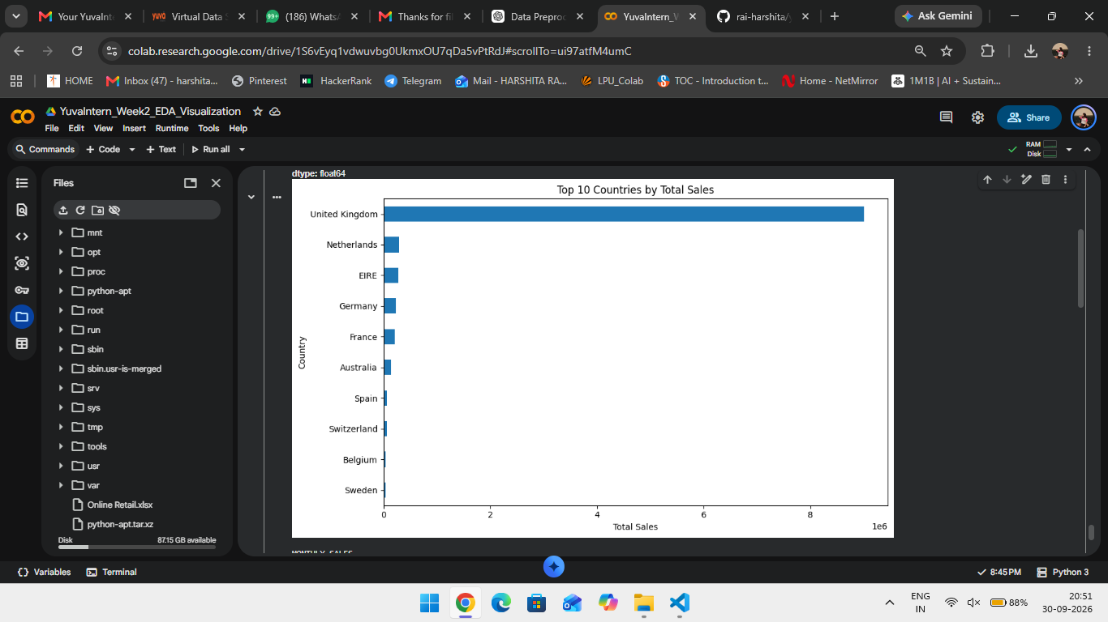
Figure 2: Top 10 countries by total sales.

6. Monthly Sales Trend
InvoiceDate was converted to datetime format and sales were aggregated by month. The line chart shows variation in sales activity, with a prominent peak in November 2011.
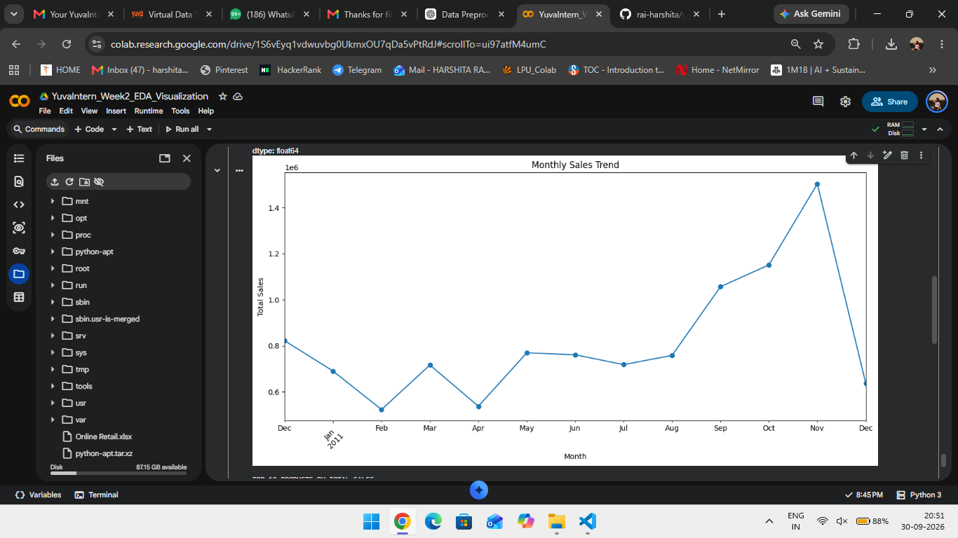
Figure 3: Monthly sales trend.

7. Product Analysis
Products were analyzed using total sales value and total quantity sold, providing two complementary views of product performance.
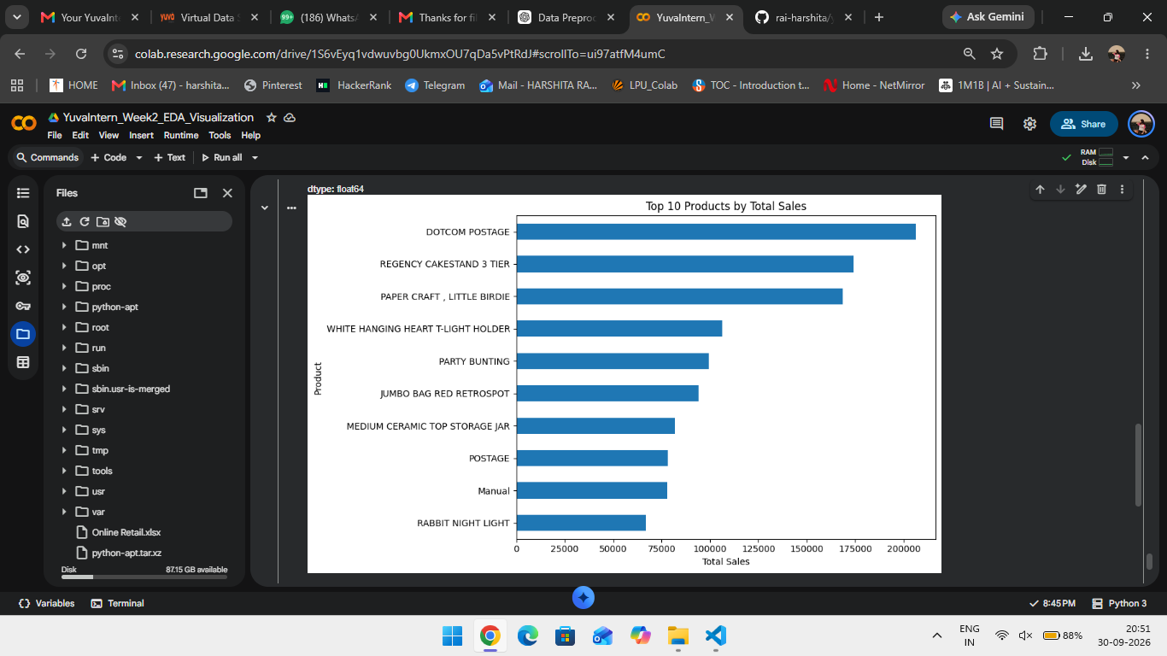
Figure 4: Top 10 products by total sales.
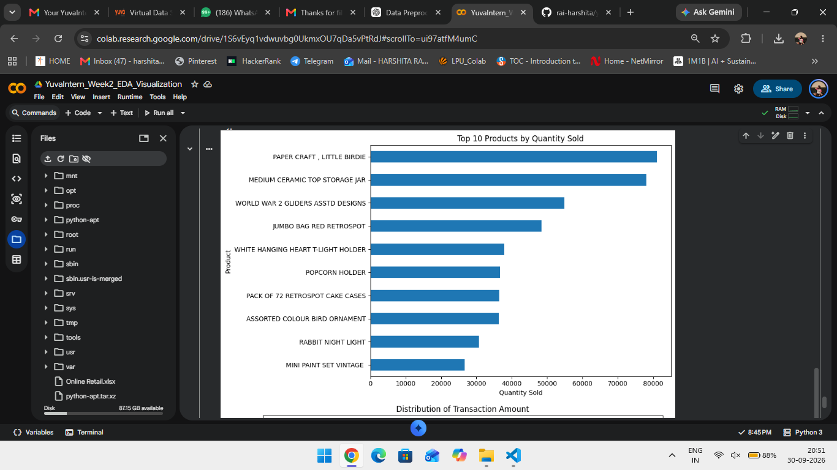
Figure 5: Top 10 products by quantity sold.
The product rankings differ depending on whether sales value or quantity is considered. PAPER CRAFT, LITTLE BIRDIE has the highest recorded quantity, while DOTCOM POSTAGE has the highest total sales value in the corresponding chart.

8. Distribution Analysis
Histograms were used to examine Quantity and TotalAmount. Both plots show strong concentration at lower values and long tails toward very large values.
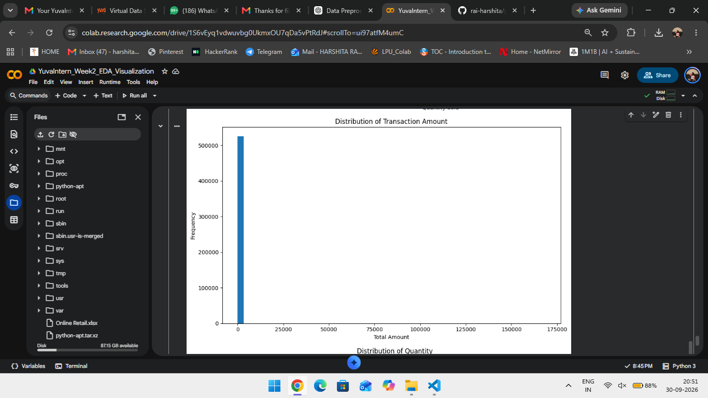
Figure 6: Distribution of transaction amount.
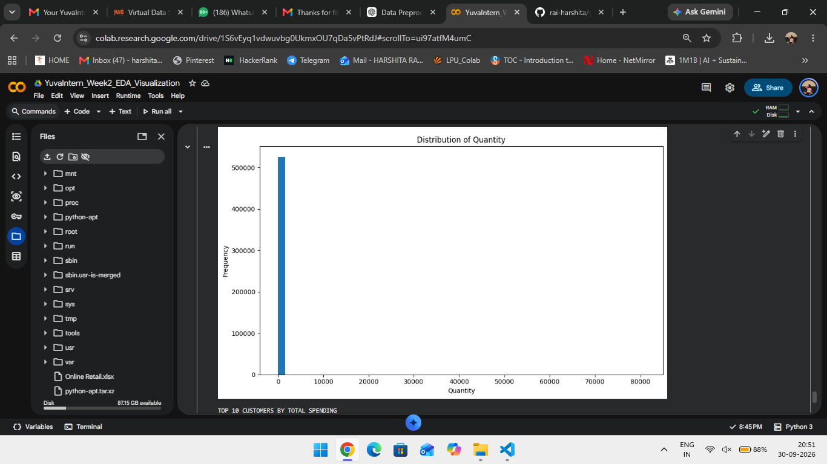
Figure 7: Distribution of quantity.

9. Customer Spending Analysis
Transactions with available CustomerID values were grouped by CustomerID and TotalAmount. Customer 14646 has the highest spending among the displayed top 10 customers, followed by Customer 18102.
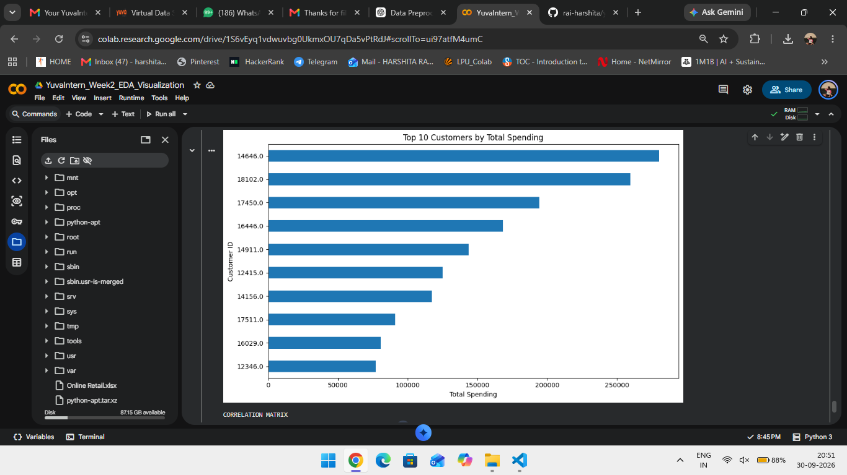
Figure 8: Top 10 customers by total spending.

10. Correlation Analysis
The correlation matrix was calculated for Quantity, UnitPrice and TotalAmount. Quantity and TotalAmount have a strong positive correlation of approximately 0.9074. UnitPrice and Quantity are approximately -0.0038 correlated, while UnitPrice and TotalAmount have a correlation of approximately 0.1374.
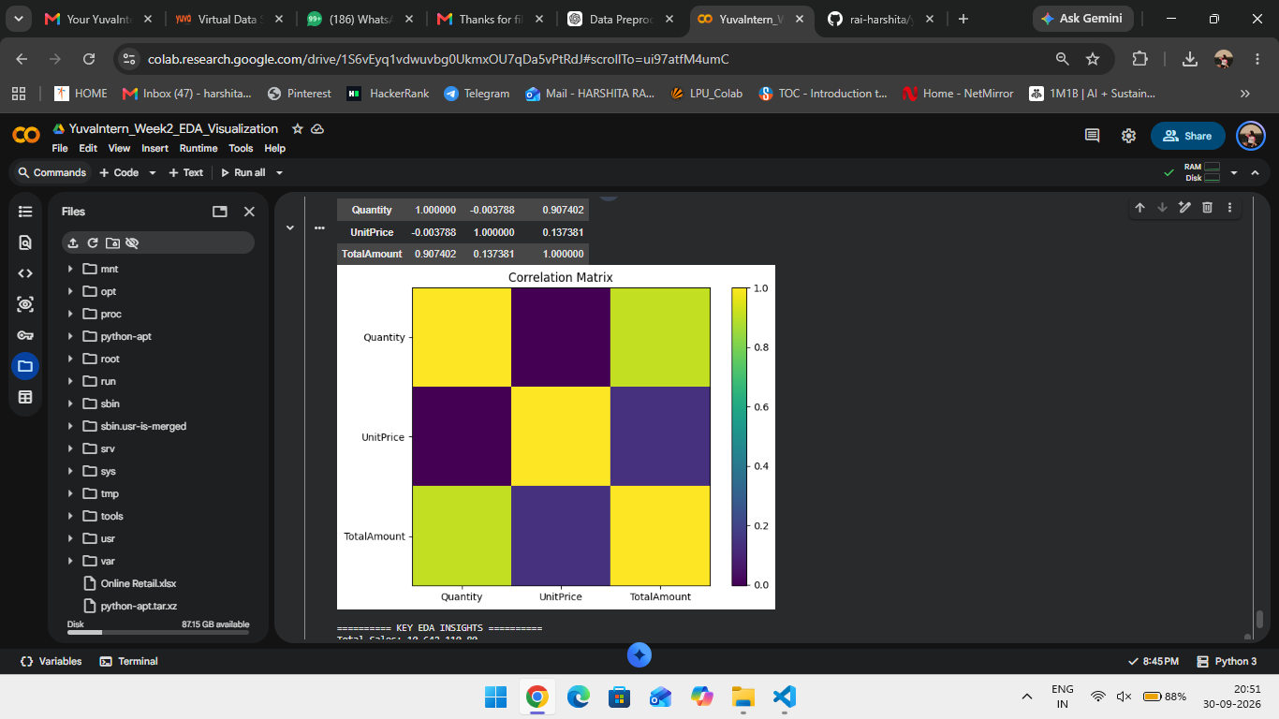
Figure 9: Correlation matrix for numerical transaction variables.

11. Key EDA Insights
- The cleaned dataset contains 524,878 transaction records and 9 columns.
- The United Kingdom contributes the largest total sales amount in the dataset.
- Monthly sales vary considerably, with a prominent peak in November 2011.
- The products with the highest sales value are not identical to the products with the highest quantities sold.
- Quantity and TotalAmount distributions are concentrated at lower values with long right tails.
- Customer spending analysis identifies a group of customers with substantially higher recorded spending.
- Quantity and TotalAmount have a strong positive correlation of approximately 0.9074.
- UnitPrice has a very weak correlation with Quantity and a relatively weak positive correlation with TotalAmount.

12. Conclusion
The Week 2 EDA examined the cleaned Online Retail dataset from multiple perspectives. Descriptive statistics, country-level sales analysis, time-series analysis, product analysis, distribution plots, customer spending analysis and correlation analysis were performed. These findings provide a foundation for the later machine-learning stages of the internship.

13. Project Links
Google Colab Notebook:
https://colab.research.google.com/drive/1S6vEyq1vdwuvbg0UkmxOU7qDa5vPtRdJ#scrollTo=ui97atfM4umC
GitHub Repository:
https://github.com/rai-harshita/yuva-intern-data-science

