UNSUPERVISED LEARNING AND CLUSTERING ANALYSIS
YuvaIntern – Week 3
Customer Segmentation using RFM Analysis and K-Means Clustering
Student Name: Harshita Rai

1. Introduction
This report presents an unsupervised learning and clustering analysis performed on the cleaned UCI Online Retail dataset as part of Week 3 of the YuvaIntern Data Science Internship. The objective was to segment customers according to purchasing behaviour without using predefined class labels. RFM analysis was used to represent customer behaviour through Recency, Frequency and Monetary value, followed by K-Means clustering.

2. Dataset and RFM Preparation
The cleaned dataset contains 524,878 transaction records and 9 columns. Customers with available CustomerID values were used for customer-level clustering. This resulted in an RFM dataset containing 4,338 customers and four columns: CustomerID, Recency, Frequency and Monetary.
Recency measures the number of days since a customer's latest purchase, Frequency represents the number of unique invoices, and Monetary represents the customer's total spending. The reference date was set to one day after the latest transaction date.

3. RFM Descriptive Statistics
The RFM variables show substantial variation among customers. Recency ranges from 1 to 374 days, Frequency ranges from 1 to 209 invoices, and Monetary value ranges from 3.75 to 280,206.02. The distributions are strongly concentrated toward lower values, with long tails.
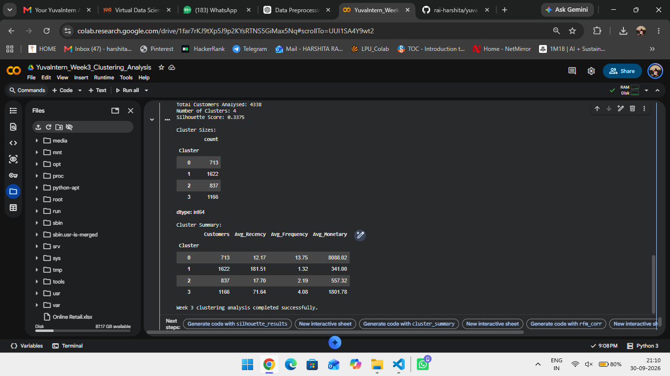
Figure 1: RFM descriptive statistics and distributions.

4. Data Transformation and Standardization
Because the RFM variables have different scales and skewed distributions, log1p transformation was applied to Recency, Frequency and Monetary values. The transformed features were then standardized using StandardScaler so that each feature could contribute appropriately to the clustering process.

5. Elbow Method
The Elbow Method was evaluated for cluster counts from 2 through 10. Inertia decreases as the number of clusters increases. The plot was used together with silhouette analysis to understand the effect of different cluster counts.
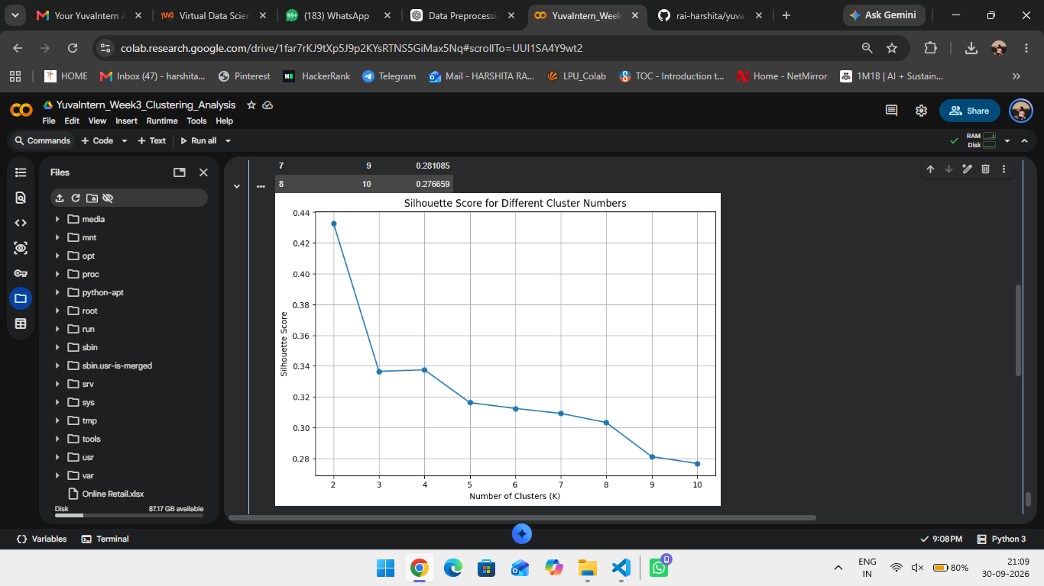
Figure 2: Elbow Method for different numbers of clusters.

6. Silhouette Analysis
Silhouette scores were calculated for K values from 2 to 10. The highest tested silhouette score was 0.432827 for K=2. The score for K=4 was 0.337517. For this project, K=4 was retained as the selected segmentation configuration used for the final customer clusters. Therefore, K=4 is reported as the chosen practical segmentation configuration rather than as the highest-scoring K according to silhouette alone.
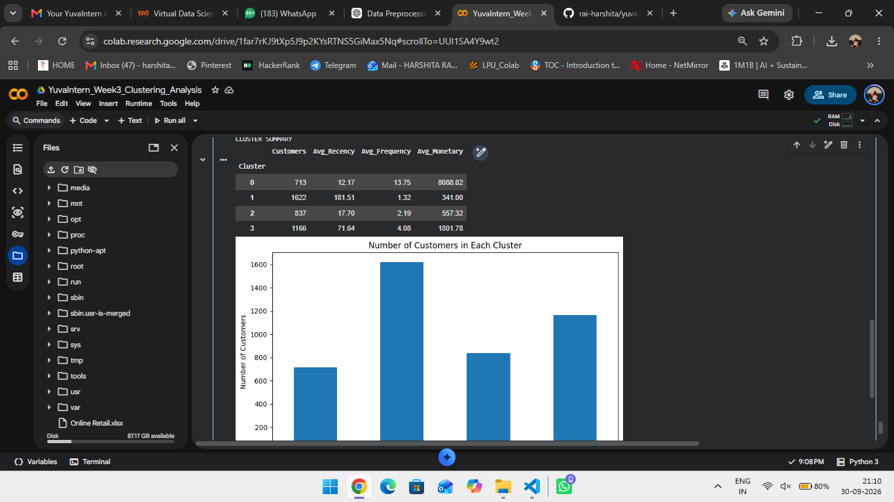
Figure 3: Silhouette scores for different cluster numbers.

7. K-Means Clustering
K-Means clustering with four clusters was applied to the standardized RFM features. The resulting clusters contain 713, 1,622, 837 and 1,166 customers respectively. The final silhouette score for the selected K=4 solution is 0.3375.
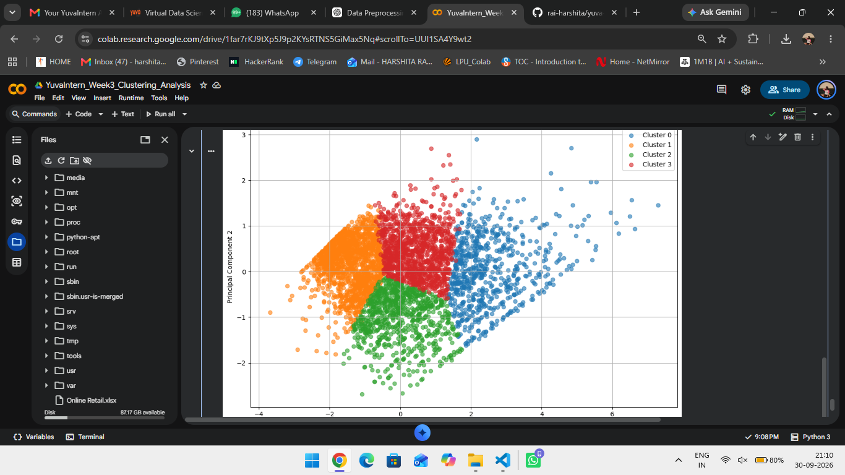
Figure 4: Cluster sizes and cluster summary.

8. Cluster Interpretation
Cluster | Customers | Avg Recency | Avg Frequency | Avg Monetary
0 | 713 | 12.17 | 13.75 | 8088.02
1 | 1622 | 181.51 | 1.32 | 341.00
2 | 837 | 17.70 | 2.19 | 557.32
3 | 1166 | 71.64 | 4.08 | 1801.78
Cluster 0 has low average recency, high frequency and the highest average monetary value among the four clusters. Cluster 1 has the highest average recency, the lowest frequency and the lowest average monetary value. Cluster 2 has low recency but comparatively low frequency and monetary value. Cluster 3 has intermediate recency, frequency and monetary values.

9. PCA Cluster Visualization
Principal Component Analysis (PCA) was used to reduce the standardized RFM feature space to two dimensions for visualization. The resulting scatter plot shows the four K-Means clusters in a two-dimensional representation.
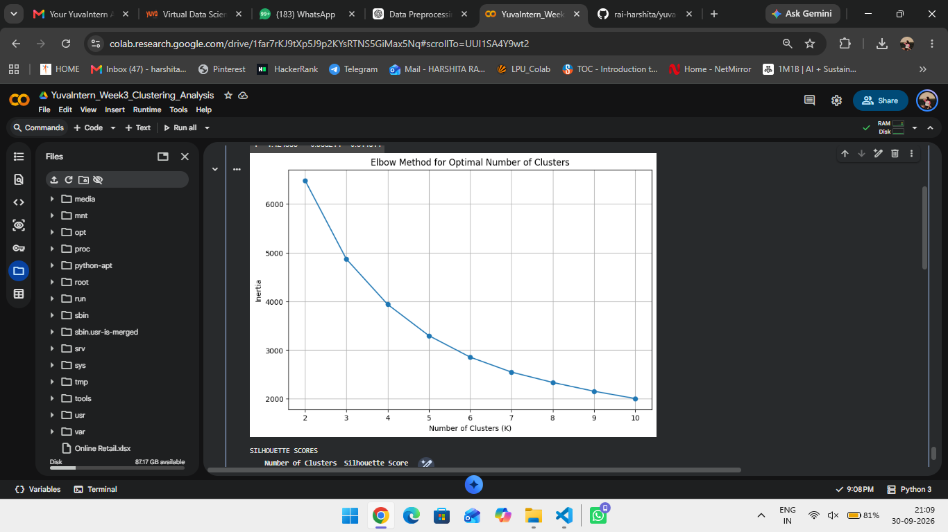
Figure 5: PCA visualization of customer clusters.

10. RFM Correlation Analysis
The RFM correlation matrix shows a moderate positive relationship between Frequency and Monetary (0.552780). Recency has a negative relationship with Frequency (-0.260578) and a smaller negative relationship with Monetary (-0.121831).
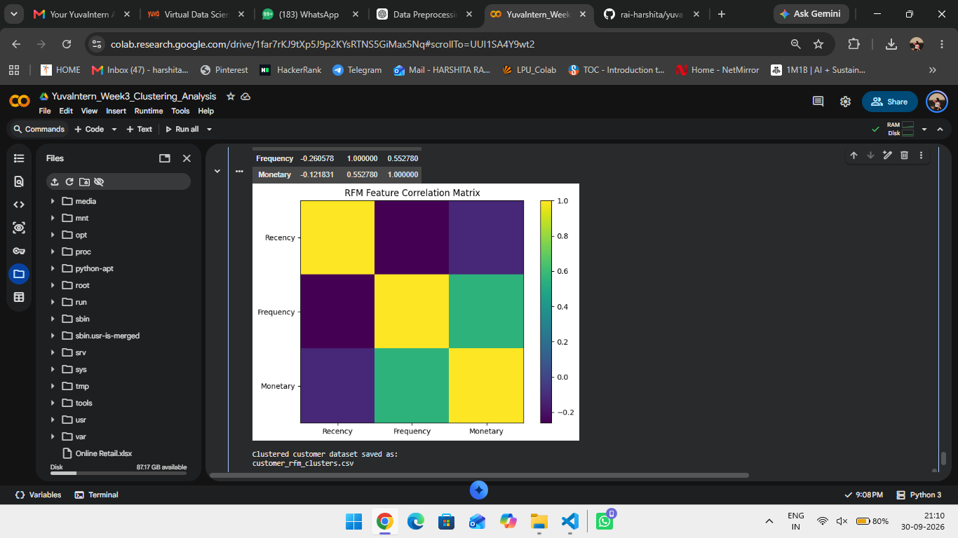
Figure 6: RFM feature correlation matrix.

11. Key Findings
- A total of 4,338 customers with available CustomerID values were analyzed.
- RFM features provide a compact representation of customer purchasing behaviour.
- The tested silhouette score was highest at K=2 (0.432827), while the selected K=4 solution produced a silhouette score of 0.337517.
- The four selected clusters contain 713, 1,622, 837 and 1,166 customers.
- Cluster 0 represents customers with recent activity, high purchase frequency and high monetary value.
- Cluster 1 contains customers with the longest recency, lowest frequency and lowest monetary value.
- Cluster 2 contains recent customers with lower frequency and spending than Cluster 0.
- Cluster 3 represents an intermediate customer group based on recency, frequency and monetary value.
- Frequency and Monetary show a moderate positive correlation.

12. Output File
The clustered customer dataset was exported as customer_rfm_clusters.csv for further analysis and reuse.

13. Conclusion
The Week 3 task demonstrated the use of unsupervised learning for customer segmentation. RFM analysis was used to transform transaction-level data into customer-level behavioural features, followed by log transformation, standardization and K-Means clustering. Elbow and silhouette analyses were used to evaluate cluster counts, while PCA provided a two-dimensional visualization of the resulting segments. The analysis demonstrates how clustering can reveal groups of customers with different purchasing behaviours.

14. Project Links
Google Colab Notebook:
https://colab.research.google.com/drive/1far7KJ9tXp5Jp2KxRTNS5GiMax5N#scrollTo=UUlSA4Y9wt2
GitHub Repository:
https://github.com/rai-harshita/yuva-intern-data-science

