**Online Beauty Parlor Management System (OBPMS)**

Database Description

**Database Description and Business Rule**

The Online Beauty Parlor Management System (OBPMS) is designed to efficiently store and manage various aspects of a beauty Parlor’s operations. MongoDB, a NoSQL document-oriented database, is utilized to provide a flexible and scalable solution for storing and retrieving data. The database design aims to capture the essential information required for effective salon management. Below is a description of the database structure and its key components:

1. **Database Name**

The MongoDB database for the OBPMS is named "Parlour".

1. **Collections**

The following collections are defined within the “Parlour”:

1. users:

This collection stores information about salon clients, such as their id (unique identifier), name, email, phone, password, and photo URL.

1. products:

The Products collection represents the various services offered by the parlours. Each document of product contains fields like service ID, title, photo, description, duration, price, and Parlour id.

1. books:

This collection represents the details of all reservations made by clients and front desk or parlor admin. It contains fields like Reservation id, name of clients, service, appointment time and date, time taken to complete the service, service completion time, price, parlour id, and client id.

1. Products:

The Products collection stores information about the parlor's services, including their ID, name, description, price, what time it was added, and availability options.

1. **Indexes:**

Indexes improve the performance of queries by allowing faster data retrieval based on specific fields. In the parlour DB, the following indexes can be created:

1. Users’ collection:

Index on the client's unique identifier for quick access to individual client records. Index on the preferred stylist field for efficient searching based on stylist preferences.

1. admin collection:

Index for the admin’s ID for fast retrieval of parlor details like name, email, address, and zip code that is associated with that admin.

1. services collection:

Index for the service ID to enable quick service lookup and availability. Index on the service name for efficient searching based on service names.

1. appointment collection:

Index for the appointment time to facilitate sorting and searching based on appointment schedules. Index for the client ID and stylist ID to enable fast retrieval of appointments by the client.

1. stylist collection:

Index for the stylist for fast retrieval of stylist information like name, services they can do, etc.

This database design provides a foundation for managing the essential aspects of a salon's operations, including client information, services, and appointments. With MongoDB's flexibility, scalability, and powerful querying capabilities, the OBPMS can efficiently handle the data requirements of a salon, making it easier to organize and streamline salon operations.

1. **Document Database Model**

This document database model captures the essential information required for an Online Beauty Parlour Management System. It includes collections for users, products(services), appointments, and parlor details. Each document within the collections contains fields representing specific attributes related to the respective entity.

Appointments Document as appointments.

Admin Document as admins.

Client or user Document as users.

Services Document as services.

Stylist Documents as stylist.

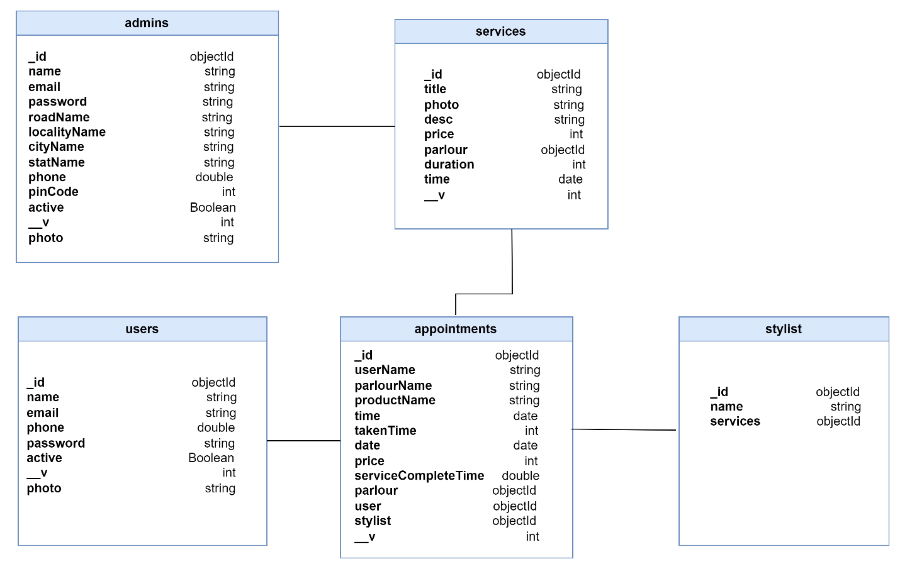

1. **Collections:**

MongoDB stores documents in collections. Collections are analogous to tables in relational databases. For OBPMS, we have 5 collections: admins, appointments, services, stylist and users.

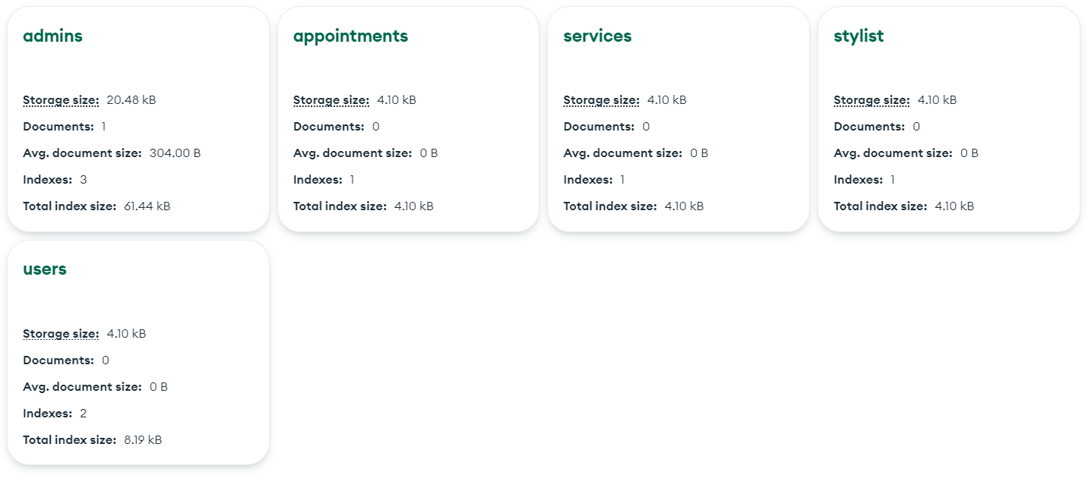

1. **Sample Data**

