Login / connect to ubuntu through winscp

Connect using putty

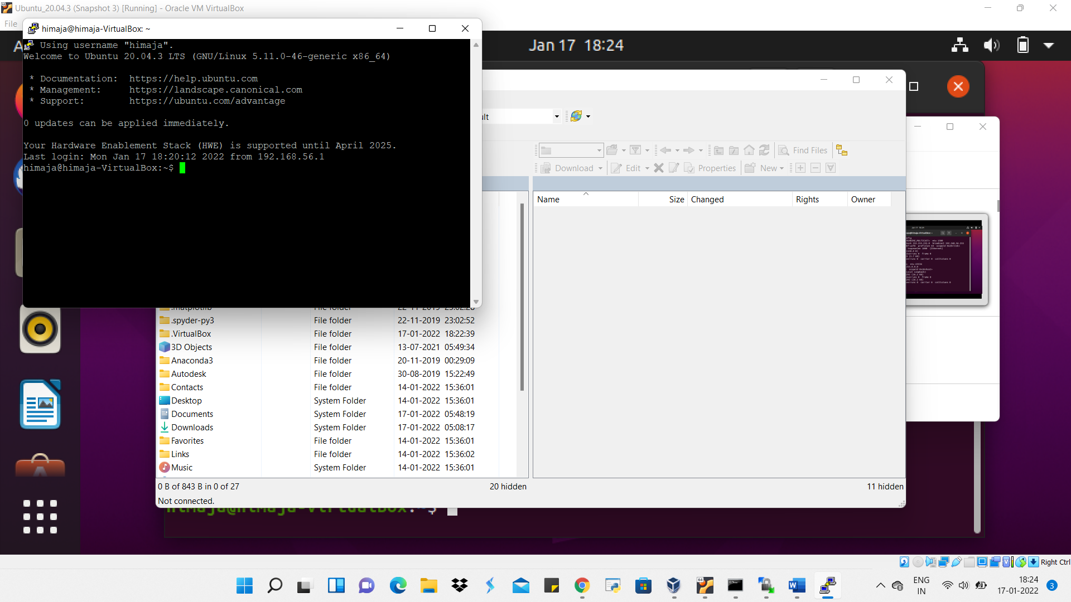

Find ip

Bridge port login : fingerprint key

ssh-ed25519 255 4sd8pD/rHyvhXF0jW+XrU0zWSUpTcoK1SNQlOh9MvJM=

ssh-ed25519 255 fb:59:0c:3a:be:75:09:c6:9c:33:2b:91:6d:e1:ce:95

NAT(Not working)

Bridgeadapter (working)

