**SCHEDULING ALGORITHMS**

**700747110**

**Chaitanya Chennu**

1. The language used: python
2. Execution: use terminal (or) anaconda using jupyter notebook
3. Total number of algorithms: 6 (3 – Preemptive, 3 – Non-preemptive)
4. Priority Round Robin Algorithm (Preemptive)
5. First Come First Serve Algorithm (Non-Preemptive)
6. Priority Scheduling Algorithm (Non-Preemptive)
7. Round Robin Scheduling Algorithm (Preemptive)
8. Shortest Job First Algorithm (Non-Preemptive)
9. Shortest Remaining Time Algorithm (Preemptive)
10. Input: From ppt slides, text and json files are used for adding process details
11. Output: Expected output from ppt and added Gantt chart for 6 algorithms using matplot package in python.

**PRIORITY WITH ROUND-ROBIN SCHEDULING ALGORITHM (PREEMPTIVE)**

1. **Input:** Source code and use text File (Process Details)
2. **Output from the terminal:**

Command: python priority_round_robin_preemptive(f).py

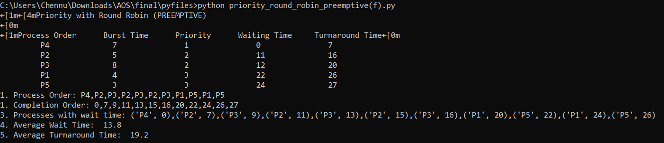

1. **Output from anaconda:**
2. Open the python file(.ipynb) in the anaconda Jupyter notebook
3. Click “RUN”

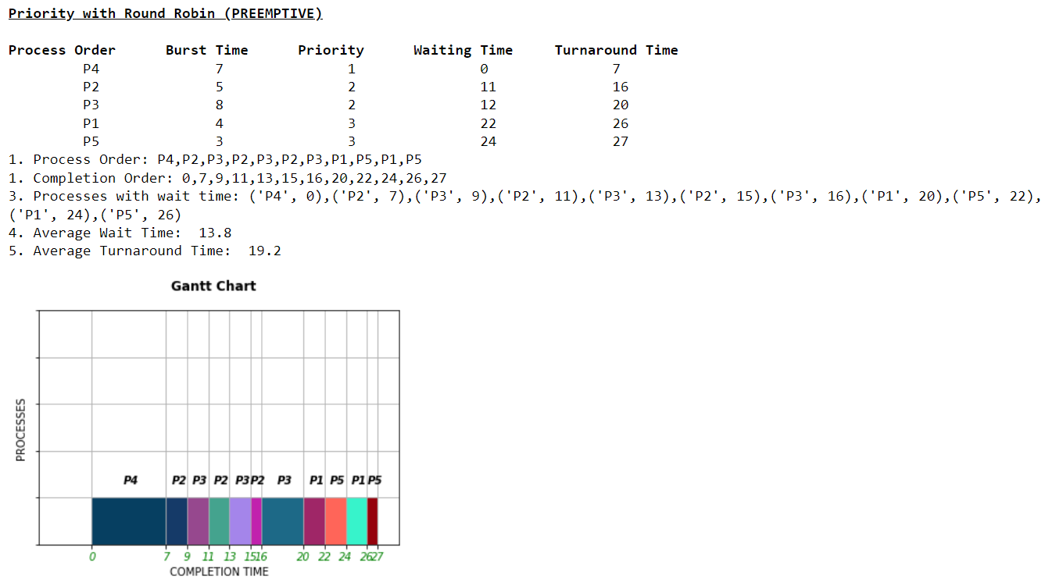

**FIRST COME FIRST SERVE ALGORITHM (NON-PREEMPTIVE)**

1. **Input:** Source code and use text File (Process Details)
2. **Output from the terminal:**

Command: python first_come_first_serve_nonpreemptive(f).py

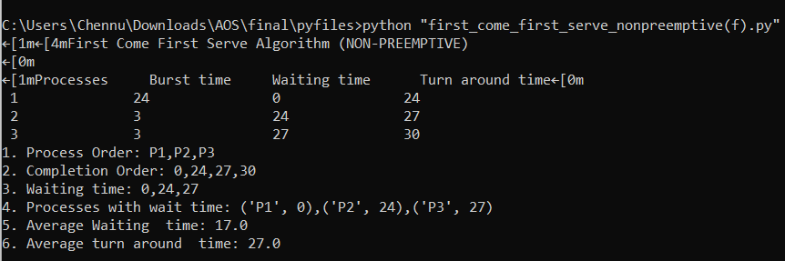

1. **Output from anaconda:**
2. Open the python file(.ipynb) in the anaconda Jupyter notebook
3. Click “RUN”

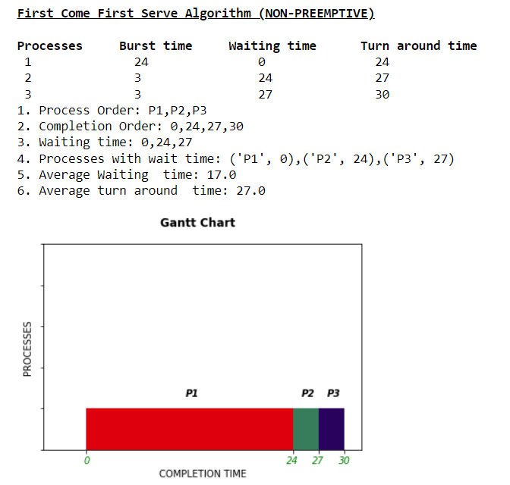

**PRIORITY SCHEDULING ALGORITHM (NON-PREEMPTIVE)**

1. **Input:** Source code and use text File (Process Details)
2. **Output from the terminal:**

Command: python priority_scheduling_nonpreemptive(f).py

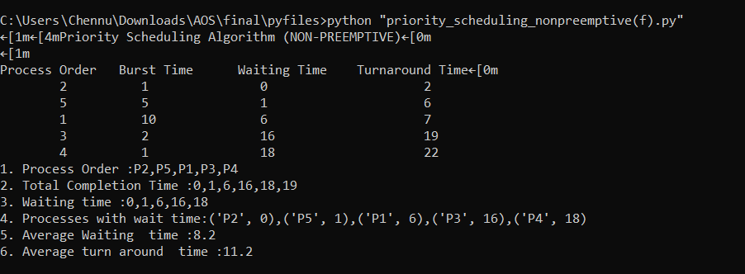

1. **Output from anaconda:**
2. Open the python file(.ipynb) in anaconda Jupyter notebook
3. Click “RUN”

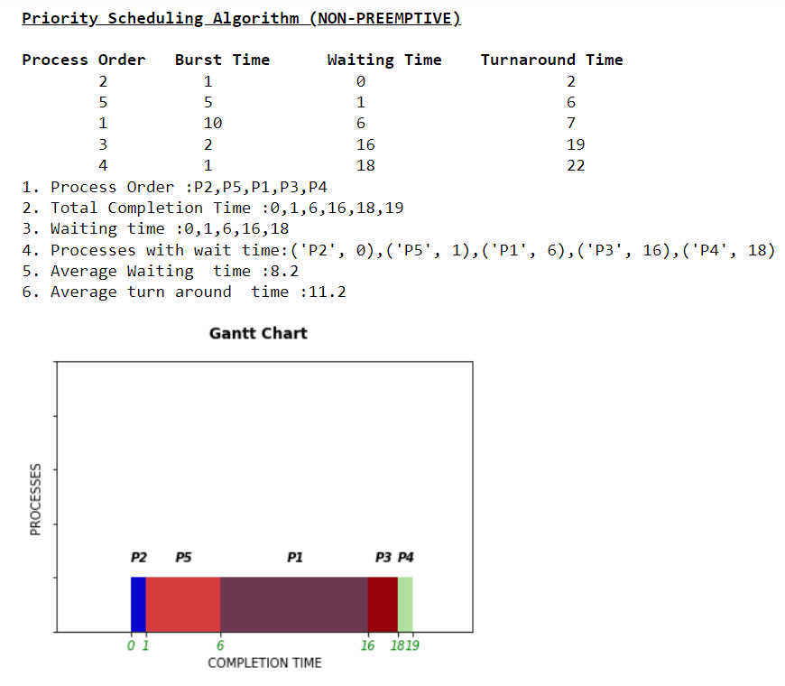

**ROUND ROBIN SCHEDULING ALGORITHM (PREEMPTIVE)**

1. **Input:** Source code and use text File (Process Details)
2. **Output from the terminal:**

Command: python round_robin_preemptive(f).py

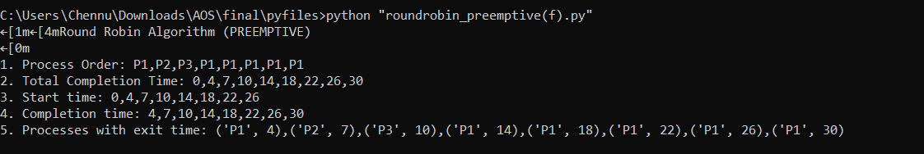

1. **Output from anaconda:**
2. Open python file(.ipynb) in anaconda Jupyter notebook
3. Click “RUN

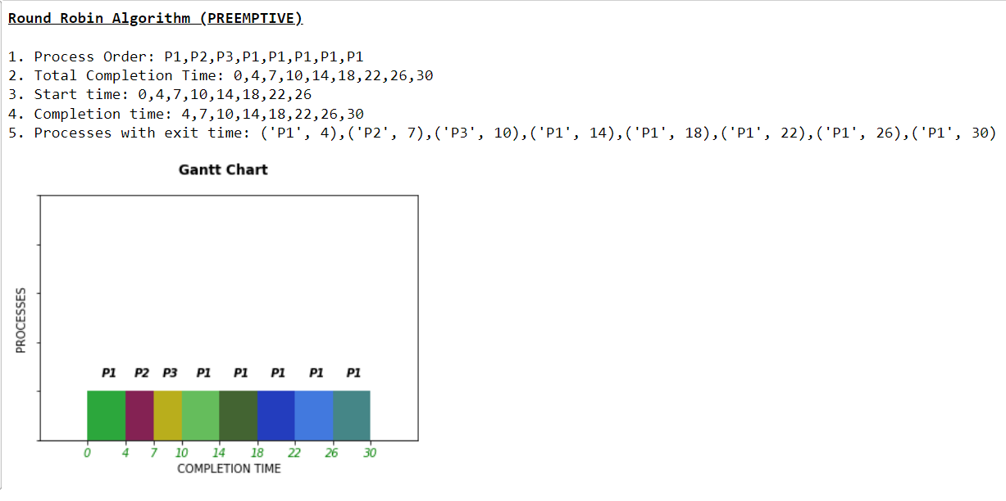

**SHORTEST JOB FIRST (NON-PREEMPTIVE)**

1. **Input:** Source code and use text File (Process Details)
2. **Output from the terminal:**

Command: python shortest_job_first_nonpreemptive(f).py

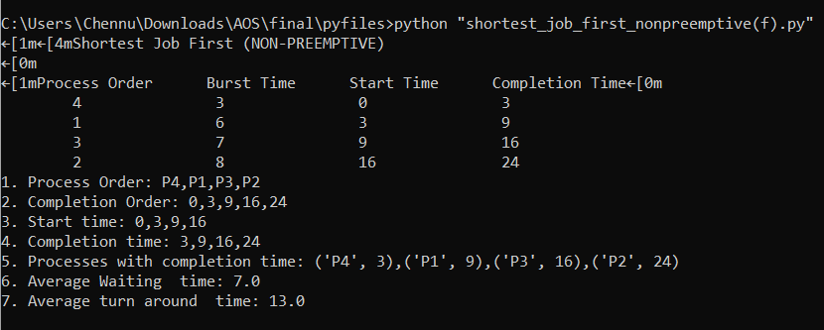

1. **Output from anaconda:**
2. Open python file(.ipynb) in anaconda Jupyter notebook
3. Click “RUN”

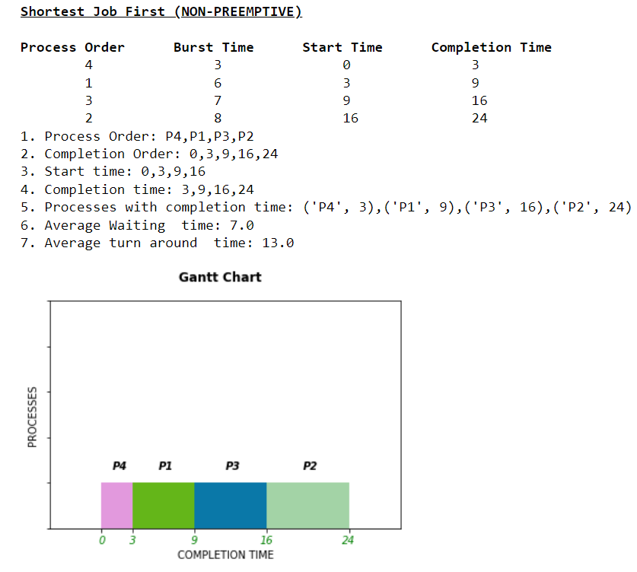

**SHORTEST REMAINING TIME (PREEMPTIVE)**

1. **Input:** Source code and use text File (Process Details)
2. **Output from the terminal:**

Command: python shortest_remaining_time_preemptive(f).py

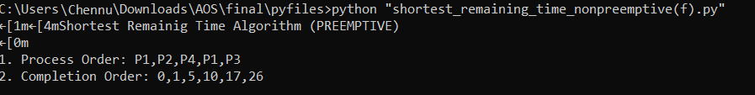

1. **Output from anaconda:**
2. Open python file(.ipynb) in anaconda Jupyter notebook
3. Click “RUN”

