

LAJPAT RAI | BSCS-21f-11

CIS

Sir Atif Jamil

16-Nov-2024

Assignment # 01

**Computer and information security**

Dawood University of Engineering and Technology

**(1) mono alphabetic**

## **a) Additive Cypher**

def preprocess_text(text, remove_spaces=True):

    text = ''.join([c for c in text if c.isalpha()])

    if remove_spaces:

        text = text.replace(" ", "")

    return text.upper()

def additive_encrypt(plain_text, key):

    plain_text = preprocess_text(plain_text)

    cipher_text = ""

    for char in plain_text:

        shifted = (ord(char) - ord('A') + key) % 26

        encrypted_char = chr(shifted + ord('A'))

        cipher_text += encrypted_char

    return cipher_text

def additive_decrypt(cipher_text, key):

    cipher_text = preprocess_text(cipher_text)

    plain_text = ""

    for char in cipher_text:

        shifted = (ord(char) - ord('A') - key) % 26

        decrypted_char = chr(shifted + ord('A'))

        plain_text += decrypted_char

    return plain_text

plain_text = input("Enter plain text: ")

key = int(input("Enter key (0-25): "))

encrypted_text = additive_encrypt(plain_text, key)

decrypted_text = additive_decrypt(encrypted_text, key)

print("Encrypted Text:", encrypted_text)

print("Decrypted Text:", decrypted_text)

**OUTPUT**

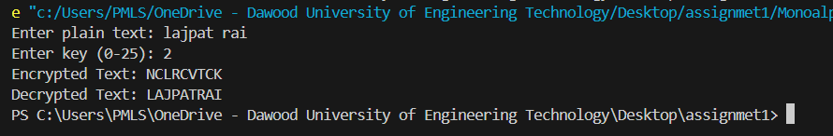

## **b) Multiplicative Cypher**

def mod_inverse(a, m):

    for x in range(m):

        if (a * x) % m == 1:

            return x

    return -1

def preprocess_text(text):

    return ''.join([c.upper() for c in text if c.isalpha()])

def multiplicative_encrypt(plain_text, key):

    plain_text = preprocess_text(plain_text)

    cipher_text = ""

    for char in plain_text:

        encrypted_char = chr(((ord(char) - ord('A')) * key % 26) + ord('A'))

        cipher_text += encrypted_char

    return cipher_text

def multiplicative_decrypt(cipher_text, key):

    cipher_text = preprocess_text(cipher_text)

    inverse_key = mod_inverse(key, 26)

    if inverse_key == -1:

        raise ValueError("No modular inverse exists for the provided key.")

    plain_text = ""

    for char in cipher_text:

        decrypted_char = chr(((ord(char) - ord('A')) * inverse_key % 26) + ord('A'))

        plain_text += decrypted_char

    return plain_text

plain_text = input("Enter plain text: ")

key = int(input("Enter key (must be coprime with 26): "))

encrypted_text = multiplicative_encrypt(plain_text, key)

decrypted_text = multiplicative_decrypt(encrypted_text, key)

print("Encrypted Text:", encrypted_text)

print("Decrypted Text:", decrypted_text)

**OUTPUT**

## **c) Affine Cypher**

def preprocess_text(text):

    return ''.join([c.upper() for c in text if c.isalpha()])

def mod_inverse(a, m):

    for i in range(1, m):

        if (a * i) % m == 1:

            return i

    return None

def affine_encrypt(plain_text, key1, key2):

    plain_text = preprocess_text(plain_text)

    cipher_text = ''.join([chr(((ord(c) - ord('A')) * key1 + key2) % 26 + ord('A')) for c in plain_text])

    return cipher_text

def affine_decrypt(cipher_text, key1, key2):

    cipher_text = preprocess_text(cipher_text)

    inverse_key1 = mod_inverse(key1, 26)

    if inverse_key1 is None:

        return "Error: No modular inverse found for the key"

    plain_text = ''.join([chr((inverse_key1 * (ord(c) - ord('A') - key2)) % 26 + ord('A')) for c in cipher_text])

    return plain_text

plain_text = input("Enter plain text: ")

key1 = int(input("Enter key1 (multiplicative key): "))

key2 = int(input("Enter key2 (additive key): "))

encrypted_text = affine_encrypt(plain_text, key1, key2)

decrypted_text = affine_decrypt(encrypted_text, key1, key2)

print(f"Encrypted Text: {encrypted_text}")

print(f"Decrypted Text: {decrypted_text}")

**OUTPUT**

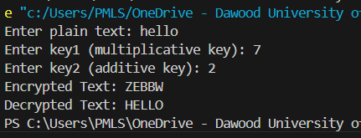

**(2) poly alphabetic**

## **a) Playfair Cypher**

import numpy as np

# Helper function to preprocess the text

def preprocess_text(text, remove_spaces=True):

    text = text.replace(" ", "") if remove_spaces else text

    return ''.join([c.upper() for c in text if c.isalpha()])

# Helper function to create the 5x5 Playfair key matrix

def create_playfair_matrix(key):

    key = preprocess_text(key)

    key_matrix = []

    used_letters = set()

    for char in key + "ABCDEFGHIKLMNOPQRSTUVWXYZ":  # J is usually merged with I

        if char not in used_letters and char != 'J':

            key_matrix.append(char)

            used_letters.add(char)

    return np.array(key_matrix).reshape(5, 5)

# Helper function to format plaintext for Playfair cipher

def format_playfair_text(text):

    text = preprocess_text(text)

    formatted_text = ""

    i = 0

    while i < len(text):

        if i == len(text) - 1:

            formatted_text += text[i] + 'X'

            i += 1

        elif text[i] == text[i + 1]:

            formatted_text += text[i] + 'X'

            i += 1

        else:

            formatted_text += text[i] + text[i + 1]

            i += 2

    return formatted_text

# Function to find position of a letter in the matrix

def find_position(matrix, letter):

    for row in range(5):

        for col in range(5):

            if matrix[row][col] == letter:

                return row, col

    return None, None

# Playfair encryption

def playfair_encrypt(plain_text, key):

    matrix = create_playfair_matrix(key)

    plain_text = format_playfair_text(plain_text)

    cipher_text = ""

    for i in range(0, len(plain_text), 2):

        r1, c1 = find_position(matrix, plain_text[i])

        r2, c2 = find_position(matrix, plain_text[i + 1])

        if r1 == r2:

            cipher_text += matrix[r1][(c1 + 1) % 5] + matrix[r2][(c2 + 1) % 5]

        elif c1 == c2:

            cipher_text += matrix[(r1 + 1) % 5][c1] + matrix[(r2 + 1) % 5][c2]

        else:

            cipher_text += matrix[r1][c2] + matrix[r2][c1]

    return cipher_text

# Playfair decryption

def playfair_decrypt(cipher_text, key):

    matrix = create_playfair_matrix(key)

    plain_text = ""

    for i in range(0, len(cipher_text), 2):

        r1, c1 = find_position(matrix, cipher_text[i])

        r2, c2 = find_position(matrix, cipher_text[i + 1])

        if r1 == r2:

            plain_text += matrix[r1][(c1 - 1) % 5] + matrix[r2][(c2 - 1) % 5]

        elif c1 == c2:

            plain_text += matrix[(r1 - 1) % 5][c1] + matrix[(r2 - 1) % 5][c2]

        else:

            plain_text += matrix[r1][c2] + matrix[r2][c1]

    return plain_text

# Input and Output demonstration

if __name__ == "__main__":

    plain_text = input("Enter the plain text: ")

    key = input("Enter the key: ")

    encrypted_text = playfair_encrypt(plain_text, key)

    print("Encrypted Text:", encrypted_text)

    decrypted_text = playfair_decrypt(encrypted_text, key)

    print("Decrypted Text:", decrypted_text)

**OUTPUT**

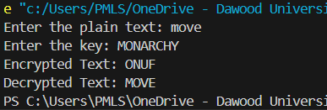

## **b) Autokey Cypher**

def preprocess_text(text):

    return ''.join([c.upper() for c in text if c.isalpha()])

def autokey_encrypt(plain_text, key):

    plain_text = preprocess_text(plain_text)

    key_stream = (key + plain_text)[:len(plain_text)]

    cipher_text = ""

    for p, k in zip(plain_text, key_stream):

        encrypted_char = chr((ord(p) - ord('A') + ord(k) - ord('A')) % 26 + ord('A'))

        cipher_text += encrypted_char

    return cipher_text

def autokey_decrypt(cipher_text, key):

    cipher_text = preprocess_text(cipher_text)

    key_stream = key

    plain_text = ""

    for i in range(len(cipher_text)):

        decrypted_char = chr((ord(cipher_text[i]) - ord('A') - (ord(key_stream[i]) - ord('A'))) % 26 + ord('A'))

        plain_text += decrypted_char

        key_stream += decrypted_char

    return plain_text

plain_text = input("Enter plain text: ")

key = input("Enter key: ")

encrypted_text = autokey_encrypt(plain_text, key)

decrypted_text = autokey_decrypt(encrypted_text, key)

print("Encrypted Text:", encrypted_text)

print("Decrypted Text:", decrypted_text)

**OUTPUT**

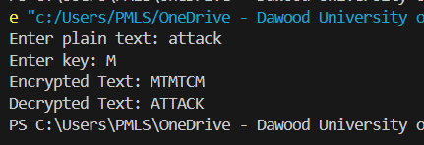

## **c) Vigenère Cypher**

def preprocess_text(text):

    return ''.join([c.upper() for c in text if c.isalpha()])

def vigenere_encrypt(plain_text, key):

    plain_text = preprocess_text(plain_text)

    key = (key * ((len(plain_text) // len(key)) + 1))[:len(plain_text)]

    cipher_text = ''.join([chr((ord(p) - ord('A') + ord(k) - ord('A')) % 26 + ord('A')) for p, k in zip(plain_text, key)])

    return cipher_text

def vigenere_decrypt(cipher_text, key):

    cipher_text = preprocess_text(cipher_text)

    key = (key * ((len(cipher_text) // len(key)) + 1))[:len(cipher_text)]

    plain_text = ''.join([chr((ord(c) - ord('A') - (ord(k) - ord('A'))) % 26 + ord('A')) for c, k in zip(cipher_text, key)])

    return plain_text

plain_text = input("Enter plain text: ")

key = input("Enter key: ")

encrypted_text = vigenere_encrypt(plain_text, key)

decrypted_text = vigenere_decrypt(encrypted_text, key)

print(f"Encrypted Text: {encrypted_text}")

print(f"Decrypted Text: {decrypted_text}")

**OUTPUT**

