TASK 01:

Grep command is used for pattern search.

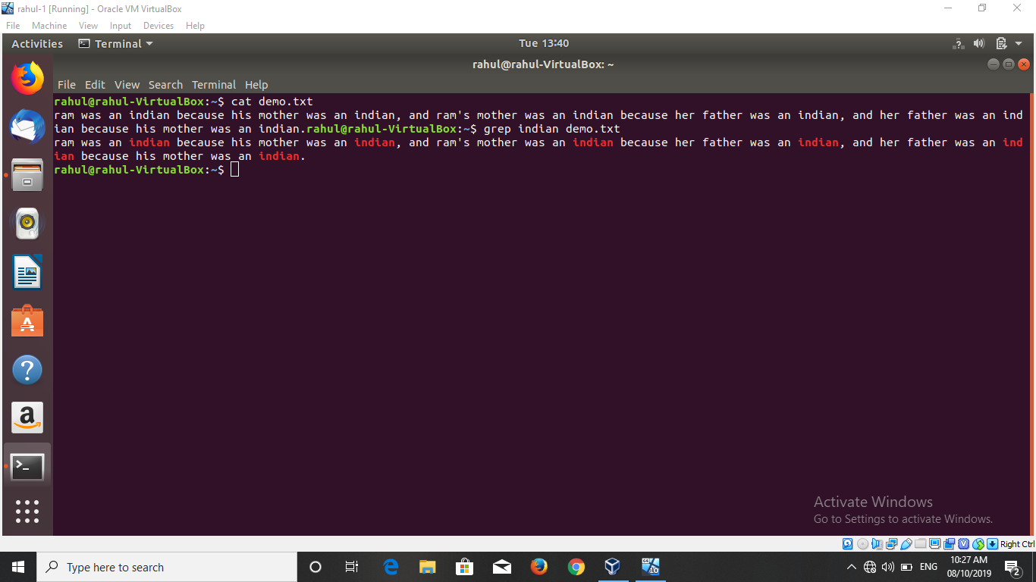

TASK 02:

There are 3 permissions used in linux. They are-

1. w: it is used for write permission.
2. r: it is used for read permission.
3. x: it is used for execute permission.

There are 3 symbols use for giving permission.

‘+’ for adding permission.

‘-‘ for removing permission.

‘=’ for assigning permission.

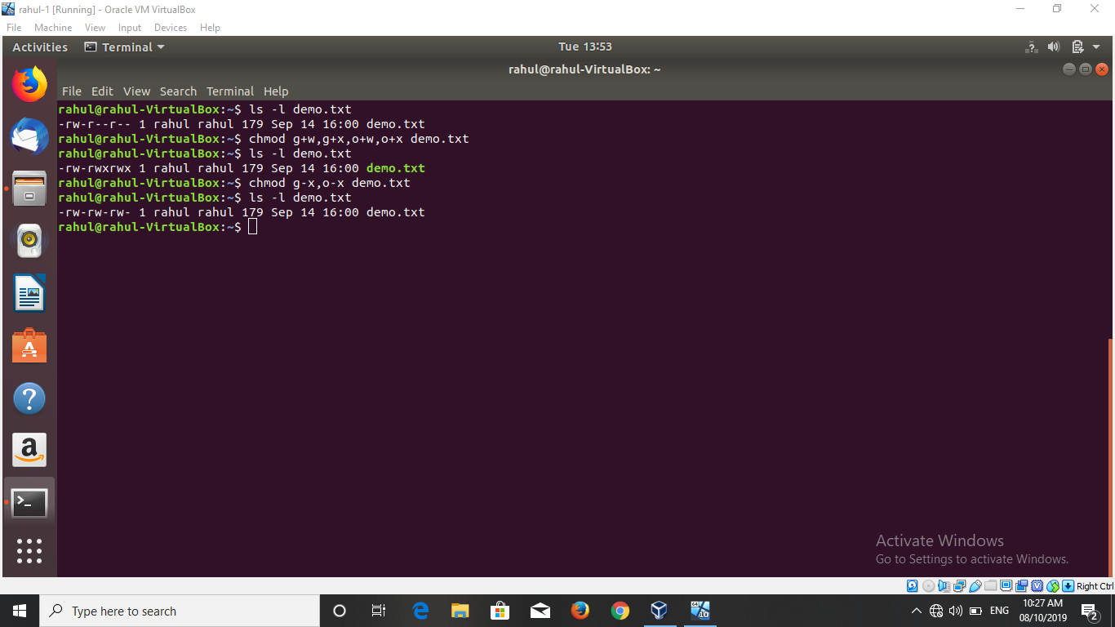

TASK 03:

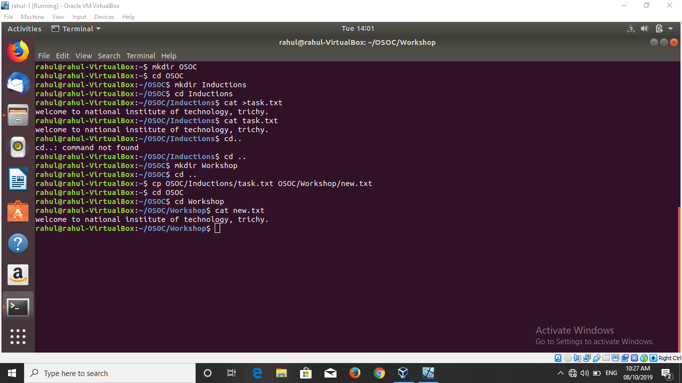

TASK 04:

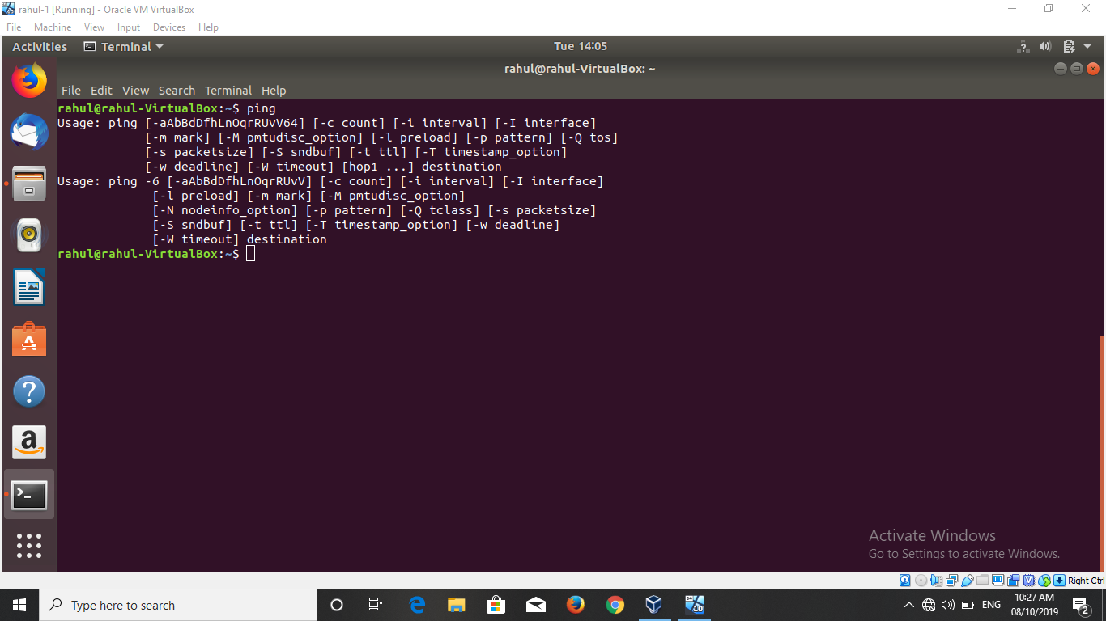

TASK 05:

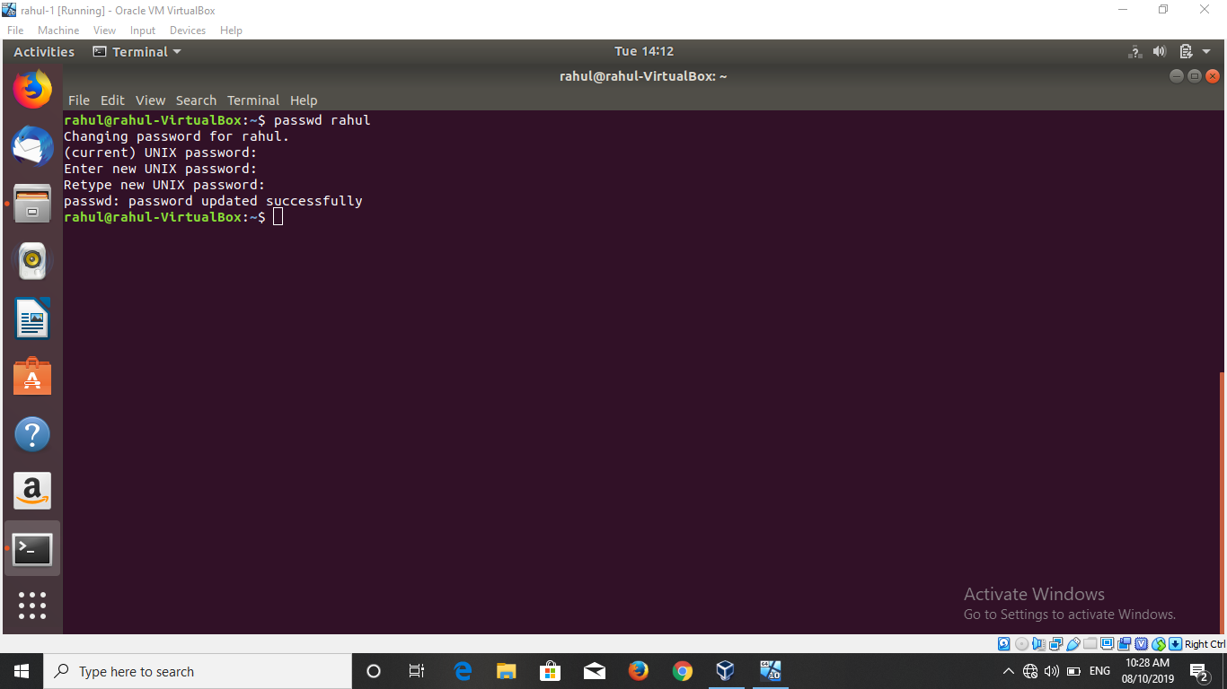

TASK 06:

