Automation Framework Process

SYNECHRON
http://www.synechron.com
JULY 26th, 2010
Table of Contents
1 Introduction 3
1.1 Purpose 3
1.2 Description 3
2 Test Automation and Usage 4
3 Advantages and Disadvantages of Automation 5
3.1 Advantages 5
3.2 Disadvantages 5
4 How much automation is enough? 8
5 When to Automate? (ROI) 9
6 Checklist for Automation 10
7 Recording and Programming Scripts 11
8 Automated Testing Frameworks 12
8.1 Goals 12
8.2 12
9 When to Automate? 13

History
Version | Date | Author | Reviewer | Description
0.1 | 09/01/2010 | Dineshsingh Patil | Vasant Khokale | 1st Draft

Introduction

Purpose
The purpose of this document is to furnish details about test automation process adopted by Synechron. This document is a how to reference that has some practical tips, tricks, and suggestions, along with a proven approach.

Description
This document explains test automation and describes the process to be followed prior to starting automation for a testing project. It describes pros and cons of automation and tools to be used for automating a particular requirement. It also educates the user on the ROI in automation and establishes a realistic expectation. This document touches various real-time situations faced during automation and describes ways to overcome them.
This document assumes that you have some serious questions about the practical aspects of test automation. You may, or may not, have a successful implementation. In any case, you most probably have experienced the operational, political, and cultural pitfalls of test automation.

Test Automation and Usage
Test automation means tool support for all aspects of a test project, not just test execution. Test automation process is one of the many new technologies used in analyzing and evaluating test results that appear to be a big help in companies. Private organizations, businesses and even governments are able to produce quick results through the use of this system.
Test automation is commonly used to support the following testing types:
- Functional Testing: Is the process when performed operations meet the expectations.
- Regression testing: Is when the system's behavior remains the same.
- Exception or Negative testing: Forces error condition throughout the system.
- Stress Testing: Determines the capacities of the operational infrastructure and the application.
- Performance testing: Assures that there will be adequate system performance for both online transactions and batch runs that are relevant to business requirements and projections.
- Load Testing: Determines the situation when the software or hardware upgrades would be needed due to degraded performance and capacity of the system.

Advantages and Disadvantages of Automation

Advantages
- Reduction in Test Cycle time for releases: It is ten times faster than the manual process. It can save not only time but the effort and use of man power as well.
- Leverage Costly Hardware: Companies nowadays invest hugely in purchasing costly hardware which is often underutilized during night time. This hardware can be used efficiently to run automation in the night this leveraging hardware investment to its fullest.
- Reliability: It can precisely perform the same task every time you use it and deliver results one can depend on. One must ensure that the pre-environment is properly set before executing automated tests.
- Repeatable: One can run automated tests repeatedly to analyze commonly repeated tests. Moreover, this process is programmable and reusable. You can easily program the software and reuse it on the application's other different versions.
- Simplifies Testing: Test automation helps simplify testing by segregating manual and automated tests. Thus, one can easily keep track of non-automated tests and dedicate manual effort towards it.
- Log Tests Results Accurately: Test results can now be logged accurately and saved for future use. One can use it to verify if a build succeeded previously or not.
- Less Manual labor required: The prime intention of purchasing an automation tool is to reduce expensive cost incurred in hiring labor.

Disadvantages
- High Cost Incurred: The following three types of costs are also involved:
  - Tool Procurement: Proprietary automated tools require a huge investment initially. Thus one needs to evaluate the cost/benefit ratio of any tool before purchasing it else you will end up purchasing the wrong tool.
  - Resource Procurement: Getting resources on board with expertise in a specific tool or training them on that tool involves a good amount.
  - Development: Developing an automation framework or a project often involves cost and one has to be pretty sure that the right approach is being used during development. A faulty approach can lead to the entire automation being on shelf and unused.
  - Maintenance: Maintenance costs are the most significant for any automation project. Any automation requires maintenance over time to keep it in use and delivering correct results. Many organizations are increasingly dependent on automation to test earlier releases using automation. They cannot afford to
- No Full Feature Support available in one tool: There is not a single tool available in the market that supports all platforms and technologies.
Another major disadvantage is that this system does not provide one hundred percent accuracy in analyzing results. The main cause is because of its sensitivity, as stated above, that it gathers unnecessary and wrong data. It is also difficult to handle technical problems and to troubleshoot the automated machine problems. The operator should be knowledgeable enough to know how to fix these problems. It is a major issue in debugging test scripts. Sometimes it can cause a huge trouble if there is an error present in the test script.
If you are interested in Test automation process, check this web-site to learn more about application testing process.

How much automation is enough?
This is the question that has been asked since the inception of automated test tools. Tools vendors have presented us with one point of view, and industry experts have given us varied viewpoints. Vendors began with basic capture/playback tools that have evolved into some very sophisticated and highly integrated tool suites. They seem to have left it to the practitioner to determine what lies beyond the basic capture/playback model.
In this text we will give you our point of view on how to do test automation.

When to Automate? (ROI)

Checklist for Automation

1. Choosing a Tool
a. Reporting is XML based. i.e. reporting schema can be altered according to user needs.
b. Reporting should:
i. be XML based
ii. have optional support for Test Management tools.
iii. XML schema should be customizable according to user needs.
iv. Reporting modules should be easily modified to suit user needs.
c. Should be suited to the needs of your project.

Test Automation Process

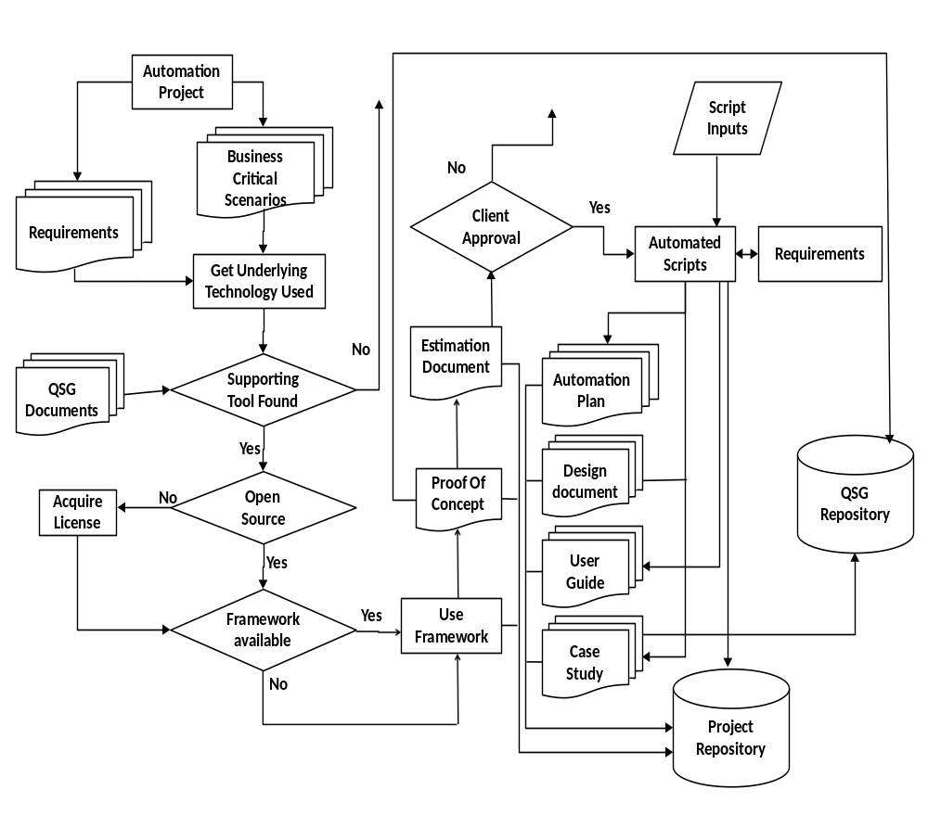

Recording and Programming Scripts

Automated Testing Frameworks

Goals
- Minimize test script maintenance: The traditional capture/playback model that testing tool vendors have championed for years leads to inordinately high script maintenance because the test data are hard coded in the body of the test script. Hence, avoid record and playback as far as possible.
- Map automated Tests to requirements: The ultimate goal of any automation effort should be a set of planned tests that corresponds to a set of test requirements that in turn are reflected in the automated tests. No automated test must be such that it does not have a corresponding requirement.

When to Automate?

