COUPON PERSONALIZATION
WITH UPLIFT MODELLING
A Databricks Implementation Guide
Segmentation & Feature Store · Treatment-vs-Holdout Campaigns
Uplift Modelling · Budget Optimization · Incremental-Lift Learn Loop
What this document covers
A step-by-step explanation of the three-stage coupon-personalization pipeline and the accompanying Databricks code. Every process box in the three design slides maps to a notebook and a section here.
Deep-dive focus, as requested, on three topics: the treatment-vs-holdout campaign run, uplift modelling, and offer optimization.

Table of Contents

1. System Overview
This project personalizes retail coupons so that each coupon is sent to the customer it will actually influence — not to customers who would have bought anyway, and not to customers a coupon cannot move. It does this by learning, from a controlled experiment, the incremental effect of a coupon on each customer, then allocating a finite coupon budget to the customers with the highest profitable incremental effect.
The design has three stages, each a notebook (or set of notebooks) in the accompanying code:
Stage | Theme | What it produces
Stage 1 | Segmentation & Feature Store | Customer routing, value-tier segments, a published Feature Store
Stage 2 | Campaign execution, training & validation | A treatment/holdout campaign and a registered uplift model
Stage 3 | Batch scoring, optimization, delivery & learn | Per-customer offers within budget, measured lift, a retrain loop

The core idea in one sentence
Treat every coupon as a small experiment, learn who is genuinely persuadable, and spend the budget only on them — then keep a control group forever so you can always prove the lift was real.

1.1 Code structure
The repository is organised so each design box maps to a notebook:
Notebook | Stage | Role
src/config.py | — | Shared table names, Feature Store, MLflow and business parameters
01_data_generation | — | Synthetic POS + customer data (swap for real sources)
02_stage1_segmentation_feature_store | 1 | Routing, clustering, profiling, Feature Store publish
03_stage2_campaign_design | 2a | Select segment → randomized treatment/holdout split
04_stage2_run_campaign | 2b | Run campaign, collect redemption + purchase outcomes
05_stage2_uplift_model | 2c | T-learner uplift model, Qini benchmark, MLflow register
06_stage3_scoring_optimization | 3a | Batch score + budget-constrained optimization
07_stage3_delivery_lift_retrain | 3b | Delivery, incremental lift vs holdout, retrain feedback
08_orchestration | — | Runs all notebooks in order
Platform requirements: a Databricks Runtime ML cluster (bundles scikit-learn, MLflow, matplotlib), the databricks-feature-engineering library for the Feature Store, and Unity Catalog for the model registry and managed feature tables. Set CATALOG and SCHEMA in config.py, then run notebook 08 end-to-end.

2. Stage 1 — Segmentation & Feature Store
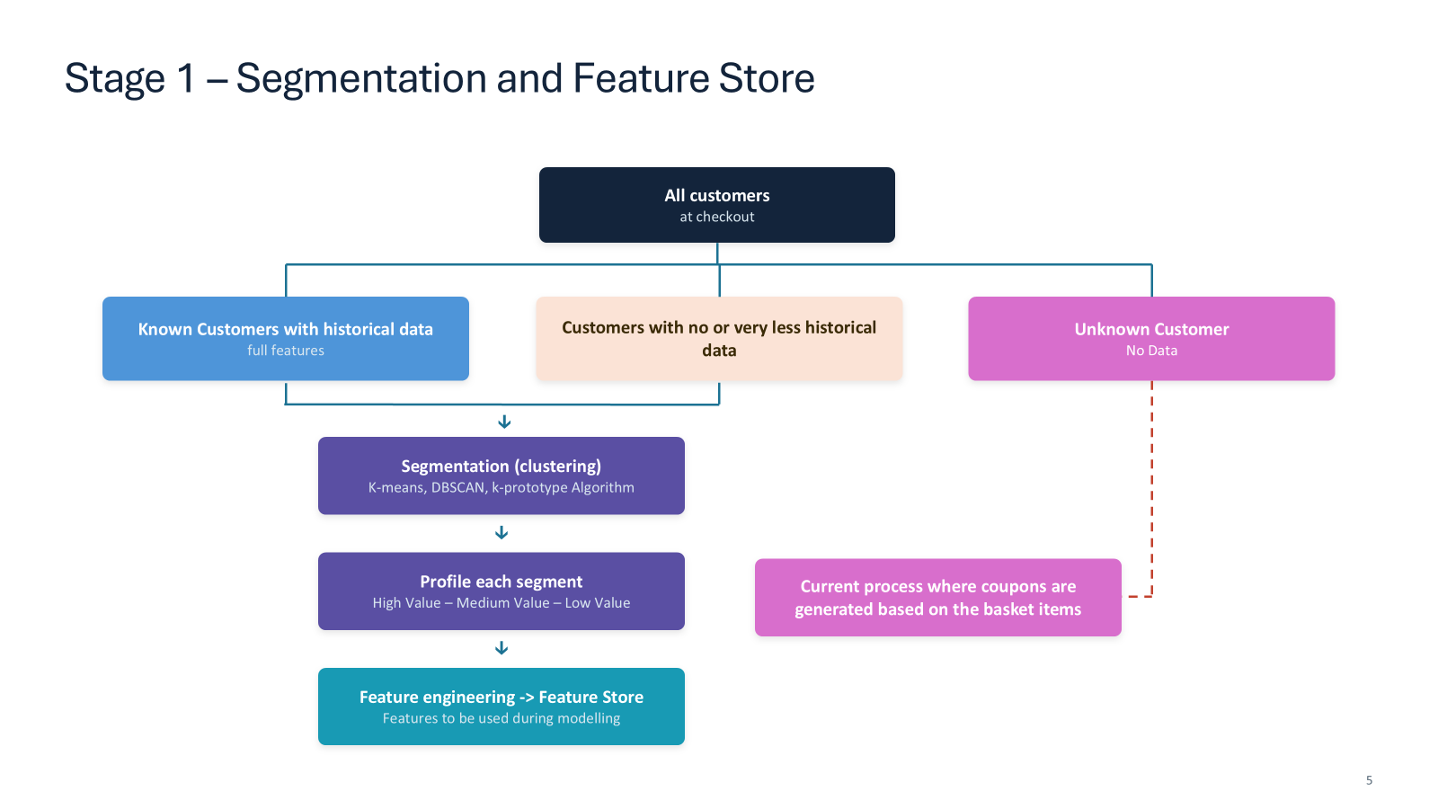
Stage 1 design — routing customers, clustering, profiling, and the Feature Store.
Stage 1 turns raw customers at checkout into segments and a reusable feature table. The first decision is routing: not every customer can be modelled.

2.1 Routing: known, sparse, unknown
At checkout a customer falls into one of three buckets, and the pipeline treats each differently:
Customer type | Data available | Handling
Known — full history | Rich transaction history (≥ a few purchases) | Full feature set → segmentation → uplift model
Sparse history | Very little history | Clustered on the features available; flagged as lower-confidence
Unknown | No data (anonymous / first-ever visit) | Falls back to the existing basket-driven coupon process
In code (notebook 02), routing is a simple, auditable rule: customers absent from the transaction table are unknown; among the rest, those with at least MIN_HISTORY_TXNS purchases are known_full, others known_sparse. Only known customers proceed to modelling; the unknown branch is intentionally left to the legacy process, exactly as the slide's dashed line shows.

2.2 Feature engineering
One row is built per customer from the transaction history, combining RFM-style and behavioural signals. These same features serve both clustering here and the uplift model later, so they are computed once and published to the Feature Store.
Feature family | Examples
Recency / tenure | recency_days, tenure_days
Frequency | txn_count, frequency_per_month
Monetary | total_spend, monetary_per_month, avg_basket_value, max_basket_value
Behavioural | avg_items, category_diversity
Static attributes | age_group, city_tier, channel_pref

2.3 Segmentation (clustering)
Known customers are clustered on scaled features. The slide lists K-means, DBSCAN and k-prototypes as candidates; the code uses K-means and validates the number of clusters with the silhouette score, but the downstream contract is only that each customer receives a segment_id, so any of the three can be substituted.
Skewed monetary features are log-transformed and all features standardised before clustering, so that distance-based K-means is not dominated by raw spend magnitude.

2.4 Profiling into value tiers
Clusters are unlabelled by nature, so each is profiled and ranked by monetary value, then mapped to a business-readable tier — High Value, Medium Value, Low Value and so on. This is the slide's “Profile each segment” box, and the tier becomes both a feature and a campaign-targeting lever.

2.5 Publishing to the Feature Store
The engineered features plus the segment are written to a Databricks Feature Store table keyed by customer_id with a timestamp key for point-in-time correctness. This is the single most important integration point in the project:
Why the Feature Store matters
Train/serve consistency. Stage 2 training and Stage 3 scoring read features from the same table, so a feature can never be computed one way in training and another in production.
Point-in-time lookups. The timestamp key prevents leakage from using a feature value that did not yet exist at decision time.
Reuse. Any future model can build on the same governed features instead of re-deriving them.
fe = FeatureEngineeringClient()
fe.create_table(
name=FS_FEATURE_TABLE,
primary_keys=['customer_id'],
timestamp_keys=['feature_ts'],
df=fs_source,
)

3. Stage 2 — Campaign Execution, Training & Validation
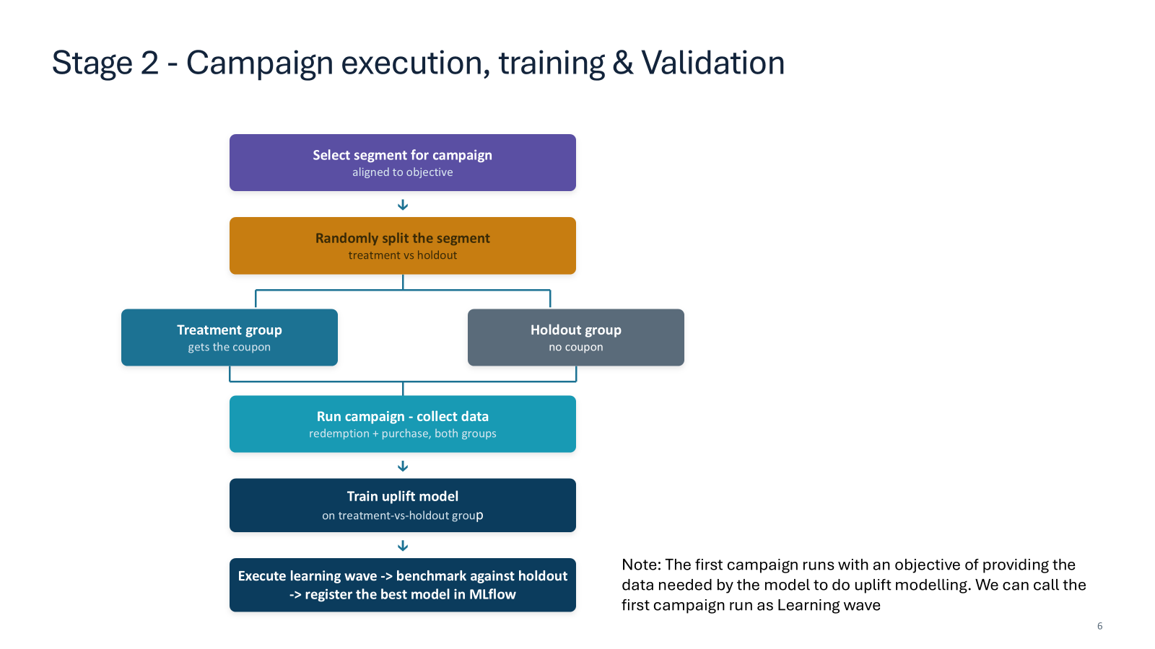
Stage 2 design — segment selection, treatment/holdout split, campaign run, uplift training, MLflow.
Stage 2 is the heart of the project and the focus of this document. It runs a controlled campaign, then uses its results to train the model that will drive all future targeting. We take the three emphasised topics in turn.

3.1 Treatment vs Holdout — the controlled experiment
Why this step decides everything
Randomly splitting the selected segment into a treatment group (gets the coupon) and a holdout group (gets nothing) converts the campaign into an A/B test. Because assignment is random, the two groups are statistically identical in every respect except the coupon. Therefore any difference in their later purchase behaviour is caused by the coupon — not by who they are. This causal difference is the raw material the uplift model learns from. Skip the holdout and you can never separate the coupon's effect from what would have happened anyway.

3.1.1 Selecting the segment (aligned to objective)
The wave begins by choosing which segment(s) to target, aligned to the campaign objective. The first wave is special: its objective is learning, so it deliberately includes all value tiers to give the model response signal across the whole base. A later revenue-objective wave might target only the high-value tiers. This first run is what the slide calls the Learning wave.

3.1.2 The randomized split
Within each value tier, customers are split into treatment and holdout. Two design choices make the split trustworthy:
- Stratified by tier. The split is done within each value tier, so treatment and holdout have the same segment composition — balance on segment, not just overall.
- Deterministic and reproducible. A stable hash of (campaign_id, customer_id) yields a uniform number in [0,1); customers below TREATMENT_FRACTION go to treatment. Re-running the job reproduces the exact same split.
assignments = (eligible
.withColumn('u', (F.abs(F.hash(F.concat_ws('::',
F.lit(CAMPAIGN_ID), F.col('customer_id')))) % 100000)/100000.0)
.withColumn('group', F.when(F.col('u') < F.lit(TREATMENT_FRACTION),
F.lit('treatment')).otherwise(F.lit('holdout'))))
The default split is 80% treatment / 20% holdout. A larger holdout gives a more precise lift estimate but withholds coupons from more customers (an opportunity cost); 20% is a common balance. The notebook prints a balance check confirming the ratio holds in every tier before any budget is spent — a skewed split would invalidate the causal interpretation.

3.1.3 Running the campaign and collecting outcomes
Coupons go to the treatment group; the holdout gets nothing. Afterwards the pipeline collects outcomes for both groups — who purchased, who redeemed, how much they spent. The holdout is observed too; it is the counterfactual baseline. The naive difference in purchase rates between the groups is the average treatment effect (ATE):
ATE = purchase_rate(treatment) − purchase_rate(holdout)
The ATE is a single population number. It tells you the campaign worked on average, but not who drove it — and that is precisely the gap uplift modelling fills.

3.2 Uplift Modelling — from average effect to individual effect
A conventional propensity model predicts who will buy. That is the wrong target for coupon targeting, because it cannot distinguish four very different kinds of customer:
Customer type | Buys if couponed? | Buys if NOT couponed? | Should we coupon?
Persuadable | Yes | No | YES — the only profitable group
Sure Thing | Yes | Yes | No — wasted margin
Lost Cause | No | No | No — coupon can't move them
Sleeping Dog | No | Yes | No — coupon backfires
A propensity model would happily target Sure Things (they have the highest purchase probability) — exactly the customers a coupon is wasted on. We instead model uplift: the change in purchase probability the coupon causes for each individual.
uplift(x) = P(purchase | x, treated) − P(purchase | x, not treated)
Why we can estimate this
Both conditional probabilities on the right are observable, because the randomized split gave us real treated customers and real untreated (holdout) customers who are otherwise comparable. Their difference, conditioned on the customer's features x, is the individual treatment effect — the uplift.

3.2.1 The T-learner (two-model) approach
The code implements the T-learner, the most transparent uplift method. It fits two probability models and subtracts them:
- model_T — P(purchase) trained on the treatment group only.
- model_C — P(purchase) trained on the holdout (control) group only.
- uplift(x) = model_T.predict_proba(x) − model_C.predict_proba(x).
Both are identical gradient-boosting pipelines (the same preprocessing and estimator), so the subtraction is apples-to-apples. They are wrapped into a single MLflow pyfunc model that outputs the uplift score directly, so Stage 3 never needs to know there are two underlying estimators.
class UpliftModel(mlflow.pyfunc.PythonModel):
def predict(self, context, X):
p_t = self.model_t.predict_proba(X[self.cols])[:, 1]
p_c = self.model_c.predict_proba(X[self.cols])[:, 1]
return pd.DataFrame({'uplift_score': p_t - p_c})
Alternatives. The T-learner is the baseline; the same MLflow interface accommodates an S-learner (one model with treatment as a feature), an X-learner, or tree methods that split on uplift directly. Swapping is a drop-in change because Stage 3 only consumes the uplift_score output.

3.2.2 Validation — benchmark against the holdout with Qini
Uplift models cannot be scored with accuracy or AUC, because the ground-truth individual uplift is never observed for any single customer (we only ever see them treated or untreated, not both). Instead we validate on the held-back evaluation set using the Qini curve:
- Rank the evaluation customers by predicted uplift, highest first.
- Walking down that ranking, track the cumulative incremental purchases — treated responders minus control responders, scaled for the group sizes.
- A good model concentrates the genuinely persuadable customers at the top, so its curve rises steeply above the random diagonal. The area between them is the Qini coefficient — higher is better.
The notebook also reports a decile sanity check: the observed treatment-minus-holdout uplift in the top predicted decile should clearly exceed the bottom decile. In testing, the top decile showed strongly positive observed uplift while the bottom decile was near zero or negative — confirming the model ranks persuadables correctly.

3.2.3 Registering the best model in MLflow
The run logs its parameters, the Qini coefficient and the Qini curve image, then registers the pyfunc model in Unity Catalog. “Register the best model” is enforced by a champion/challenger guard: the new version is promoted to the @champion alias only if its Qini beats the incumbent champion; otherwise it is kept as a challenger. This makes the learning wave's output a governed, versioned, comparable asset.
with mlflow.start_run():
mlflow.log_metric('qini_coef', qini_coef)
mlflow.pyfunc.log_model('uplift_model', python_model=uplift_model,
registered_model_name=REGISTERED_MODEL_NAME)
# promote to @champion only if qini beats the incumbent

4. Stage 3 — Batch Scoring, Optimization, Delivery & Learn
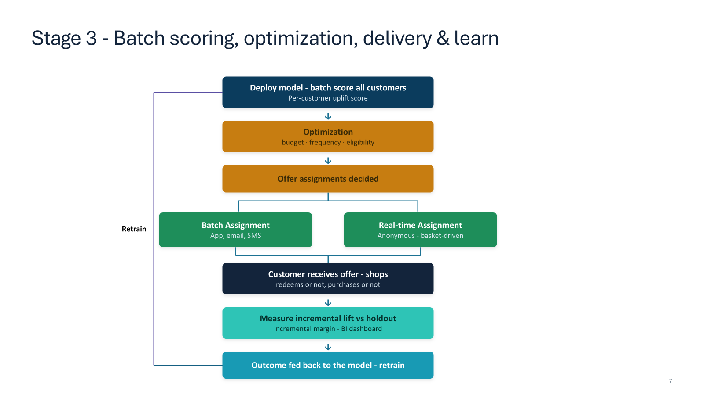
Stage 3 design — batch scoring, optimization, dual delivery, lift measurement, retrain loop.
Stage 3 operationalises the model: it scores everyone, decides who to actually mail, delivers the offers, measures the real lift, and feeds the result back to retrain.

4.1 Batch scoring
The champion model is loaded from the registry and applied to the full Feature Store snapshot, producing one uplift score per known customer. Scoring is pure prediction — a high score means a coupon meaningfully raises that customer's purchase probability. Unknown customers are excluded; they are served by the legacy or real-time path.
champion = mlflow.pyfunc.load_model(
f'models:/{REGISTERED_MODEL_NAME}@champion')
scored['uplift_score'] = champion.predict(scored[FEATURES])['uplift_score']

4.2 Optimization — from scores to decisions
Scoring ranks; optimization decides
An uplift score tells you who would respond most, but not who to mail. You have a finite coupon budget, frequency caps, and eligibility rules. Optimization turns the ranked scores into an actual offer list that maximises expected incremental margin subject to those business constraints. This is a separate, deliberate step — not just “mail the top N scores”.

4.2.1 The economics per customer
For each eligible customer the code computes the two quantities every allocation decision needs:
expected incremental margin = uplift × avg_basket_value × MARGIN_RATE
expected coupon cost = P(redeem) × COUPON_VALUE
The ratio of the two is the customer's bang-for-buck — expected incremental margin per dollar of expected coupon cost. Customers whose expected incremental margin does not even exceed their expected cost are dropped: mailing them loses money regardless of budget.

4.2.2 The constraints
Constraint | Rule in code | Why
Budget | Total expected coupon cost ≤ CAMPAIGN_BUDGET | Finite marketing spend per wave
Eligibility | uplift > MIN_UPLIFT_THRESHOLD and margin > cost | Only target profitable, persuadable customers
Frequency | ≤ MAX_OFFERS_PER_CUSTOMER_30D in last 30 days | Avoid fatiguing customers / coupon dependence

4.2.3 Solving it: a budget-constrained knapsack
Choosing a profitable subset of customers under a budget is a knapsack problem: each customer is a 0/1 item with a value (incremental margin) and a weight (expected cost). Because each item is tiny relative to the budget, the optimal solution is well-approximated by a greedy rule — sort by bang-for-buck and allocate until the budget is exhausted. This is provably near-optimal for the fractional/large-item-count case and is fully transparent to stakeholders.
opt = opt[opt['uplift_score'] > MIN_UPLIFT_THRESHOLD]
opt['exp_incr_margin'] = opt['uplift_score']*opt['avg_basket_value']*MARGIN_RATE
opt['exp_cost'] = opt['p_redeem']*COUPON_VALUE
opt = opt[opt['exp_incr_margin'] > opt['exp_cost']]
opt = opt.sort_values('roi_per_dollar', ascending=False)
opt['cum_cost'] = opt['exp_cost'].cumsum()
opt['offer'] = (opt['cum_cost'] <= CAMPAIGN_BUDGET).astype(int)
The output is the offer_assignments table: the exact set of customers to mail, the expected spend, the expected incremental margin and the expected ROI — the slide's “Offer assignments decided” box. In testing this produced a profitable selection (expected ROI above 1.5x) by concentrating budget on persuadables.
Extensions. The same framework supports choosing the coupon value per customer (not just whether to mail), per-segment budget envelopes, or a linear-programming solver if constraints become interdependent — the greedy version is the readable baseline.

4.3 Delivery — batch and real-time
The slide shows two delivery paths, and the code reflects both:
- Batch assignment — the optimized offer list is pushed to known customers via app, email or SMS.
- Real-time assignment — anonymous / unknown customers cannot be uplift-scored, so the legacy basket-driven rules decide their coupon at checkout. These are logged for measurement too.
Crucially, the optimized wave still reserves a fresh random holdout. Even though these customers were chosen because they have high uplift, a control slice is withheld so lift remains measurable on every wave — the holdout never disappears.

4.4 Measuring incremental lift vs holdout
After customers shop, the pipeline computes the honest, holdout-validated KPI — not gross redemptions, which would over-credit the campaign by counting purchases that would have happened anyway.
incremental margin = (margin/head_treatment − margin/head_holdout) × n_treated − coupon_cost
This incremental margin, plus the incremental purchase rate and ROI, is written to the incremental_lift table that feeds the BI dashboard. It is the number that proves the program created value beyond what would have happened anyway.

4.5 The learn loop (retrain)
The treatment-vs-holdout outcomes from each wave are appended to the outcomes table. On the next scheduled run, the uplift model retrains on the accumulated experience and the champion/challenger guard decides whether to promote the new version. This is the slide's “Retrain” arrow looping back to “Deploy model” — the system keeps getting better as it runs.
The closed loop
score → optimize → deliver (batch + real-time) → measure lift vs holdout → retrain → score …
Schedule notebooks 05 → 06 → 07 as a recurring Databricks Job and the loop runs continuously, each wave both earning margin and generating fresh experimental data for the next model.

5. Running the Project

5.1 First-time setup
- Import the coupon_uplift folder into Databricks (Repos or Workspace).
- Edit CATALOG and SCHEMA in src/config.py to a Unity Catalog schema you can write to.
- Attach a Databricks Runtime ML cluster.
- Run notebook 08_orchestration end-to-end, or run 01→07 in order.

5.2 Productionising as a Job
Wire the notebooks into a multi-task Databricks Job with dependencies matching the stage arrows. A typical cadence:
Schedule | Notebooks | Purpose
One-off onboarding | 01 → 02 → 03 → 04 → 05 | Build features, run the learning wave, train the first model
Recurring (e.g. weekly) | 02 → 05 → 06 → 07 | Refresh features, retrain, score, deliver, measure
Key parameters to tune (all in config.py): TREATMENT_FRACTION (holdout size), COUPON_VALUE, MARGIN_RATE, CAMPAIGN_BUDGET, MAX_OFFERS_PER_CUSTOMER_30D and MIN_UPLIFT_THRESHOLD. These encode the business's economics and risk appetite and are the main levers for steering the program.

6. Summary
The project implements the full coupon-personalization design as runnable Databricks code, with three ideas doing the heavy lifting:
- The holdout makes it causal. A randomized treatment/holdout split turns each campaign into an experiment, so measured effects are real and lift is always provable.
- Uplift makes it efficient. Modelling incremental effect — not propensity — spends budget on persuadables and spares it on sure things, lost causes and sleeping dogs.
- Optimization makes it actionable. A budget-constrained knapsack converts scores into a concrete, profitable offer list under real-world constraints, and the learn loop improves the model every wave.

