Software Requirements Specification
for
Hospital Provider Services
Version 1.0 approved
Prepared by Ayush Rai

01/December/2022

Introduction

Purpose
The doctor and clinics are available in every place but we find the place which is nearest to our home. This product is very helpful to them to the nearest doctor with timing and specialization of degree and how much experience he /she had

Document Conventions
The Software helps the user (patient) to find the best suitable doctor and clinic in his or her locality the main problem of those people whose has newly shifted their home. if any incident takes place and you do not any this software help you to find a suitable doctor near .

Project Scope

The objective of the software is to provide the following the nearby area oa n convenient time – Doctors Recommendation according. to patient locality Available lab tests

Class Diagram

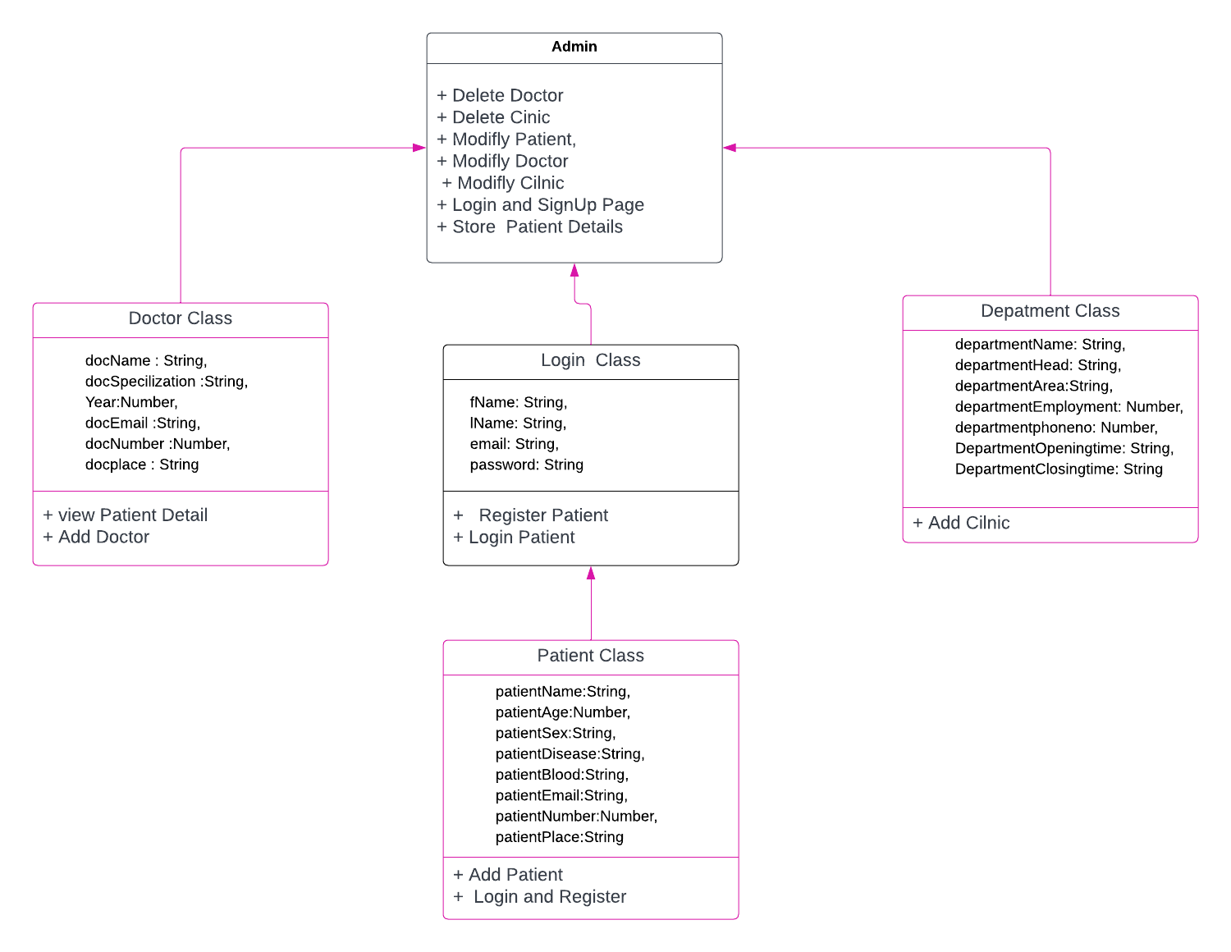

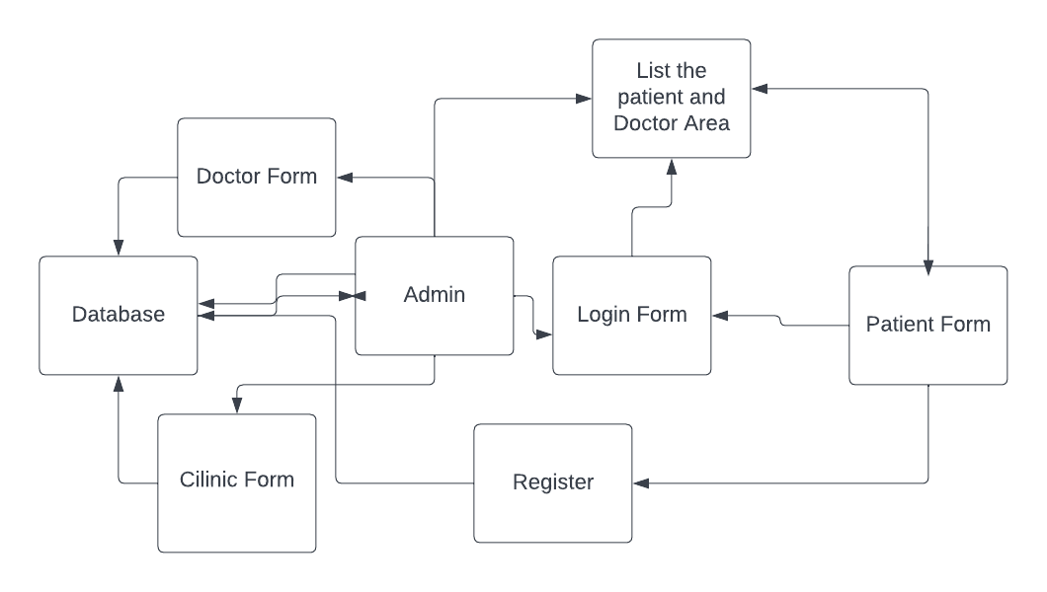

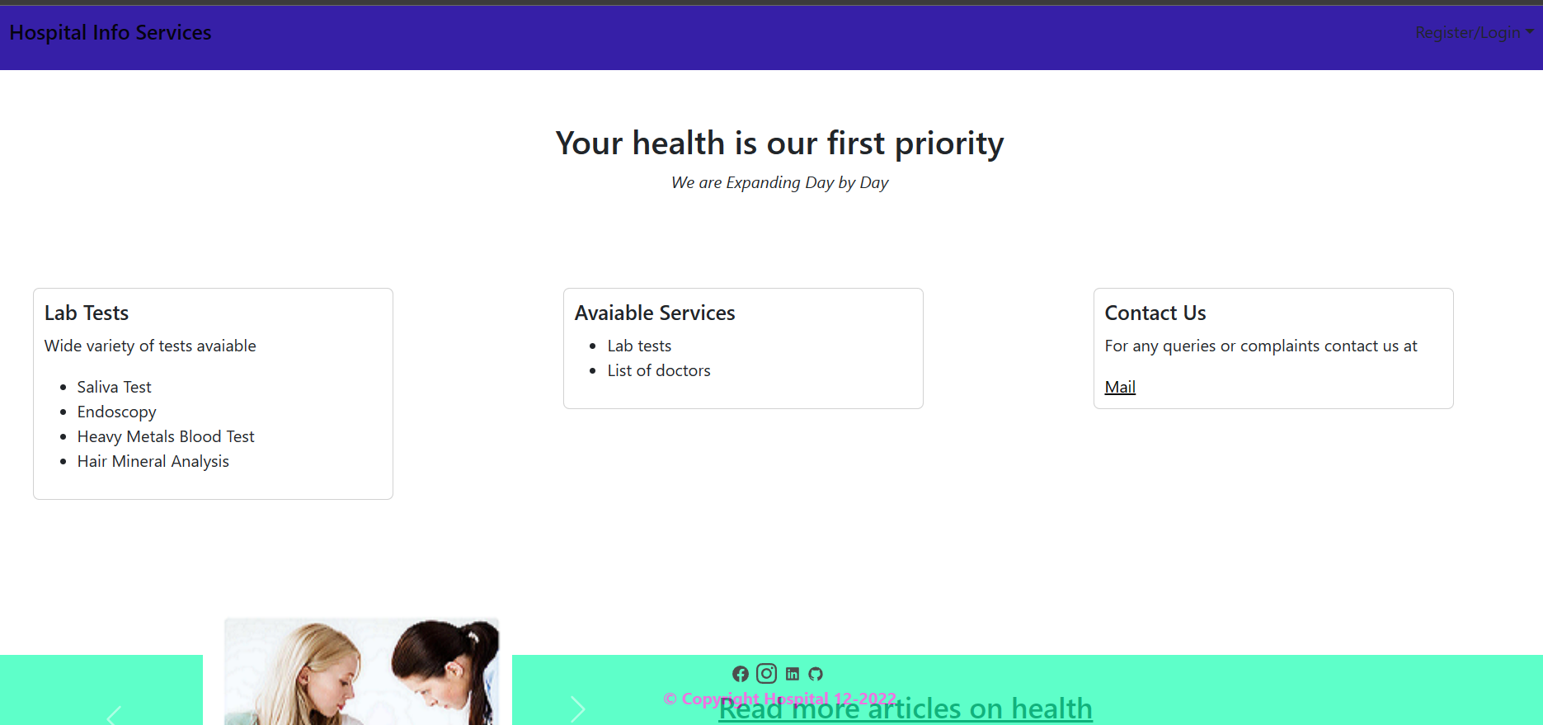

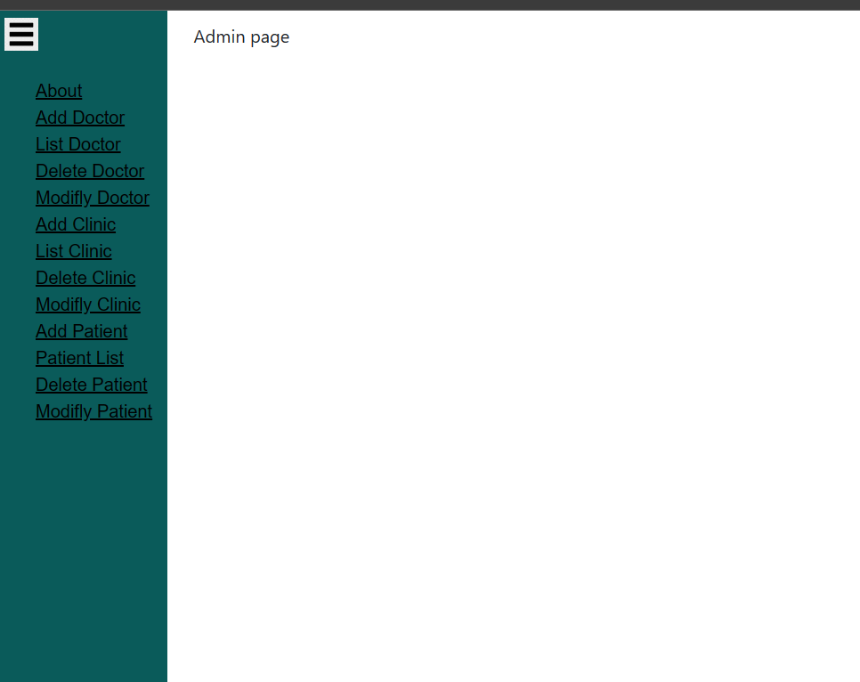
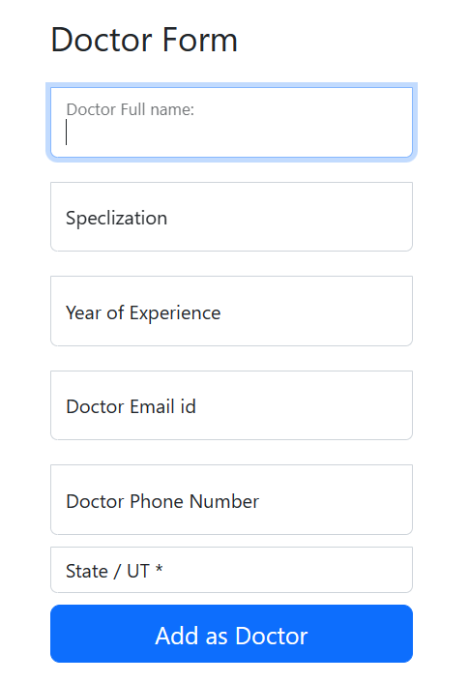

Delete the modify the Doctor only admi can do
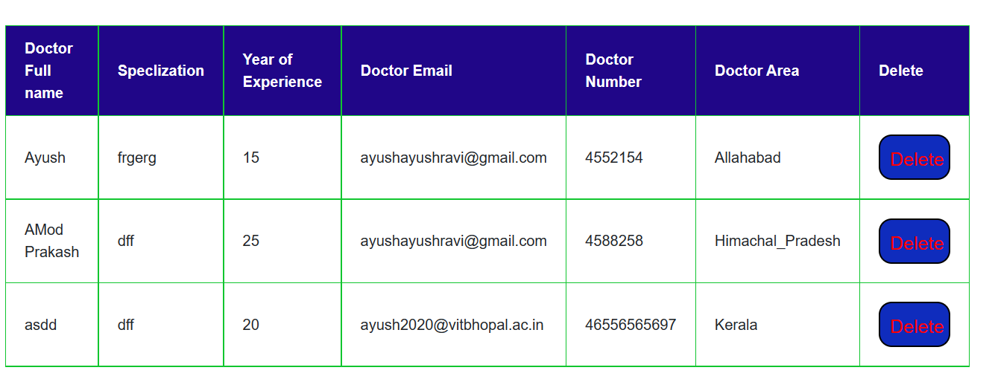

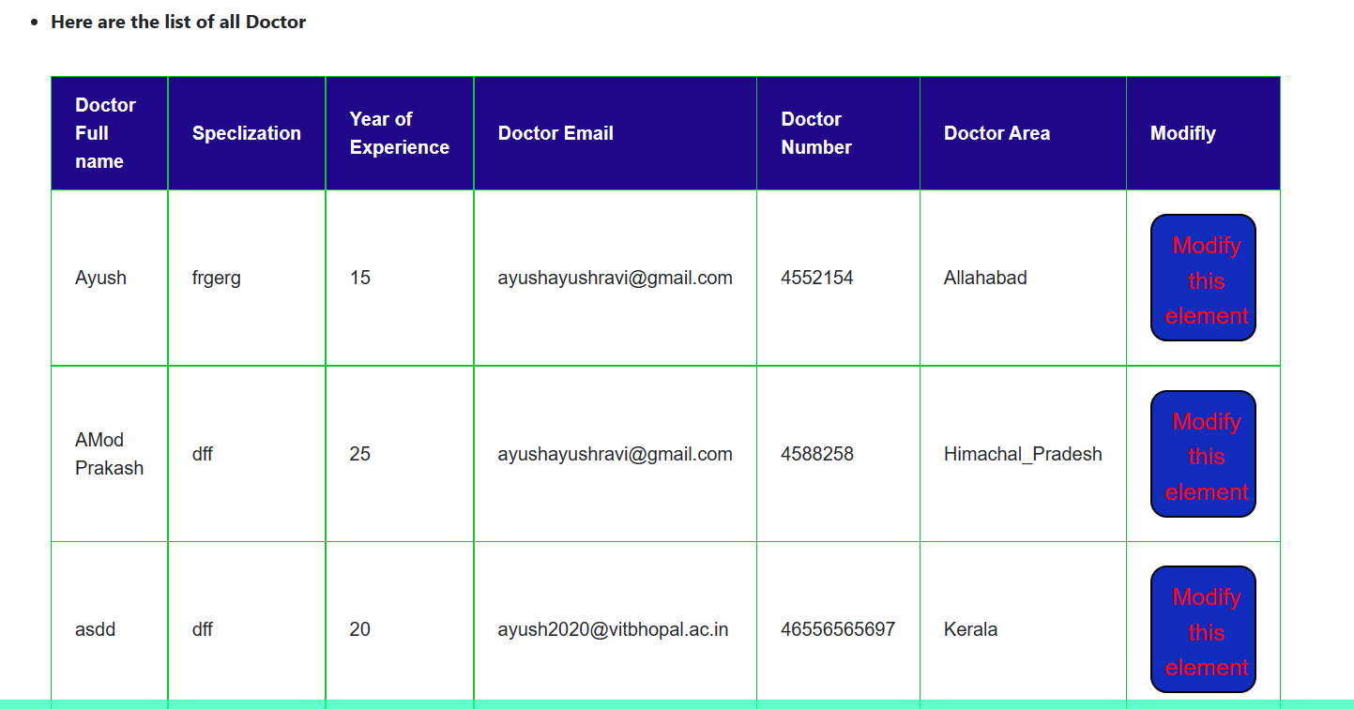

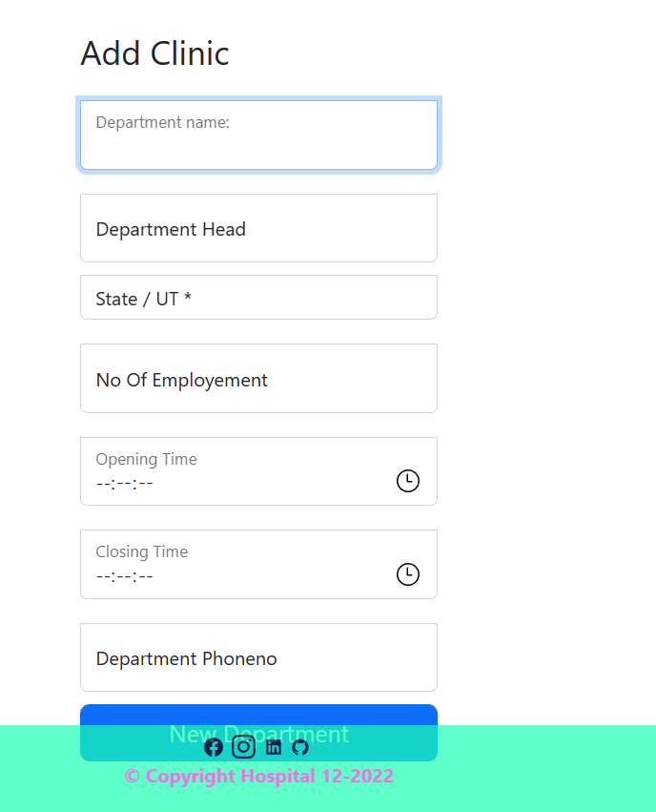

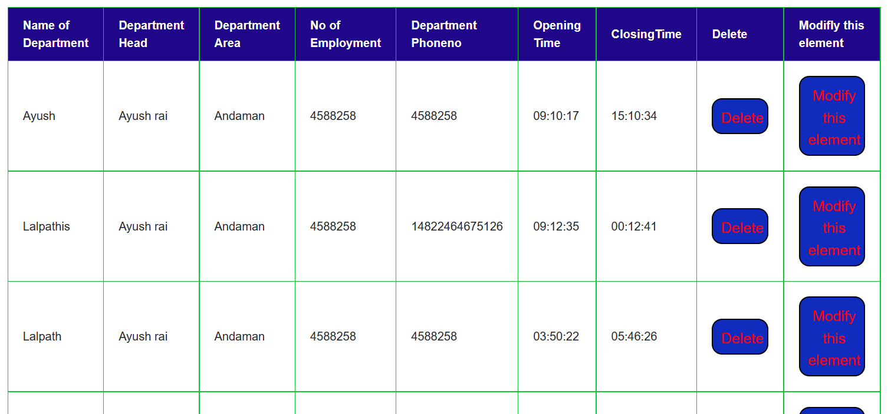
Department details

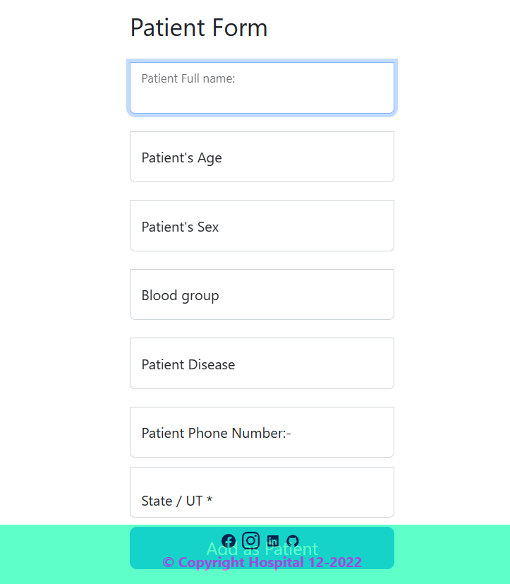

Login Page and Register Page

