PCA Model Evaluation and Comparison Report
Dataset: fraud_pca_95_variance.csv | Scope: trained fraud-detection models in this repository
Summary: Random Forest is the strongest trained model on the PCA feature set by PR-AUC (0.0313) and F1-score (0.0625). Overall scores remain low, which suggests PCA compression preserved broad variance but weakened minority-class fraud signal.

1. Evaluation Scope
This report compares every trained model available for the PCA dataset. The PCA dataset is treated as the feature-selected and PCA-analyzed representation of the fraud pipeline. It contains 11 principal-component features plus the binary fraud target. The same repository artifacts were used for the report; no model was retrained while compiling this document.
Item | Value
Dataset | PCA/fraud_pca_95_variance.csv
Feature representation | Wrapper-selected features transformed with PCA at 95% variance retention
Target | fraud (1 = suspected fraud, 0 = non-fraud)
Evaluated model families | MLP, RNN, Linear Regression, Decision Tree, Random Forest, XGBoost
Primary ranking metric | PR-AUC, because the fraud class is rare

2. Model Evaluation Results
Model | Family | Features | Threshold | Accuracy | Precision | Recall | F1 | ROC-AUC | PR-AUC
Random Forest | Classical ML | 11 | 0.5492 | 0.9160 | 0.0417 | 0.1244 | 0.0625 | 0.5633 | 0.0313
XGBoost | Classical ML | 11 | 0.5781 | 0.9006 | 0.0364 | 0.1342 | 0.0573 | 0.5555 | 0.0288
Decision Tree | Classical ML | 11 | 0.5719 | 0.7219 | 0.0268 | 0.3214 | 0.0494 | 0.5420 | 0.0263
MLP | Deep learning | 11 | 0.5000 | 0.5490 | 0.0239 | 0.4778 | 0.0455 | 0.5232 | 0.0250
RNN | Deep learning | 11 | 0.5000 | 0.5089 | 0.0244 | 0.5345 | 0.0467 | 0.5253 | 0.0243
Linear Regression | Classical ML | 11 | 0.4994 | 0.5158 | 0.0239 | 0.5148 | 0.0456 | 0.5192 | 0.0238
Interpretation: accuracy is high for several tree models because the non-fraud class dominates. PR-AUC, recall, and F1 give a more useful view of fraud detection quality.

3. Confusion Matrix Summary
Model | TN | FP | FN | TP
Random Forest | 32971 | 2321 | 711 | 101
XGBoost | 32406 | 2886 | 703 | 109
Decision Tree | 25801 | 9491 | 551 | 261
MLP | 19434 | 15858 | 424 | 388
RNN | 17941 | 17351 | 378 | 434
Linear Regression | 18203 | 17089 | 394 | 418

4. Visual Comparison
The following chart compares the two most relevant aggregate metrics for rare-event fraud classification.
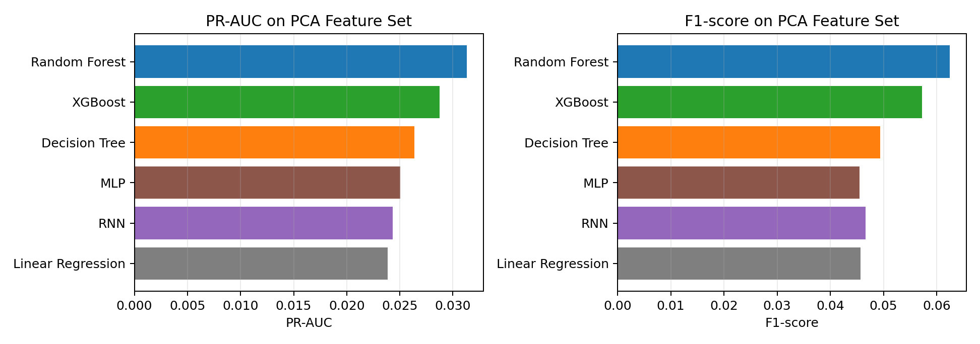
Figure 1. PR-AUC and F1-score comparison for all trained models on the PCA feature set.
The combined PR and ROC curves show how the model probability scores behave across thresholds.
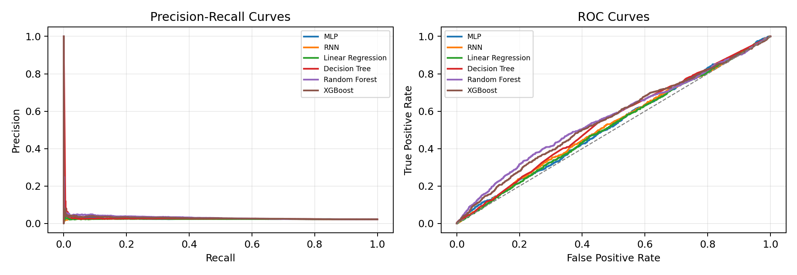
Figure 2. Precision-recall and ROC curves for PCA-trained models.

5. Findings
- Random Forest ranks first by both PR-AUC and F1-score on the PCA representation.
- XGBoost is the second strongest classical model by PR-AUC, but its recall and F1 remain modest.
- Decision Tree reaches the highest recall among the top three classical models, but it also creates many false positives.
- MLP and RNN perform close to the linear baseline on this PCA feature set, indicating that the PCA representation does not expose strong nonlinear fraud patterns to the neural models.
- Because fraud is rare, a model can show high accuracy while still missing most fraud cases. PR-AUC and F1 should be prioritized over accuracy in the final comparison.

6. Conclusion
For the PCA-analyzed fraud dataset, Random Forest is the recommended baseline among the currently trained models. However, all PCA-based scores are weak compared with the prepared numeric feature-space results already present in the repository, so the PCA representation should be treated as a compact experimental view rather than the best production feature set.

