DEPARTMENT OF COMPUTER SCIENCE
KULLIYYAH OF INFORMATION AND COMMUNICATION TECHNOLOGY
CSCI 4340
MACHINE LEARNING
SEMESTER 2 2025/2026
SECTION 1
DETECTING FRAUDULENT TRANSACTIONS IN SUPPLY CHAIN MANAGEMENT USING A RECURRENT NEURAL NETWORK (GRU) AGAINST CLASSICAL MACHINE LEARNING BASELINES
INSTRUCTOR: PROF. DR. AMELIA RITAHANI BT. ISMAIL
PREPARED BY:
GROUP J
NO | NAME | MATRIC NO. | CONTRIBUTION
1 | AZAM MUZAFFAR BIN ALDZAHIR | 2318593 | 100%
2 | MUHAMMAD HARITH IRFAN | 2211867 | 100 %
3 | MUHAMMAD ALIF ALTAF BIN ABD RAHIM | 2222949 | 100 %
4 | WAN MUHAMMAD SYAMIL BIN W MOHD YUSOF | 2220561 | 100%
FULL CODE: https://github.com/raichiiiiiii/Machine-Learning

Table of Contents
1.0 Abstract
2.0 Introduction
3.0 Literature Review
4.0 Data Analysis
5.0 Experimental Setup
6.0 Deployment
7.0 Results and Discussion
8.0 Conclusion
9.0 References

Note: Update page numbers using Word's automatic Table of Contents after any final manual formatting changes.

1.0 Abstract
This project applies machine learning to detect fraudulent transactions in supply chain data. The project required us to choose an algorithm that was not studied in class and compare it against at least three classical algorithms learned in class. We selected a Recurrent Neural Network with Gated Recurrent Units (GRU) as the proposed model, and compared it against five other models: Logistic Regression, Decision Tree, Random Forest, XGBoost, and a Multi-Layer Perceptron (MLP).
The dataset used is the DataCo Smart Supply Chain dataset, which contains 180,519 order records with 53 features. Fraud cases make up only about 2.3% of all orders, which makes this a severely imbalanced classification problem. To prepare the data, we removed personal information, handled missing values and outliers, encoded categorical features, removed leakage columns, and applied feature selection followed by Principal Component Analysis (PCA) at 95% variance retention, producing 11 principal components.
All six models were trained and evaluated on the same PCA feature set using identical data splits. Because fraud is rare, we used PR-AUC (Precision-Recall Area Under Curve) as the primary ranking metric instead of accuracy. The results show that Random Forest achieved the best PR-AUC (0.0313) and F1-score (0.0625), while the proposed GRU RNN achieved the highest recall (0.5345) among all models, meaning it caught the largest share of true fraud cases. However, all scores on the PCA feature set were low overall, which suggests that PCA compression preserved the broad variance of the data but weakened the rare fraud signal.
The key lesson from this project is that for rare-event detection, the choice of feature representation and evaluation metric matters as much as the choice of model. A model can show over 90% accuracy while still missing most fraud, so accuracy alone is misleading for imbalanced problems.

2.0 Introduction
Global supply chains move millions of orders every day, and each order carries financial risk. Among these risks, transaction fraud is one of the most damaging because it directly causes financial loss, disrupts logistics planning, and erodes trust between businesses and customers. As e-commerce supply chains grow in size and complexity, manually reviewing every order becomes impossible, so companies increasingly rely on data analytics and machine learning to flag suspicious transactions automatically.
Fraud detection is a difficult machine learning problem for one main reason: fraud is rare. In a typical transaction dataset, fraudulent orders make up only a small percentage of all records. A naive model can simply predict that every order is legitimate and still achieve very high accuracy, while catching zero fraud. This is why fraud detection requires careful handling of class imbalance and careful selection of evaluation metrics that focus on the rare positive class, such as precision, recall, F1-score, and PR-AUC.
This project uses the DataCo Smart Supply Chain dataset, a publicly available transactional record of e-commerce orders, to study fraud detection. The problem domain is established by Sattar et al. (2025), who studied machine learning for supply chain analytics; following the project requirement, our dataset differs from the one used in the reference paper. The proposed model is a Recurrent Neural Network with Gated Recurrent Units (GRU), an architecture that was not covered in class. GRU networks use internal gates to control what information is kept or forgotten as the network reads its input, which allows them to learn patterns that simple feed-forward networks may miss.
The objectives of this project are:
- To detect fraudulent transactions in the DataCo supply chain dataset using classification algorithms.
- To apply a complete preprocessing pipeline including feature selection and PCA, and study its effect on model performance.
- To compare the proposed GRU RNN against five baseline models (Logistic Regression, Decision Tree, Random Forest, XGBoost, and MLP) using metrics suitable for imbalanced data.
- To identify the best model for deployment as a fraud screening layer, and recommend how it should be used in practice.

3.0 Literature Review

3.1 Machine Learning in Supply Chain Management
Machine learning has become a core tool for managing modern supply chains. Min (2010) provided an early survey of artificial intelligence in supply chain management, showing how learning algorithms can support forecasting, planning, and risk management. More recently, Baryannis et al. (2019) reviewed the state of the art in supply chain risk management with artificial intelligence and identified fraud and disruption detection as key application areas. Riahi et al. (2021) confirmed this trend in a systematic review, finding that classification algorithms are among the most frequently applied techniques in supply chain analytics. These works establish that the problem studied in this project, automated fraud detection in transactional supply chain data, is an active and practically important research area.

3.2 Fraud Detection with Classification Algorithms
Li and Wang (2017) reviewed fraud detection specifically in supply chain management and highlighted two recurring challenges: severe class imbalance and the difficulty of obtaining reliable fraud labels. Sarker (2021) surveyed machine learning algorithms across real-world applications and noted that ensemble tree methods such as Random Forest and gradient boosting are consistently strong on tabular business data, because they capture non-linear feature interactions and are robust to noisy inputs. This justifies the use of Random Forest and XGBoost as strong classical baselines in this project, alongside the simpler Logistic Regression and Decision Tree models taught in class.

3.3 Deep Learning and Recurrent Neural Networks
Deep learning models offer an alternative to tree-based methods by learning feature representations automatically. The Multi-Layer Perceptron (MLP) is the standard feed-forward network for tabular data, while Recurrent Neural Networks (RNNs) process inputs as ordered sequences. The Gated Recurrent Unit (GRU), the architecture proposed in this project, simplifies the older LSTM design by using two gates (update and reset) instead of three, which reduces the number of parameters while keeping the ability to retain information across the sequence. For tabular data with one row per order, the standard adaptation is to treat each feature as one timestep, so the network reads the feature vector element by element. Nguyen et al. (2018) noted in their review of big data analytics in supply chains that deep learning adoption is growing, but its advantage over classical methods depends heavily on whether the data contains structure the network can exploit.

3.4 Dimensionality Reduction with PCA
Principal Component Analysis (PCA) is a feature extraction technique that transforms the original features into a smaller set of uncorrelated components ordered by the amount of variance they explain. It is widely used to compress high-dimensional data before model training, reducing noise and computational cost. However, PCA selects directions of maximum overall variance, not directions that best separate the classes. For rare-event problems such as fraud detection, this is a known limitation: the variance that distinguishes the tiny fraud class can be lost during compression. This project applies PCA at 95% variance retention after wrapper-based feature selection, and the results in Chapter 7 directly illustrate this trade-off. It is important to distinguish PCA (feature extraction, which creates new combined features) from feature selection methods such as RFECV (which keep a subset of the original features unchanged); this project uses both, in sequence.

3.5 Reference Paper
The problem domain for this project is established by Sattar et al. (2025), published in MDPI Sustainability, which applied machine learning models to supply chain data. The paper compared XGBoost and recurrent neural networks across supply-chain forecasting and risk-mitigation tasks, reporting strong XGBoost forecasting accuracy and strong RNN performance for fraud and delivery-risk prediction. It also introduced cost-accuracy and ESG-aware evaluation, showing that model selection should consider operational cost and sustainability alongside predictive accuracy. Following the project requirement, this project uses a different dataset (the DataCo Smart Supply Chain dataset) from the one used in the reference paper, while addressing the same domain of supply chain analytics with machine learning.

3.6 Summary
In short, the literature supports each design choice in this project. Supply chain fraud detection is an established and important problem (Li and Wang, 2017; Baryannis et al., 2019). Ensemble trees are strong baselines for tabular data (Sarker, 2021), simple linear and tree models provide the classroom reference points, deep networks including the GRU provide the novel comparison required by the project, and PCA provides a compact but imperfect feature representation whose limitations for rare classes are well documented. The experiments in this report test all of these expectations on a single shared pipeline.

4.0 Data Analysis
This chapter describes the dataset, the exploratory analysis performed to understand it, and the preprocessing pipeline used to prepare it for modelling.

4.1 Dataset Description and Exploratory Data Analysis
This study uses the DataCo Smart Supply Chain dataset, a publicly available transactional record of e-commerce orders. The raw dataset contains 180,519 rows and 53 columns spanning four broad categories: financial fields (sales, profit, discounts), logistics fields (shipping mode, scheduled and actual delivery days, delivery status), customer demographics (location, segment), and product details (category, price, quantity).
The prediction target is a binary fraud label (1 = suspected fraud, 0 = non-fraud), derived from the order status recorded in the dataset. Exploratory analysis revealed the defining characteristic of this problem: severe class imbalance. Fraud cases make up only about 2.3% of all orders. On the held-out test set used in this report, only 812 out of 36,104 orders are fraudulent. This imbalance shaped every later decision in the project, from the choice of evaluation metrics to the interpretation of results.
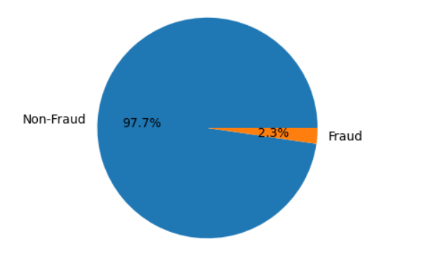
Figure 1. Class distribution of the fraud target. Fraud cases form only about 2.3% of all orders.
Boxplots and summary statistics were also used to inspect the numerical features. The Sales feature in particular showed extreme values, which motivated the winsorization step described below.

4.2 Data Preprocessing
The cleaning pipeline, shared across the whole group, applied the following steps to the raw dataset:
- Ethical data pruning: personally identifiable fields (customer names, emails, passwords) were removed to protect privacy.
- Missing-value handling: numerical gaps were filled by median imputation.
- Outlier mitigation: the Sales field was winsorized to limit the influence of extreme values.
- Categorical encoding: text categories were converted to integers using label encoding, producing a fully numeric matrix.
- Chronological splitting: the data was ordered by time and divided 70 / 15 / 15 into training, validation, and test files, so that every model in the study shares identical splits and the comparison stays fair.
Leakage control was a critical step. Leakage columns are fields that would not be known at prediction time, or that mathematically encode the target. For the fraud task, the order status field that the fraud label is derived from was removed, along with post-event delivery fields and identifier columns. The dropped columns were: Order Status, Delivery Status, Late_delivery_risk, Days for shipping (real), shipping date (DateOrders), Type, Order Id, Order Item Id, Product Card Id, Product Category Id, Customer Id, Department Id, Category Id, Order Customer Id, Customer Email, Customer Password, Customer Fname, Customer Lname, Customer Street, Order Zipcode, Product Description, Product Price, Product Status, Order Item Total, and Order Profit Per Order. Keeping such columns would let a model learn target leakage rather than genuine predictive patterns.

4.3 Feature Selection and PCA
Two dimensionality-handling steps were applied in sequence. First, wrapper-based feature selection identified the subset of original features most useful for the fraud target. Feature selection keeps original columns unchanged, so the surviving features remain interpretable. Second, Principal Component Analysis (PCA) was applied to the selected features with 95% variance retention, producing 11 principal components. PCA is a feature extraction step: it creates new features that are weighted combinations of the inputs, ordered by how much variance they explain.
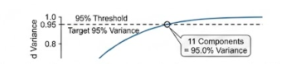
Figure 2. Cumulative explained variance of the principal components. Eleven components retain 95% of the variance.
The final modelling dataset, fraud_pca_95_variance.csv, therefore contains 11 principal-component features plus the binary fraud target. Every model in Chapter 7 was trained and evaluated on this same representation, so any performance difference between models comes from the algorithms themselves and not from differences in their inputs.

5.0 Experimental Setup

5.1 Tools and Python Libraries
All experiments were developed in Google Colab notebooks using Python. The Scikit-learn library provided the classical models (LogisticRegression, DecisionTreeClassifier, RandomForestClassifier), the preprocessing utilities (scaling, encoding, PCA), and the evaluation metrics. The XGBoost library provided the gradient boosting model. The deep learning models (MLP and GRU RNN) were built with TensorFlow / Keras. Pandas was used to load and manipulate the data, and Matplotlib and Seaborn were used for visualisation. A fixed random seed (42) was used throughout for reproducibility.

5.2 Methodology
The experimental procedure followed four stages. First, the shared preprocessing pipeline described in Chapter 4 produced the PCA feature set. Second, the four classical baselines were trained on the training split: Logistic Regression and Decision Tree as the simple classroom baselines, then Random Forest and XGBoost as the stronger ensemble baselines. To address the class imbalance, the tree ensembles used class weighting (class_weight=’balanced’ for Random Forest and scale_pos_weight for XGBoost), so the rare fraud class received more attention during training.
Third, the two deep learning models were trained. The MLP is a feed-forward network with Dense(128, ReLU), Batch Normalization, Dropout(0.3), Dense(64, ReLU), Batch Normalization, Dropout(0.3), Dense(32, ReLU), Dropout(0.2), and a Dense(1, sigmoid) output for binary classification. The proposed GRU RNN treats the 11 principal components as a sequence of 11 timesteps with one value each, so the input shape is (samples, timesteps = 11, 1). Its architecture is GRU(64, return_sequences=True), Dropout(0.2), GRU(32), Dropout(0.2), Dense(32, ReLU), Dropout(0.3), and Dense(1, sigmoid). Both deep models used Adam with learning rate 1e-3, binary cross-entropy, class weights, batch size 256, up to 30 epochs, and early stopping on validation PR-AUC.
Fourth, every model was evaluated on the same held-out test set, which no model saw during training. For each model a decision threshold was selected on the validation split: the classical models used tuned thresholds (for example 0.5492 for Random Forest), while the deep models used the default 0.5. The metrics reported are accuracy, precision, recall, F1-score, ROC-AUC, and PR-AUC. PR-AUC was chosen as the primary ranking metric because the fraud class is rare: it summarises the precision-recall trade-off across all thresholds and is far more informative than accuracy when positives are scarce.

6.0 Deployment
The deployment design turns the trained models into a practical fraud screening layer for the supply chain. The deployment pipeline mirrors the experimental pipeline exactly: an incoming order is cleaned with the same preprocessing steps (PII removal is not needed at inference since the model never uses those fields, but encoding and scaling are applied with the statistics fitted on the training data), transformed with the saved feature-selection and PCA transformers, and then scored by the trained model.
Based on the results in Chapter 7, the model selected for deployment is Random Forest, which achieved the best PR-AUC and F1-score on the PCA feature set. The saved Random Forest model, together with the fitted PCA transformer and the tuned decision threshold (0.5492), forms the deployed artifact. Each new order receives a fraud probability; orders scoring above the threshold are flagged.
Because fraud is rare and the precision of all models on this feature set is modest, the deployed model is intended as a screening layer, not an automatic blocker. Flagged orders should be placed on a watchlist for human review rather than being cancelled automatically. This design uses the model’s recall to reduce the manual workload (reviewers only inspect the flagged subset instead of every order) while keeping a human decision in the loop to protect legitimate customers from false positives.
Two operational recommendations complete the deployment plan. First, the model should be retrained quarterly, because supply chain and fraud patterns shift over time. Second, the high-recall GRU RNN can serve as a complementary second screener: because it catches the largest share of true fraud cases (recall 0.5345), orders flagged by both models can be prioritised for the fastest review.

7.0 Results and Discussion
This chapter reports the test-set performance of all six models on the PCA feature set. Throughout this chapter, remember the base rate: only 812 of the 36,104 test orders (about 2.2%) are fraud. A model that predicts “not fraud” for everything would score 97.8% accuracy while catching nothing, so accuracy is reported for completeness but PR-AUC, recall, and F1-score carry the real meaning.

7.1 Logistic Regression
Logistic Regression is the simplest classroom baseline: it learns a weighted sum of the input features and passes it through a sigmoid to produce a fraud probability. On the PCA feature set it achieved an accuracy of 0.5158 with a recall of 0.5148 and precision of 0.0239, giving an F1-score of 0.0456 and a PR-AUC of 0.0238. The confusion matrix shows 418 true positives against 17,089 false positives: the model catches about half of the fraud cases, but only because it flags almost half of all orders. Its ROC-AUC of 0.5192 is barely above the 0.5 of random guessing, which tells us the linear decision boundary finds almost no usable fraud signal in the principal components.
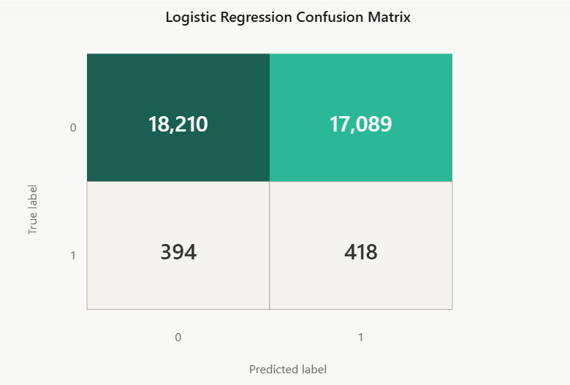
Figure 3. Logistic Regression confusion matrix on the test set.

7.2 Decision Tree
The Decision Tree splits the data with a sequence of if-then rules. It reached an accuracy of 0.7219 with a recall of 0.3214, precision of 0.0268, F1-score of 0.0494, and PR-AUC of 0.0263. Compared with Logistic Regression, the tree flags far fewer orders (9,491 false positives instead of 17,089), so its accuracy looks much better, but it also catches fewer true fraud cases (261 instead of 418). This is the classic precision-recall trade-off: tightening the net reduces false alarms but lets more fraud slip through. Interestingly, among the three tree-based models the single Decision Tree achieves the highest recall, at the cost of the most false positives.
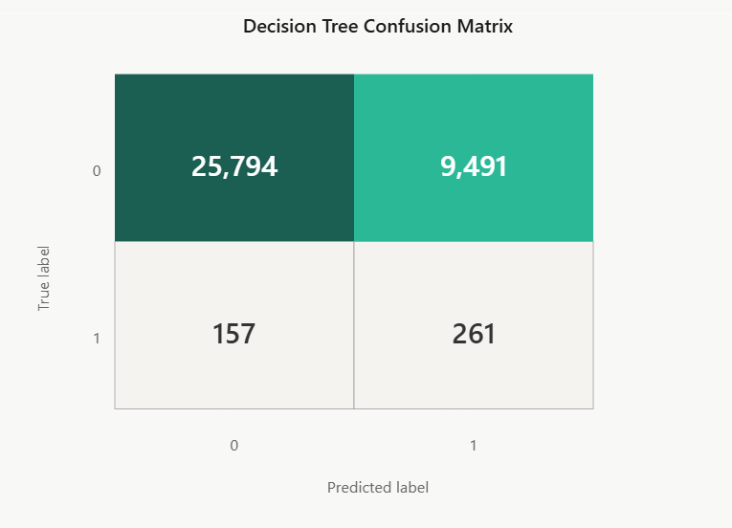
Figure 4. Decision Tree confusion matrix on the test set.

7.3 Random Forest
Random Forest combines many decision trees trained on random subsets of the data and features, then averages their votes. With class weighting and a tuned threshold of 0.5492, it achieved the best PR-AUC (0.0313) and the best F1-score (0.0625) of all six models, with an accuracy of 0.9160. Its precision of 0.0417 is the highest in the study, meaning that when Random Forest flags an order, it is more likely to be genuine fraud than for any other model. The cost is recall: it catches only 101 of the 812 fraud cases (recall 0.1244). The high accuracy comes mostly from correctly labelling the huge non-fraud majority (32,971 true negatives), which is exactly why accuracy alone would have been misleading.
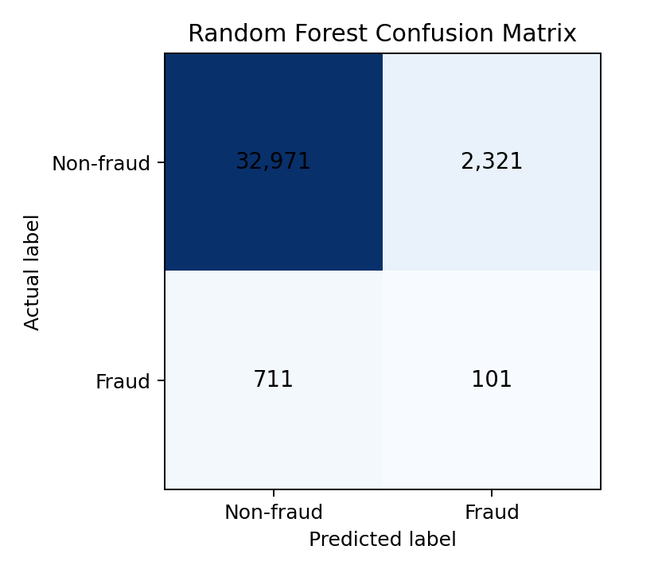
Figure 5. Random Forest confusion matrix on the test set.

7.4 XGBoost
XGBoost builds trees sequentially, with each new tree correcting the mistakes of the previous ones. Using scale_pos_weight to handle the imbalance and a tuned threshold of 0.5781, it achieved an accuracy of 0.9006, precision of 0.0364, recall of 0.1342, F1-score of 0.0573, and PR-AUC of 0.0288. Its profile is very close to Random Forest: slightly higher recall (109 true positives against 101) but slightly lower precision and PR-AUC, making it the clear second-best classical model. The fact that the two strongest ensembles land within a whisker of each other suggests both are extracting close to all the fraud signal that survives in the 11 principal components.
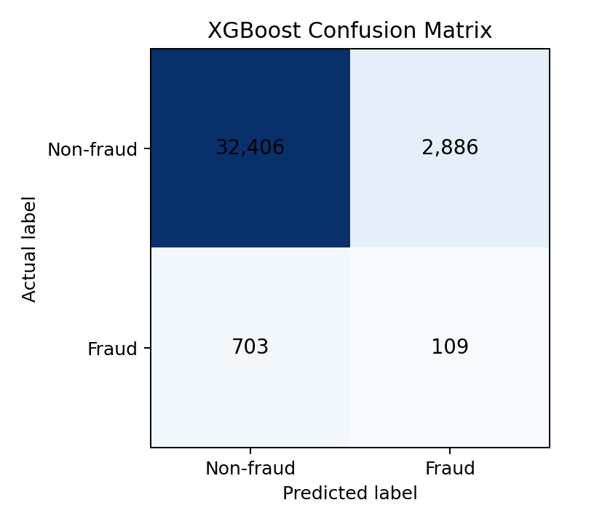
Figure 6. XGBoost confusion matrix on the test set.

7.5 Multi-Layer Perceptron (MLP)
The MLP is a feed-forward neural network with fully connected hidden layers. At the default 0.5 threshold it achieved an accuracy of 0.5490, precision of 0.0239, recall of 0.4778, F1-score of 0.0455, and PR-AUC of 0.0250. Its behaviour sits between the linear baseline and the GRU: it flags very widely (15,858 false positives) to capture 388 of the fraud cases. Its ROC-AUC of 0.5232 is only marginally better than Logistic Regression, indicating that the network found little extra non-linear structure in the PCA components to exploit.
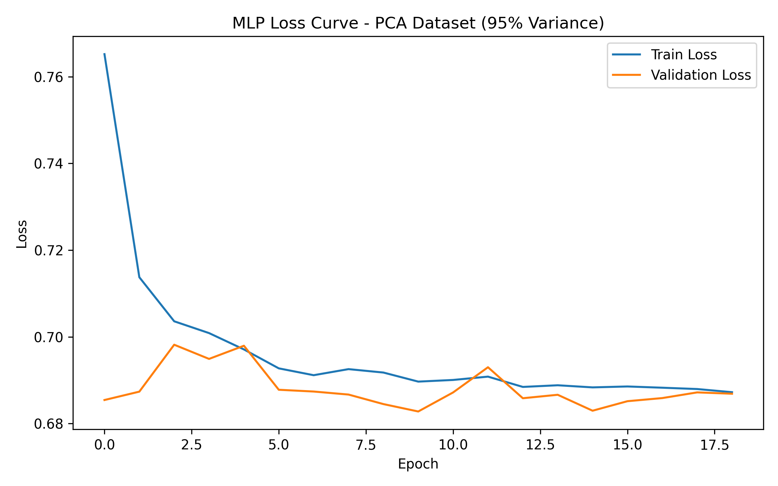
Figure 7. MLP training and validation loss by epoch.
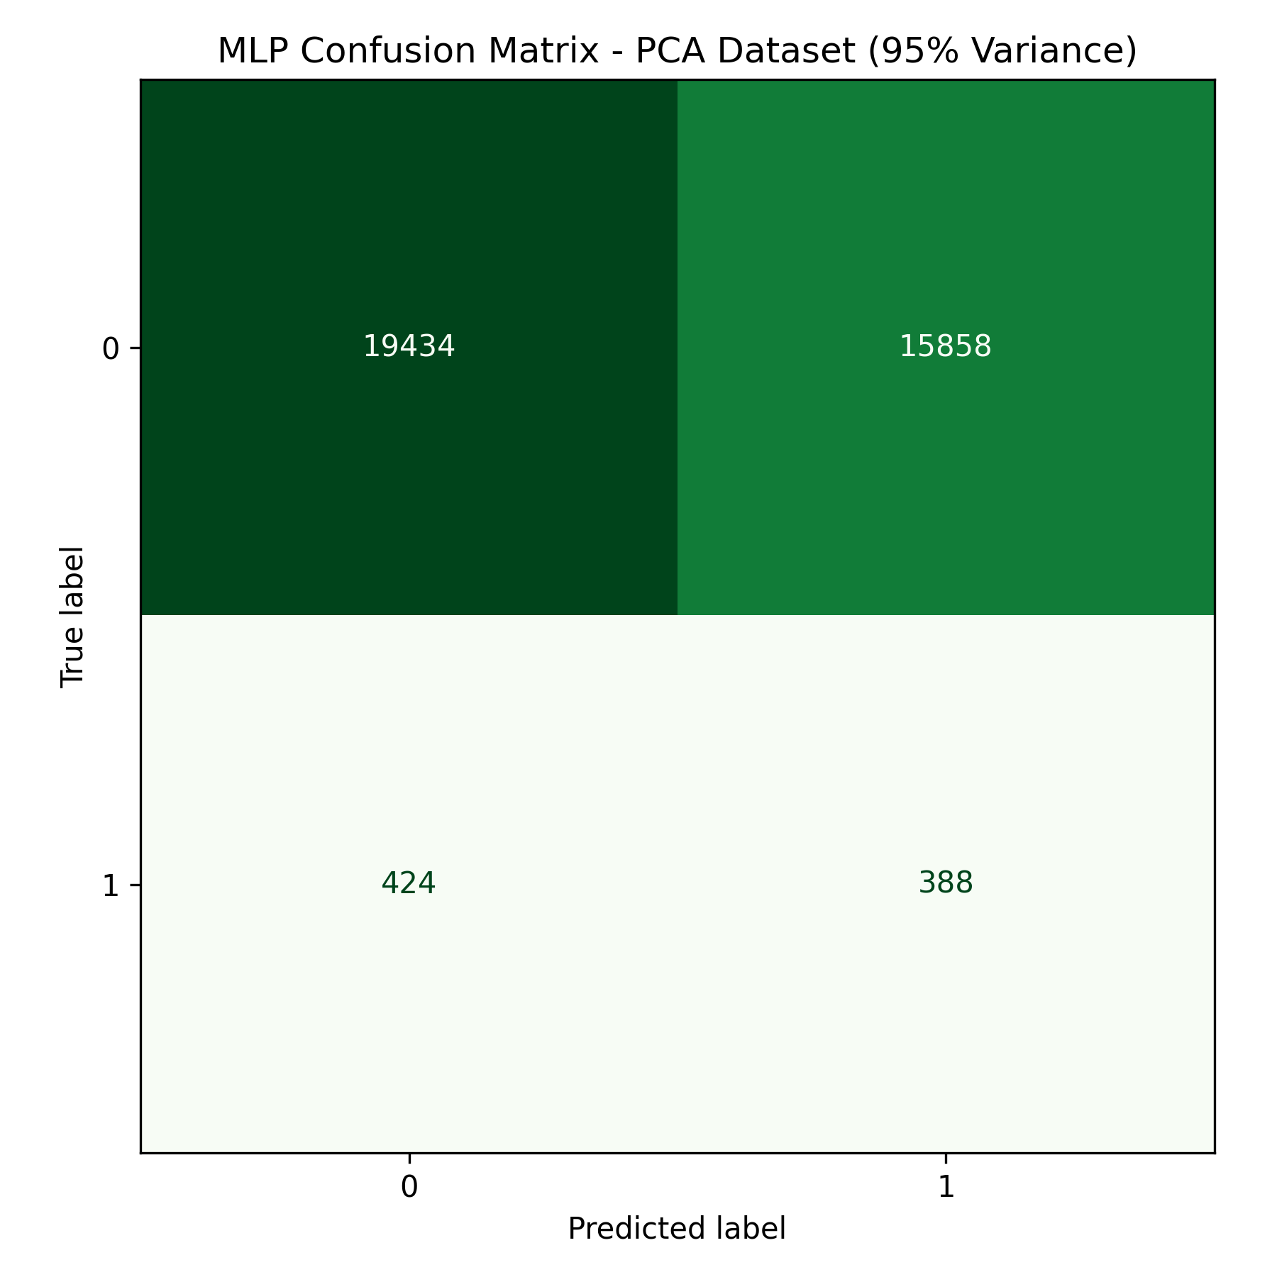
Figure 8. MLP confusion matrix on the test set.

7.6 Proposed Model: Recurrent Neural Network (GRU)
The proposed GRU RNN reads the 11 principal components as an ordered sequence of 11 timesteps, using its update and reset gates to control what information flows along the sequence. At the default 0.5 threshold it achieved an accuracy of 0.5089, precision of 0.0244, recall of 0.5345, F1-score of 0.0467, ROC-AUC of 0.5253, and PR-AUC of 0.0243.
The GRU’s standout result is recall: 434 of the 812 fraud cases were caught, the highest of all six models. In a fraud setting where each missed case is a direct financial loss, this is a meaningful strength. The trade-off is severe, however: 17,351 legitimate orders were also flagged, so precision is only 0.0244. In plain terms, the GRU casts the widest net in the study; it brings in the most fish, but also the most seaweed.
Why did the deep models not beat the ensembles here? Two reasons. First, recurrent networks are designed for genuinely sequential data, but each row of this dataset is an independent order; treating features as timesteps gives the GRU no real temporal pattern to learn. Second, PCA compression appears to have removed much of the non-linear structure the network would have needed: the GRU’s ROC-AUC (0.5253) lands very close to the linear baseline (0.5192), which is the signature of a feature set with little exploitable non-linearity remaining. The honest conclusion is that the GRU is a high-recall screener on this representation, not an overall winner.
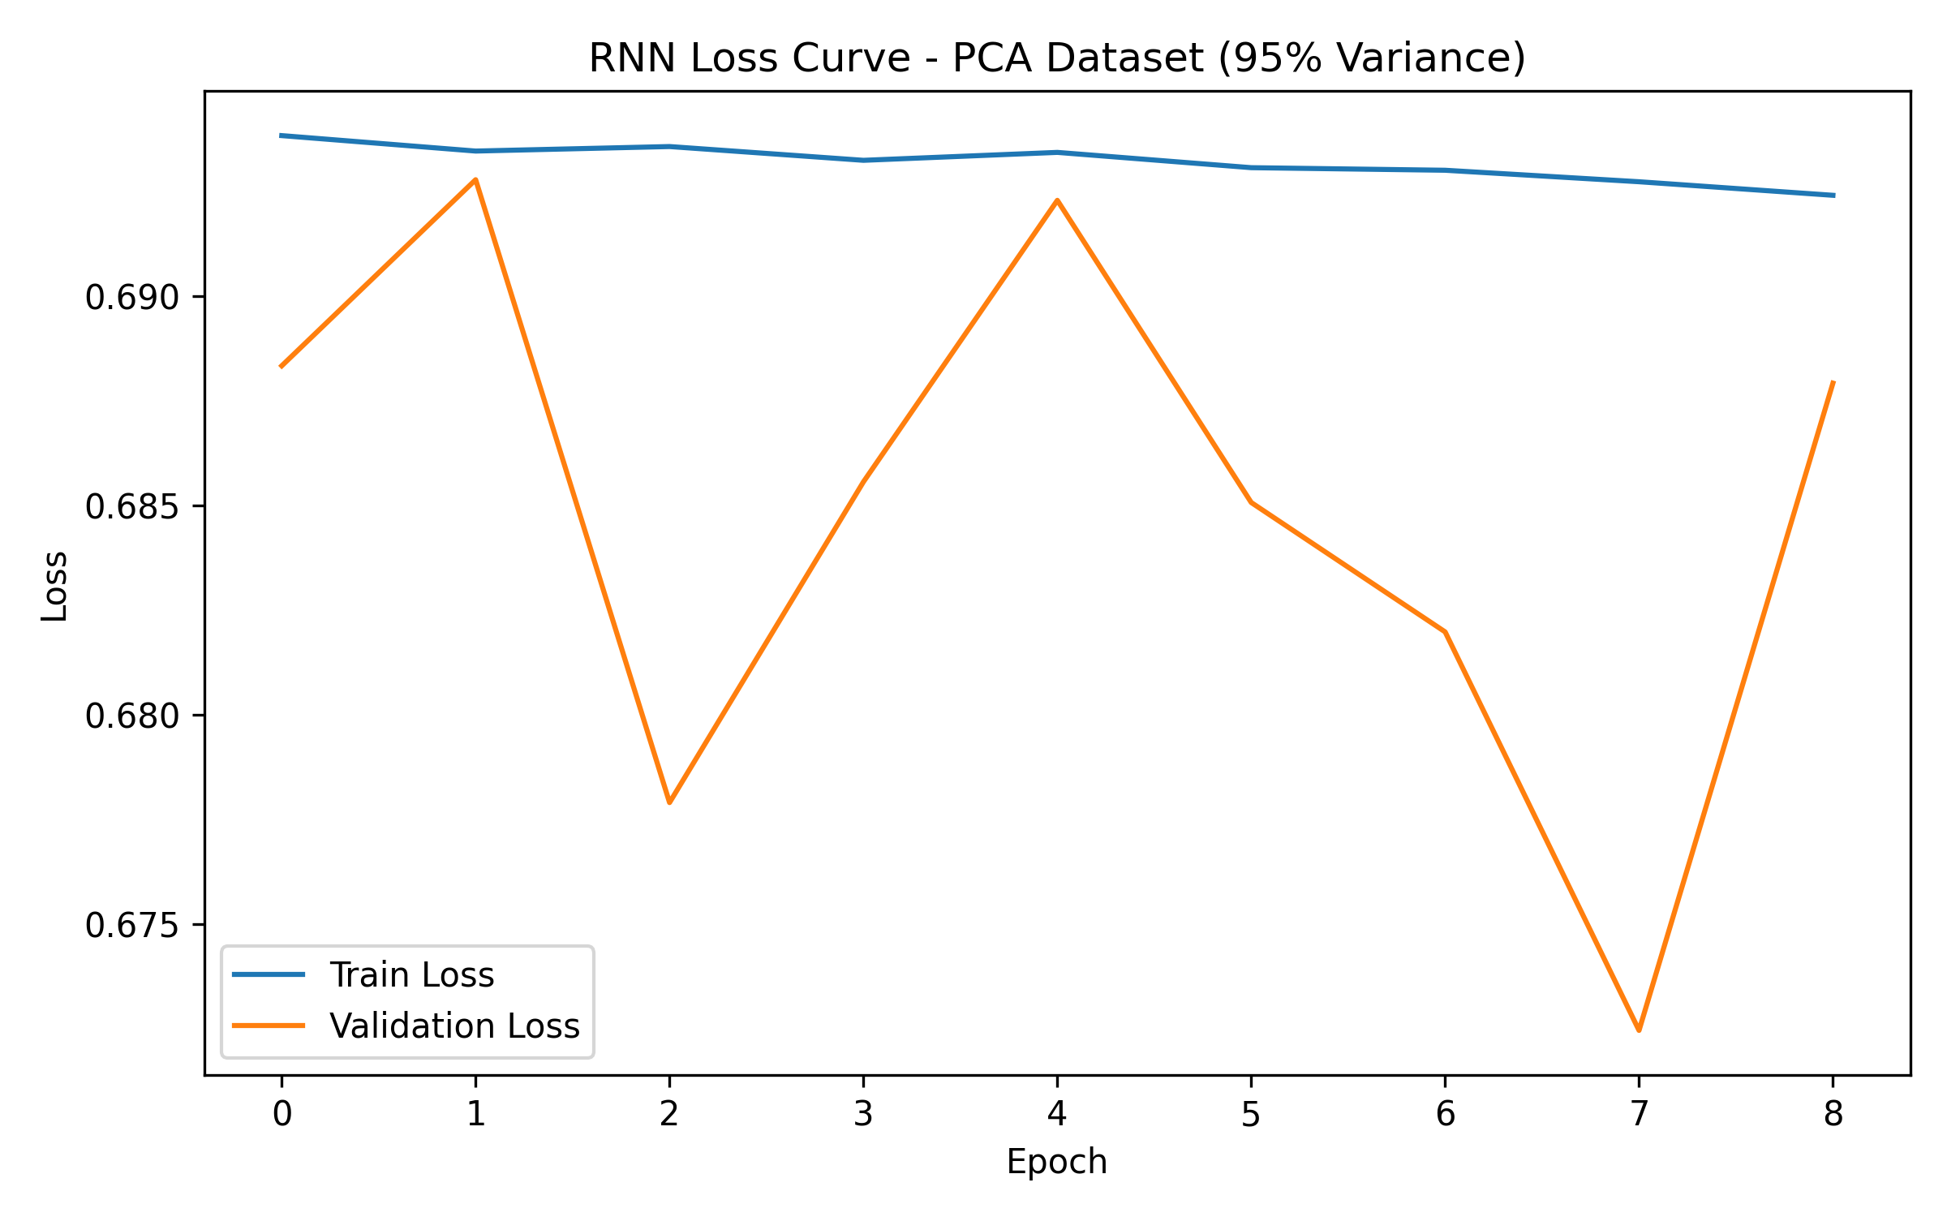
Figure 9. GRU RNN training and validation loss by epoch.
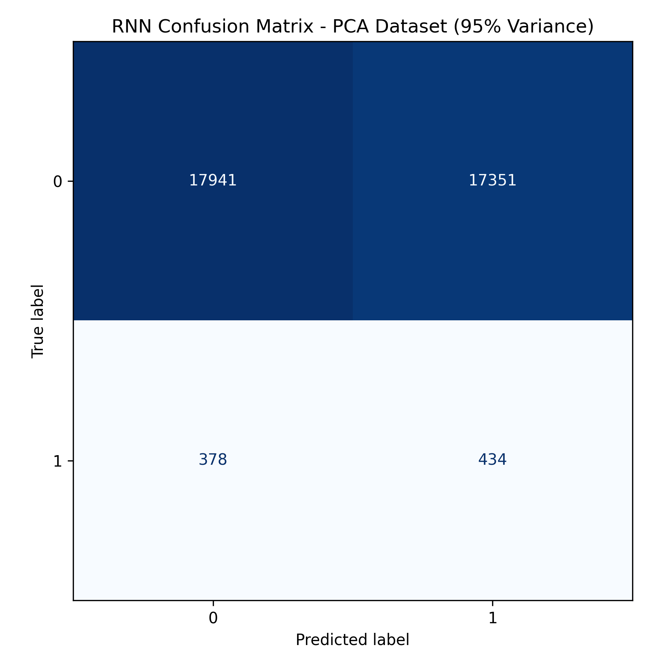
Figure 10. GRU RNN confusion matrix on the test set.

7.7 Model Comparison
Table 1 brings all six models together on the identical PCA feature set, identical splits, and the thresholds described in Chapter 5.
Model | Accuracy | Precision | Recall | F1-score | PR-AUC
Logistic Regression | 0.5158 | 0.0239 | 0.5148 | 0.0456 | 0.0238
Decision Tree | 0.7219 | 0.0268 | 0.3214 | 0.0494 | 0.0263
Random Forest | 0.9160 | 0.0417 | 0.1244 | 0.0625 | 0.0313
XGBoost | 0.9006 | 0.0364 | 0.1342 | 0.0573 | 0.0288
MLP | 0.5490 | 0.0239 | 0.4778 | 0.0455 | 0.0250
RNN (GRU) — proposed | 0.5089 | 0.0244 | 0.5345 | 0.0467 | 0.0243
Table 1. Test-set results for all models on the PCA feature set. Best values for PR-AUC, F1, precision, and recall are in bold.
Table 2 reports the raw confusion matrix counts behind these scores.
Model | TN | FP | FN | TP
Logistic Regression | 18,203 | 17,089 | 394 | 418
Decision Tree | 25,801 | 9,491 | 551 | 261
Random Forest | 32,971 | 2,321 | 711 | 101
XGBoost | 32,406 | 2,886 | 703 | 109
MLP | 19,434 | 15,858 | 424 | 388
RNN (GRU) — proposed | 17,941 | 17,351 | 378 | 434
Table 2. Confusion matrix counts on the test set (TN = true negative, FP = false positive, FN = false negative, TP = true positive).
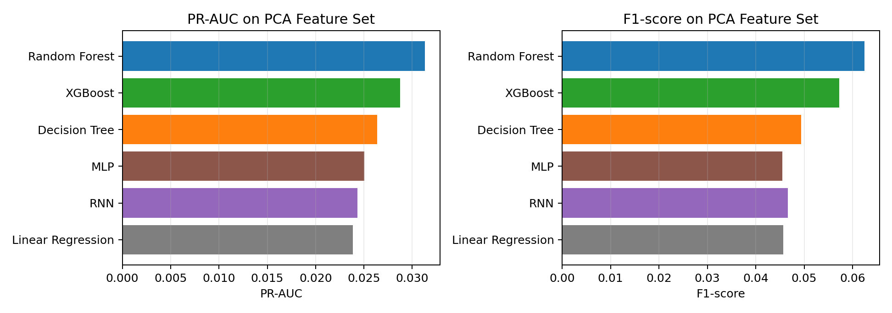
Figure 11. PR-AUC and F1-score comparison for all trained models on the PCA feature set.
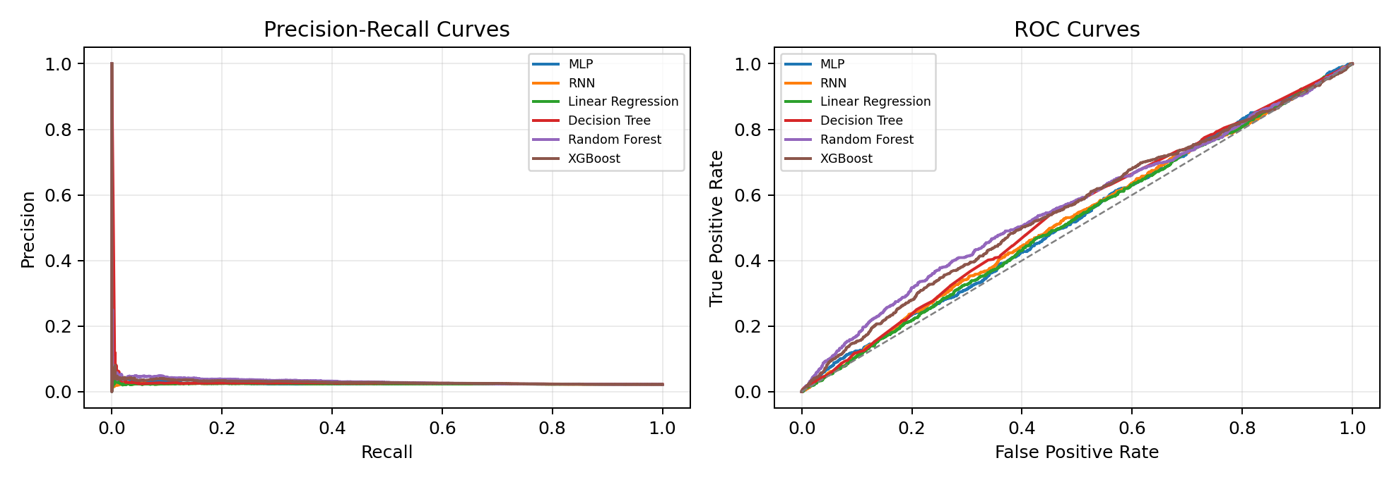
Figure 12. Precision-recall and ROC curves for the PCA-trained models.
Three findings stand out. First, Random Forest ranks first by both PR-AUC and F1-score, making it the recommended model on this representation, with XGBoost a close second. Second, the models split cleanly into two behaviour groups: conservative ensembles (high precision, low recall, high accuracy) and wide-net models (high recall, very low precision), with the GRU leading the second group. Third, and most importantly, every score is low in absolute terms. The PR-AUC of even the best model (0.0313) is only modestly above the 0.022 base rate that random guessing would achieve. This points to the feature representation, not the algorithms: PCA at 95% variance retention preserved the broad shape of the data but compressed away much of the minority-class fraud signal. The PCA results should therefore be treated as a compact experimental view, and future work should compare them against models trained on the full selected feature set without PCA.

8.0 Conclusion
This project built a complete machine learning pipeline for fraud detection in supply chain data, from raw transactional records through preprocessing, feature selection, PCA, model training, and evaluation. Six models were compared on an identical 11-component PCA representation of the DataCo Smart Supply Chain dataset: Logistic Regression, Decision Tree, Random Forest, XGBoost, MLP, and the proposed GRU Recurrent Neural Network.
Random Forest emerged as the strongest model by the metrics that matter for rare-event detection, achieving the best PR-AUC (0.0313) and F1-score (0.0625), and was selected for deployment as a screening layer with human review of flagged orders. The proposed GRU RNN achieved the highest recall of all models (0.5345), catching the largest share of true fraud, but at the cost of very low precision. Overall scores were weak in absolute terms, and the analysis traced this to PCA compression: maximising preserved variance is not the same as preserving the signal of a class that makes up only 2.3% of the data.
The project delivered three lessons that go beyond the numbers. First, accuracy is the wrong headline metric for imbalanced problems; a model with 91.6% accuracy here still missed 87.6% of the fraud. Second, data leakage must be actively hunted: a feature that duplicates the target can silently produce perfect but meaningless results, and removing such columns was essential for an honest evaluation. Third, the choice of feature representation can matter more than the choice of model; the gap between any two algorithms in this study is smaller than the gap PCA likely created against the full feature set.
Alhamdulillah, this project was completed as a combined effort of the group. Br. Azam handled the data analysis component, covering the preprocessing pipeline, ethical data pruning, missing-value and outlier handling, encoding, and the chronological data splits, as well as the dataset description. Br. Harith worked on the classical baseline models, implementing and tuning Logistic Regression and Decision Tree. Br. Alif handled the ensemble baselines, implementing and tuning Random Forest and XGBoost, together with the literature review. Br. Syamil developed the deep learning component, building and training the proposed GRU Recurrent Neural Network and the MLP comparison, and compiling the model evaluation on the PCA feature set. All group members contributed to the abstract, introduction, results discussion, conclusion, and references.
For future work, three directions are recommended. First, retrain all models on the full selected feature set without PCA and compare against the PCA results, to quantify exactly how much signal the compression removed. Second, apply resampling techniques such as SMOTE or cost-sensitive learning to strengthen the minority class during training. Third, tune the decision thresholds of the deep models on the validation set (as was done for the ensembles) and explore a two-stage deployment in which the high-recall GRU pre-screens orders and the high-precision Random Forest confirms them.

9.0 References
Baryannis, G., Validi, S., Dani, S., & Antoniou, G. (2019). Supply chain risk management and artificial intelligence: State of the art and future research directions. International Journal of Production Research, 57(7), 2179-2202.
Choi, T. M., Wallace, S. W., & Wang, Y. (2018). Big data analytics in operations management. Production and Operations Management, 27(10), 1868-1883.
Li, J., & Wang, S. (2017). A review of fraud detection in supply chain management. Supply Chain Management: An International Journal, 22(6), 492-508.
Min, H. (2010). Artificial intelligence in supply chain management: Theory and applications. International Journal of Logistics Research and Applications, 13(1), 13-39.
Nguyen, T., Zhou, L., Spiegler, V., Ieromonachou, P., & Lin, Y. (2018). Big data analytics in supply chain management: A state-of-the-art literature review. Computers & Operations Research, 98, 254-264.
Riahi, Y., Saikouk, T., Gunasekaran, A., & Badraoui, I. (2021). Artificial intelligence applications in supply chain management: A systematic literature review. Logistics, 5(2), 20.
Sarker, I. H. (2021). Machine learning: Algorithms, real-world applications and research directions. SN Computer Science, 2(3), 160.
Sattar, M. U., Dattana, V., Hasan, R., Mahmood, S., Khan, H. W., & Hussain, S. (2025). Enhancing Supply Chain Management: A Comparative Study of Machine Learning Techniques with Cost-Accuracy and ESG-Based Evaluation for Forecasting and Risk Mitigation. Sustainability, 17(13), 5772. https://doi.org/10.3390/su17135772
Wamba, S. F., Gunasekaran, A., Akter, S., Bhattacharya, M., & Dubey, R. (2017). Big data analytics and business process innovation. International Journal of Production Economics, 192, 6-10.
Zhong, R. Y., Newman, S. T., Huang, G. Q., & Lan, S. (2016). Big data for supply chain management in the context of the internet of things. Computers & Industrial Engineering, 101, 572-580.
Constante, F., Silva, F., & Pereira, A. (2019). DataCo Smart Supply Chain for Big Data Analysis [Data set]. Mendeley Data. https://doi.org/10.17632/8gx2fvg2k6.5

Generative AI Declaration
We acknowledge the use of Generative AI tools for code automation, document structuring, and comparative analysis formatting. All outputs were verified for academic integrity by the group members. We use ChatGPT, Claude and Gemini to help with the assignment.

