SRT411A0-Justin Gourgouvelis

## Todo #1 Perform calculation, get percentage

((2018-2014)/(2014-1984)) * 100

## [1] 13.33333

## Todo #2 Save answer to variable, erase variable

percent=((2018-2014)/(2014-1984)) * 100  
rm(percent)

## Todo #3 Sum of numbers

sum(4,5,8,11)

## [1] 28

## Todo #4 Plot 100 random numbers

plot(rnorm(100))

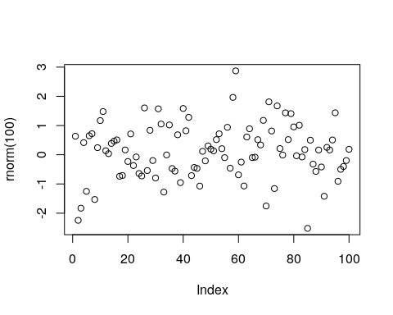

## Todo #5 Open Manual for Square Root Function

help(sqrt)

## Todo #6 Make sequence from 31 to 61, then display them as both a row and a matrix P and Q

p=seq(from=31, to=60, by=1)  
q=matrix(p,ncol=5, nrow=6)  
p

## [1] 31 32 33 34 35 36 37 38 39 40 41 42 43 44 45 46 47 48 49 50 51 52 53  
## [24] 54 55 56 57 58 59 60

q

## [,1] [,2] [,3] [,4] [,5]  
## [1,] 31 37 43 49 55  
## [2,] 32 38 44 50 56  
## [3,] 33 39 45 51 57  
## [4,] 34 40 46 52 58  
## [5,] 35 41 47 53 59  
## [6,] 36 42 48 54 60

## Todo #7 Create new matrix x1,x2,x3 making a data frame with columns a,b,c. Displaying information

x1=seq(from=1, to=100, by=1)  
x2=seq(from=101, to=200, by=1)  
x3=seq(from=201, to=300, by=1)  
t= data.frame(a=x1,b=x1+x2,c=x1+x2+x3)  
plot(t)

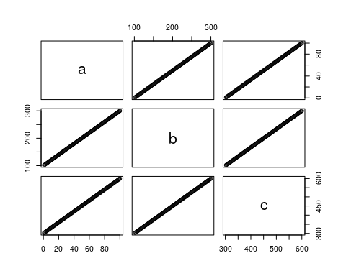

## Todo #8 Add colors to the graph rgb = red,green,blue. Level of color dependant on number provided

plot(t$a, type="l", ylim=range(t),lwd=3, col=rgb(1,0,0,0.3))  
lines(t$b, type="s", lwd=2,col=rgb(0.3,0.4,0.3,0.9))  
points(t$c, pch=20, cex=4,col=rgb(0,0,1,0.3))

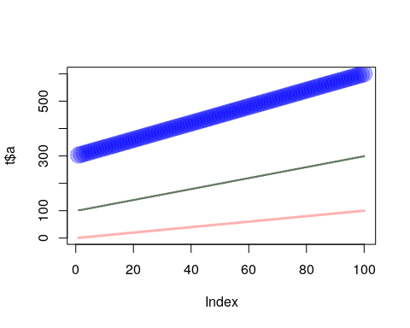

## Todo #9 Take a Sqaure Root of the mean of 100 random numbers

sqrt(mean(rnorm(100)))

## [1] 0.4153225

## Todo #10 Create a file tst1.txt and add information to that file. Change the file by calculating values

d = data.frame(g = c(3,4,5),h = c(12,43,54))  
write.table(d, file="tst1.txt", row.names=FALSE)  
d2 = read.table(file="tst1.txt",header=TRUE)  
d2$g*5

## [1] 15 20 25

## Todo #11 Enter Today’s date and date of my birthday this year

date1=strptime( c("20190219","20190815"),format="%Y%m%d")  
present=c(10,6)  
date1

## [1] "2019-02-19 EST" "2019-08-15 EDT"

## Todo #12 Create a for loop that checks i against a number and performs calculations based on the result

vector=seq(from=1, to=100, by=1)  
s=c()  
for(i in 1:100)  
{  
 if(vector[i]<5)  
 {  
 s[i]=vector[i]*5;  
 }  
 else if(vector[i]>90)  
 {  
 s[i]=vector[i]*10;  
 }  
 else  
 {  
 s[i]=vector[i]*0.1;  
 }  
}  
s

## [1] 5.0 10.0 15.0 20.0 0.5 0.6 0.7 0.8 0.9 1.0  
## [11] 1.1 1.2 1.3 1.4 1.5 1.6 1.7 1.8 1.9 2.0  
## [21] 2.1 2.2 2.3 2.4 2.5 2.6 2.7 2.8 2.9 3.0  
## [31] 3.1 3.2 3.3 3.4 3.5 3.6 3.7 3.8 3.9 4.0  
## [41] 4.1 4.2 4.3 4.4 4.5 4.6 4.7 4.8 4.9 5.0  
## [51] 5.1 5.2 5.3 5.4 5.5 5.6 5.7 5.8 5.9 6.0  
## [61] 6.1 6.2 6.3 6.4 6.5 6.6 6.7 6.8 6.9 7.0  
## [71] 7.1 7.2 7.3 7.4 7.5 7.6 7.7 7.8 7.9 8.0  
## [81] 8.1 8.2 8.3 8.4 8.5 8.6 8.7 8.8 8.9 9.0  
## [91] 910.0 920.0 930.0 940.0 950.0 960.0 970.0 980.0 990.0 1000.0

## Todo #13 create a function that will take in a value i for calculation

fun= function(arg1,arg2 )  
{  
 vector[i]=arg1[i];  
 for(i in length(vector))  
 {  
   
 }  
}