Introduction:
The application deals with the Detection of Different marbles and to more precise with the ui component which deals with informing the user about the state of the different states the system may be in. This document explains the Different components the purpose of the different components as well how they were planned to be implemented by Mirko Mannigel.
To do so I will commence with the communication layers that are available form the outside which I will then follow up by how the different steps in the process may be visualized to end it with a short issue analysis. A short introduction to qt will also be given, to provide the next developer with a smother Entry to the Project.
Communication:
In the application there are 2 major method of communication. One being the named pipe implemented by the Author of this text and 2 being shared memory. This text will only explain the named pipe as there are better sources of information for the latter of the both. For further information please refer to Stefan Nolting or the generated example code.
As for the Named pipe there is an example provided with in the Doxygen comments of the name pipe library. The dessision to abstact the code into a separate library was made to ensure that the component could be injected more simply into other projects. Care should be taken when using it though as the Code is at the moment set to be blocking.
Should the user of the library want to write to the fifo (named pipe) with out connecting a reader at all times he should set the Named pipe to nonblocking a usage of O_NONBLOCK when opening the file may be needed a good reference point may be this stack overflow post https://stackoverflow.com/questions/50155525/fifo-block-program-until-other-process-read. If you ignore this and try to write and then read non-simultaneously this may lead to the application going into a blocking state and not running as expected!
This feature was not implemented as it was not a wanted feature at the time but the addition should not be to difficulty. Further Feature idears where written down as @todo in the .h file of the name pipe library to document future idears for the module.
To keep communication as well as data stream conversion simple a deliberate choice was made to utilize json for communication between in the named pipe. The reason being that the data is in human readable form an can be read directly format the named pipe as well as not requiring complex memory structures to copy the byte stream from object to data stream and vice versa.
To convert an object to Json and back one most only overload object.to_json as well as from_json. Simple data may just be assigned on the run with the [index] operator. Indexes may consist of numerical as well as strings. The project is well documented and has found utilization in a loot of projects such as vtk as it is quite similar of how it would be would it be part of the c++ stl.
Example of a comment in the .h file (only needed for the internship documentation)
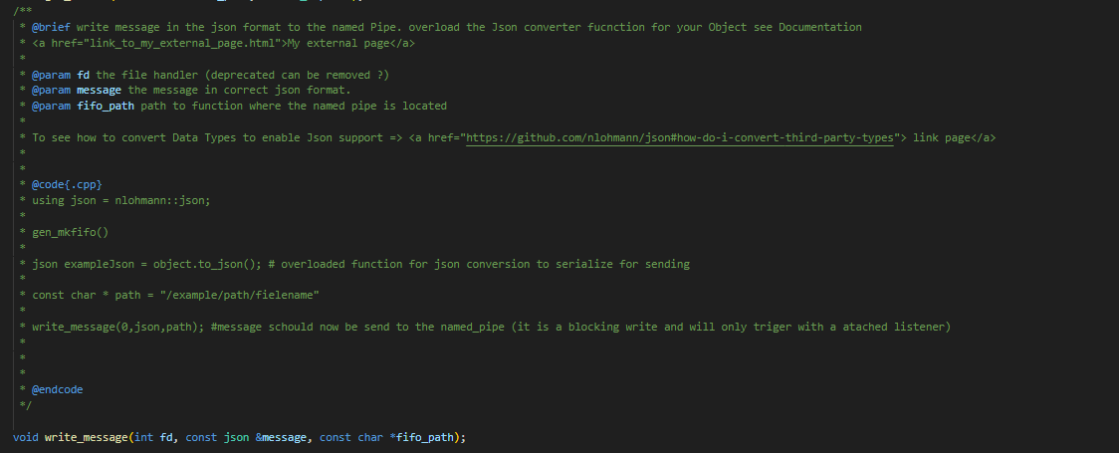
Sources of Information:
During the run as mentiond before there are 2 different ways of communication one which is the named pipe and two wich is the shared memory, at the moment each of those 2 communciation layers is attached to one core. Name pipe is the counter part of the HPC core and shared memory of the Management core. Bothe cores provide different informations to the ui.
As of writing this documentation the following information is an available to the different cores:
HPC core:
- learn epoch
- federate learning epoch
Management core:
- Exptected marbles.
- The State the maschine is currently in
- Inference result marble
State refers to whether the application is in a training cycle or inference. Based on the different States different information may have to be visualized.
UI elements:
during the duration of the Project I made my self some notes on how I would implement the visualization sadly some issues with the frameworks (which I will discus latter) caused a delay which meant that it could not be completed by the end of my internship. However, I will shortly highlight the current design ideas to give the next person that works on the project a starting idea. There are currently 2 major ui States planed Training Cycle and Inference mode.
Hier a scetch of the full ui seen I Diagram x for the Training mode and in Diagram Y
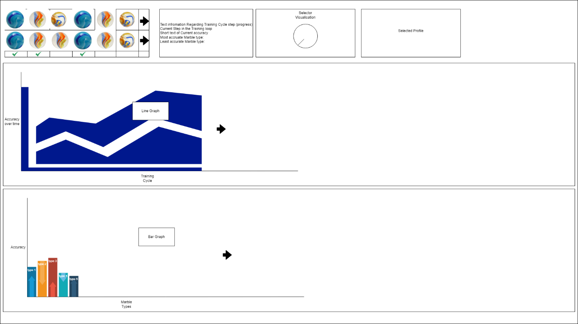
Figure 1Training Mode
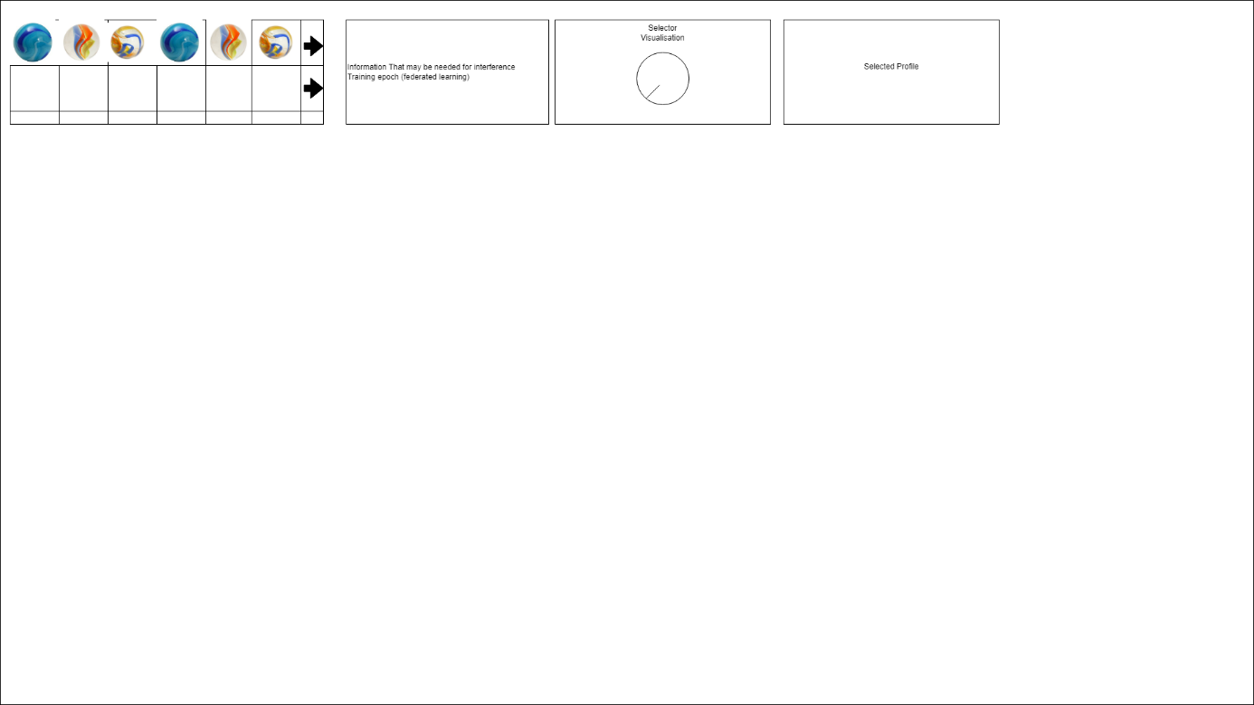
Figure 2 Inference Mode
Now that we have had a look at the overall ui context let’s look at the separate components. Starting with the ones that are used by both ui.
First element we will have a look at is the State selector.
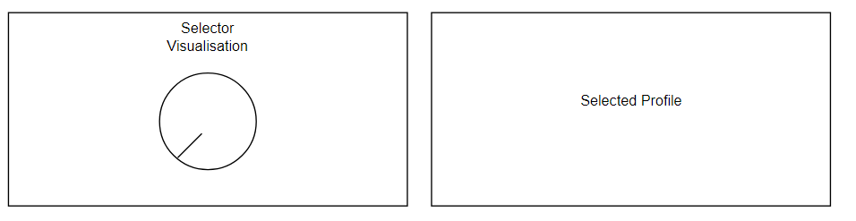
The State selector is connected to a LCD UI widget which depicts the Select Profile this was done to ensure that the user had a feedback in the ui when moving the physical selector. It was programed in a way that its simple to change the range as well as modify the value its pointing to. The values of the range and step size are determined by a json config. See base_config.json in the json folder under ui_elements =>Dial => maximum. Sample code how to use it is currently only available in the main.cpp.

Now to the Marble visualization although different between both commponts in regards of inference displaying less information. They both have a similar enough structure.
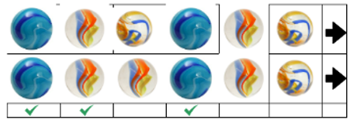
While The training cycle is able to provide a expected marble vs is marble view where we can provide a run time check if the prediction with the current training cycle was correct, this is not avaible via the Management core. Instead of generating a new ui element we decided to not fill the corresponding fields with data when not applicable. The arrows indicate the direction new marbles will be added. It will act like a sliding window. The checkmark is a indication of a matching marble between expected and delivered. The order of marbles is store/provided by the Management core.
Now to the “State” specific ui elements.
Inference:
For the Inference the following elements are planed to be implemented.
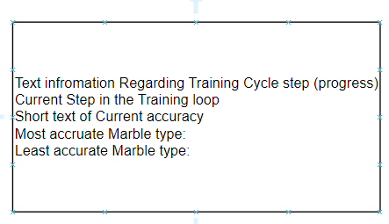
The inference mode will have a text filed which will provide more context information provided form the management core. At this stage we plan to include the information provided in the image above.

During the planning Phase of the project it was apparent that we would like to have a visualization of the training Progression as well as a way to depict any discrepancies of training between different marbles types for this purpose we added 2 different graphs.
Graph 1 depicts a Line graph representing the accuracy’s growth curve over time This could be a good measure to evaluate which value the accuracy stabilizes on. This could help determine how many training cycles are needed to get to a point where the gain stops to flatline.
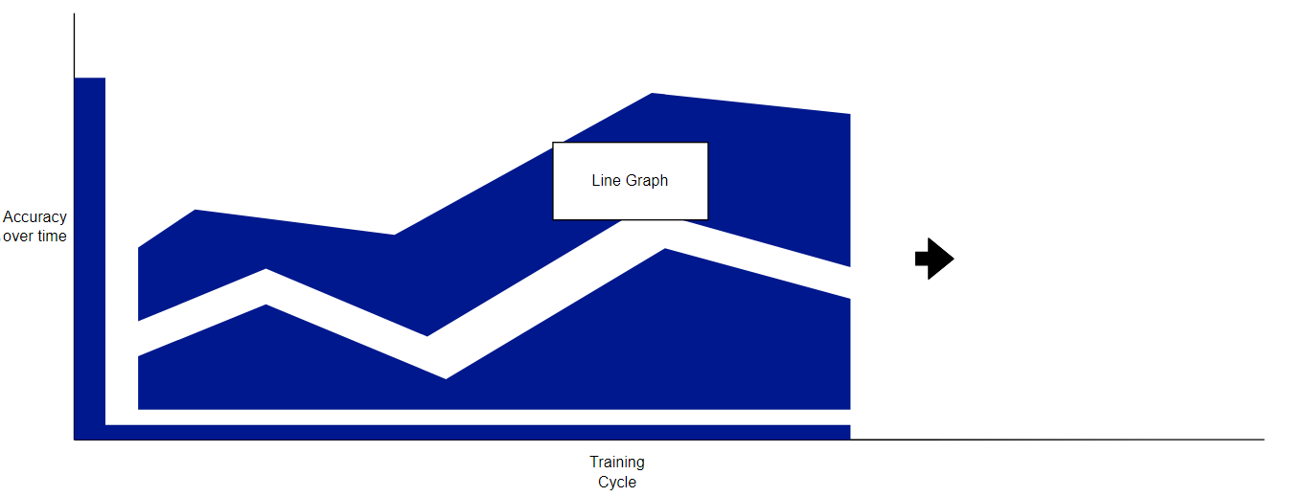
Graph 2 would be a Bar That Represents the accuracy on a per marble type, this is a good indicator to trac if certain traits may have less impact on the sound profile of the marble, example could be the differentiation of a broken vs an intact marble. Different types of marbles may require a different quantity to be able to get accurately distinguish. At the moment only, a growth or decline in accuracy in relation to the previous set is planed indicating the percentage it is correctly or incorrectly guessed as well as if it has decreased or increased compared to the marble before. This is done using the arrows however color coding may also be used. The specific implementation will be up to the develop that finalizes the Code implementation as well as the Project supervisor.
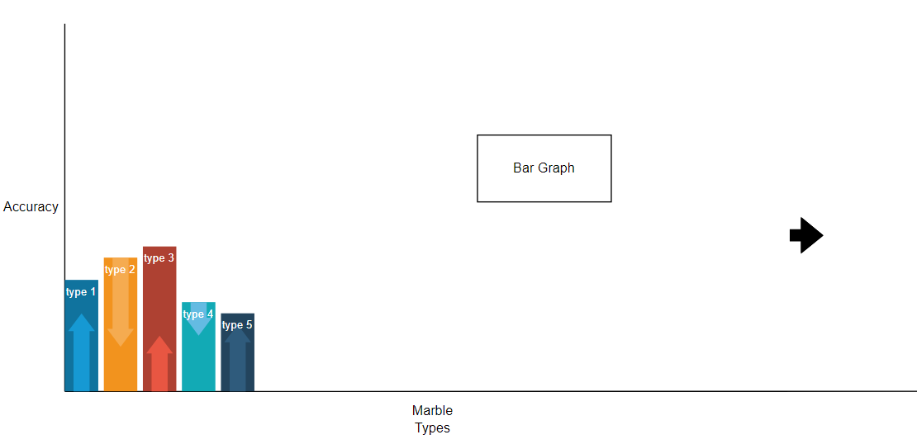
The inference only has one unique ui element which is the Data it depicts in the Data Field as well as the fact that it poses a reduced version of the Prediction Box from the Training Cycle.
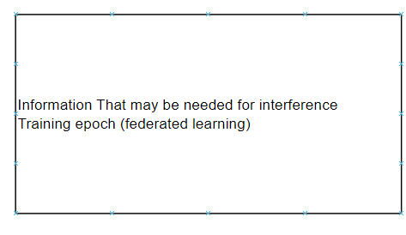
QT
Short explanation on the Functionality of QT and how the development Cycle is done (as develop by the Author of the text). A basic ui is created using the QT creator which then stored as a .ui file. The cmake is setup in way that will automatically load in the new .ui file. You then include the .ui file in either the .h or .cpp, see example in gitlab. The compiler is set to automatically updte the render ui file. This can be found in the build folder MyProject_autogen. In this folder you will find the .h file containing all the ui elements. Any button events can be programed through the function connect which will add a function call to the different elements.
VTK
The VTK lib was introduced to create tables as well as draw the png for the marbles.
vtk can be build with qt support sadly issue arose when developing the cmakelist.txt for the integration of both components, the issue seems to stem from the Collision of the the json lib provided from the vtk lib and the one I used to implement the config/json loader. First steps to a integration have been made in the cmaklist.txt this is not yet fully functional.
The vtk build provided by the apt repo was havin issues thus you have to either build the project with the flag set to build from source which will automatically build the vtk with qt support for you or you need to modify the cmake set flag to point to the path where you build vtk. You should enable VTK qt support and some other flags. An option to do so is ccmake
Project Structure:
The project is organized as shown in Diagram X. CMake is configured to automatically load different .h, .cpp, and .ui files from their dedicated folders using glob. If the project reaches a production state, it is highly recommended to switch to a static definition of the included project files.
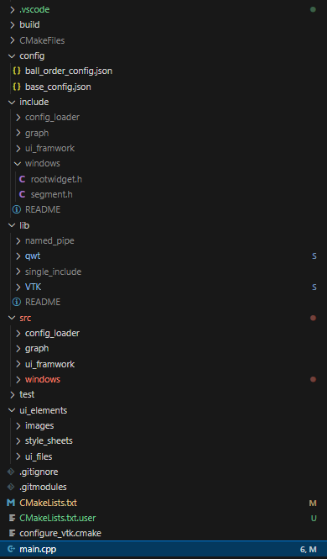
The build folder is automatically created by Visual Studio. Build flags can be set in the settings.json file located in the .vscode directory. To add flags, include the following lines:
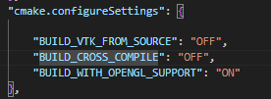
The purpose of these flags is documented within the CMake files as comments. Alternatively, if you prefer to build the project using the terminal, you can use ccmake and make.

For any questions regarding CMake, please contact Husin.
Configuration files should be formatted in JSON. They can be loaded as previously described. Header and .cpp files are separated into include and src directories. These files contain only the code and not the UI layout.
UI elements, such as images, style sheets, and .ui files (which can be edited using Qt Creator), are located in their corresponding folders within the ui_elements directory.

