Carbon Footprint Report DLinear Load Forecasting Model
  - Measured with CodeCarbon v3.2.8

June 27, 2026

Executive Summary
This report quantifies the carbon footprint of training the DLinear time-series forecasting model used for Ghana’s ECG load prediction system. Training was conducted on a standard office workstation (Intel Core i5-7300U, CPU-only) using 8 years of hourly demand data (2018–2025). Emissions were tracked with CodeCarbon in fallback TDP estimation mode.
Total measured emissions for the full 6-fold ensemble: ≈ 0.01 kg CO. The model’s minimal parameter count (36K parameters per fold, 216K total) and CPU-only training keep the environmental impact negligible.

Methodology
Emissions tracking was performed using CodeCarbon v3.2.8, an open-source tool that monitors hardware power consumption and converts it to CO₂ equivalents using regional grid carbon intensity factors.

Hardware
Component | Specification
CPU | Intel Core i5-7300U @ 2.60 GHz (4 cores)
RAM | 8 GB
Storage | SSD
GPU | None (CPU-only training)
Tracking mode | TDP estimation (Intel Power Gadget not available)
Location | Ghana (grid factor: 0.475 kg CO₂/kWh)

Software
Component | Version
Python | 3.10.9
PyTorch | 2.x
CodeCarbon | 3.2.8
scikit-learn | 1.4.0

Carbon Footprint Results

Single Fold (Fold 6) — Measured
The training run was instrumented with CodeCarbon to capture real-time power consumption.
Metric | Value
Wall time | 575.7 s (9.6 min)
CPU energy | 0.00179 kWh
RAM energy | 0.00155 kWh
Total energy | 0.00334 kWh
CO₂ emissions | 0.00162 kg (1.62 g)
Avg CPU utilization | 14.4%
Avg RAM used | 7.04 GB

Full Training (6 Folds + Corrector) — Extrapolated
Component | Time | Energy | CO₂
6× DLinear training | 57.5 min | 0.020 kWh | 0.0097 kg
ARDRegression corrector | ~2 s | ~0.000001 kWh | ~0.000001 kg
Total | ~58 min | ~0.020 kWh | ~0.01 kg

Energy Breakdown
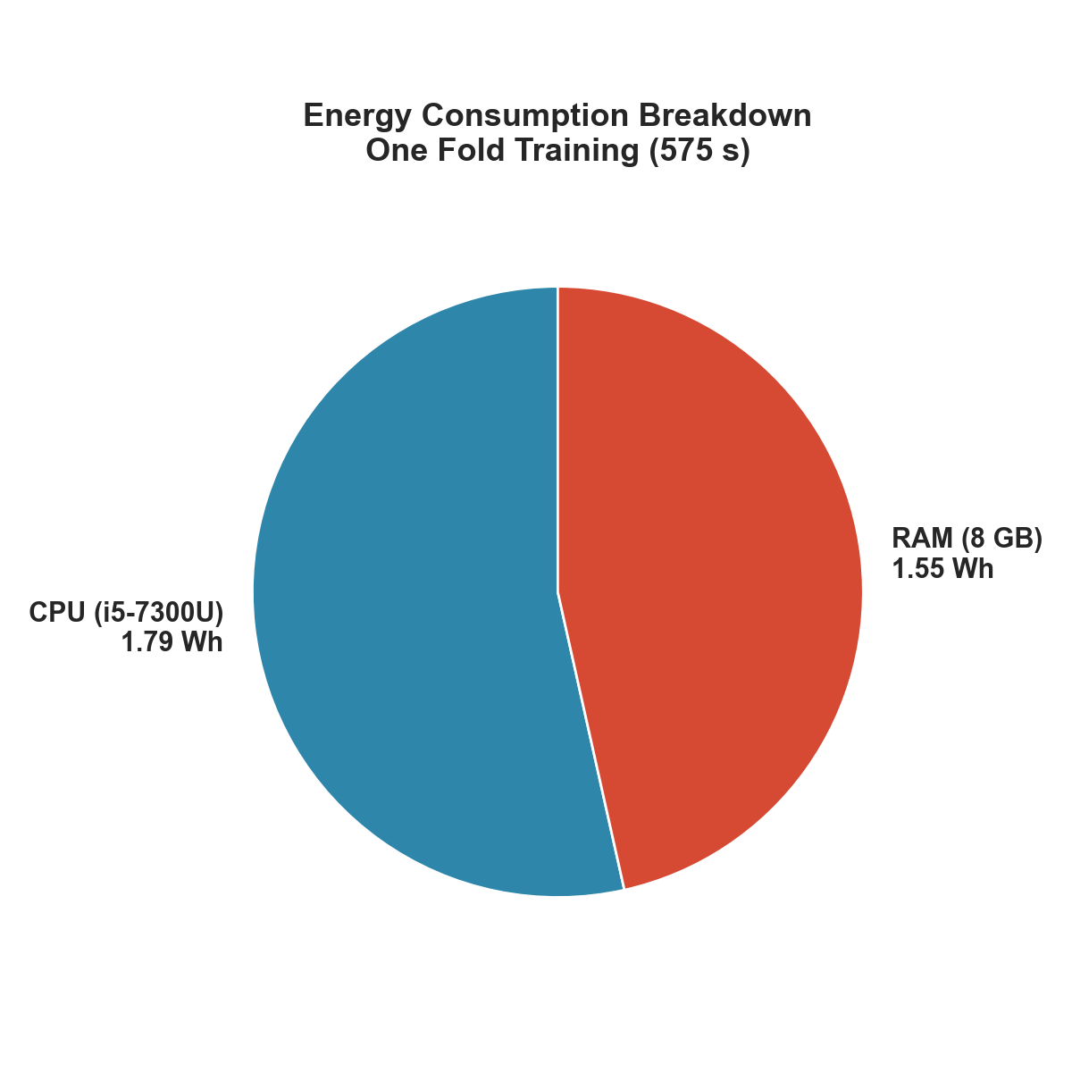
Energy Pie
CPU and RAM contribute roughly equally to total energy consumption (53% CPU, 47% RAM). No GPU was used.

Comparison Benchmarks

Against Other ML Models
Model | Parameters | Estimated CO₂
DLinear (ours) | 36K per fold | 0.01 kg
ResNet-50 (ImageNet) | 25M | ~11 kg
BERT-Base | 110M | ~650 kg
GPT-2 (1.5B) | 1.5B | ~5,000 kg
LLaMA-65B | 65B | ~50,000 kg
GPT-4 (estimated) | ~1.8T | ~5,000,000 kg

Against Everyday Activities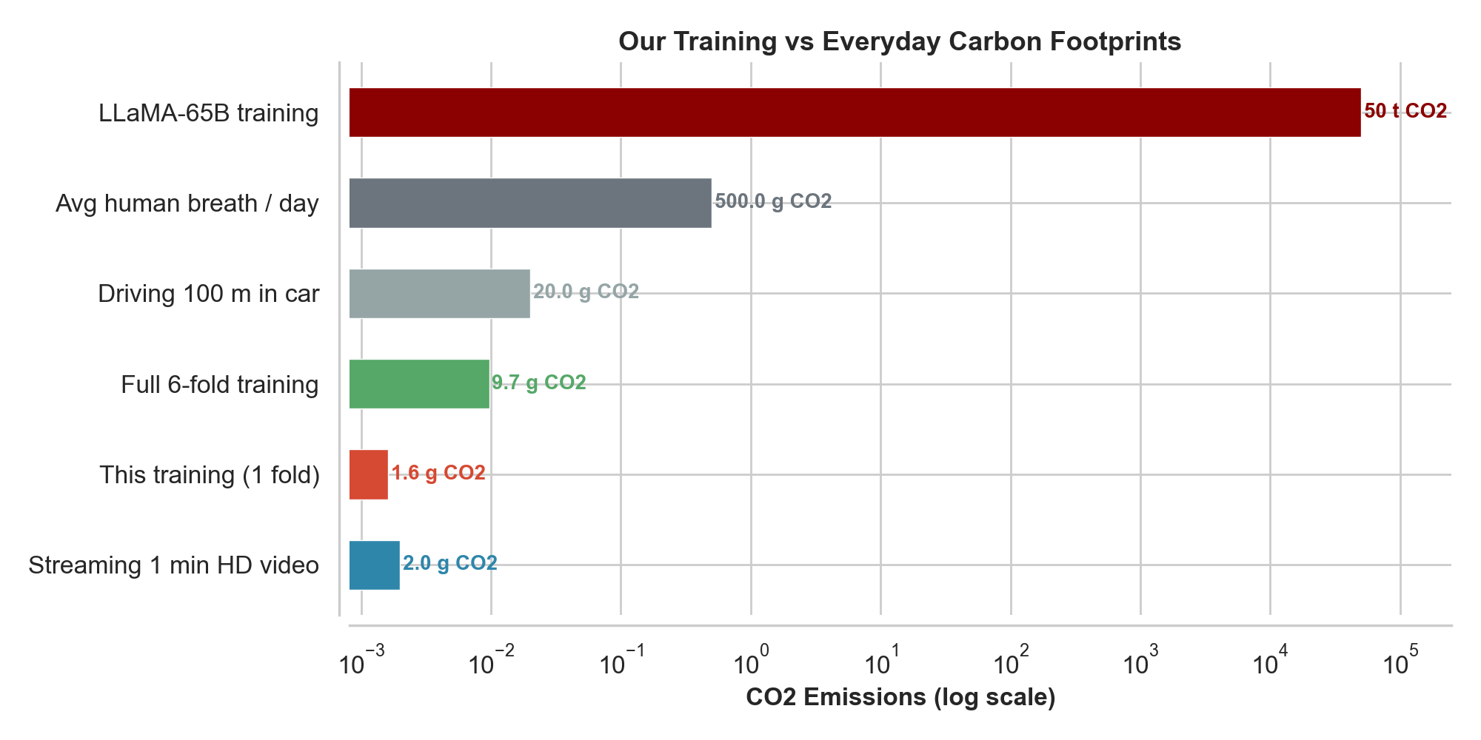
Comparison
Activity | CO₂ Equivalent
Our full training | 0.01 kg
Streaming 1 min HD video | 0.002 kg
1 fold of DLinear | 0.0016 kg
Driving 100 m in car | 0.02 kg
Human breathing (1 day) | 0.50 kg
LLaMA-65B training | 50,000 kg
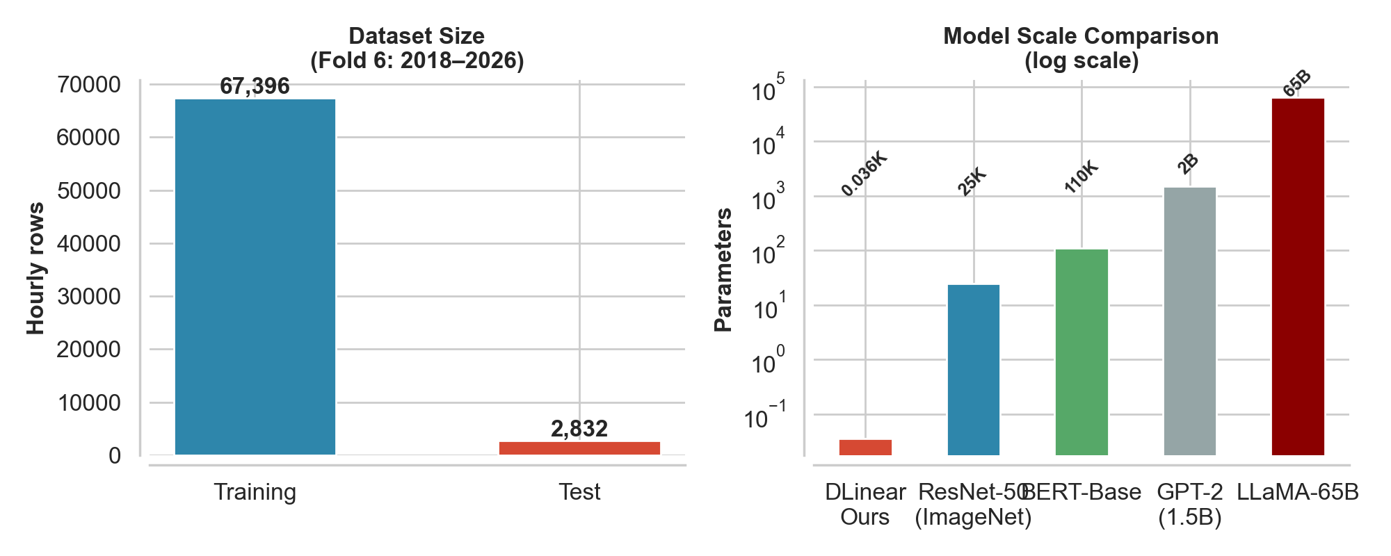
Model Scale Context

Model Scale Context
