MIS 150 Group Project

Group Number: 1



Group Members:

Erin Martin
Joshua Wesselman
Leticia Magalhaes
Robert Velazquez

Instructor: Xiaolin Lin
12/7/2025

Table of Contents
Project Description 3
Team Description with Roles 3
Erin Martin – Project Manager 3
Joshua Wesselman – Systems Analyst / Data Modeler 3
Robert Velazquez – Database Architect 4
Leticia Magalhaes – Documentation Specialist / ERD Support 4
Team Collaboration 4
Primary Business Activities 5
Primary Business Activities 5
1. Staffing and Placement 5
2. Candidate Management 5
3. Training and Courses 6
4. Qualification Management 6
ERD DIAGRAM 7
Normalization Process 8
First Normal Form (1NF) 8
Second Normal Form (2NF) 8
Third Normal Form (3NF) 8
Outcome of Normalization 8
Database Dictionary 9
1. COMPANY 9
2. QUALIFICATION 9
3. COURSE 9
4. SESSION 10
5. CANDIDATE 10
6. OPENING 10
7. PLACEMENT 11
8. JOBHISTORY 11
9. ENROLL 11
10. EDUCATION 12
11. PREREQUISITE 12
12. EMPLOYEE 12
Table Descriptions 13
1. COMPANY Table: 13
2. QUALIFICATION Table Description 13
3. COURSE Table Description 14
4. SESSION Table Description 14
5. CANDIDATE Table Description 15
6. OPENING Table Description 15
7. PLACEMENT Table Description 16
8. JOBHISTORY Table: 16
9. ENROLL Table Description 17
10. EDUCATION Table Description 17
11. PREREQUISITE Table Description 18
12. EMPLOYEE Table Description 18
Qwery SQL Code 19
Query #1 19
Query #2 20
Query #3 21
Query #4 22
Query #5 23
Query #6 24
Query #7 25
Query #8 26
Query #9 27
Query #10 28
Business Rationale for Custom Queries 29
Summary 30

Project Description
Temporary Employment Corporation (TEC) is a professional staffing agency that connects qualified temporary employees with client companies experiencing peak workloads or short-term staffing needs. As the company expands, TEC requires a relational database system to centralize and manage its key business information, including candidate profiles, qualifications, training courses and sessions, client companies, and active job openings. The database will enable staff to efficiently match candidates to openings based on required qualifications, record placements and total hours worked, and maintain accurate job history records for each worker. It will also track course prerequisites, enrollment fees, and candidate participation in training programs, ensuring continuous skill development across the workforce. By integrating these functions into a single, structured system, the database will improve operational efficiency, enhance data accuracy, and provide management with timely insights for better staffing and training decisions.

Team Description with Roles

Our team consisted of four members, each contributing to different parts of the TEC Database Project. While we collaborated closely throughout the assignment, each team member took primary responsibility for specific components based on our strengths and availability.

Erin Martin – Project Manager
Erin served as the Project Manager and oversaw the full lifecycle of the project. Responsibilities included coordinating team meetings, assigning tasks, ensuring deadlines were met, and maintaining communication across the team. Erin also worked extensively on building and validating the SQL database, inserting data records, checking table relationships for accuracy, generating additional placement history, normalization write-up, and assisting with the creation of the custom SQL queries required for the assignment. Erin ensured all deliverables aligned with project requirements and compiled the final submission.

Joshua Wesselman – Systems Analyst / Data Modeler
Joshua took the lead in designing and refining the Entity-Relationship Diagram (ERD), including updating all entities, attributes, keys, and relationships. He also contributed to the preparing of the normalization process to verify that all tables were compliant with 1NF, 2NF, and 3NF. Joshua supported query development by reviewing JOIN structures and ensuring the ERD accurately represented the logical schema used in the SQL script.

Robert Velazquez – Database Architect
Robert focused on defining the table relationships and ensuring referential integrity across all foreign keys. He reviewed the relational schema for consistency, assisted in validating the correctness of composite keys, and helped prepare the table descriptions section. Robert also reviewed the CREATE TABLE statements for structure, constraints, and proper alignment with the ERD.

Leticia Magalhaes – Documentation Specialist / ERD Support
Leticia prepared the Table of Contents and completed the Data Dictionary, ensuring that all fields, data types, and key definitions were correctly reflected. She also supported documentation formatting and reviewed written sections for clarity. In addition, Leticia assisted with validating the ERD relationships, ensuring consistency between the SQL script, prerequisite tables, enrollment relationships, and the final ERD diagrams.

Team Collaboration
Overall, the team worked well together. Each member fulfilled their assigned responsibilities, and communication was consistent throughout the project. Whenever challenges arose—such as aligning the ERD with the SQL database or expanding the dataset—team members collaborated to find solutions quickly. The combination of technical, analytical, and organizational skills across the team allowed us to complete the project thoroughly and on time.

Primary Business Activities

Primary Business Activities
Temporary Employment Corporation (TEC) performs several key business operations that revolve around staffing, training, and record management. The database must support the following primary business activities and rules:

1. Staffing and Placement

Business Rules:
  - TEC connects qualified temporary workers with client companies that post open positions.
  - Each Company may post zero or many Openings, and each Opening must belong to exactly one Company (1:M relationship).
  - Every Opening must require exactly one main Qualification, and a Qualification may be required by zero or many Openings (1:M relationship).
  - A Candidate may be placed into zero or many Openings, and an Opening may be filled by zero or many Candidates (M:N relationship).
  - This many-to-many relationship is resolved through the Placement entity, which records each assignment.
- Data Tracked:
Company information (name, contact, phone), job openings (opening number, required qualification, start and end dates, hourly pay), placements (candidate ID, opening ID, total hours worked), and job history (dates worked, comments).

2. Candidate Management

Business Rules:
  - TEC maintains a file of all candidates who are willing to work.
  - Each Candidate may possess zero or many Qualifications, and a Qualification may belong to zero or many Candidates (M:N relationship).
  - This relationship is resolved through the Candidate_Qualification table, which captures the candidate’s earned qualifications.
  - This allows TEC to quickly match candidates to Openings requiring specific skills.
Data Tracked:
Candidate ID, name, phone, email, qualifications earned (qualification code and description), and date or issuer of qualification.

3. Training and Courses

Business Rules:
  - To help candidates build or improve their skills, TEC offers Courses that correspond to or lead to specific Qualifications.
A Course may require zero or many Qualifications as prerequisites, and a Qualification may be a prerequisite for zero or many Courses (M:N relationship).
  - This relationship is resolved through the Course_Prerequisite table.
  - Each Course may be offered through zero or many Sessions, but every Session must deliver exactly one Course (1:M relationship).
  - Candidates may enroll in zero or many Sessions, and each Session may include zero or many Candidates (M:N relationship).
  - This relationship is resolved through the Enrollment table, which also tracks registration and payment details.
Data Tracked:
Course details (course name, description), prerequisites (qualification codes required), session information (dates, fees, and course taught), and candidate enrollments (payment status, registration date).

4. Qualification Management

Business Rules:
  - TEC maintains a master list of qualifications, each identified by a unique code (e.g., PRG-PY, SEC-60).
  - A qualification can serve both as a skill indicator and as a course prerequisite.
  - Each Opening must require one Qualification as its minimum requirement for placement.
Data Tracked:
Qualification code, description, related courses, and associated openings requiring that qualification.

ERD DIAGRAM
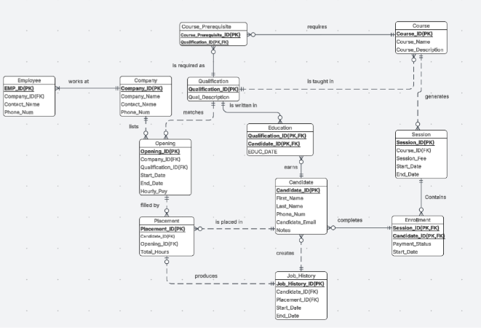

Normalization Process
To make sure the TEC database is clean, efficient, and easy to maintain, it was fully normalized using the standard levels of First, Second, and Third Normal Form (1NF, 2NF, and 3NF). The goal of this process was to eliminate unnecessary duplication, reduce the chance of errors, and ensure that every piece of information is stored in the right place.

First Normal Form (1NF)
All tables in the database meet the requirements of 1NF. Each field contains a single, clear value nothing repeated or combined and every table has a primary key that uniquely identifies each record. Information like company names, qualifications, candidates, and courses is stored in separate tables instead of being duplicated. This structure keeps the data organized and easier to manage.

Second Normal Form (2NF)
To meet 2NF, every non-key attribute must depend on the entire primary key, especially in tables that use composite keys. In the TEC database, tables like ENROLL, EDUCATION, and PREREQUISITE use two-column primary keys, and all of their additional fields (such as ENROLL_DATE or EDUC_DATE) rely on both parts of that key. Because of this, there are no partial dependencies, and the data remains consistent and logically structured.

Third Normal Form (3NF)
The database also meets 3NF by ensuring that all non-key attributes depend only on the primary key and not on other non-key fields. For example, attributes like COMP_NAME, QUAL_DESCRIPTION, and COURSE_FEE live only in their correct parent tables and are linked through foreign keys rather than repeated in multiple places. This prevents transitive dependencies and keeps data changes simple and accurate.

Outcome of Normalization
By applying 1NF, 2NF, and 3NF across all tables, the TEC database avoids typical problems such as inconsistent updates or duplicate information. The result is a well-organized, reliable system where each table serves a clear purpose. This makes reporting, data analysis, and future system enhancements much smoother and more dependable.

.

Database Dictionary

1. COMPANY
Attribute Name | Description | Data Type | Key | Format
COMP_CODE | Unique identifier for each company | VARCHAR(10) | PK | XXXXXXXXXX
COMP_NAME | Company name | VARCHAR(100) |  | Up to 100 chars

2. QUALIFICATION
Attribute Name | Description | Data Type | Key | Format
QUAL_CODE | Unique qualification code | VARCHAR(10) | PK | XXXXXXXXXX
QUAL_DESCRIPTION | Description of the qualification | VARCHAR(255) |  | Up to 255 chars

3. COURSE
Attribute Name | Description | Data Type | Key | Format
COURSE_NUM | Unique identifier for each course | VARCHAR(10) | PK | XXXXXXXXXX
COURSE_DESCRIPTION | Description of the course | VARCHAR(255) |  | Up to 255 chars
COURSE_FEE | Standard course fee | DECIMAL(10,2) |  | 99999999.99
QUAL_CODE | Qualification associated with this course | VARCHAR(10) | FK | XXXXXXXXXX

4. SESSION
Attribute Name | Description | Data Type | Key | Format
SESSION_NUM | Unique identifier for each session | VARCHAR(10) | PK | XXXXXXXXXX
SESSION_STARTDATE | Start date of the session | DATE |  | YYYY-MM-DD
SESSION_FEE | Fee for this session | DECIMAL(10,2) |  | 99999999.99
COURSE_NUM | Course taught in this session | VARCHAR(10) | FK | XXXXXXXXXX

5. CANDIDATE
Attribute Name | Description | Data Type | Key | Format
CAND_NUM | Unique candidate identifier | VARCHAR(10) | PK | XXXXXXXXXX
CAND_LNAME | Candidate last name | VARCHAR(50) |  | Up to 50 chars

6. OPENING
Attribute Name | Description | Data Type | Key | Format
OPENING_NUM | Unique opening identifier | VARCHAR(10) | PK | XXXXXXXXXX
OPENING_DESCRIPTION | Description of the opening | VARCHAR(255) |  | Up to 255 chars
OPENING_AVAILABLE | Indicates availability | VARCHAR(5) |  | YES/NO
COMP_CODE | Company offering the opening | VARCHAR(10) | FK | XXXXXXXXXX
QUAL_CODE | Required qualification | VARCHAR(10) | FK | XXXXXXXXXX

7. PLACEMENT
Attribute Name | Description | Data Type | Key | Format
PLACEMENT_NUM | Unique placement record | VARCHAR(10) | PK | XXXXXXXXXX
PLACEMENT_DATE | Date the placement occurred | DATE |  | YYYY-MM-DD
PLACEMENT_TOTALHOURS | Total hours worked | INT |  | 999999
OPENING_NUM | Opening being filled | VARCHAR(10) | FK | XXXXXXXXXX
CAND_NUM | Candidate placed | VARCHAR(10) | FK | XXXXXXXXXX

8. JOBHISTORY
Attribute Name | Description | Data Type | Key | Format
JH_ID | Unique job history record | VARCHAR(10) | PK | XXXXXXXXXX
CAND_NUM | Candidate in this record | VARCHAR(10) | FK | XXXXXXXXXX
PLACEMENT_NUM | Related placement record | VARCHAR(10) | FK | XXXXXXXXXX

9. ENROLL
Attribute Name | Description | Data Type | Key | Format
SESSION_NUM | Session enrolled in | VARCHAR(10) | PK/FK | XXXXXXXXXX
CAND_NUM | Candidate enrolled | VARCHAR(10) | PK/FK | XXXXXXXXXX
ENROLL_DATE | Date of enrollment | DATE |  | YYYY-MM-DD
ENROLL_FEEPAID | Fee paid by candidate | DECIMAL(10,2) |  | 99999999.99

10. EDUCATION
Attribute Name | Description | Data Type | Key | Format
QUAL_CODE | Qualification earned | VARCHAR(10) | PK/FK | XXXXXXXXXX
CAND_NUM | Candidate who earned it | VARCHAR(10) | PK/FK | XXXXXXXXXX
EDUC_DATE | Date qualification was earned | DATE |  | YYYY-MM-DD

11. PREREQUISITE
Attribute Name | Description | Data Type | Key | Format
QUAL_CODE | Required prerequisite qualification | VARCHAR(10) | PK/FK | XXXXXXXXXX

12. EMPLOYEE
Attribute Name | Description | Data Type | Key | Format
EMPLOYEE_ID | Unique employee identifier | VARCHAR(10) | PK | XXXXXXXXXX
COMP_CODE | Company the employee works with | VARCHAR(10) | FK | XXXXXXXXXX
FIRST_NAME | Employee first name | VARCHAR(50) |  | Up to 50 chars
LAST_NAME | Employee last name | VARCHAR(50) |  | Up to 50 chars
ROLE | Employee job role | VARCHAR(50) |  | Up to 50 chars
EMAIL | Employee email address | VARCHAR(100) |  | Up to 100 chars

Table Descriptions

1. COMPANY Table:
This table stores information about the companies that offer job openings. COMP_CODE is the primary key, and COMP_NAME stores the official name of each company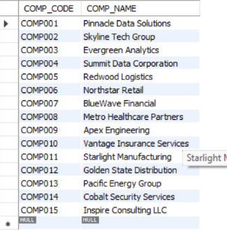

2. QUALIFICATION Table Description
This table stores all qualifications associated with courses, job openings, and candidate training. QUAL_CODE is the primary key, and QUAL_DESCRIPTION provides a description of the qualification
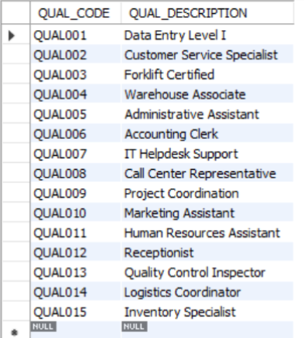

3. COURSE Table Description
This table stores all training courses offered through the program. COURSE_NUM is the primary key. COURSE_DESCRIPTION provides details about the course, COURSE_FEE stores the standard cost, and QUAL_CODE is a foreign key linking the course to its associated qualification.
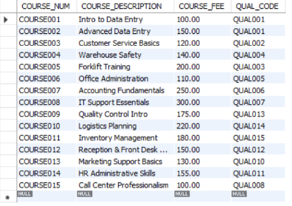

4. SESSION Table Description
This table stores scheduled offerings of courses. SESSION_NUM is the primary key. SESSION_STARTDATE records the start date of the session, SESSION_FEE stores the fee for attending, and COURSE_NUM is a foreign key linking the session to a course.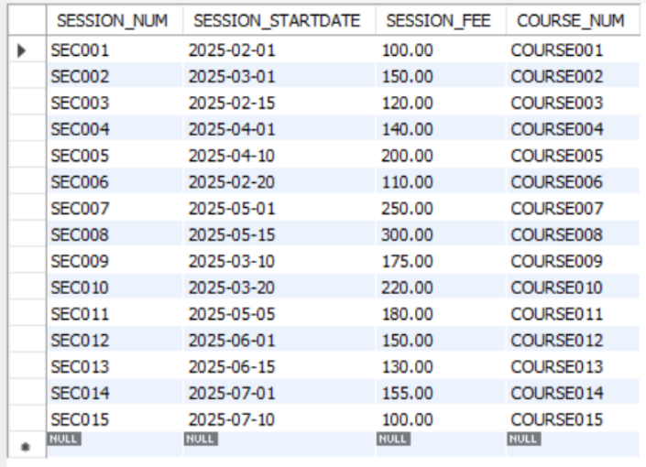

5. CANDIDATE Table Description
This table stores information about job seekers enrolled in the agency’s programs. CAND_NUM is the primary key, and CAND_LNAME stores the last name of each candidate.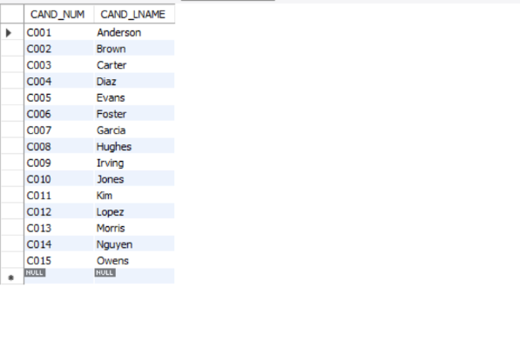

6. OPENING Table Description
This table stores job openings provided by companies. OPENING_NUM is the primary key. OPENING_DESCRIPTION describes the job, OPENING_AVAILABLE indicates whether the position is currently open, COMP_CODE links to the COMPANY table, and QUAL_CODE links to the QUALIFICATION table.
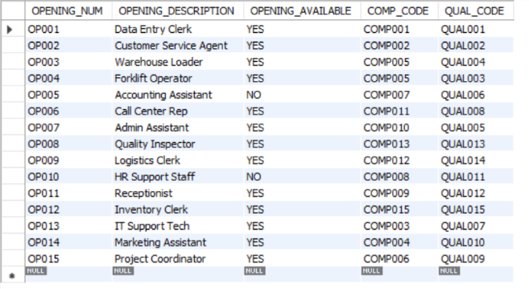

7. PLACEMENT Table Description
This table stores records of candidates who have been placed into job openings. PLACEMENT_NUM is the primary key. PLACEMENT_DATE records the date of the placement, PLACEMENT_TOTALHOURS stores the hours worked, OPENING_NUM is a foreign key linking to the OPENING table, and CAND_NUM is a foreign key linking to the CANDIDATE table.
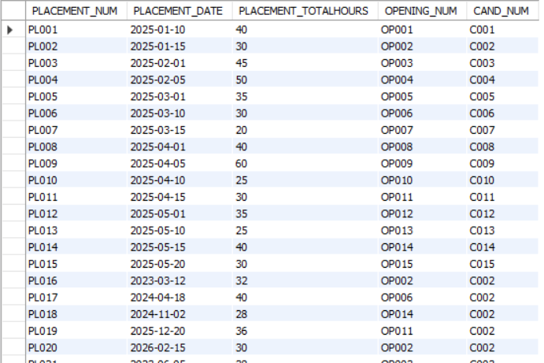

8. JOBHISTORY Table:
This table tracks each candidate’s work history based on their placements. JH_ID is the primary key. CAND_NUM is a foreign key referencing the CANDIDATE table, and PLACEMENT_NUM is a foreign key referencing the PLACEMENT table.
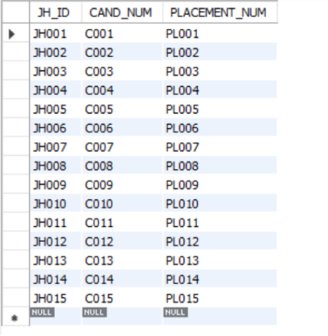

9. ENROLL Table Description
This table records which candidates have enrolled in which training sessions, representing a many-to-many relationship. SESSION_NUM and CAND_NUM form a composite primary key. SESSION_NUM references the SESSION table, and CAND_NUM references the CANDIDATE table. ENROLL_DATE records the date of enrollment, and ENROLL_FEEPAID stores the fee paid by the candidate.
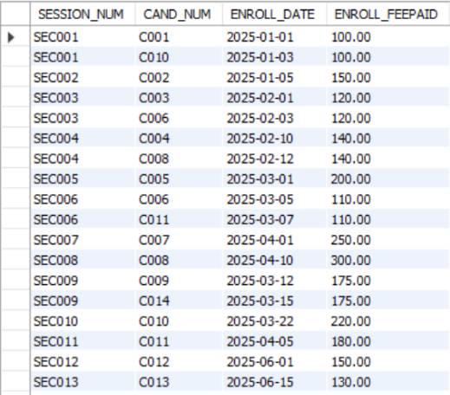

10. EDUCATION Table Description
The EDUCATION table stores qualifications earned by candidates. QUAL_CODE and CAND_NUM form a composite primary key. QUAL_CODE references the QUALIFICATION table, and CAND_NUM references the CANDIDATE table. EDUC_DATE records the date the qualification was earned.
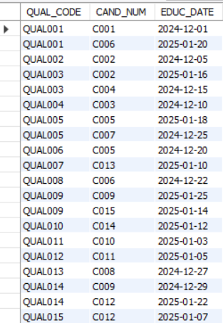

11. PREREQUISITE Table Description
This table lists qualification requirements for each course. QUAL_CODE and COURSE_NUM form a composite primary key, and both are foreign keys referencing the QUALIFICATION and COURSE tables respectively.
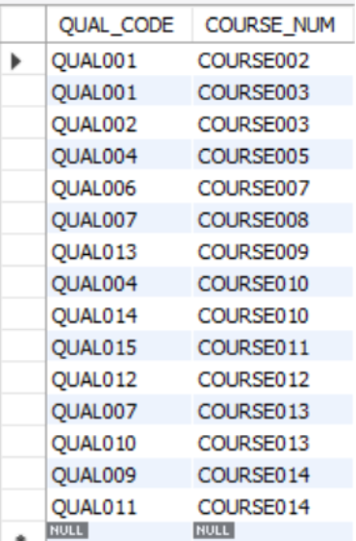

12. EMPLOYEE Table Description
This table stores information about employees working for companies in the system. EMPLOYEE_ID is the primary key. COMP_CODE is a foreign key linking the employee to a company. FIRST_NAME and LAST_NAME store the employee’s full name, ROLE stores their job title, and EMAIL stores their contact information.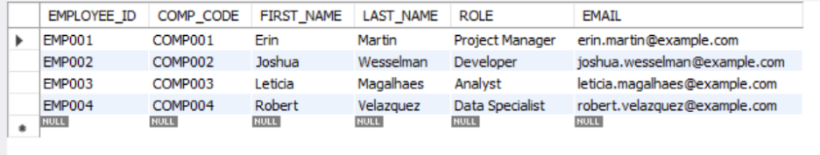

Qwery SQL Code

Query #1
Write a query to find out how many prerequisite courses for each course. The result should include those courses (if any) that have no prerequisite.
Answer:
SELECT
c.COURSE_NUM,
c.COURSE_DESCRIPTION,
COUNT(p.QUAL_CODE) AS Num_Prerequisites
FROM COURSE c
LEFT JOIN PREREQUISITE p
ON c.COURSE_NUM = p.COURSE_NUM
GROUP BY
c.COURSE_NUM,
c.COURSE_DESCRIPTION
ORDER BY
c.COURSE_NUM;

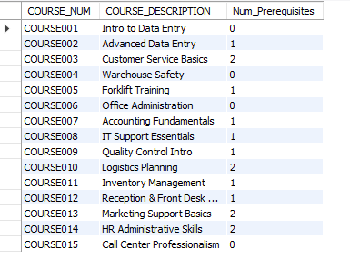

Query #2
Write a query to display courses that have one or more sections.
Answer:
/*QWERY #2 -prerequisite courses for each course*/
SELECT
c.COURSE_NUM,
c.COURSE_DESCRIPTION,
COUNT(s.SESSION_NUM) AS Num_Sessions
FROM COURSE c
JOIN SESSION s
ON c.COURSE_NUM = s.COURSE_NUM
GROUP BY
c.COURSE_NUM,
c.COURSE_DESCRIPTION
ORDER BY
c.COURSE_NUM;
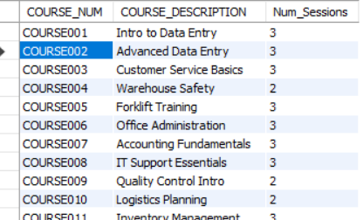

Query #3
Write a query to display job history for a candidate of your choice.
Answer:

/*QWERY #3 */
SELECT
j.JH_ID,
j.CAND_NUM,
p.PLACEMENT_NUM,
p.PLACEMENT_DATE,
p.PLACEMENT_TOTALHOURS,
o.OPENING_DESCRIPTION,
o.COMP_CODE
FROM JOBHISTORY j
JOIN PLACEMENT p
ON j.PLACEMENT_NUM = p.PLACEMENT_NUM
JOIN OPENING o
ON p.OPENING_NUM = o.OPENING_NUM
WHERE j.CAND_NUM = 'C001';
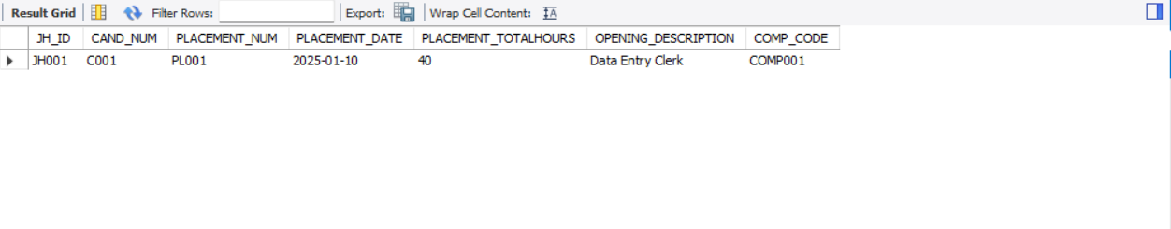

Query #4
Write a query to find out which company has the most openings that requires a specific qualification of your choice.
Answer:
SELECT
o.QUAL_CODE,
q.QUAL_DESCRIPTION,
o.COMP_CODE,
c.COMP_NAME,
COUNT(o.OPENING_NUM) AS NUM_OPENINGS
FROM OPENING o
JOIN COMPANY c
ON o.COMP_CODE = c.COMP_CODE
JOIN QUALIFICATION q
ON o.QUAL_CODE = q.QUAL_CODE
WHERE o.QUAL_CODE = ‘QUAL010’
GROUP BY
o.QUAL_CODE,
q.QUAL_DESCRIPTION,
o.COMP_CODE,
c.COMP_NAME
ORDER BY
NUM_OPENINGS DESC;
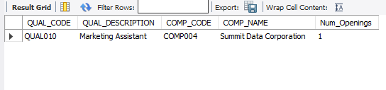

Query #5
Write a query to find out which candidate has the most placements in a company of your choice.
Answer:
SELECT
p.CAND_NUM,
c.CAND_LNAME,
o.COMP_CODE,
COUNT(p.PLACEMENT_NUM) AS NUM_PLACEMENTS
FROM PLACEMENT p
JOIN OPENING o
ON p.OPENING_NUM = o.OPENING_NUM
JOIN CANDIDATE c
ON p.CAND_NUM = c.CAND_NUM
WHERE o.COMP_CODE = ‘COMP001’
GROUP BY
p.CAND_NUM,
c.CAND_LNAME,
o.COMP_CODE
ORDER BY
NUM_PLACEMENTS DESC;
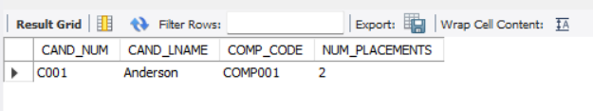

Query #6
Write a query to calculate the total revenue generated by each course based on enrollment fees.
Purpose: Find the total enrollment revenue generated by each course.
Only courses with at least one enrolled candidate are returned, since revenue is based on actual payments recorded in the ENROLL table.
Explanation: This query calculates how much revenue each course has generated by summing the enrollment fees paid by candidates. Only courses with active enrollments appear in the results because revenue is based on actual payments recorded in the ENROLL table. This helps the TEC agency identify which training courses produce the most income and where program demand is highest.
SELECT
c.COURSE_NUM,
c.COURSE_DESCRIPTION,
SUM(e.ENROLL_FEEPAID) AS Total_Revenue
FROM COURSE c
JOIN SESSION s
ON c.COURSE_NUM = s.COURSE_NUM
JOIN ENROLL e
ON s.SESSION_NUM = e.SESSION_NUM
GROUP BY
c.COURSE_NUM,
c.COURSE_DESCRIPTION
ORDER BY
Total_Revenue DESC;
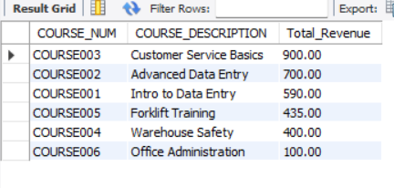

Query #7
Write a query to find out how many candidates have earned each qualification.

Purpose: Calculate the number of candidates who have earned each qualification, showing which qualifications are most commonly completed. This helps TEC understand training demand and candidate skill distribution.
Explanation: This query joins QUALIFICATION and EDUCATION to determine how many candidates completed each qualification. It summarizes skill distribution across the candidate pool, which helps identify training programs with high demand.
SELECT
q.QUAL_CODE,
q.QUAL_DESCRIPTION,
COUNT(e.CAND_NUM) AS Num_Candidates
FROM QUALIFICATION q
JOIN EDUCATION e
ON q.QUAL_CODE = e.QUAL_CODE
GROUP BY
q.QUAL_CODE,
q.QUAL_DESCRIPTION
ORDER BY
Num_Candidates DESC;

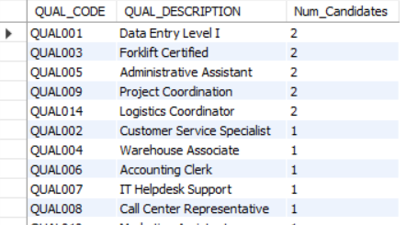

Query #8
Write a query to find how many available (open) job openings each company currently has.

Purpose: This query counts the number of job openings marked as available for each company. It helps TEC identify which companies have the highest hiring demand and where candidate placement opportunities are greatest.
Explanation: This query works by joining the COMPANY and OPENING tables so that each job opening can be matched to the company that listed it. Because the OPENING table includes an availability flag, the query applies a filter to return only openings marked as available. Once the available positions are isolated, the query groups the data by company name and uses an aggregate count to calculate how many open positions each company currently has. Sorting the results in descending order highlights which companies have the greatest hiring needs. This structure ensures the query accurately reflects each company’s active demand for candidates.
SELECT
q.QUAL_CODE,
q.QUAL_DESCRIPTION,
COUNT(e.CAND_NUM) AS Num_Candidates
FROM QUALIFICATION q
JOIN EDUCATION e
ON q.QUAL_CODE = e.QUAL_CODE
GROUP BY
q.QUAL_CODE,
q.QUAL_DESCRIPTION
ORDER BY
Num_Candidates DESC;
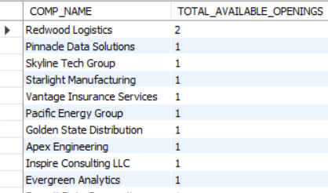

Query #9
Write a query to analyze all candidates who have been placed within a company of your choice and determine which candidate has the highest number of placements. The results should list all candidates placed at that company, ordered from the highest placement count to the lowest.

Purpose: The purpose of this query is to evaluate placement activity within a specific company by listing all candidates who have been placed there and identifying which one has the most placements. Sorting the results by placement count allows TEC to clearly see the top-performing candidate while still viewing placement activity for all candidates associated with that employer.
Explanation: This query joins the PLACEMENT, OPENING, and CANDIDATE tables to analyze which candidates have completed placements for a specific company. By filtering the openings based on the selected company code, the query isolates all relevant placement records. It then groups these records by candidate and counts the total placements for each one. Sorting the results in descending order places the candidate with the highest number of placements at the top of the list. Although the query highlights the candidate with the most placements, it also returns all candidates who have been placed at the company, allowing for comparison and providing a complete view of candidate performance for that employer.
SELECT
p.CAND_NUM,
c.CAND_LNAME,
o.COMP_CODE,
COUNT(p.PLACEMENT_NUM) AS NUM_PLACEMENTS
FROM PLACEMENT p
JOIN OPENING o
ON p.OPENING_NUM = o.OPENING_NUM
JOIN CANDIDATE c
ON p.CAND_NUM = c.CAND_NUM
WHERE o.COMP_CODE = 'COMP005'
GROUP BY
p.CAND_NUM,
c.CAND_LNAME,
o.COMP_CODE
ORDER BY
NUM_PLACEMENTS DESC;

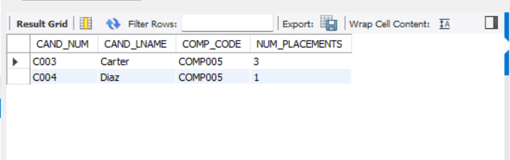

Query #10
Write a query to determine how many qualifications each candidate has earned. The results should list all candidates who appear in the EDUCATION table along with the total number of qualifications each one has received.

Purpose: The purpose of this query is to measure candidate preparedness by identifying how many qualifications each candidate has earned. This helps TEC understand which candidates have completed the most training and may be more competitive for job openings requiring multiple skill sets.
Explanation: This query analyzes candidate training history by joining the CANDIDATE and EDUCATION tables. The EDUCATION table records every qualification a candidate has earned, and by grouping these records by candidate, the query counts how many individual qualifications each candidate has received. The join allows the query to display candidate names alongside their qualification counts, while ordering the results from highest to lowest quickly highlights the most highly trained candidates.
SELECT
c.CAND_NUM,
c.CAND_LNAME,
COUNT(e.QUAL_CODE) AS TOTAL_QUALIFICATIONS
FROM CANDIDATE c
JOIN EDUCATION e
ON c.CAND_NUM = e.CAND_NUM
GROUP BY
c.CAND_NUM,
c.CAND_LNAME
ORDER BY
TOTAL_QUALIFICATIONS DESC;
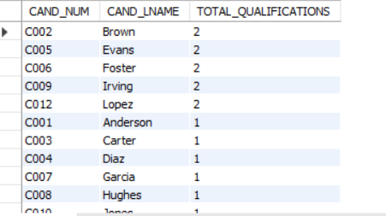

Business Rationale for Custom Queries
To demonstrate how the TEC database can support real-world decision-making, three of the custom SQL queries (Query #6, Query #7, and Query #8) were analyzed from a business perspective. Each of these queries provides actionable insights that TEC management could use to make informed staffing, training, and operational decisions.
Query #6, which calculates total revenue generated by each course, is valuable because it allows TEC to understand which training programs are financially successful and which may require adjustment. By identifying high-earning courses, TEC can allocate resources more efficiently, prioritize popular programs, and recognize where additional marketing or scheduling may be beneficial. This information directly supports decisions around budgeting, course planning, and long-term training strategy.
Query #7, which determines how many candidates have earned each qualification, provides TEC with a clear view of the skill distribution across its candidate pool. Knowing which qualifications are most common helps TEC anticipate placement capacity, identify potential skill shortages, and determine which training programs may need expansion. This helps the agency ensure that candidate qualifications align with marketplace demand and that clients receive workers with the skills they require.
Query #8, which counts how many available job openings each company currently has, offers insight into hiring trends across TEC’s client companies. By showing which organizations have the highest number of active openings, TEC can better determine where to focus recruiting efforts, which industries show the strongest demand, and where candidates are most likely to be placed quickly. This supports operational planning and helps TEC maintain strong relationships with high-demand clients.
Together, these three queries highlight how the TEC database can transform raw data into meaningful business intelligence. They support strategic decisions in training, candidate preparation, and staffing services, demonstrating the practical value of a well-designed relational database.

Summary
The TEC database project brings together everything we learned about building a functional, well-designed relational database. Our work began by translating the business rules of a temporary employment agency into a clear data model and then normalizing the structure to 1NF, 2NF, and 3NF. This ensured the database was organized, free of unnecessary duplication, and able to maintain accurate and reliable information across all tables. The final design includes twelve interconnected tables that track companies, job openings, candidates, placements, training courses, qualifications, and session enrollments essentially everything TEC needs to manage its day-to-day operations.
After establishing the structure, we populated the database with realistic sample data to reflect how TEC might function in a real business environment. This made it possible to analyze hiring activity, candidate training history, company needs, job qualifications, and placement performance. We also built a complete data dictionary and table descriptions to clearly explain the purpose of each table and how they relate to one another.
To show how the database can support real decision-making, we created ten SQL queries: five from the instructor and five of our own design. Each query includes a clear description, purpose, explanation, SQL code, and expected output. Together, they demonstrate how the database can answer practical business questions such as which courses generate the most revenue, which companies have the highest number of openings, and which candidates have the strongest placement history or the most qualifications. These insights show how TEC could use this system to improve staffing decisions, identify trends, and better support both candidates and employers.
Overall, this project walks through the entire process of building a database from the ground up from modeling and normalization to implementation, documentation, and analysis. It demonstrates not only technical SQL skills but also an understanding of how a well-designed database can support real-world business operations in a meaningful way.

