SPECIFICATION

P002: Display Entity-to-Entity Connections and Agreements.   
  
Desired Outcome:   
  
Write C# code that accepts 4 parameters and displays (on a webpage) a view of 2 circles, which are connected by a clickable document icon. When the icon is clicked display the content found at the web address defined in the code; display that web page in a separate browser window.   
  
Also display clickable icons on each circle. When the icon inside a circle is clicked, display the content found at the web address defined in the code; display that web page in a new browser tab. In the example below, if each icon is clicked, then there will be a browser window with 3 tabs, one for each icon. Each icon has a web URL to display defined in the code.   
  
Use the D# library for rendering the circles.  
  
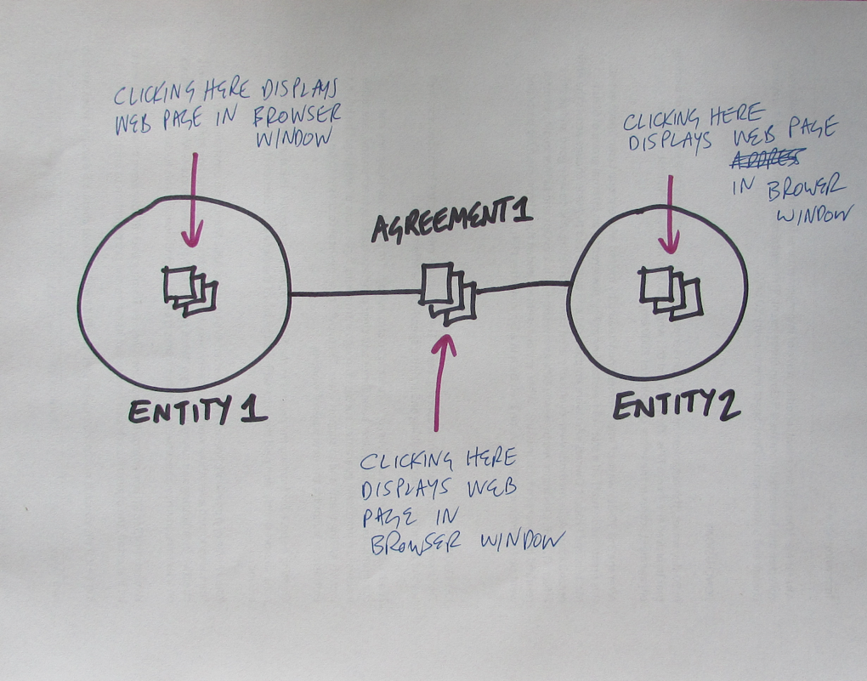

SPECIFICATION:   
Please refer to the diagram when reading the spec defined below:   
  
  
Given:   
Entity1: a string containing the name of an individual, team or group

Entity2: a string containing the name pf a 2nd individual, team or group

Agreement1: a string containing an agreement name  
Link1: A valid web link to display in web-browser window

Link2: A valid web link to display in web-browser window

Link3: A valid web link to display in web-browser window  
  
When: these 6 parameters are passed from a web page to a C# function  
  
Then:   
  
1. Render the 2 Entities in D3 (version 4) as 2 distinct D3 circles.

2. Display their connection with a connecting line and a clickable ‘document icon’  
3. Assign the Label1 string as the name of the entity on the left

4. Assign the Label2 string as the name of the entity on the right

5. Assign Link1 to the clickable icon displayed on Entity1  
6. Assign Link2 to the clickable icon displayed on Entity2

7. Assign Link3 to the clickable icon displayed on Agreement1

8. Assign the Agreement1 string to the document icon displayed on the connecting line BETWEEN the Entities  
9. Assign the Link1 URL to the document icon displayed, so when it is clicked the content at the web address specified is displayed in another browser window  
10. Also add a a clickable ‘document icon’ to each circle, when the icon is clicked, the content at the web address specified in the code is displayed in another browser window

Clicking any space outside of these rendered shapes/icons should hide those rendered shapes and icons so they disappear.