Test Script updates

1. Do not show any Test Scripts until a project is selected, right now test scripts show automatically when the page loads:
2. Make ‘Story Status’ filter optional, as of now the Story drop down will not load until a status is selected, the stories should load when Project is selected
3. Move the ‘Action’ column from the last column to the first column
4. Can we convert the Story drop down to a smart text box? So if a user types in the Story ID we filter the stories by what the user types? If this would take a lot of time we could hold off for now

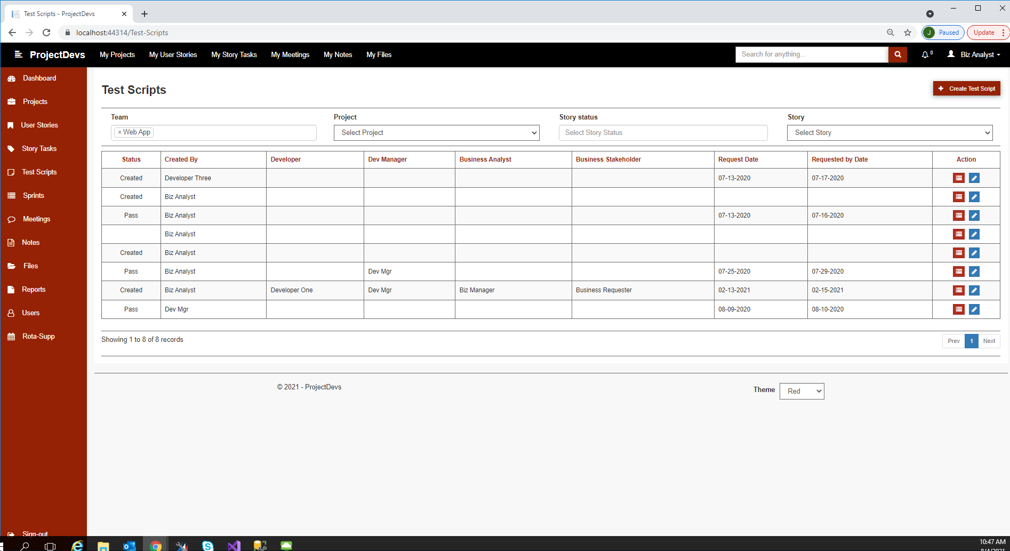

Test Script Steps update:

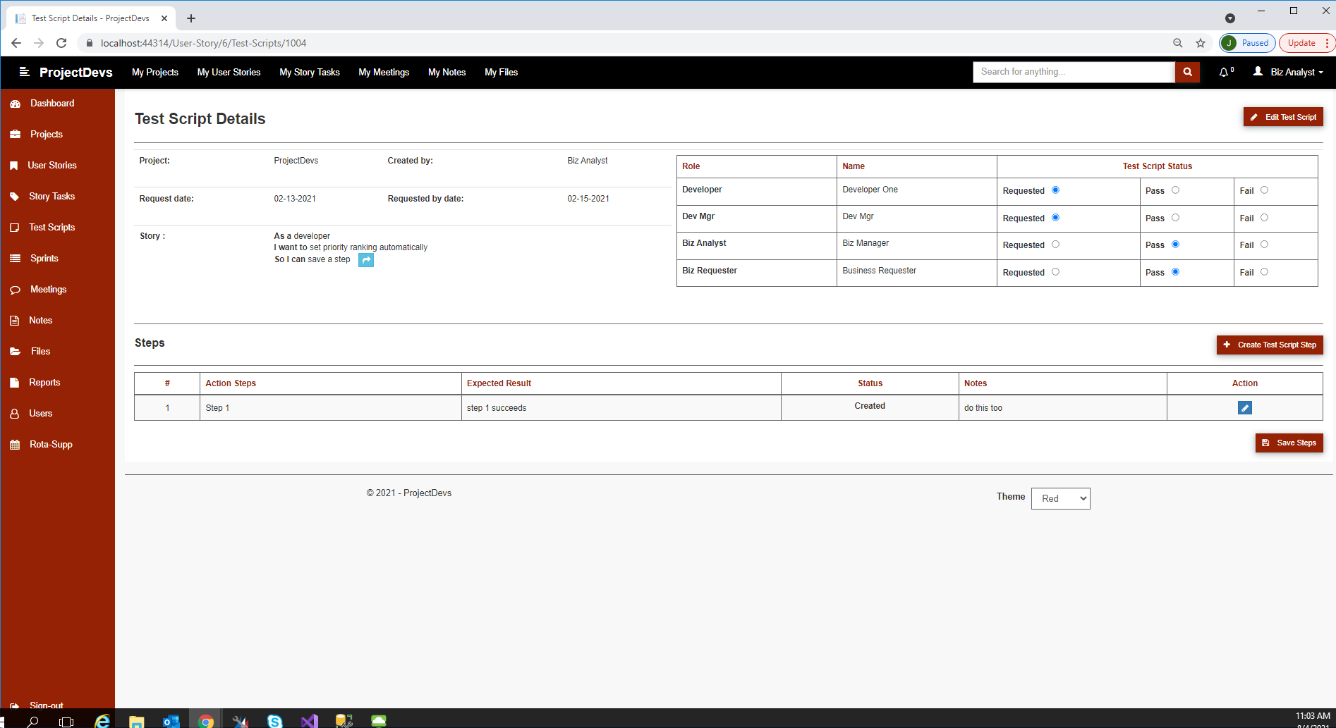

Using this layout / description:

