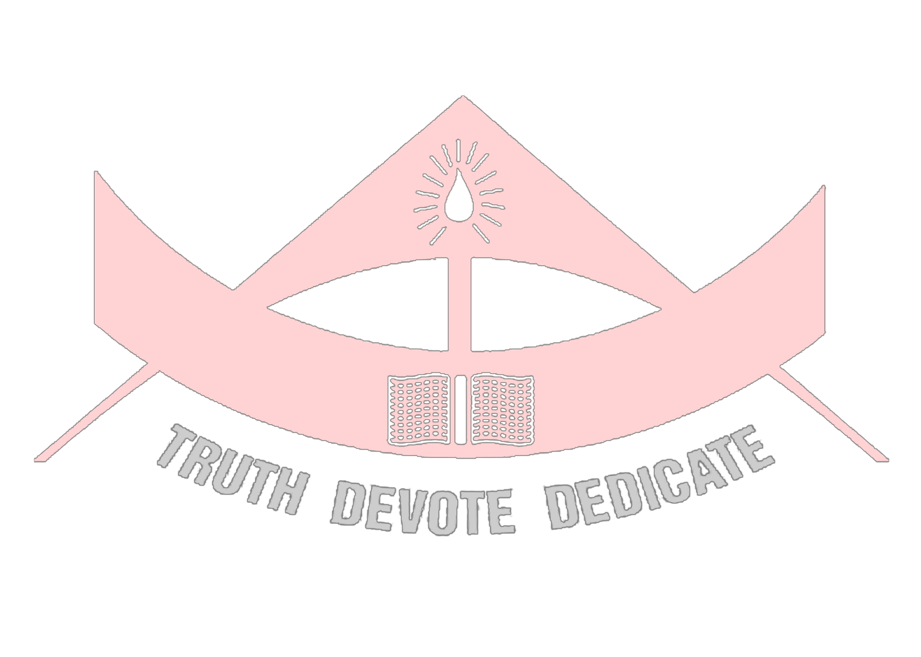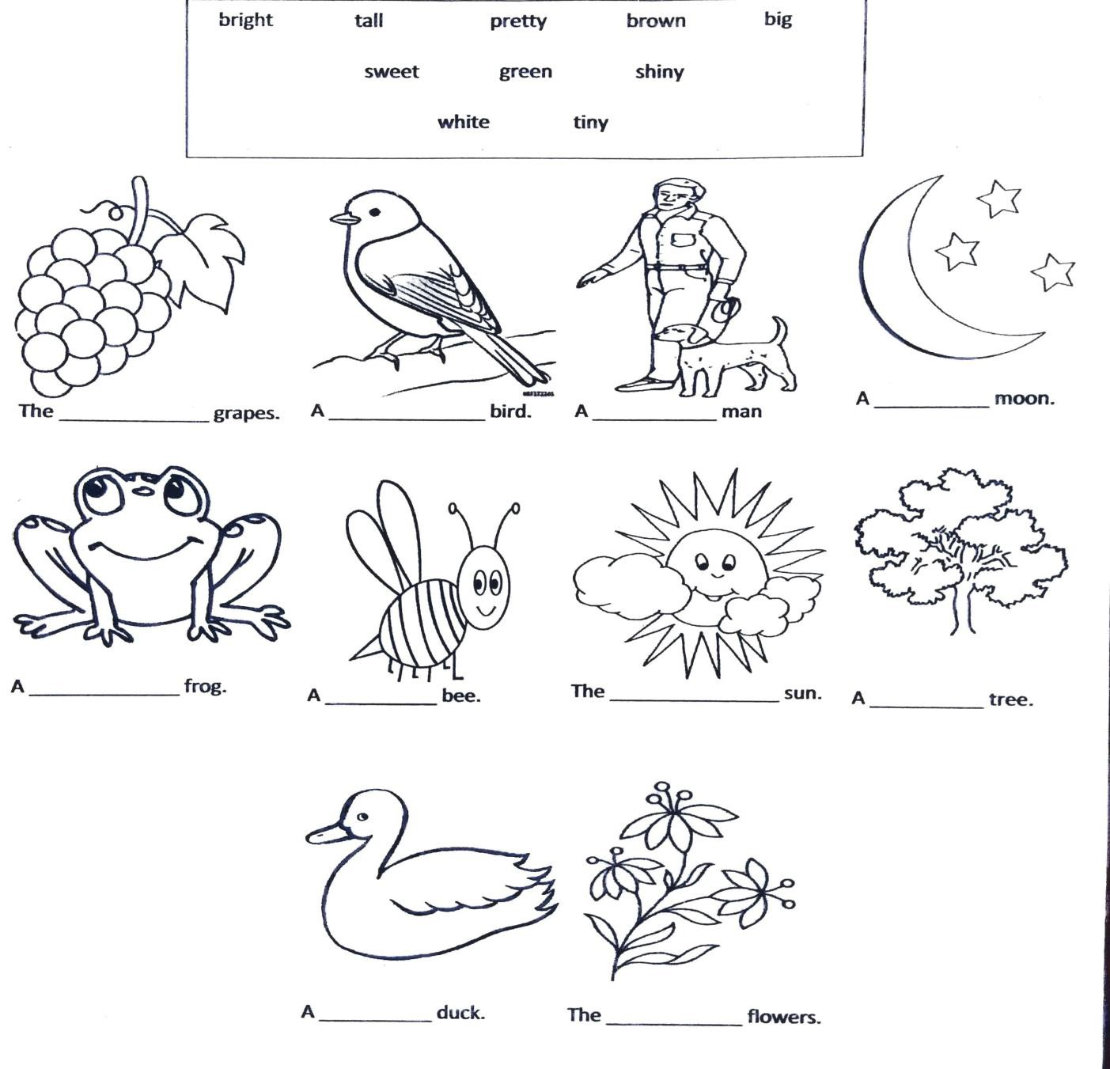MODERN SCHOOL JAIPUR SUBJECT ENRICHMENT - 1 (2021-22)
CLASS – SECOND
SUBJECT– ENGLISH GRAMMAR

Q1. Fill in the blanks with the help of adjectives given in the help box and colour the pictures:

[MM – 5]

1

