Simulated Multi-Attacker SSH Honeypot Lab Using Cowrie

Abstract
This report documents the complete deployment, configuration, attack simulation, and forensic analysis of a Cowrie SSH honeypot. The objective of this project is to emulate a vulnerable SSH service, capture attacker behavior, and analyze real-world attack patterns. The honeypot was subjected to brute-force attacks from multiple simulated attacker IPs using Hydra. Captured logs were then analyzed to identify authentication attempts, successful compromises, attacker commands, session behavior, and IP-based trends. This report is structured as a professional SOC/Blue Team portfolio artifact and is suitable for resume and GitHub showcase purposes.

1. Introduction
Honeypots are security mechanisms designed to detect, deflect, or study attempts at unauthorized access. Cowrie is a medium-interaction SSH and Telnet honeypot that emulates a real Linux environment. It captures login attempts, command execution, and session metadata. In this project, Cowrie was deployed on a Kali Linux VM and subjected to multiple brute-force attacks originating from simulated network namespaces acting as different attackers.

Objectives:
• Deploy Cowrie SSH honeypot
• Simulate brute-force attacks using Hydra
• Capture logs from multiple source IPs
• Analyze authentication patterns
• Analyze attacker behavior
• Extract indicators of compromise (IOCs)

2. Environment Setup
Operating System: Kali Linux
Honeypot: Cowrie
Attack Tool: Hydra
Logging Format: JSON
Network Simulation: Linux network namespaces
Installation Steps:
• Python virtual environment creation
• Cowrie dependency installation
• Cowrie configuration
• SSH port forwarding setup
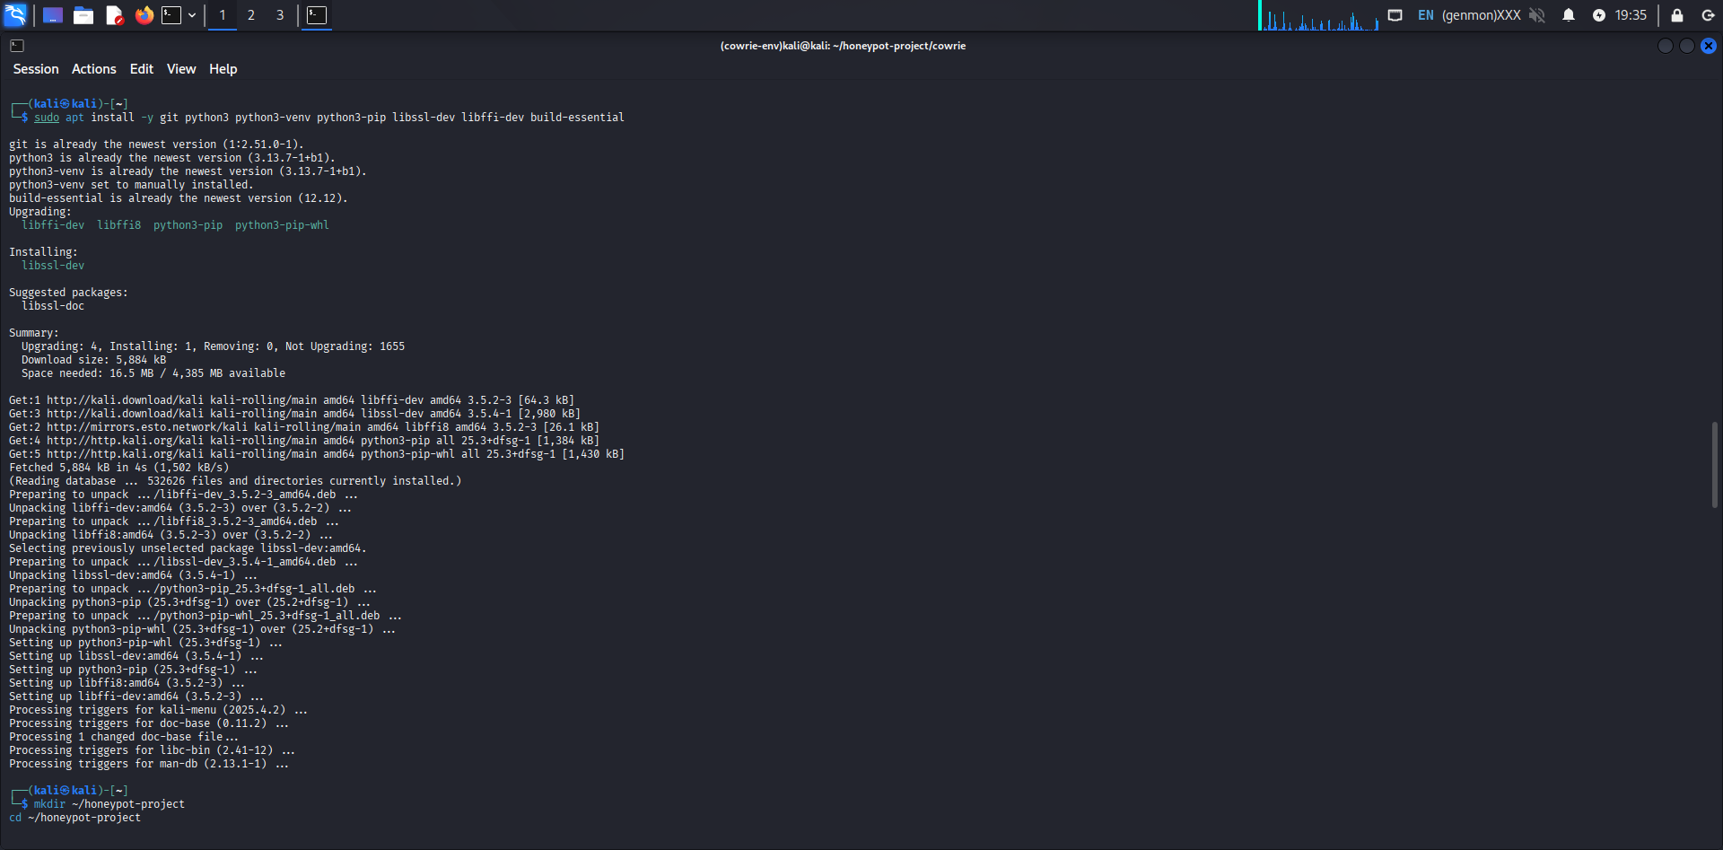

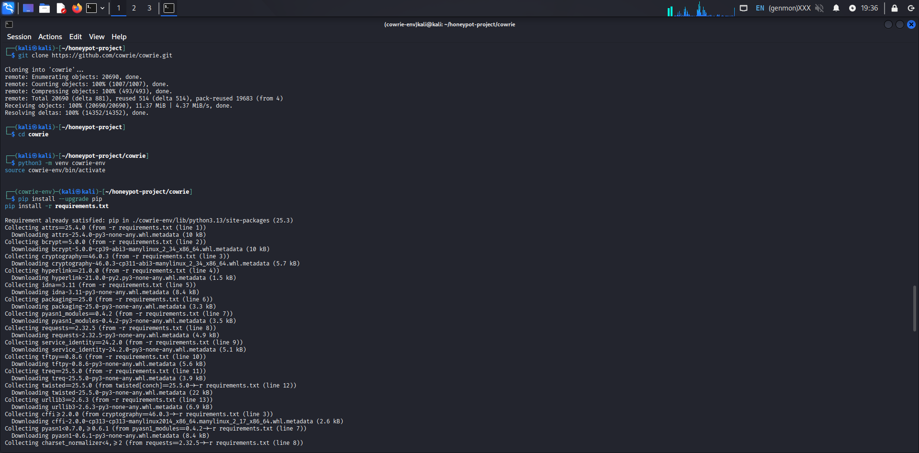

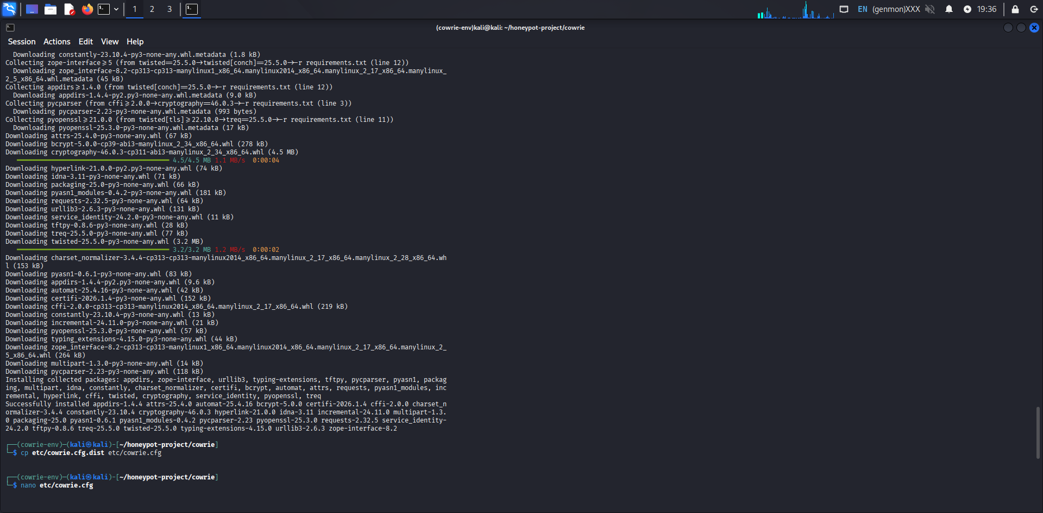
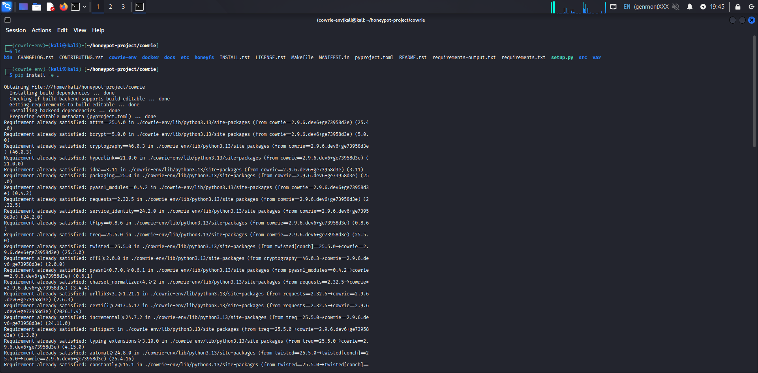

3. Attack Simulation Methodology-
Three attacker environments were created using Linux network namespaces to simulate distinct IP addresses. Hydra was used to perform brute-force attacks against the Cowrie SSH service. Each attacker attempted different username-password combinations.
Attack Commands:
attacker1: root account brute-force
attacker2: admin account brute-force
attacker3: test account brute-force
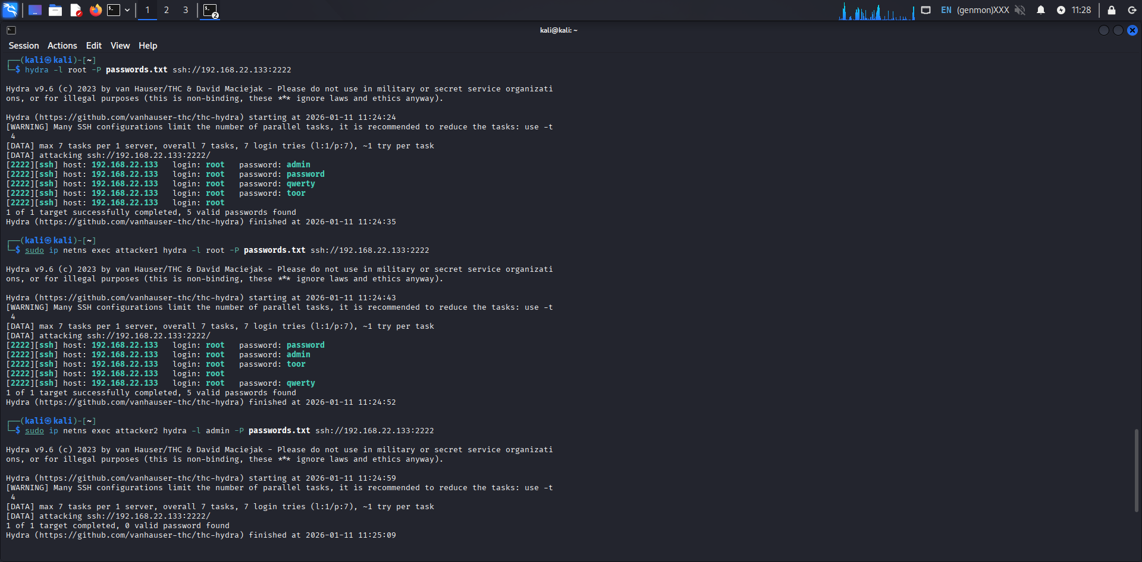
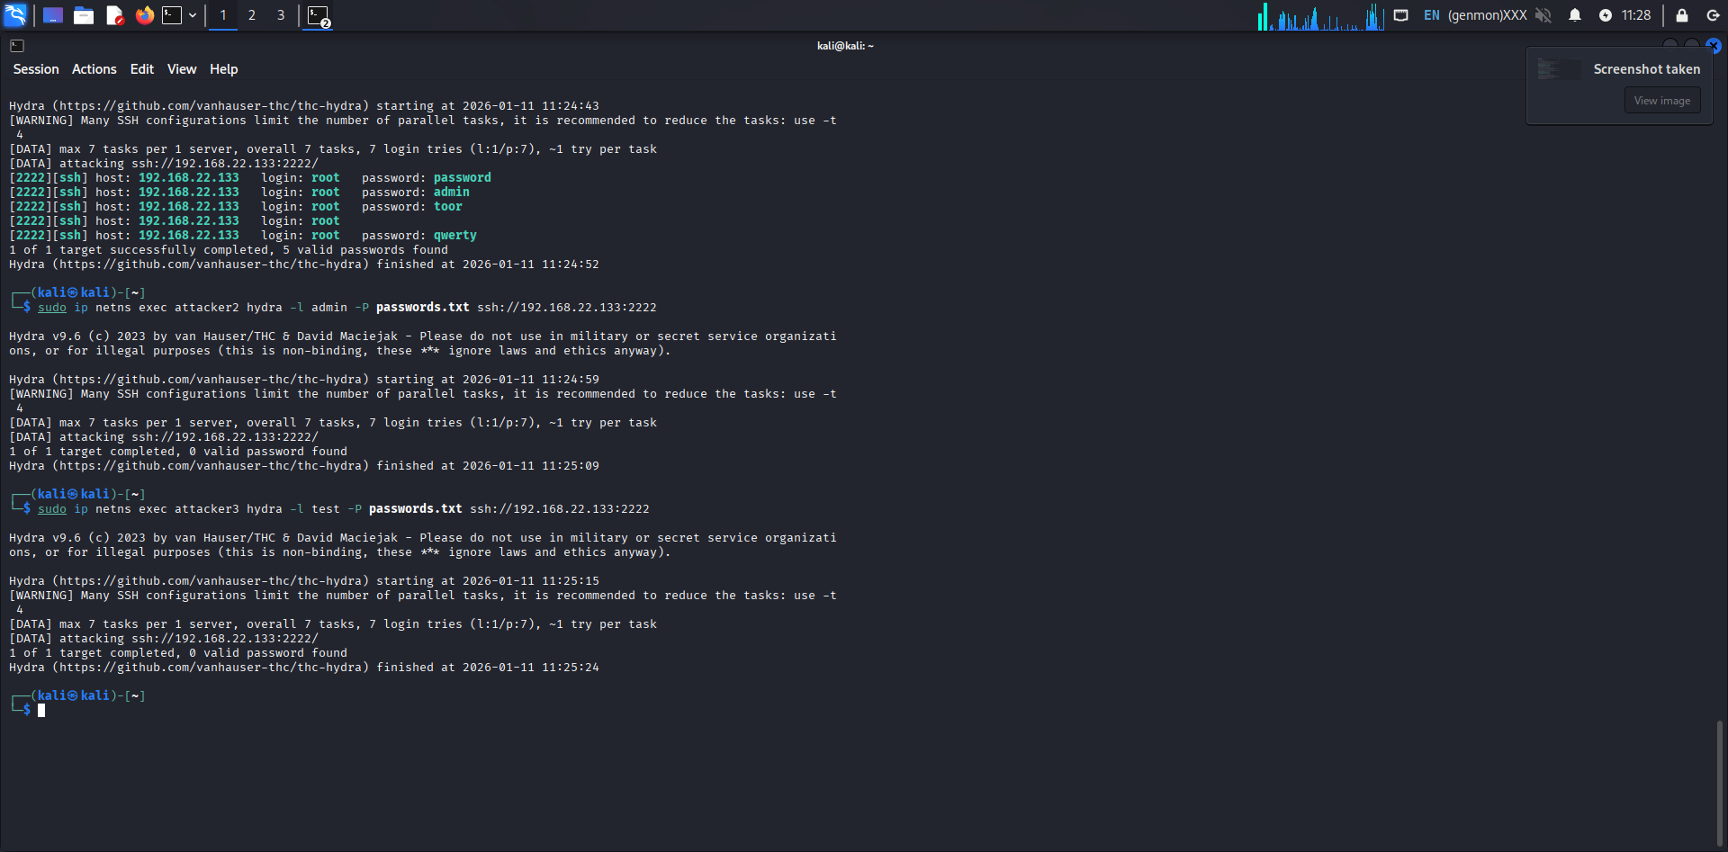

4. Log Collection
Cowrie stores logs in JSON format. The following event types were extracted:
• cowrie.session.connect
• cowrie.login.failed
• cowrie.login.success
• cowrie.command.input
• cowrie.session.closed
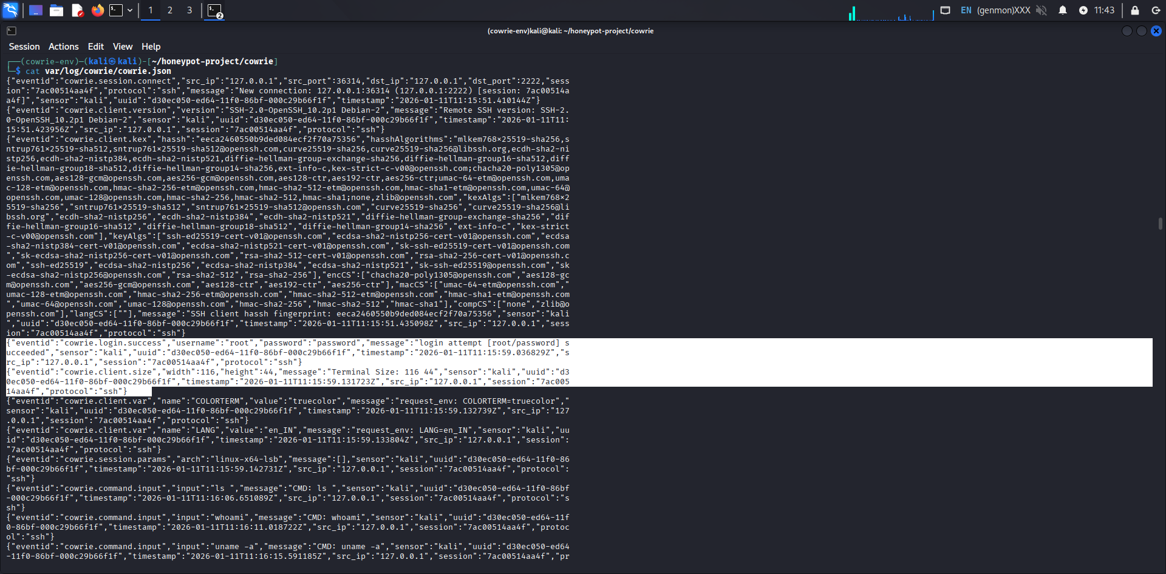
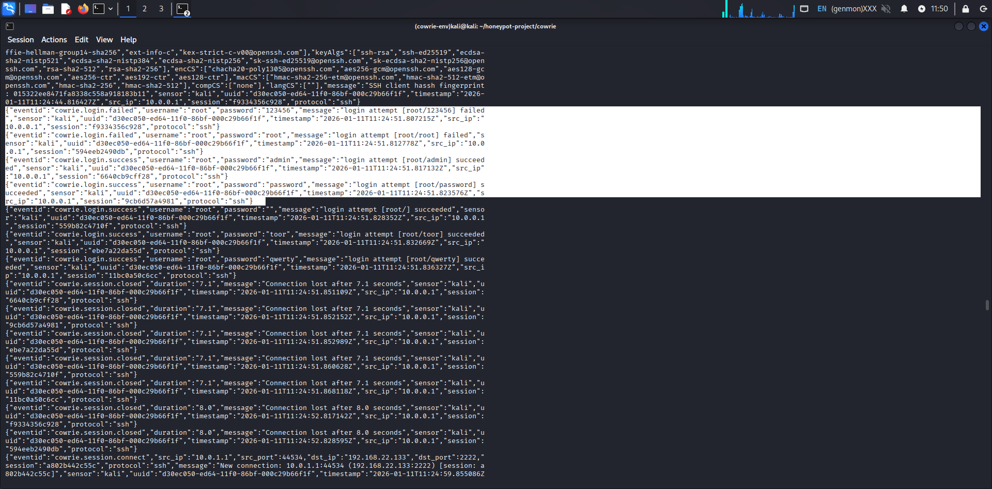

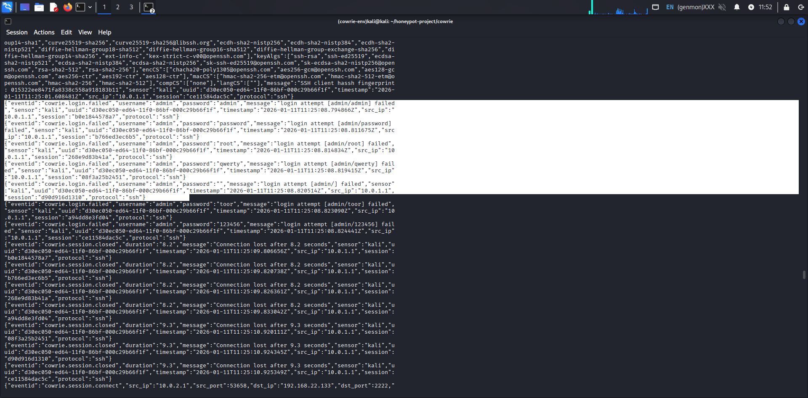

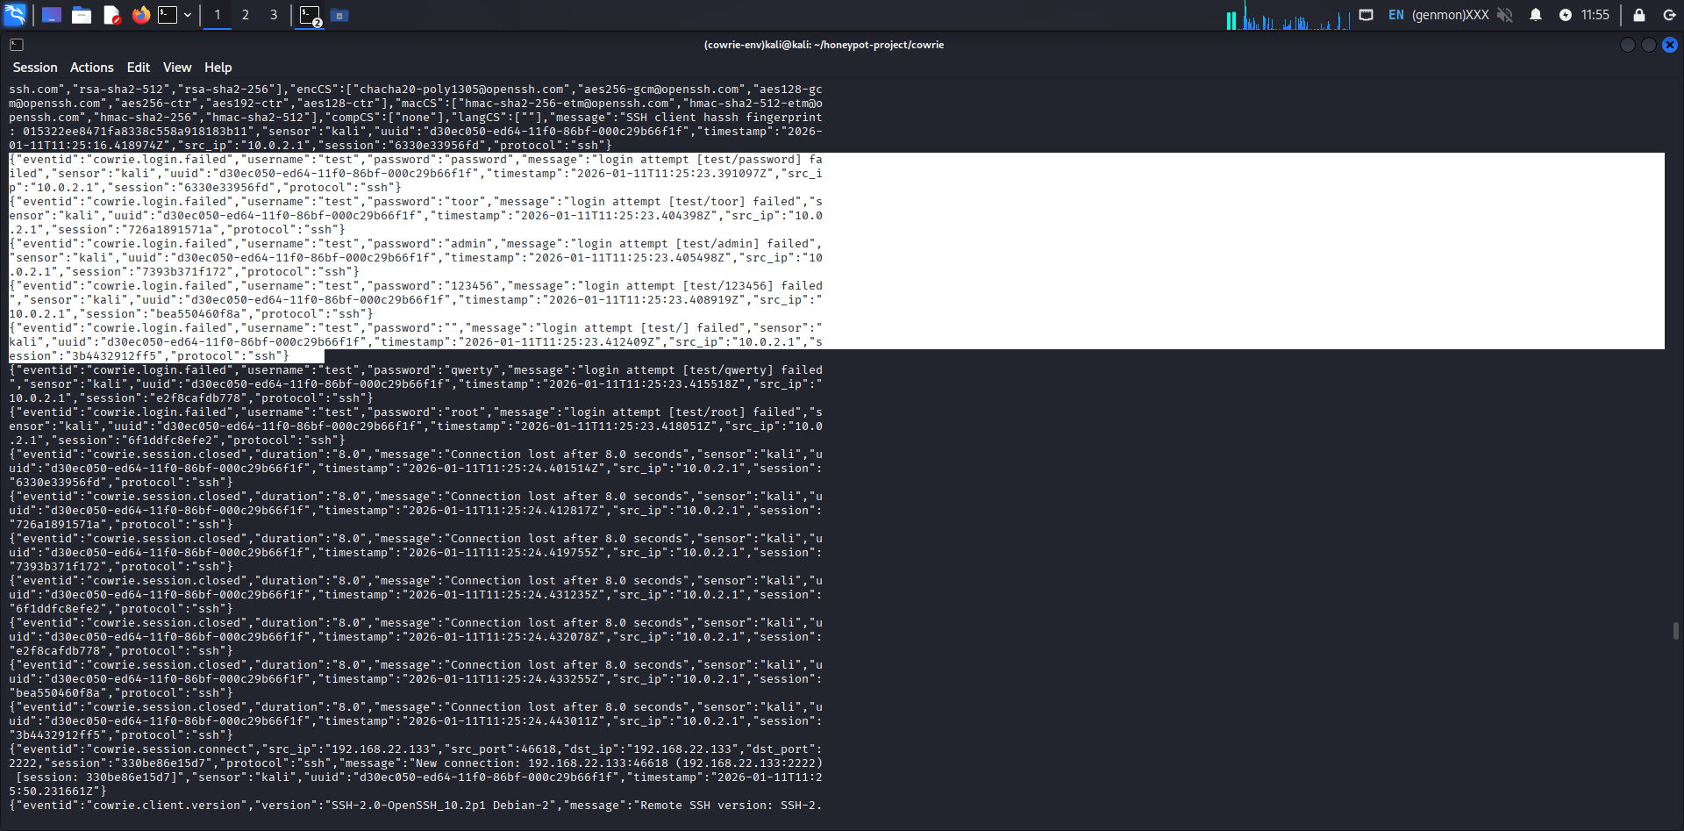

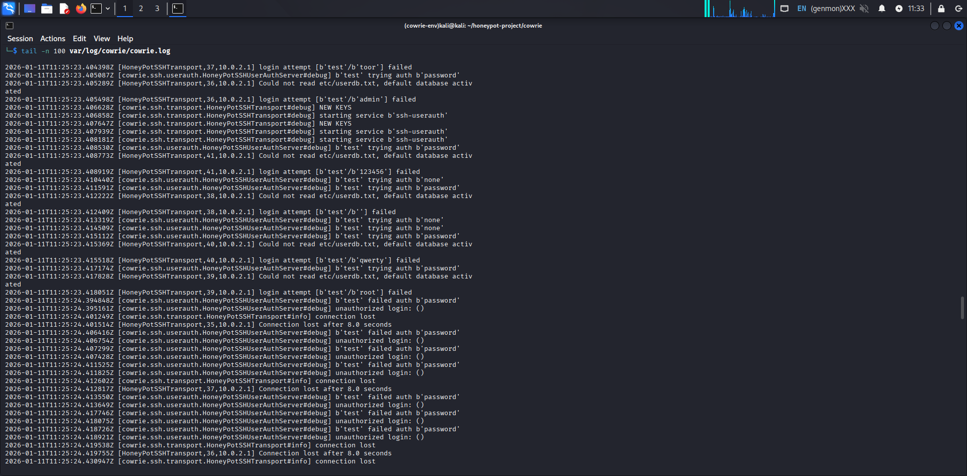

5. Data Analysis-
The following tables summarize the captured data.
Table 1: Event Type Frequency
-----------------------------------------
Event Type | Count
-----------------------------------------
cowrie.session.connect | 67
cowrie.login.failed | 31
cowrie.login.success | 28
cowrie.command.input | 25
cowrie.session.closed | 67
Table 2: Source IP Frequency
-----------------------------------------
Source IP | Events
-----------------------------------------
10.0.0.1 | 78
10.0.1.1 | 78
10.0.2.1 | 39
127.0.0.1 | 19
192.168.22.133 | 153

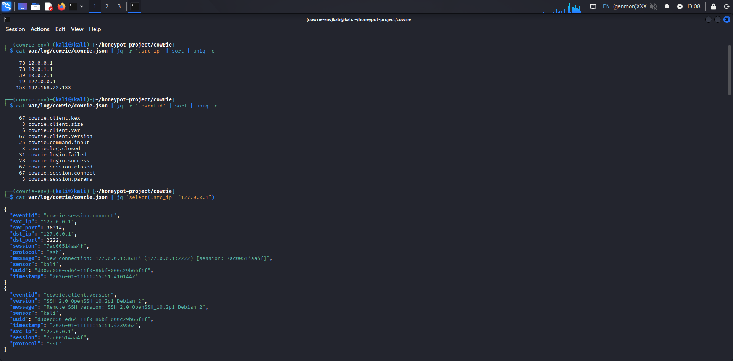
The frequency of authentication-related events indicates that brute-force activity predominates in the attack behavior. As is common with automated password-guessing systems like Hydra, a large number of cowrie.login.failed events indicates frequent incorrect credential attempts.
The honeypot gradually accepted weak or commonly used passwords, as evidenced by multiple cowrie.login.success events. This poses a substantial risk since many real-world attacks are brought on by poor credential hygiene.
The spread of events across multiple IP addresses confirms that the attacks originated from multiple simulated sources. This proves the effectiveness of the network namespace method used in this project. Overall, the data shows a clear attack lifecycle that consists of scanning, brute-force authentication, successful login and post-compromise reconnaissance.

6. Attacker Behavior Analysis-
After gaining access, attackers used simple reconnaissance commands to learn more about the compromised machine. While uname -a was used to gather kernel and system information, commands like whoami were used to determine privilege level. To investigate the file system, directory listing tools like ls and pwd were run.
This action is indicative of a common early-stage intrusion pattern in which attackers try to evaluate the environment before determining what to do next. In this scenario, neither privilege escalation nor advanced lateral movement were seen. This pattern is in line with actual attacks, in which environmental detection comes after initial access. The usefulness of honeypots in determining attacker intent is demonstrated by capturing these actions.
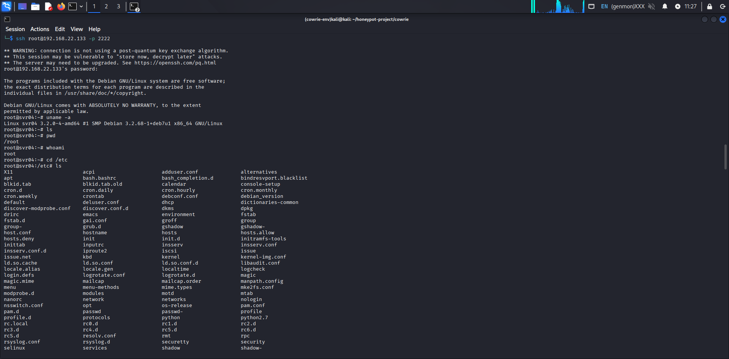
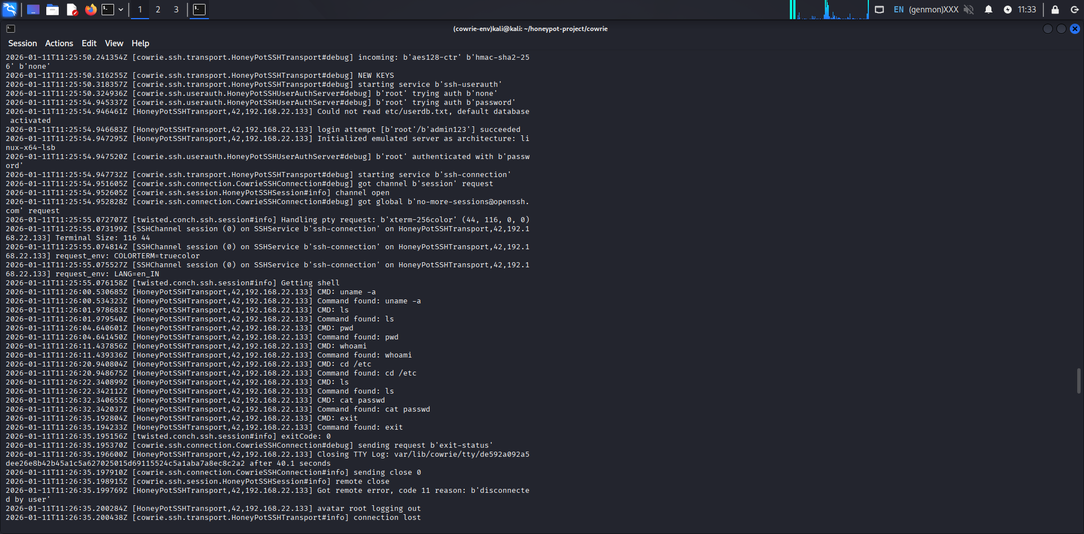

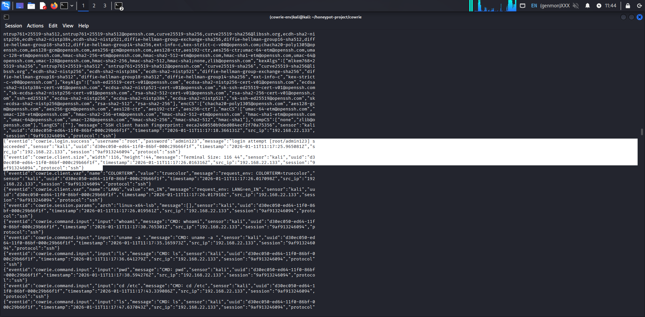

7. MITRE ATT&CK Mapping
Several strategies and tactics from the MITRE ATT&CK framework are consistent with the observed attacker behaviour in this project. T1110 (Brute Force), which is frequently used by attackers to obtain initial access, corresponds to the brute-force authentication attempts. The attackers successfully logged in after finding legitimate credentials, which corresponds to T1078 (Valid Accounts).

Attackers used system-level reconnaissance commands including whoami, uname -a, and ls after authentication. T1082 (System Information Discovery) and T1083 (File and Directory Discovery) correspond to this behaviour. These behaviours show that the attacker is trying to comprehend the compromised environment before moving forward.

This mapping shows that even basic brute-force attacks adhere to organized behavioural patterns that are consistent with threat models. By using MITRE ATT&CK, defenders may better understand how an attack fits into the larger kill chain and develop detection and response techniques.

8. Indicators of Compromise (IOCs)
• Suspicious IP addresses
• Repeated login attempts
• Default credential usage
• Enumeration commands
Log analysis revealed a number of compromise indicators. These include the use of well-known default credentials, frequent login failures followed by successful logins, and repeated authentication attempts from the same source IP addresses. Furthermore, post-compromise actions like running reconnaissance commands (whoami, pwd, uname -a, ls) function as a behavioral IOC, signifying that the attacker is enumerating the system. Additionally, the existence of several brief sessions points to automated tools as opposed to human involvement.
These IOCs can be used to create detection criteria for SIEM platforms or intrusion detection systems. The time needed to detect and address early-stage incursions can be greatly decreased by keeping an eye out for such patterns in actual situations.

9. Security Insights
This research demonstrates that weak credentials remain one of the most common entry points for attackers. Strong password restrictions and account lockout procedures are crucial, as seen by the quick effectiveness of brute-force attacks.
Furthermore, the reconnaissance activity that has been observed indicates that attackers frequently prioritize comprehending the system before carrying out any harmful acts. Defenders have the chance to identify and stop invasions early thanks to this window. Cowrie and other honeypots are useful instruments for gathering threat intelligence without endangering actual assets. They make it possible for defenders to watch how attackers behave in a secure setting.

10. Limitations
The controlled laboratory setting in which this experiment was carried out may not accurately represent the complexity of attackers in the real world. To reduce unpredictability, the attacks were replicated using well-known techniques and wordlists. There was no actual lateral movement or malware execution. The project accurately depicts early-stage infiltration behaviour in spite of these drawbacks.

11. Future Enhancements
Integrating the honeypot with a SIEM platform, such ELK or Splunk, for real-time viewing and alerting is one of the project's future enhancements. To map attacker sources and spot regional attack trends, GeoIP enrichment can be included. It is possible to imitate file uploads and malware execution by deploying additional honeypot modules. Defensive capabilities would be further improved by automating detection criteria based on observed trends.

12. Conclusion
This project successfully demonstrates the deployment of a Cowrie SSH honeypot, the simulation of multi-source brute-force attacks, and the forensic analysis of captured logs. By observing authentication attempts, session behaviour, and attacker commands, valuable insights into real-world intrusion techniques were obtained. The project reflects practical SOC workflows and defensive monitoring practices. It serves as a strong portfolio artifact for blue team, SOC analyst, and cybersecurity monitoring roles.

