**./assignment2.py**

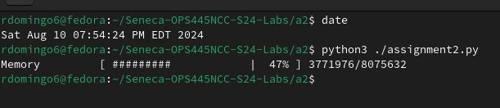

**./assignment2.py firefox**

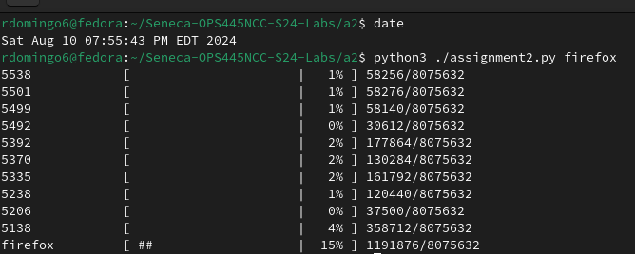

**./assignment2.py -H firefox**

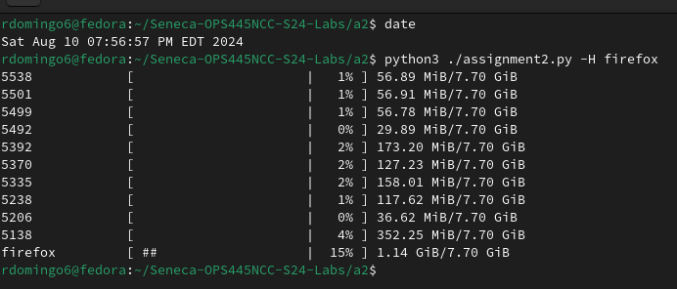

**./assignment2.py -l 40 firefox**

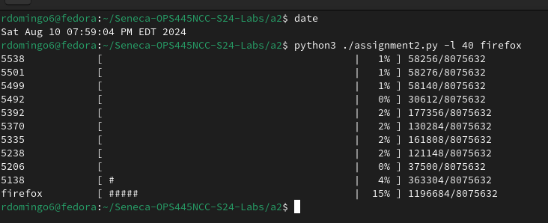

**./assignment2.py -l 50**

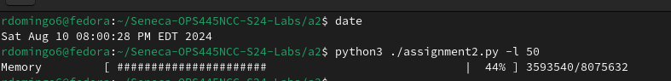

**./assignment2.py oopsie**

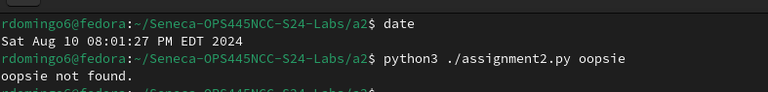

**./assignment2.py -h**

