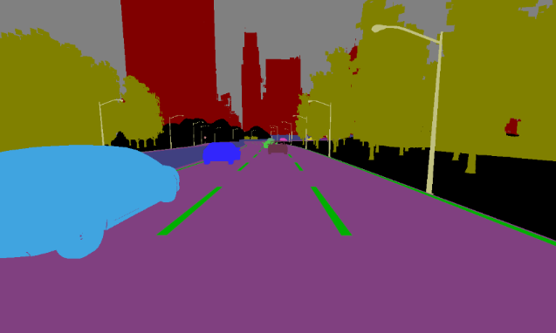

**Moving**

**Base**

**Danger zone**

**Safety zone**

**Slopping lines**

**Anchor point**