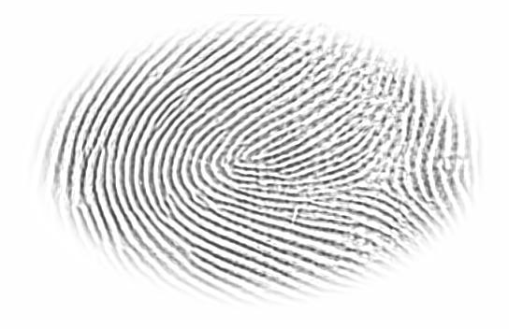

IIITD Fingerphoto dataset\Live Scan\1_1_1.jpg

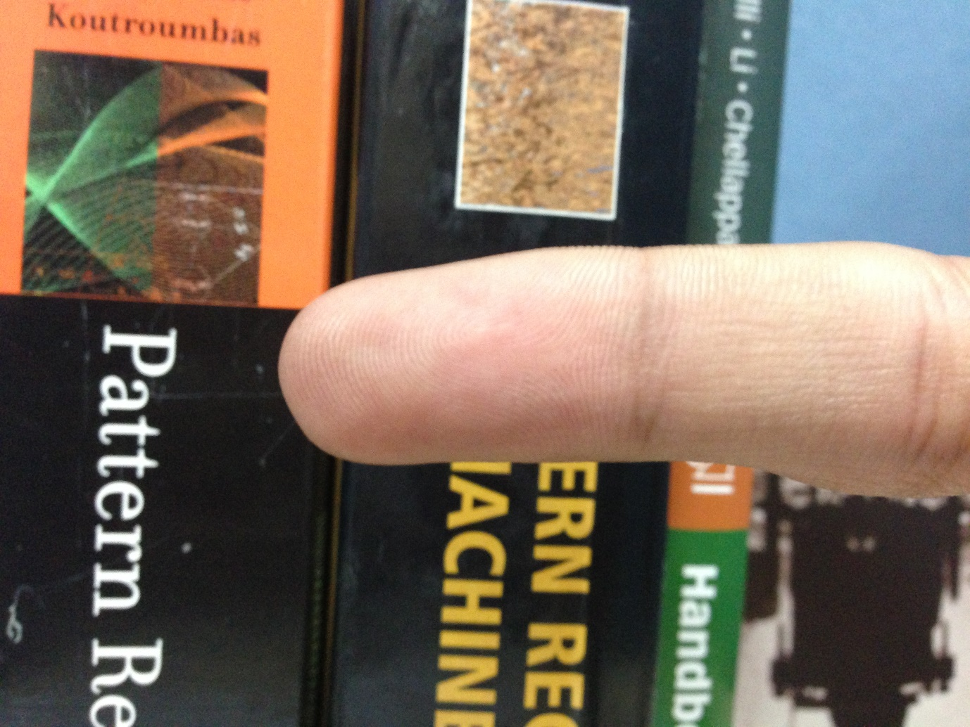

IIITD Fingerphoto dataset\Natural\Indoor\5_i_1_n_2.jpg

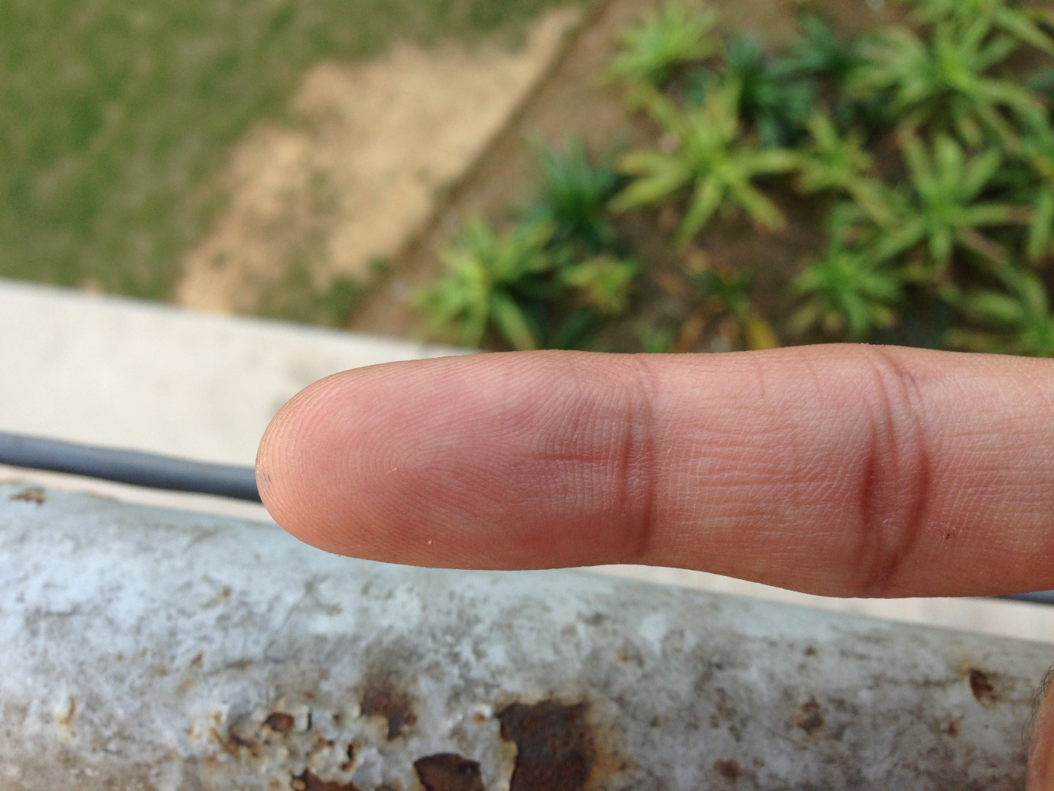

IIITD Fingerphoto dataset\Natural\Outdoor\1_o_1_n_1.jpg

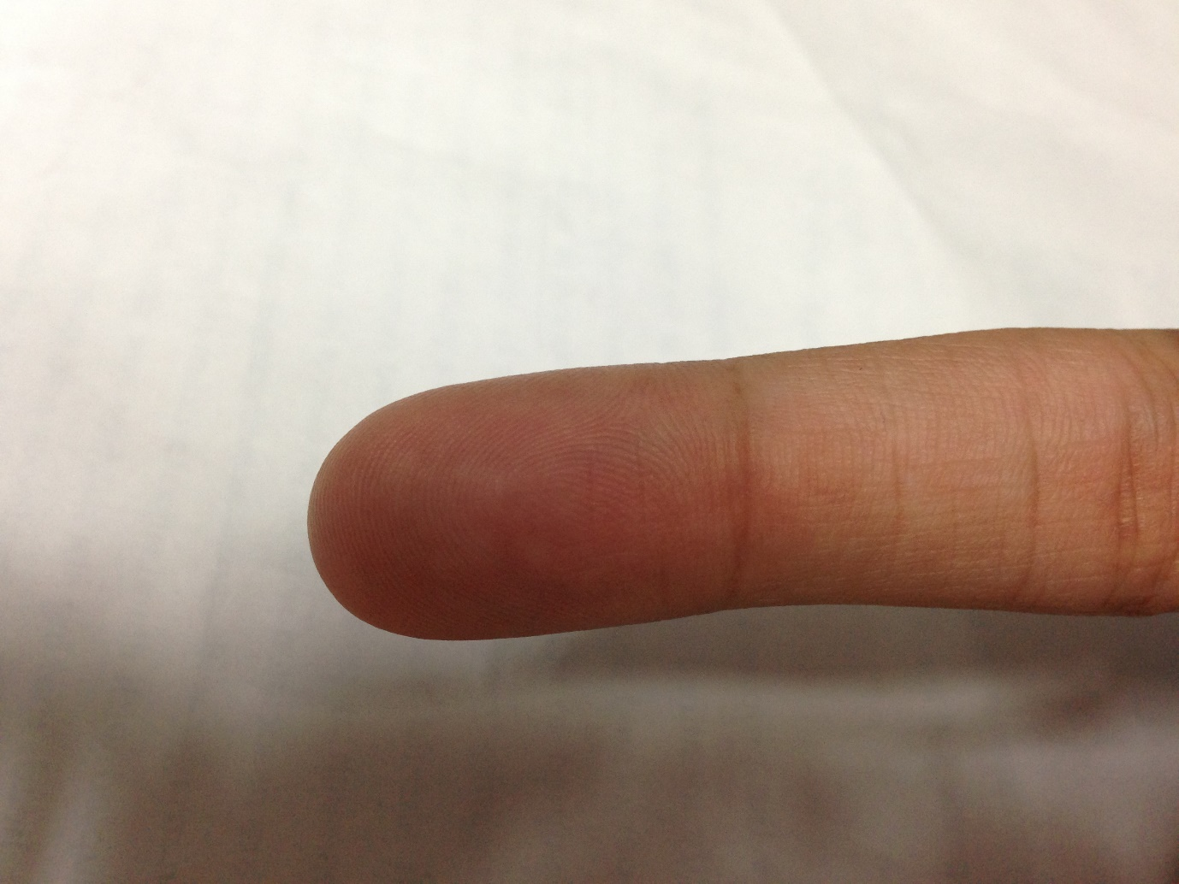

IIITD Fingerphoto dataset\White\Indoor\14_i_1_w_6.jpg

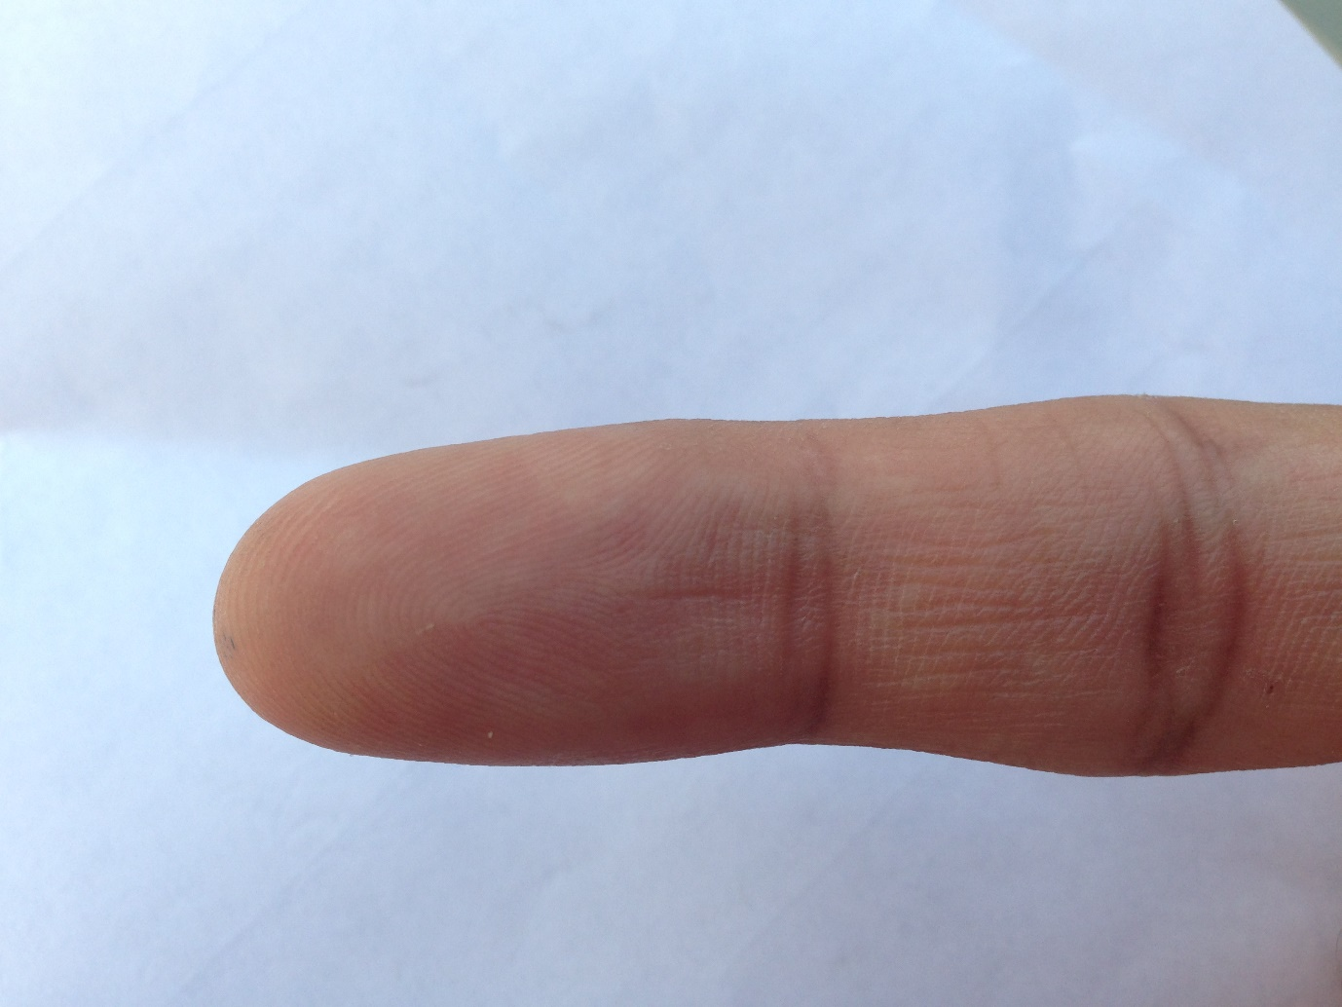

IIITD Fingerphoto dataset\White\Outdoor\1_o_1_w_2.jpg