SOFTWARE REQUIREMENTS SPECIFICATION

Zero-Click Mitigation Validation Framework (ZC-MVF)
Research-to-Mitigation Validation Platform for Telecommunications and VPN Security R&D
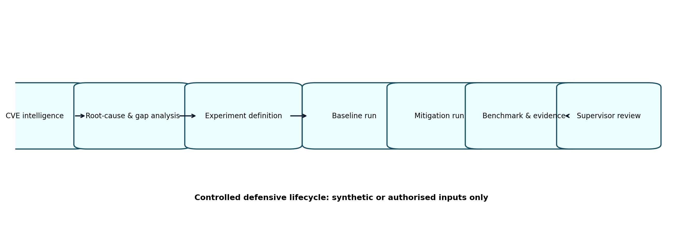
Controlled research-to-mitigation lifecycle
Field | Value
Prepared by | Raiha Mariam — Cybersecurity Intern
Organisation | Potech Australia
Team | R&D / Red Teaming
Project Lead | Rasha Malaeb
Advisor | Dr Carole Bassil
R&D Engineer | Layla Maasarani
Document version | 1.0 — Requirements baseline draft
Date | 30 July 2026
Status | Proposed; subject to supervisor validation and change control

Document Control
Version | Date | Author | Change summary | Approval
0.1 | 30 Jul 2026 | Raiha Mariam | Initial SRS derived from Assessment 1, Assessment 2 brief and current CVE dataset | Pending
1.0 | TBD | Raiha Mariam | Baseline after supervisor review | Pending

Approval Record
Role | Name | Decision | Date | Comments
Project Lead | Rasha Malaeb | Pending
Advisor | Dr Carole Bassil | Pending
R&D Engineer | Layla Maasarani | Pending
Developer / Intern | Raiha Mariam | Prepared | 30 Jul 2026 | Requirements proposed for review

Purpose of this SRS
This Software Requirements Specification defines the intended behaviour, boundaries, architecture, quality attributes, evidence model, safety controls and acceptance conditions for ZC-MVF. It converts the process improvement proposed in Assessment 1 into an implementable engineering baseline. The SRS is deliberately more detailed than the Assessment 2 synopsis; the synopsis can later be written from this controlled source of truth.

Source Material and Evidence Boundary
- ATW306 Assessment 1: identified fragmented traceability across CVE research, Overleaf, GitHub, prototypes, sandbox outputs, benchmarks and supervisor review.
- ATW306 Assessment 2 brief: requires a project synopsis covering objectives, methodology comparison, managerial and technical plans, risks, tools, ethics and closeout.
- Current CVE workbook: contains 55 CVE records across telecommunications and VPN/remote-access domains, structured intelligence fields, mitigation-gap review, summaries and source families.
- This SRS does not assert that real vendor vulnerabilities have been reproduced or mitigated. All implementation and test results remain future work unless separately evidenced.

1. Introduction

1.1 Project Overview
ZC-MVF is a defensive cybersecurity R&D platform that transforms validated zero-click vulnerability intelligence into safe, reproducible mitigation experiments. The platform will trace each selected research finding from CVE evidence through root-cause classification, vendor-remediation analysis, mitigation-gap analysis, hypothesis formation, synthetic test design, baseline execution, mitigation execution, benchmarking, evidence packaging and supervisor review.

1.2 Organisational Problem
Potech already uses GitHub, Overleaf, Python, sandbox services and a structured CVE dataset. The identified gap is not the absence of artefacts; it is the absence of a consistent lifecycle and common identifier that prove how a research claim becomes an implementation task, experiment, benchmark and reviewed conclusion. Without this linkage, evidence can be duplicated, conclusions can use inconsistent metrics, and handover requires manual cross-checking.

1.3 Product Vision
Provide Potech researchers with a lightweight, auditable and extensible mechanism for answering: “What recurring failure condition is supported by the evidence, what defensive control is proposed, and what measurable result demonstrates whether the control improved security without unacceptable operational cost?”

1.4 Objectives
- Establish end-to-end traceability between selected CVEs, research claims, code, test data, runs, evidence and supervisor decisions.
- Create a reusable experiment schema that supports one VPN and one telecommunications experiment in Phase 1.
- Compare baseline and mitigated behaviour using identical synthetic test sets and measurable acceptance criteria.
- Enforce defensive safety boundaries through configuration, approval gates and policy-as-code.
- Produce reproducible evidence packages suitable for technical review, handover and later expansion.
- Demonstrate maintainable software engineering through modular architecture, typed models, automated tests and version control.

1.5 Success Definition
Phase 1 is successful when two supervisor-approved experiments—one VPN and one telecommunications—can be executed in baseline and mitigated modes, produce comparable metrics and complete evidence manifests, and be traced to their source research without unsafe payloads or external targeting.

2. Scope

2.1 In Scope — Phase 1
- Experiment registry and typed experiment definitions
- One VPN experiment based on pre-authentication request validation or another approved pattern
- One telecommunications experiment based on SIP-like structural/state validation or another approved pattern
- Synthetic and benign test data
- Baseline and mitigated strategy execution
- Python runner and pytest suite
- Local evidence repository and comparison report
- Traceability to Excel, GitHub and Overleaf
- Dockerised execution after local runner validation
- Basic API and asynchronous execution only after core logic is stable

2.2 Deferred / Optional
- RabbitMQ queue and multiple workers
- MinIO object storage
- Prometheus and Grafana dashboards
- Automated Excel ingestion
- Additional protocols and domains
- Recovery Readiness Index and prioritisation engine
- CI/CD and multi-user authentication

2.3 Explicitly Out of Scope
- Weaponised exploits, shellcode or persistence mechanisms
- External scanning, internet targeting or unauthorised product testing
- Claims of protection for vendor products not tested in an approved environment
- Live telecom-network interference, rogue base-station activity or production traffic
- Collection of personal, customer or confidential traffic
- Autonomous disclosure to vendors without organisational approval

2.4 Constraints and Assumptions
ID | Constraint / assumption
C-01 | The internship timeline and individual-developer capacity require incremental delivery.
C-02 | Experiment selection and safety classification require Project Lead approval.
C-03 | The current workbook is the structured research source; entries still require source-level validation before experimental use.
C-04 | Phase 1 uses synthetic or benign inputs unless a separately authorised vulnerable environment exists.
C-05 | FastAPI, RabbitMQ, MinIO, Prometheus and Grafana are architectural options, not mandatory proof of project success.
C-06 | No production availability or commercial SLA is assumed for the prototype.

3. Stakeholders, Roles and Users
Stakeholder | Role | Responsibilities / decisions
Rasha Malaeb | Project Lead / sponsor | Approves scope, experiment selection, safety boundary, acceptance criteria and closeout.
Dr Carole Bassil | Advisor | Provides research and strategic guidance; reviews scientific defensibility where requested.
Layla Maasarani | R&D Engineer | Provides engineering feedback and domain review where assigned.
Raiha Mariam | Cybersecurity Intern / developer | Researches CVEs, models experiments, implements, tests, documents and reports risks.
Future R&D researchers | Primary users | Create or rerun experiments, inspect evidence, extend strategies and reuse outputs.
Technical reviewers | Secondary users | Review lineage, safety, metrics, limitations and conclusions.

3.1 User Classes
- Researcher: prepares CVE evidence, root-cause and mitigation-gap records.
- Experiment designer: creates testable questions, hypotheses, datasets and acceptance criteria.
- Developer: implements baseline and mitigation strategies.
- Reviewer: approves or rejects experiment definitions and conclusions.
- Auditor / handover recipient: verifies evidence lineage and reproducibility.

4. System Context and Architecture
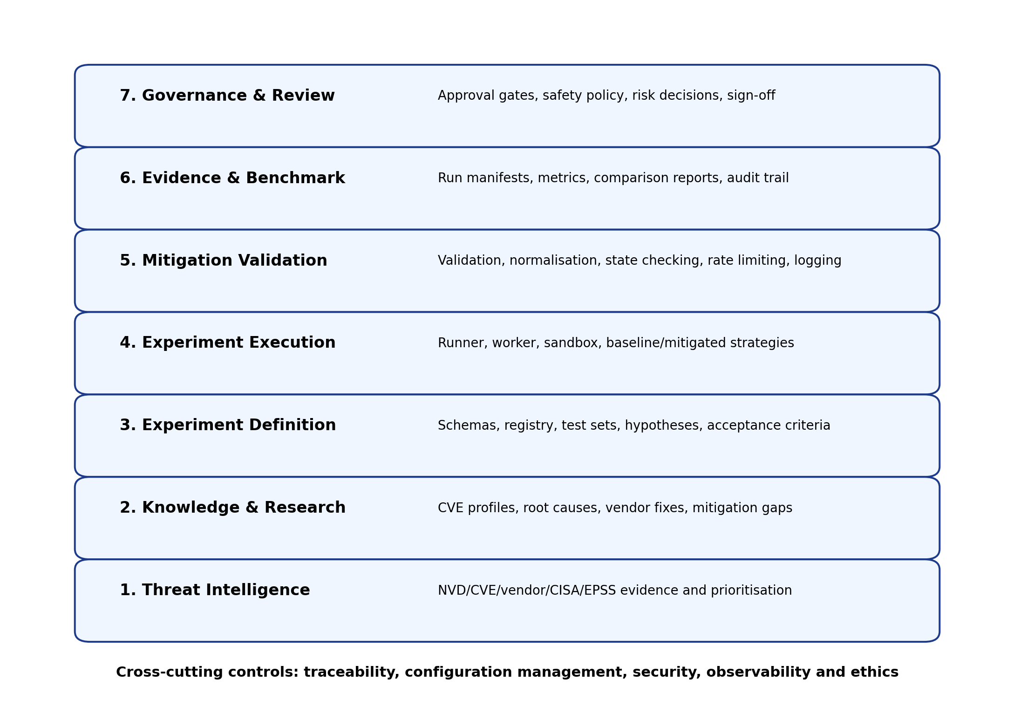
Figure 1. Seven-layer logical architecture

4.1 Architectural Principles
- Research evidence precedes implementation.
- The same dataset and runner must be used for baseline and mitigated comparisons.
- Safety controls are enforceable system behaviour, not only written policy.
- Every material artefact must be versioned and traceable.
- Infrastructure must remain replaceable; research logic must not depend on a specific queue, object store or dashboard.
- Conclusions must distinguish demonstrated results from inference and limitations.

4.2 Design Patterns
Pattern | Use | Justification
Strategy | Baseline and mitigation algorithms implement a common interface. | Enables fair switching and extension without modifying the runner.
Factory | Resolves strategy and parser implementations from approved identifiers. | Prevents uncontrolled dynamic loading and centralises validation.
Repository | Abstracts experiment, run and evidence persistence. | Allows migration from local files to MinIO/database without rewriting domain logic.
Producer–Consumer | API submits jobs; workers execute experiments. | Useful only when execution becomes asynchronous or concurrent.
Dependency Injection | Runner receives repositories, clock, logger and strategies. | Improves testability and avoids hidden infrastructure dependencies.
Policy Object | Safety and approval rules are evaluated before execution. | Makes ethical constraints testable and auditable.

4.3 Target Deployment
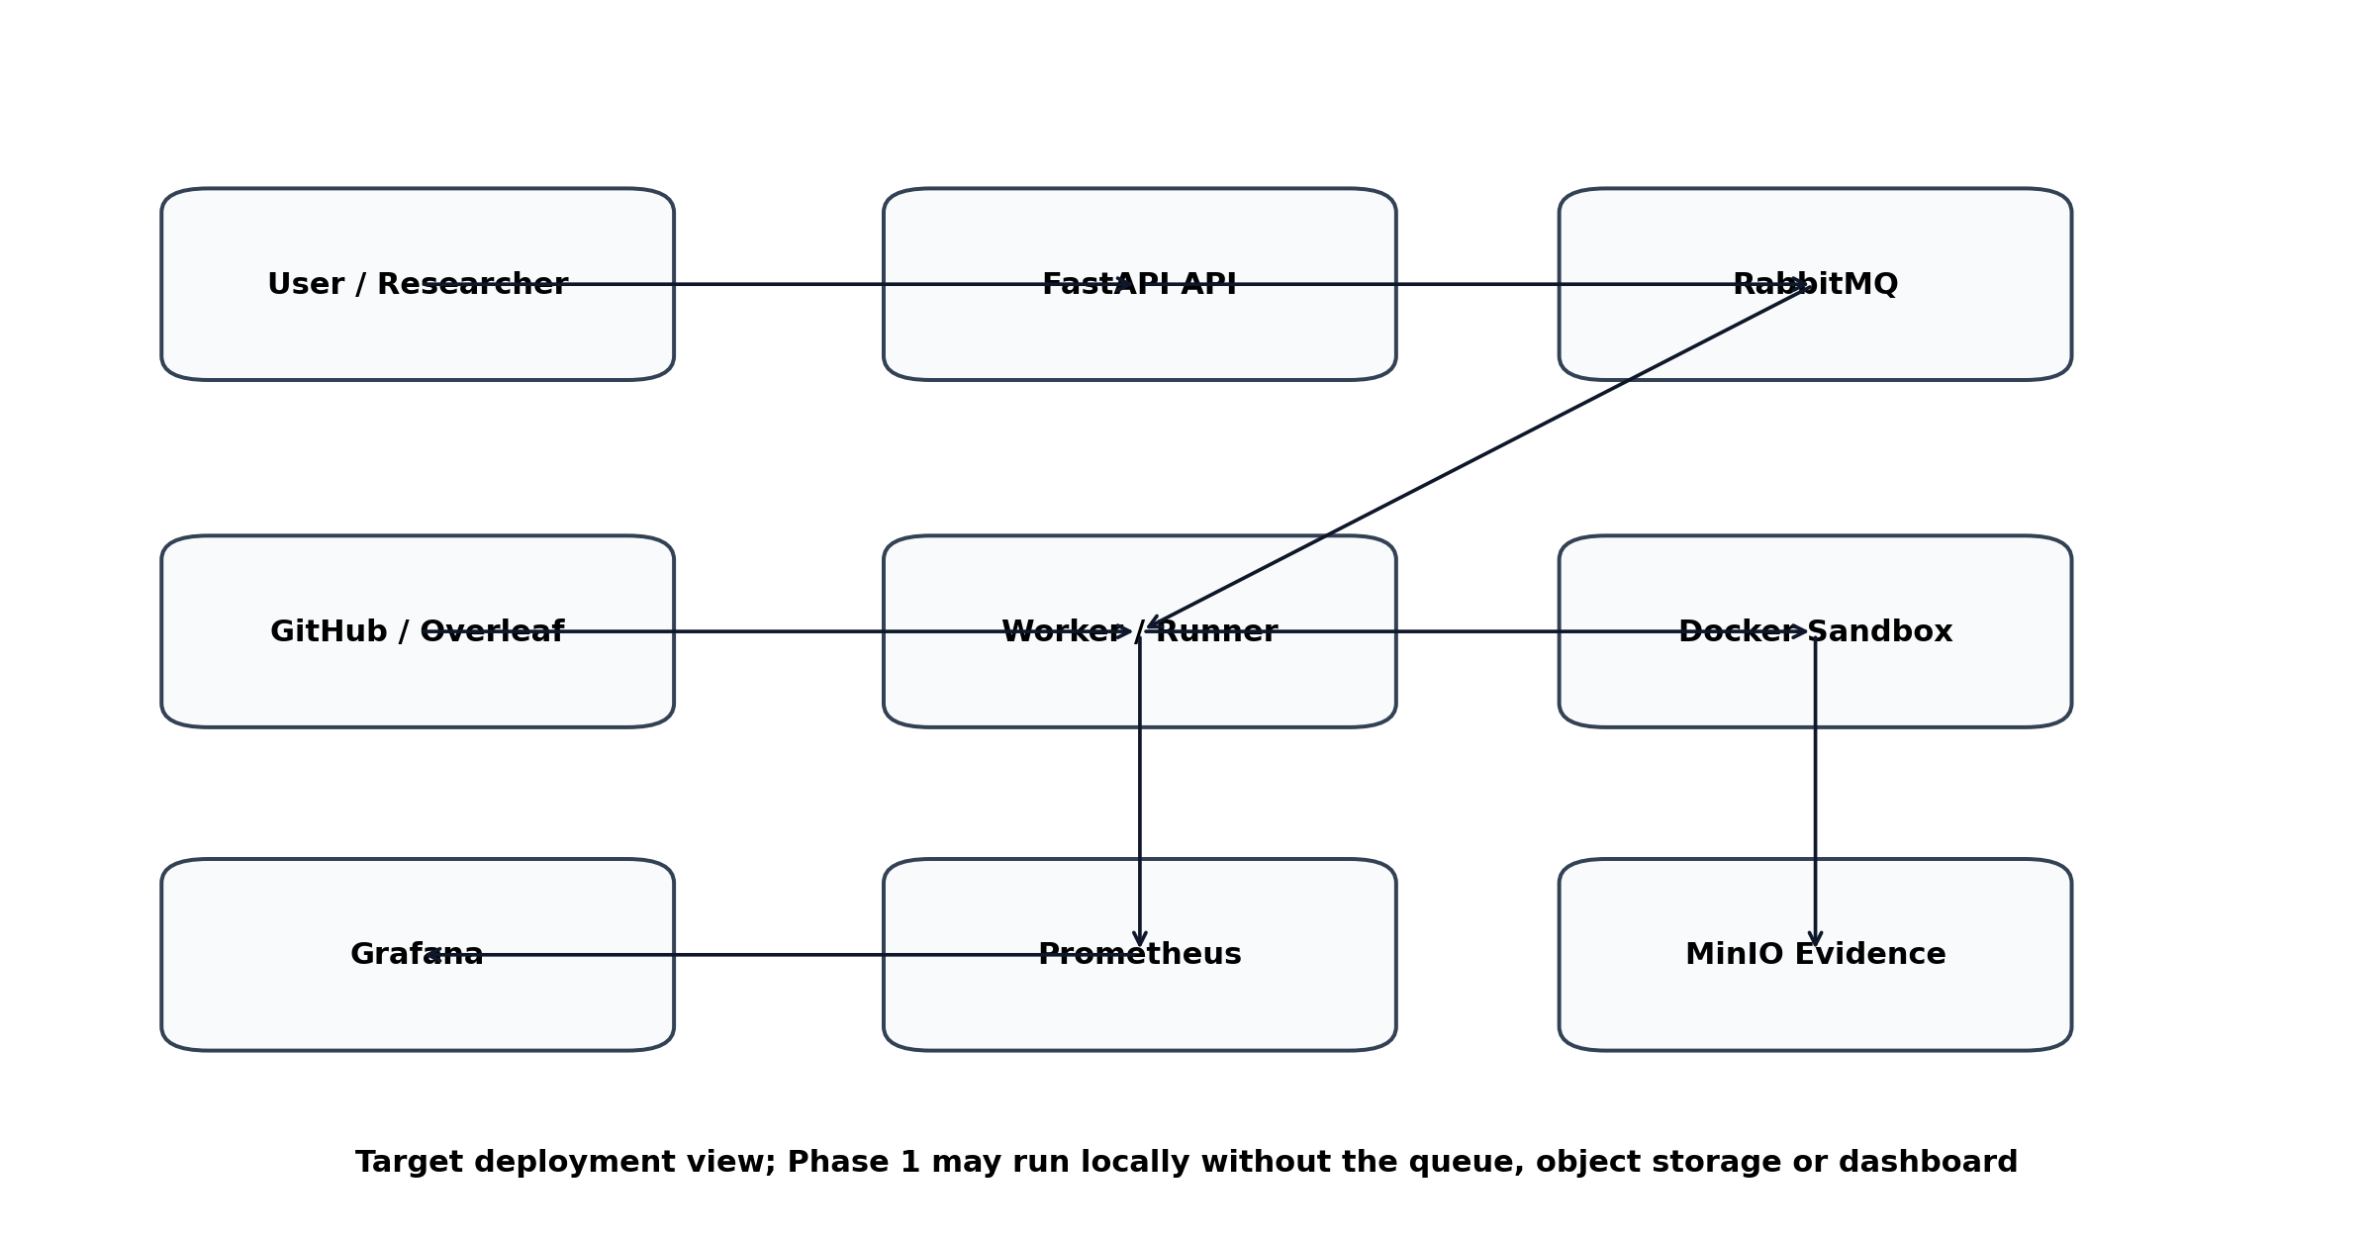
Figure 2. Target deployment and deferred infrastructure

5. Functional Requirements
Priority uses MoSCoW: M = Must, S = Should, C = Could. “Acceptance” states the minimum verifiable condition.
ID | Priority | Requirement | Acceptance
FR-001 | M | Create and validate an experiment definition containing identifier, domain, research basis, root cause, vendor mitigation, gap, question, hypothesis, safety class, strategies, metrics and approval status. | Invalid or incomplete definitions are rejected with field-level errors.
FR-002 | M | Assign a unique immutable traceability ID using the pattern ZC-<DOMAIN>-EXP-<NNN>. | Duplicate IDs cannot be stored.
FR-003 | M | Link each experiment to one or more CVE records and source references. | A run cannot be approved without at least one evidence reference.
FR-004 | M | Store structured root-cause and mitigation-gap classifications. | Values must use controlled enumerations with extension notes.
FR-005 | M | Load synthetic test cases labelled valid, malformed or boundary. | Every case has expected outcome and provenance.
FR-006 | M | Execute the same test set in baseline and mitigated modes. | Comparison rejects mismatched dataset versions.
FR-007 | M | Record whether an input was accepted, blocked, parser-reached, errored and logged. | One result record is produced per test case.
FR-008 | M | Calculate block rate, valid acceptance rate, false-positive rate, false-negative rate, parser reach rate, latency and log completeness. | Metrics are reproducible from raw result records.
FR-009 | M | Generate a baseline-versus-mitigated comparison report. | Report includes absolute counts, rates, overhead and limitations.
FR-010 | M | Generate an evidence manifest for every run. | Manifest includes experiment version, code commit, data hash, timestamps, environment, metrics and artefact paths.
FR-011 | M | Enforce safety policy before execution. | Runs with prohibited external targeting or unapproved input classes are refused and logged.
FR-012 | M | Support supervisor decision states: draft, pending review, approved, revision required, rejected, closed. | Only approved experiment definitions can be marked final.
FR-013 | S | Expose experiment and run operations through FastAPI. | API validates schema and returns stable identifiers/status.
FR-014 | S | Queue approved jobs and process them asynchronously. | Duplicate submission is idempotent or detectable.
FR-015 | S | Store large evidence artefacts in MinIO with immutable run prefixes. | Manifest paths resolve to stored objects.
FR-016 | S | Publish operational and experiment metrics to Prometheus. | Documented metric names and labels are emitted.
FR-017 | C | Render Grafana dashboards for experiment history and comparison. | Dashboard distinguishes scientific metrics from service-health metrics.
FR-018 | C | Import selected CVE records from the workbook after user review. | Importer reports mapping errors and does not silently overwrite data.
FR-019 | C | Rank experiment candidates using transparent weighted criteria. | Every score is explainable and weights are configurable.
FR-020 | C | Calculate a project-defined Recovery Readiness Index. | Output is labelled as an internal decision aid, not an industry standard.

6. Experiment Requirements

6.1 VPN Phase 1 Candidate
Candidate pattern: pre-authentication request validation and parser shielding. Selection must be confirmed against current CVE evidence and supervisor priorities. The experiment models a generic unsafe processing condition rather than a vendor exploit.
Element | Requirement
Research question | Can a pre-parser validation layer reject structurally invalid VPN-like requests before sensitive processing?
Baseline | Weak or incomplete schema/length/normalisation controls in a safe Python model.
Mitigation | Strict schema, length, type, duplicate-field and canonicalisation checks with structured logging.
Inputs | Valid, boundary, oversized, mismatched length, duplicate field, unsupported encoding and invalid path cases.
Metrics | Block rate, parser reach, valid acceptance, false positives/negatives, latency and log completeness.
Limitation | Does not prove mitigation effectiveness for an original vendor product.

6.2 Telecommunications Phase 1 Candidate
Candidate pattern: SIP-like structural and protocol-state validation. It uses a simplified message grammar and state machine; it does not implement or attack a live telecommunications stack.
Element | Requirement
Research question | Can grammar and state-aware validation reject malformed or out-of-sequence messages before handler execution?
Baseline | Simplified handler with weak mandatory-field and state checks.
Mitigation | Header normalisation, size limits, mandatory fields, sequence validation, state-machine enforcement and logging.
Inputs | Valid setup, missing header, oversized field, malformed length, duplicate identity, invalid sequence and invalid transition.
Metrics | Structural block rate, state-transition block rate, valid acceptance, parser reach, overhead and event visibility.
Limitation | Synthetic protocol abstraction; no claim of full SIP compliance or vendor protection.

6.3 Experiment Definition Schema
Minimum logical fields: experiment_id, title, domain, related_cves, source_references, root_cause_category, vendor_mitigation_pattern, mitigation_gap, research_question, hypothesis, baseline_strategy, mitigation_strategy, test_set_version, metric_definitions, acceptance_criteria, input_classification, external_targeting, approval_status, approver, version and change_history.

7. Data Requirements

7.1 Core Entities
Entity | Key attributes | Relationships
CVE Evidence | CVE ID, domain, source URLs, CVSS, KEV, EPSS, trust boundary, root cause, mitigation, gap | Many-to-many with Experiment
Experiment | Traceability ID, question, hypothesis, strategies, safety, status, version | Has Test Sets and Runs
Test Case | ID, category, input, expected decision, provenance, version | Belongs to Test Set
Run | Run ID, mode, timestamps, environment, commit, dataset hash, status | Produces Results and Manifest
Result | Case ID, decision, parser reached, error, latency, logging outcome | Belongs to Run
Metric | Name, definition, value, unit, calculation version | Derived from Results
Evidence Manifest | Hashes, paths, versions, environment, review status | One per Run
Review Decision | Reviewer, decision, date, comments, conditions | Applies to Experiment or Conclusion

7.2 Data Integrity Rules
- IDs are immutable after creation.
- Raw result records are append-only; corrections create a new run or version.
- Comparison requires identical experiment version and test-set hash unless explicitly marked exploratory.
- Source URLs and retrieved dates must be retained for evidence provenance.
- Sensitive or proprietary content must not be stored without approval.
- Evidence manifests must use SHA-256 or an approved equivalent to identify artefact versions.

7.3 Retention and Classification
Prototype data should default to Internal / Research. Synthetic datasets may be shareable only after review. Any vendor-restricted, confidential or exploit-capable material must use stricter storage and access controls defined by Potech; the current source files do not specify formal retention periods, so this remains a supervisor decision.

8. Interface Requirements

8.1 Command-Line Interface — Mandatory First Release
- validate-experiment --file <path>
- run --experiment <id> --mode baseline|mitigated --test-set <version>
- compare --experiment <id> --baseline-run <id> --mitigated-run <id>
- verify-evidence --run <id>

8.2 Proposed API
Method | Endpoint | Purpose
POST | /experiments | Create validated experiment definition
GET | /experiments | List/filter experiments
GET | /experiments/{id} | Retrieve experiment and lineage
POST | /experiments/{id}/runs | Submit approved run
GET | /runs/{run_id} | Retrieve run status
GET | /runs/{run_id}/results | Retrieve raw and aggregate results
GET | /experiments/{id}/comparison | Retrieve baseline/mitigated comparison
POST | /experiments/{id}/reviews | Record supervisor decision

8.3 External Tool Interfaces
- GitHub: source control, issues, pull requests and commit identifiers.
- Overleaf: research narrative and final conclusions linked by traceability ID.
- Excel workbook: curated research source and potential import input.
- RabbitMQ: optional job transport only; experiment semantics remain independent.
- MinIO: optional object storage implementing the evidence repository interface.
- Prometheus/Grafana: optional operational visibility and trend reporting.

9. Non-Functional Requirements
ID | Attribute | Requirement | Measure
NFR-001 | Security | All execution defaults to local, non-routable or explicitly approved targets. | No external destination permitted by default configuration.
NFR-002 | Safety | Prohibited input classes and unapproved modes fail closed. | Policy tests achieve 100% pass rate.
NFR-003 | Traceability | Every conclusion maps to evidence, code and review identifiers. | 100% of closed experiments have complete lineage.
NFR-004 | Reproducibility | Runs capture code, data, configuration and environment versions. | Independent rerun reproduces decisions within documented tolerance.
NFR-005 | Reliability | A failed case must not corrupt other case results. | Runner isolates case errors and completes remaining safe cases.
NFR-006 | Performance | Mitigation overhead must be measurable and bounded by experiment-specific criteria. | Default target: report p50/p95 and no hidden timeouts; exact limit approved per experiment.
NFR-007 | Maintainability | Domain logic is modular and typed. | New strategy can be added without modifying runner core.
NFR-008 | Testability | Critical domain and policy logic has automated tests. | Target ≥85% branch coverage for core modules; safety-policy paths 100%.
NFR-009 | Usability | A researcher can run an approved experiment from documented commands. | Fresh setup completed using README without undocumented steps.
NFR-010 | Portability | Core runner operates on supported Windows/Linux hosts via Python; Docker provides repeatability. | CI or manual smoke test passes on at least two environments if resources permit.
NFR-011 | Observability | Runs produce structured logs with IDs and decisions. | No result lacks experiment_id, run_id and case_id.
NFR-012 | Scalability | Architecture supports later worker concurrency without changing experiment schema. | Queue integration passes contract tests.
NFR-013 | Accessibility | Reports use clear headings, tables and text alternatives for diagrams. | Document and UI review identifies no critical accessibility barrier.
NFR-014 | Sustainability | Infrastructure is introduced only when justified by workload. | Phase review records benefit/cost before enabling optional services.

10. Security, Safety and Ethical Requirements

10.1 Policy-as-Code Controls
Rule ID | Rule
SAFE-001 | external_targeting must be false unless a separately documented authorisation exists.
SAFE-002 | input_classification must be synthetic, benign or explicitly authorised.
SAFE-003 | weaponised_payloads must be false for Phase 1.
SAFE-004 | experiment approval must be approved before execution outside local unit tests.
SAFE-005 | network egress is denied by default for sandbox containers.
SAFE-006 | secrets and real credentials are prohibited from test datasets.
SAFE-007 | logs must avoid personal or confidential content.
SAFE-008 | unsafe configuration attempts are rejected and recorded.

10.2 Responsible Research Requirements
- Use least-harmful methods capable of answering the research question.
- Separate vulnerability research evidence from operational exploitation instructions.
- Do not publish uncoordinated vendor-sensitive findings.
- Document uncertainty, assumptions and non-generalisation limits.
- Retain evidence integrity and do not alter results to fit the hypothesis.
- Escalate ambiguous scope, licensing or authorisation questions before execution.

10.3 Threat Model for the Framework
Threat | Control
Malicious or accidental unsafe experiment definition | Typed schema, allow-listed strategies, approval gate and policy evaluation.
Path traversal or evidence overwrite | Canonical paths, immutable run directories, generated IDs and repository boundary.
Queue job tampering | Signed/validated payloads, least-privilege broker permissions and idempotency.
Sensitive data leakage | Synthetic inputs, secret scanning, restricted logs and access controls.
Metric manipulation or cherry-picking | Raw results retained, deterministic calculations and manifest hashes.
Dependency compromise | Pinned dependencies, vulnerability scanning and controlled updates.
Container escape or unnecessary network access | Non-root containers, dropped capabilities, resource limits and no egress by default.

11. Quality Assurance and Test Requirements

11.1 Test Levels
Level | Coverage
Unit | Models, validators, strategy decisions, metric calculations, hashes and policy rules.
Contract | Strategy interface, repository interface, API schemas and queue payloads.
Integration | Runner + repository; API + runner; worker + queue; MinIO adapter.
Experiment validation | Expected decisions for all valid, malformed and boundary cases.
Regression | Previously approved datasets and benchmark baselines.
Security | Input validation, path handling, auth when added, dependency scan and egress control.
Reproducibility | Re-run from manifest inputs and compare decisions/hashes.
User acceptance | Project Lead reviews traceability, evidence, metrics, limitations and documentation.

11.2 Quality Gates
Gate | Entry | Exit
QG-1 Research readiness | CVE sources and gap recorded | Research question and experiment candidate approved
QG-2 Design readiness | Schema, safety, test set and metrics drafted | Experiment definition approved
QG-3 Baseline readiness | Baseline code and tests complete | Expected weakness demonstrated safely
QG-4 Mitigation readiness | Mitigation and unit tests complete | No critical test failure; valid traffic preserved
QG-5 Evidence readiness | Both runs complete | Manifest, raw results and comparison verified
QG-6 Closeout | Reviewer has evidence | Decision, limitations, handover and backlog recorded

11.3 Phase 1 Acceptance Criteria
AC ID | Criterion
AC-01 | Exactly one approved VPN and one approved telecommunications experiment are delivered.
AC-02 | Each experiment links to CVE evidence, GitHub task, implementation, test set, runs, benchmark and Overleaf section.
AC-03 | All valid test cases are accepted unless an exception is explicitly justified.
AC-04 | Mitigated mode blocks the experiment-defined malformed conditions before sensitive processing.
AC-05 | Baseline and mitigated results use the identical versioned test set.
AC-06 | Every rejection generates a structured security event.
AC-07 | Comparison includes effectiveness, false positives/negatives, parser reach and latency.
AC-08 | Evidence manifest passes integrity verification.
AC-09 | No unsafe execution, external targeting or real credential use occurs.
AC-10 | Project Lead records a review decision and closeout status.

12. Risk Management Requirements
ID | Risk | Likelihood | Impact | Preventive control | Contingency
R-01 | Scope expansion into many CVEs/infrastructure | High | High | Phase gates; WIP limit; two experiments only | Defer optional services and additional CVEs
R-02 | Experiment does not faithfully represent recurring weakness | Medium | High | Research review; explicit abstraction and limitations | Redesign or choose a more feasible pattern
R-03 | Unsafe or unauthorised testing | Low | Critical | Policy-as-code, no egress, synthetic inputs, approval | Stop work, preserve logs, notify Project Lead
R-04 | CVE dataset contains stale or weakly supported entries | Medium | High | Revalidate selected CVEs against primary sources | Exclude unsupported records and document gap
R-05 | False confidence from synthetic model | High | High | No vendor-protection claims; limitation statements | Frame results as pattern-level evidence only
R-06 | Infrastructure complexity delays core research | High | Medium | CLI-first delivery; optional architecture staged | Remove queue/storage/dashboard from Phase 1
R-07 | Metrics are inconsistent or gamed | Medium | High | Predefine metrics; retain raw data; identical datasets | Re-run after reviewer-approved metric correction
R-08 | Time or placement availability changes | Medium | High | Weekly plan, prioritisation and early escalation | Reduce to one fully completed experiment with approval
R-09 | Dependency or container vulnerability | Medium | Medium | Pinned packages, scans, least privilege | Patch, rebuild and record version change
R-10 | Loss or corruption of evidence | Low | High | Version control, hashes, backups, immutable prefixes | Restore and rerun from source definitions
R-11 | Confidential information enters logs/repository | Low | High | Synthetic inputs, review, secret scanning | Remove access, notify lead, sanitise and rotate secrets
R-12 | Supervisor availability delays decisions | Medium | Medium | Decision log and review windows | Proceed only with safe preparatory work; replan gate

13. Development and Delivery Plan

13.1 Selected Process Model
The recommended process is risk-driven iterative prototyping governed through Kanban and formal approval gates. Waterfall provides documentation discipline but reacts poorly to changing research evidence. Full Scrum is unnecessarily ceremony-heavy for an individual placement project. A spiral-style risk focus is valuable, but the project will use a simplified cycle: evidence → risk review → prototype → measurement → supervisor decision.

13.2 Work Breakdown and Milestones
Milestone | Primary outputs | Exit decision
M1 Requirements baseline | Approved SRS, scope, roles, risks | Proceed / revise
M2 Experiment selection | VPN and telecom candidates, source packs, questions | Approve experiments
M3 Core framework | Models, registry, runner, repositories, tests | Core quality gate
M4 VPN cycle | Dataset, baseline, mitigation, comparison, evidence | Approve / revise
M5 Telecom cycle | Dataset, baseline, mitigation, comparison, evidence | Approve / revise
M6 Integration | Docker, API; optional queue/storage/metrics | Accept architecture scope
M7 Closeout | Handover, limitations, backlog, synopsis inputs | Project Lead sign-off

13.3 Indicative Effort and Cost
The source material does not provide an approved budget or labour rate. Therefore, the SRS records effort in person-hours rather than inventing monetary cost. Phase 1 is estimated at approximately 80–120 intern hours, subject to experiment complexity and supervisor review latency. Software components are open-source or already-used tools, but organisational costs include supervision, computing, secure storage and review time.
Work package | Indicative hours
Requirements, architecture and approval | 10–15
CVE revalidation and experiment design | 15–20
Core models, runner and tests | 18–25
VPN experiment | 12–18
Telecom experiment | 12–18
Evidence, documentation and closeout | 10–15
Optional infrastructure | Additional 15–30; not committed

13.4 Configuration and Change Management
- All code changes use Git branches and pull requests or equivalent reviewed commits.
- Experiment definitions, datasets and calculation logic are versioned.
- Changes affecting safety, scope, metrics or acceptance require Project Lead approval.
- Approved results are never overwritten; a new run or experiment version is created.
- A decision log records rationale, owner, date and affected requirements.

14. Technology Requirements and Rationale
Technology | Role | Selection rationale / boundary
Python 3.12 | Core implementation | Strong typing ecosystem, security tooling and rapid prototyping; version subject to environment compatibility.
Pydantic v2 | Schemas | Explicit validation and serialisation for experiment and API contracts.
pytest | Automated testing | Fixtures and parametrisation suit repeatable experiment datasets.
FastAPI | Optional service layer | Typed API and OpenAPI support; introduced only after CLI logic is stable.
Docker / Compose | Isolation and reproducibility | Consistent dependencies and network controls; not a substitute for experiment validity.
RabbitMQ | Optional queue | Reliable asynchronous dispatch; unnecessary for initial synchronous runs.
MinIO | Optional evidence storage | S3-compatible local object storage; repository abstraction allows replacement.
Prometheus | Optional metrics | Time-series operational and experiment counters; raw scientific evidence remains separately stored.
Grafana | Optional visualisation | Review-friendly dashboards; must not replace raw data and reports.
GitHub | Versioning and workflow | Issues, commits, reviews and traceability.
Overleaf | Research documentation | Collaborative technical narrative and references linked to experiment IDs.
Excel workbook | Current intelligence registry | Existing structured CVE and mitigation-gap evidence; not the long-term transactional store.

15. Reporting, Evidence and Audit Requirements

15.1 Evidence Package Contents
- Experiment definition and version
- Source CVE list and evidence references
- Synthetic test set and hash
- Baseline raw results and logs
- Mitigated raw results and logs
- Metric calculation version and comparison report
- Code commit and dependency/environment record
- Safety-policy decision
- Known limitations and interpretation
- Supervisor review decision

15.2 Evidence Manifest Example
A manifest should contain: manifest_version, experiment_id, experiment_version, run_id, mode, test_set_id, test_set_sha256, git_commit, container_image_digest, started_at, completed_at, strategy_id, metrics, artefact_paths, safety_decision, review_status and manifest_sha256.

15.3 Audit Questions
- Which evidence supports the experiment?
- Which exact code and data produced the result?
- Were baseline and mitigation compared fairly?
- Did any prohibited behaviour occur?
- Can another researcher reproduce the decision?
- Who reviewed the conclusion and under what conditions?

16. Requirements Traceability Matrix
Objective | Functional requirements | Quality requirements | Acceptance
OBJ-1 Traceability | FR-002, FR-003, FR-010, FR-012 | NFR-003, NFR-004 | AC-02, AC-08, AC-10
OBJ-2 Reusable experiments | FR-001, FR-004, FR-005, FR-006 | NFR-007, NFR-008 | AC-01, AC-05
OBJ-3 Mitigation evaluation | FR-007, FR-008, FR-009 | NFR-005, NFR-006 | AC-03, AC-04, AC-07
OBJ-4 Safety | FR-011 | NFR-001, NFR-002 | AC-09
OBJ-5 Evidence and handover | FR-010, FR-012 | NFR-004, NFR-009, NFR-011 | AC-08, AC-10
OBJ-6 Extensibility | FR-013–FR-020 | NFR-010, NFR-012, NFR-014 | Post-Phase-1 roadmap

17. Open Decisions
Decision ID | Question | Owner | Required by
D-01 | Which exact VPN CVE pattern will anchor Phase 1? | Project Lead | Before M2 exit
D-02 | Which exact telecommunications pattern will anchor Phase 1? | Project Lead | Before M2 exit
D-03 | Are real vulnerable product images or public PoCs authorised? | Project Lead / organisation | Before any non-synthetic test
D-04 | What performance overhead is acceptable per experiment? | Project Lead / researcher | Before M3/M4
D-05 | Which evidence repository and retention policy apply? | Project Lead | Before M6
D-06 | Is FastAPI/RabbitMQ/MinIO/Grafana delivery required or optional? | Project Lead | Requirements baseline
D-07 | What is the correct Assessment 2 word limit: 1,200 or 1,500 words? | Learning Facilitator | Before synopsis drafting

18. Project Closeout Requirements
- All accepted requirements are verified or formally deferred.
- Open defects, risks and limitations are documented with owners.
- Evidence manifests and source repositories are accessible to authorised team members.
- A handover guide explains setup, execution, extension and safety controls.
- The Project Lead records approval, conditional acceptance or rejection.
- Deferred architecture and future research are moved to a prioritised backlog.
- The final Overleaf conclusion distinguishes demonstrated outcomes from future claims.

19. References and Standards Baseline
- ATW306 Assessment 1 — A Phased Zero-Click Intelligence and Sandbox Analysis Framework (Raiha Mariam).
- ATW306 Assessment 2 Brief — Option 1: Industry Placement.
- Current telecom_vpn_cve_zero_click.xlsx workbook, including CVE Intelligence, Mitigation Gap Review, summary and reference sheets.
- ISO/IEC/IEEE 12207:2017 — Systems and software engineering — Software life cycle processes.
- NIST SP 800-218 — Secure Software Development Framework (SSDF) Version 1.1.
- CISA Known Exploited Vulnerabilities Catalog.
- FIRST CVSS v3.1 and Exploit Prediction Scoring System (EPSS).
- MITRE ATT&CK knowledge base.
- OWASP Web Security Testing Guide v4.2.
- Bourque and Fairley, Guide to the Software Engineering Body of Knowledge (SWEBOK v3.0).
- Sommerville, Software Engineering (10th ed.).
- Pressman and Maxim, Software Engineering: A Practitioner’s Approach (8th ed.).
- Primary vendor advisories and NVD records listed in the CVE workbook for any experiment selected.
Note: Standards, advisory versions and current vulnerability status should be revalidated before final submission or implementation. This SRS records the baseline derived from the supplied project materials.

Appendix A — Proposed Repository Structure
zero-click-mitigation-framework/
├── experiments/
│ ├── ZC-VPN-EXP-001.json
│ └── ZC-TEL-EXP-001.json
├── test_data/
│ ├── vpn/
│ └── telecom/
├── src/
│ ├── models/
│ ├── policies/
│ ├── strategies/
│ ├── parsers/
│ ├── validators/
│ ├── runners/
│ ├── repositories/
│ ├── metrics/
│ └── api/
├── tests/
│ ├── unit/
│ ├── integration/
│ ├── policy/
│ └── experiments/
├── results/
├── docs/
├── docker-compose.yml
├── pyproject.toml
└── README.md

Appendix B — Definition of Done
- Requirement and acceptance criteria are linked.
- Code is typed, reviewed and passes automated tests.
- Safety policy permits the run.
- Test-set provenance and hash are recorded.
- Baseline and mitigated runs are complete and comparable.
- Metrics are reproducible from raw results.
- Evidence manifest verifies successfully.
- Limitations and non-generalisation statements are written.
- Supervisor review decision is recorded.
- Documentation and handover are updated.

