EEE241L Multisim Assignment
Electrical Circuits II Lab
Name: | Farhana Tasnim | Student ID: | 2532289043
Section: | 04 | Date: | 08/09/2026

Objective:
To simulate inductive and capacitive load circuits in NI Multisim, measure peak voltages and time differences using an oscilloscope, and calculate load current, phase angle, and power drawn by the load.

Circuit Schematics:
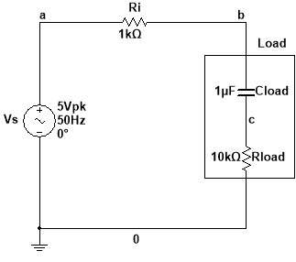
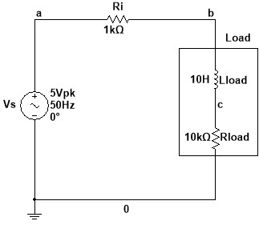

Figure 1: Inductive load in a series circuit Figure 2: Capacitive load in a series circuit

Problem 1: Inductive Load in a Series Circuit
Simulate the inductive load circuit shown in Figure 1. Measure the load voltage, the voltage across Ri, and the required time differences using the oscilloscope. Then complete Table 1 and calculate the load current and power drawn by the load.

Table 1: Inductive Load
Reading | Parameter | Value
1 | V_Load (peak) | 4.58 V (peak)
2 | Δt for load voltage | 140 µS
3 | θ for load voltage | θ = (Δt ×f ×360) = (140 ×10⁻⁶ ×50 ×360) = 2.52º ( Leading )
4 | V_Ri (peak) | 440 mV (peak)
5 | Δt for Ri voltage | 880 µS
6 | θ for Ri voltage / current | θ = (Δt ×f ×360) = (880 ×10⁻⁶ ×50 ×360) =15.84° (Lagging)
7 | I_s ∠ θ | I_{s} $=\frac{V\left(Ri\right)}{Ri}=\frac{440∠-15.84º}{1000}$  = 0.44 mA_{pk} ∠-15.84 º
8 | Power drawn by the load, P | P = ($\frac{1}{2}$ I_{pk}² ×R_{load} )= 0.5×(0.44×10⁻³)²×10⁴  = 0.968 mW

Calculation ( Inductive Load ):
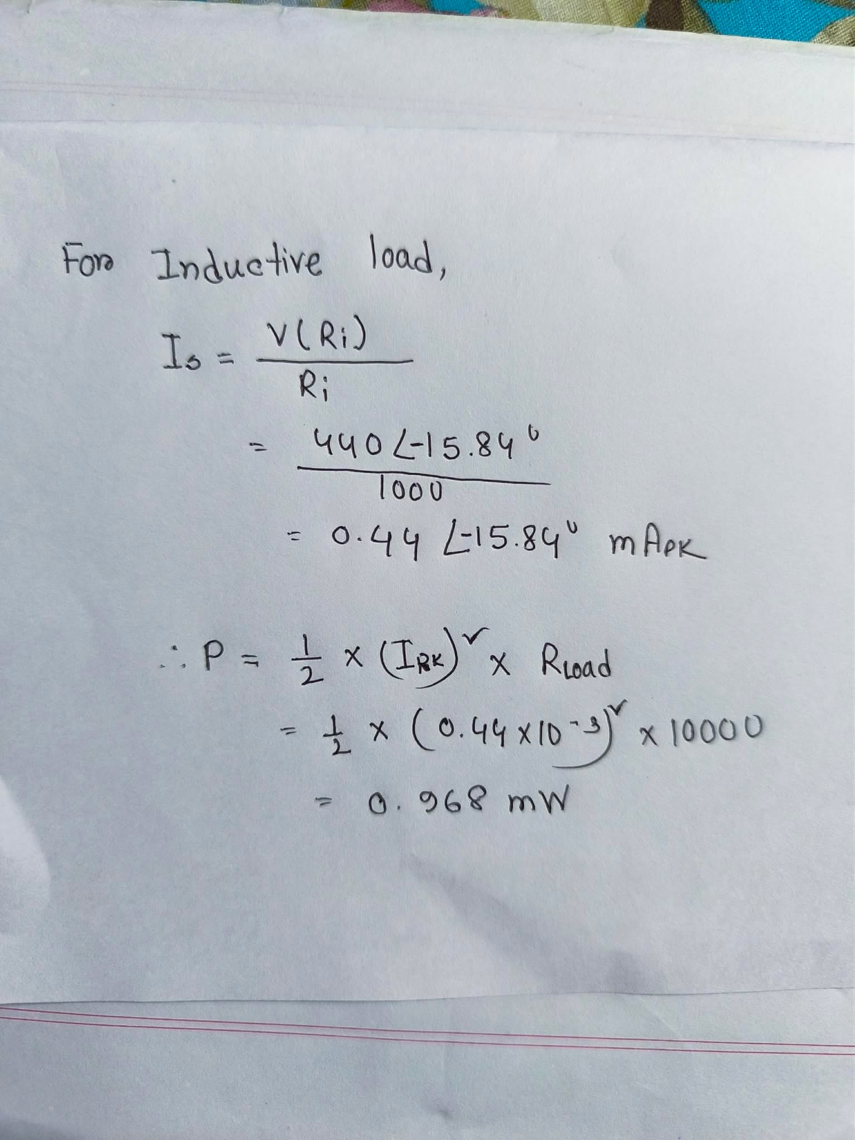
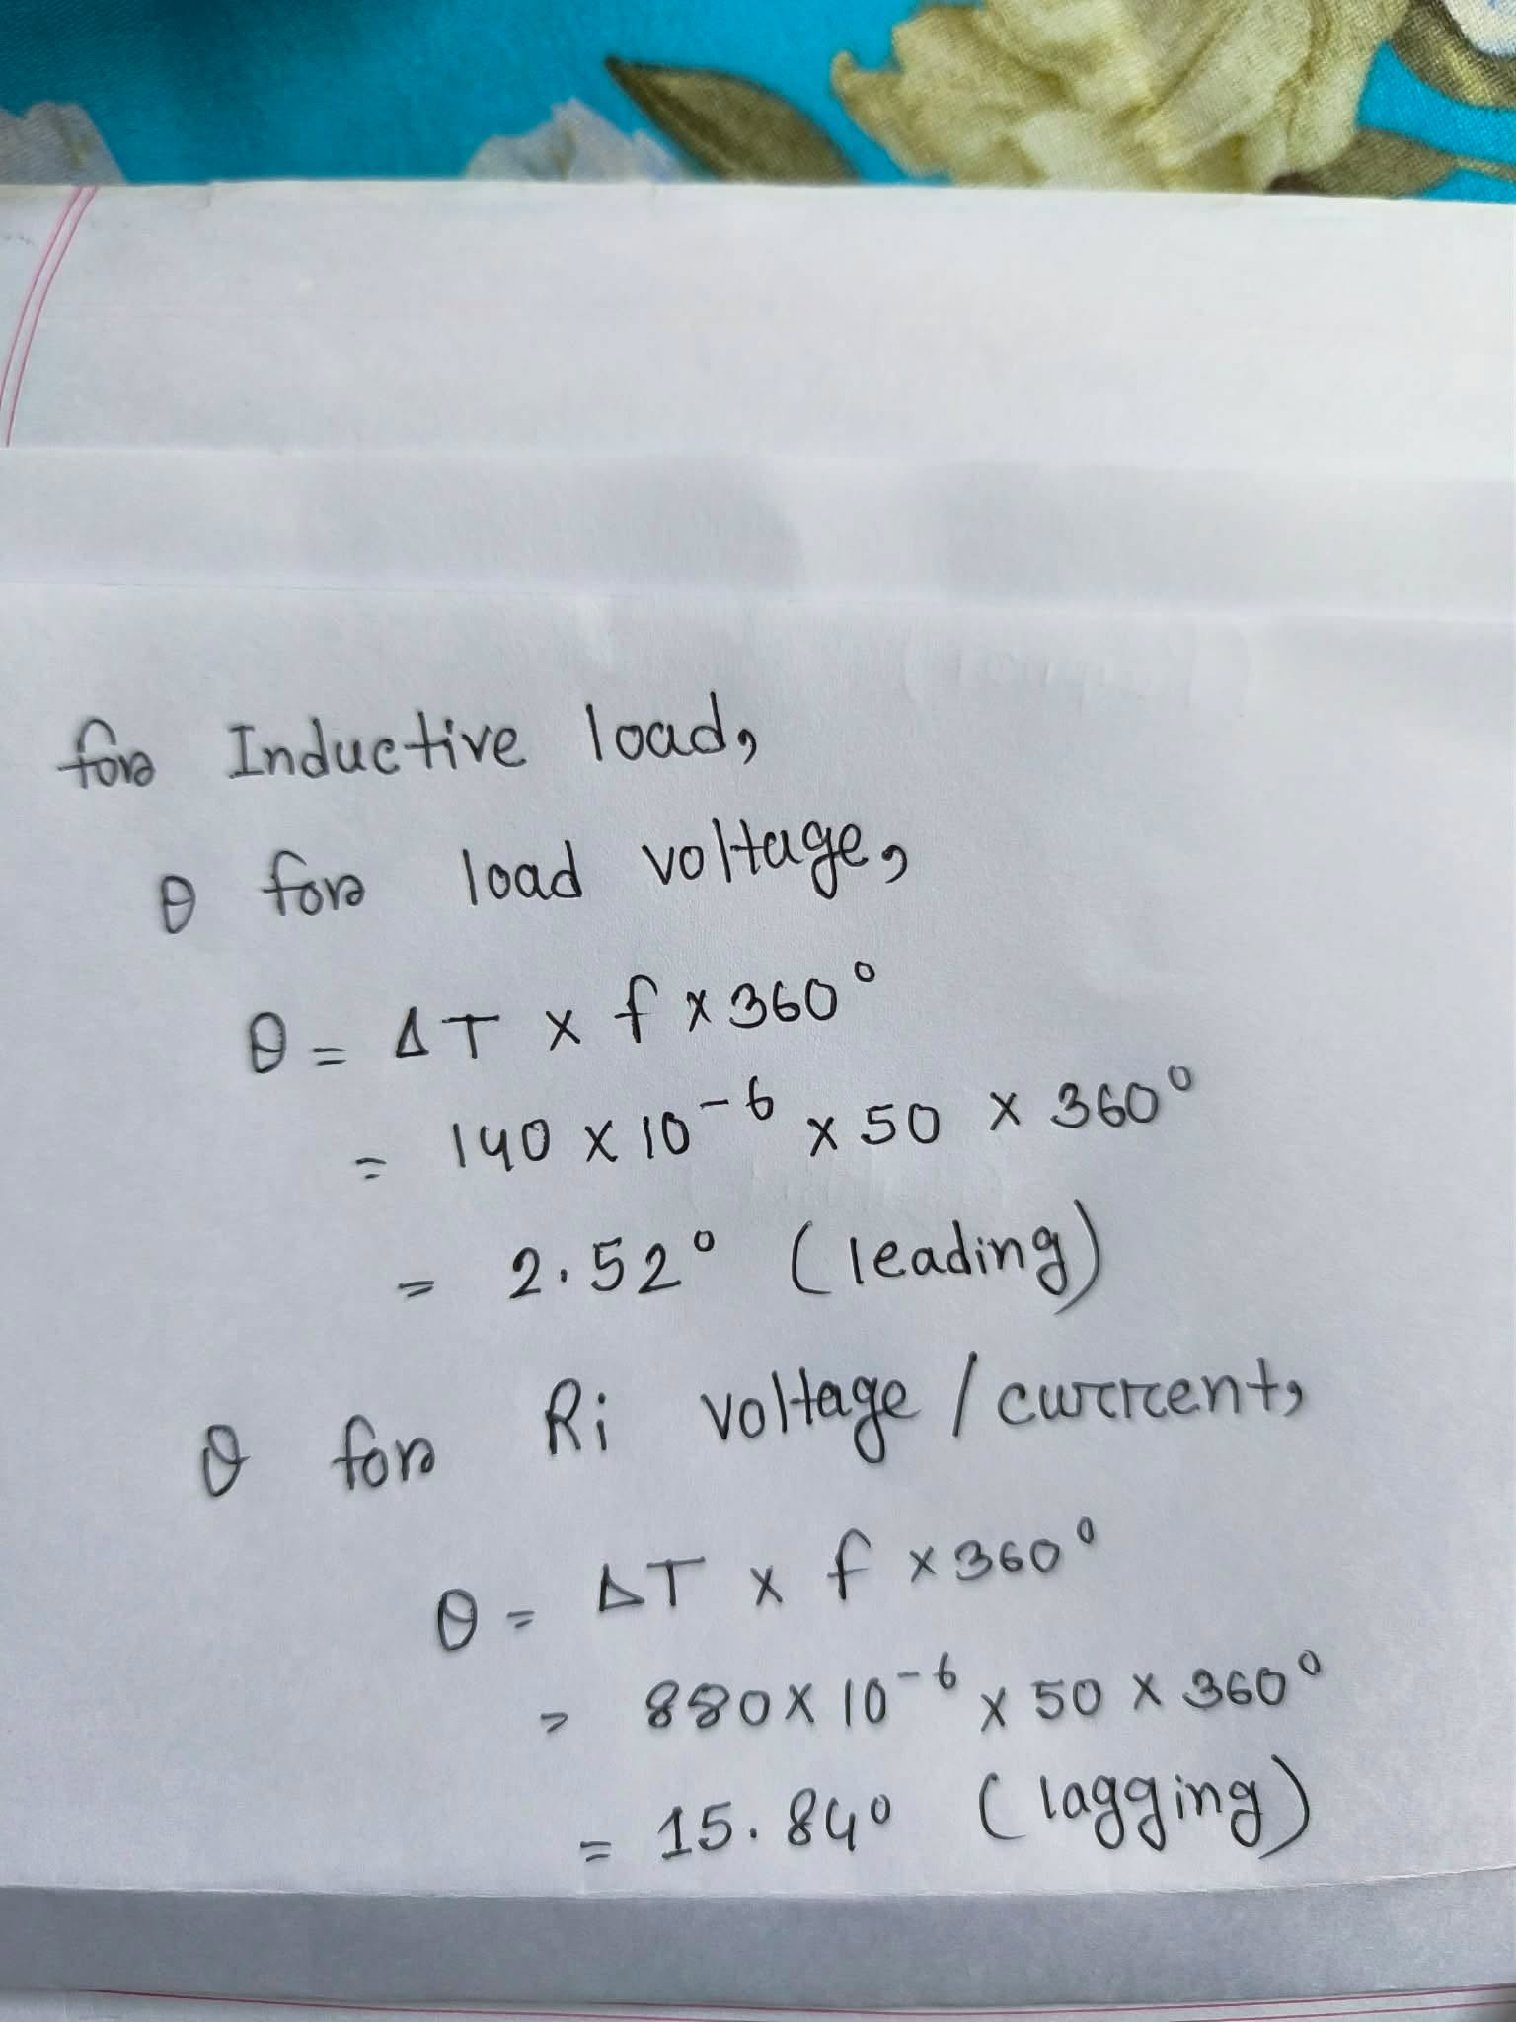

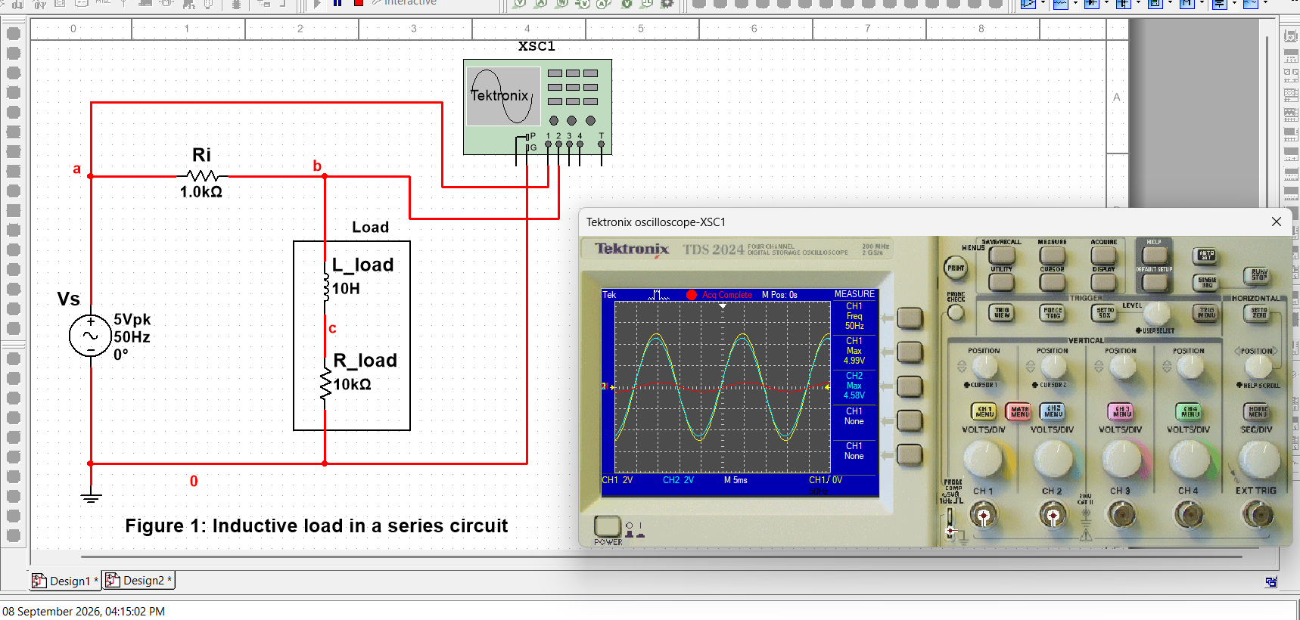
Screenshots ( Inductive Load ):
Reading 1: Circuit with oscilloscope connection

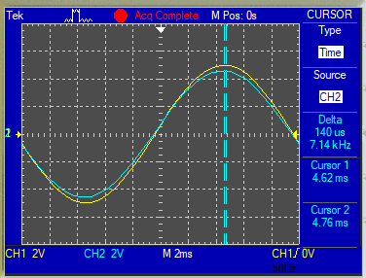
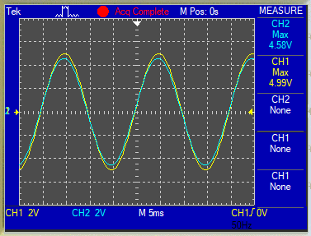

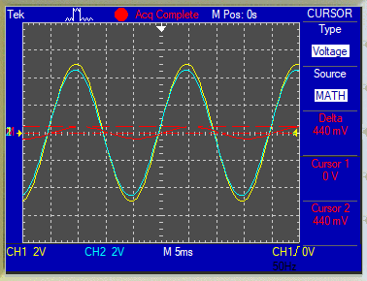
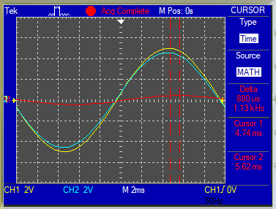
Reading 2: Δt for load voltage
Reading 5: Δt for Ri voltage
Reading 4: V_Ri (peak)
Reading 1: V_Load (peak)

Problem 2: Capacitive Load in a Series Circuit
Simulate the capacitive load circuit shown in Figure 2. Measure the load voltage, the voltage across Ri, and the required time differences using the oscilloscope. Then complete Table 2 and calculate the load current and power drawn by the load.

Table 2: Capacitive Load
Reading | Parameter | Value
1 | V_Load (peak) | 4.57 V (peak)
2 | Δt for load voltage | 80 µS
3 | θ for load voltage | θ = (Δt ×f ×360) = (80×10⁻⁶ ×50 ×360) = 1.44º ( Lagging )
4 | V_Ri (peak) | 420 mV (peak)
5 | Δt for Ri voltage | 1.5 mS
6 | θ for Ri voltage / current | θ = (Δt ×f ×360) = (1.5 ×10⁻³ ×50 ×360) = 27º ( Leading )
7 | I_s ∠ θ | I_{s} $=\frac{V\left(Ri\right)}{Ri}=\frac{420∠27º}{1000}$  = 0.42 mA_{pk} ∠27 º
8 | Power drawn by the load, P | P = ($\frac{1}{2}$ I_{pk}² ×R_{load} )= 0.5×(0.42×10⁻³)² ×10⁴  = 0.882 mW

Calculation ( Capacitive Load ):
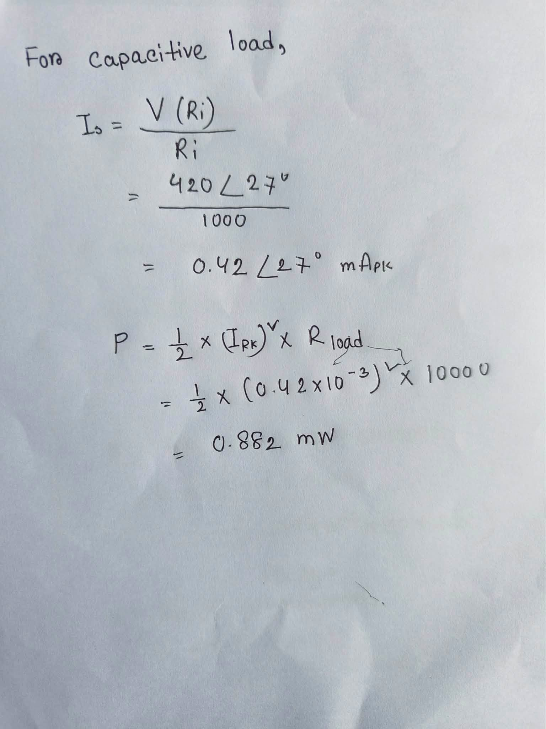
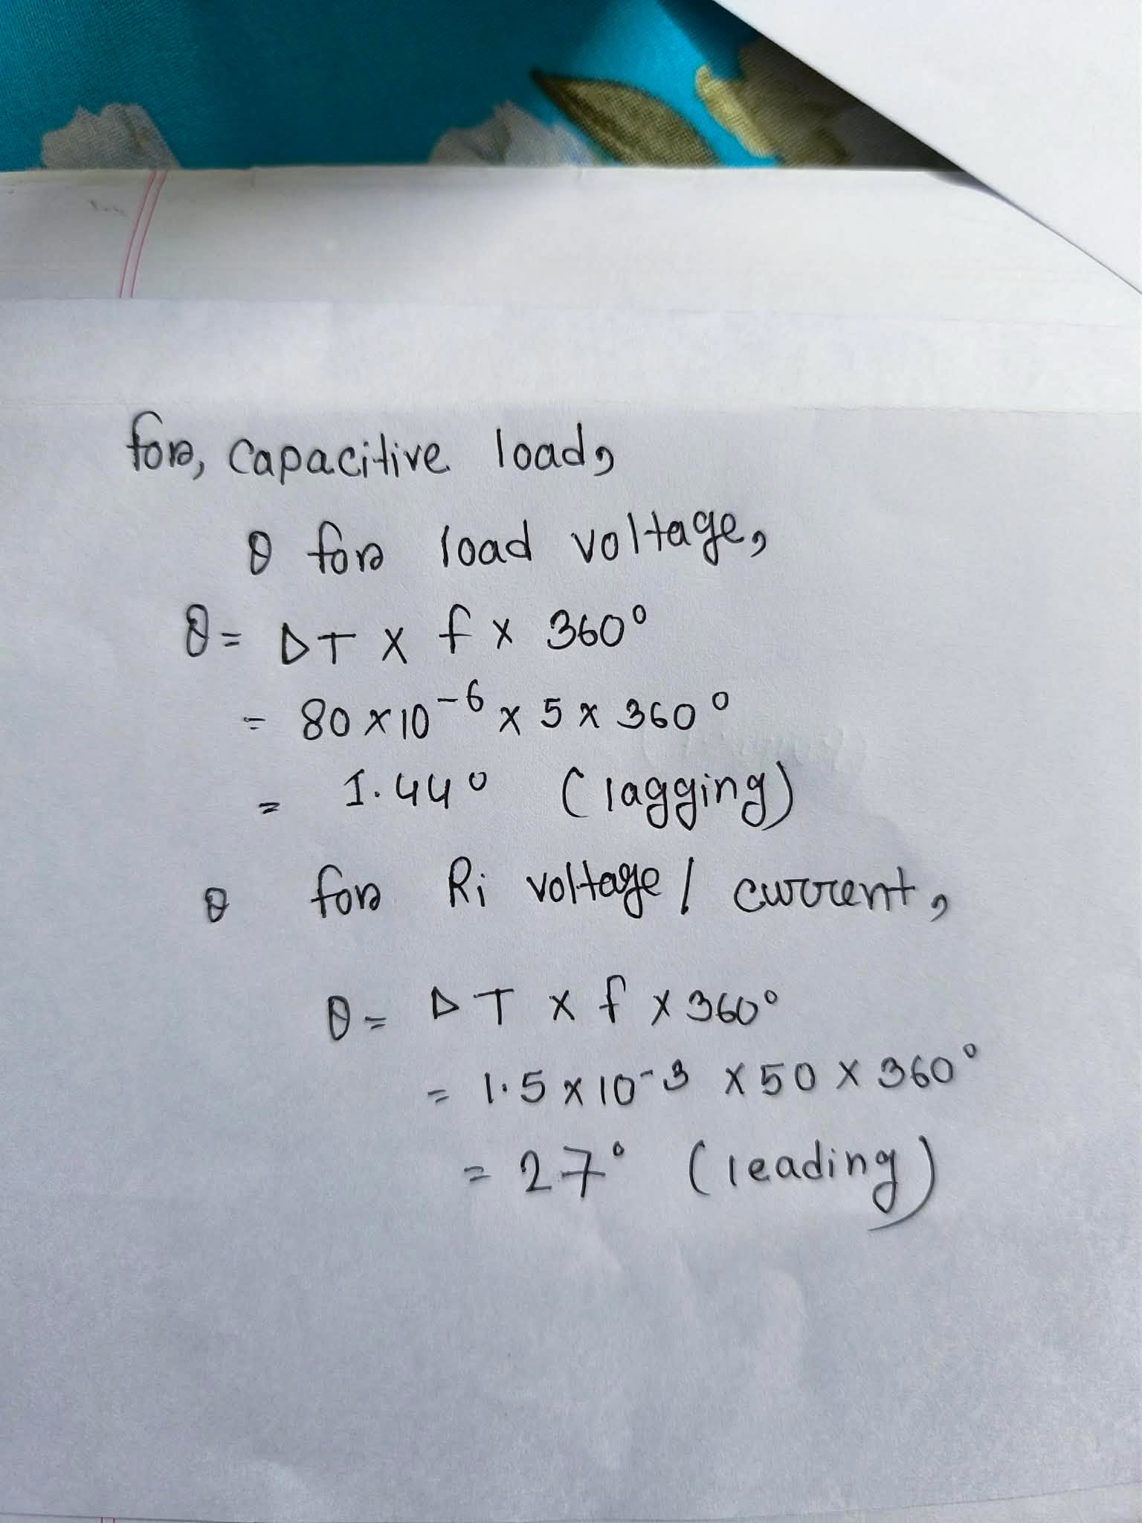

Screenshots (Capacitive Load):
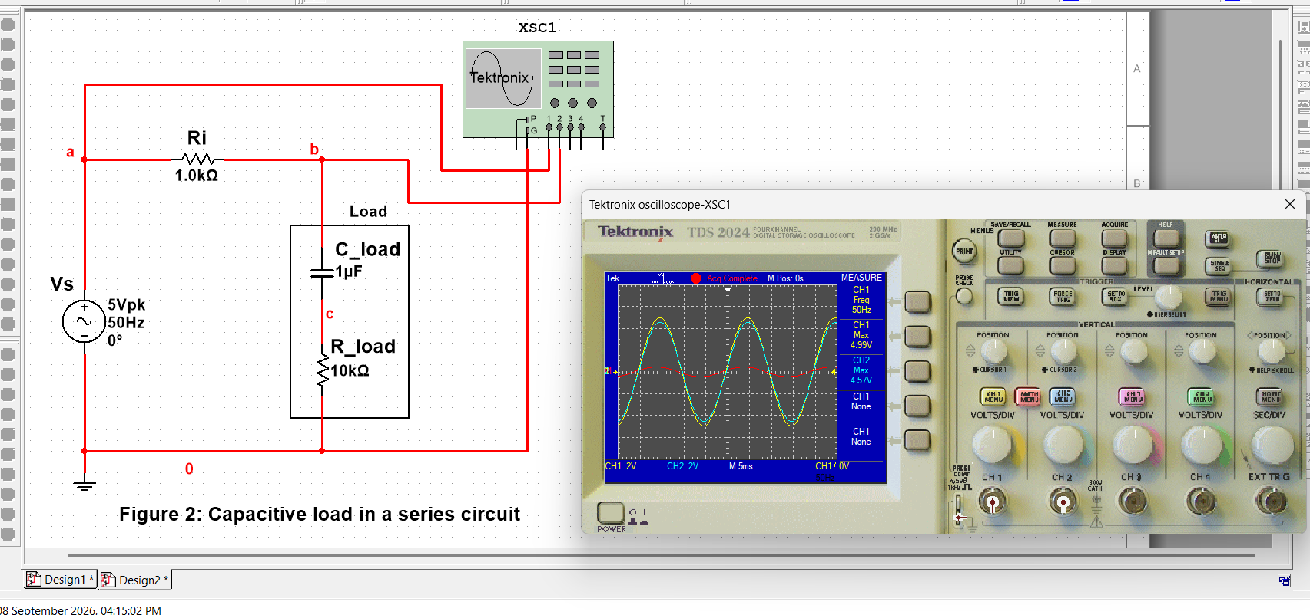
Reading 1: Circuit with oscilloscope connection
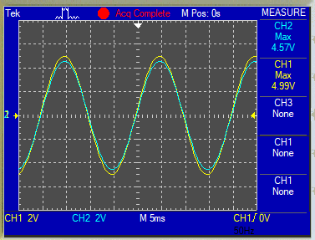
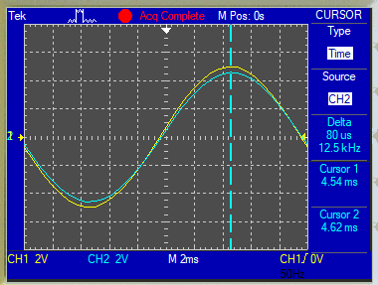
Reading 2: Δt for load voltage
Reading 1: V_Load (peak)

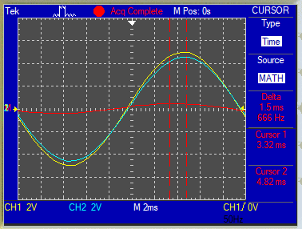
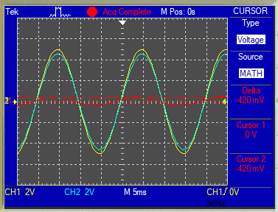
Reading 5: Δt for Ri voltage
Reading 4: V_Ri (peak)

